Examining Culture in Organisations:
Guidance on Using Qualitative Methods in Organisational Research
Doc. Type | ONR Guidance Document
Unique Doc. ID: | TD-HOC-GD-001 |  | Issue No.: | 1.5
Record Reference: | 2020/320758
Date Issued: | Dec-23 | Next Major Review Date: |  | Dec-24
Prepared by: |  | Principal Nuclear Safety Inspector
Approved by: |  | Human and Organisational Capability Professional Lead
Process Owner: |  | Human and Organisational Capability Professional Lead
Revision Commentary: | Review date extended to December 2024.

Table of Contents
1. Introduction 4
2. Purpose & Scope 5
3. Further Reading 6
4. Responsibilities 7
5. The Research Process 8
5.1. Determining the Research Focus 9
5.2. Identifying the Research Objectives and Research Questions 14
5.3. Writing the Research Proposal 16
5.4. Designing the Research 16
5.5. Collecting the Data 18
5.6. Analysing the Data 28
5.7. Reporting the Research Findings 38
5.8. Review, Learn and Improve 39
References & Supplementary Reading 40
Appendix A – An Example Research Proposal 44
Appendix B - An Example of a Semi-Structured Interview Guide 47
Appendix C – An Example of a Participant Information Sheet 49
Appendix D – An Example of an Observation Guide 51
Appendix E – Typical Assessment Note Contents 52

List of Figures
Figure 1: The Research Process 8
Figure 2: Harmonised Safety Culture Model 9
Figure 3: Iceberg model of organisational culture 10
Figure 4: Antecedents and Consequences 13
Figure 5: Linking Safety Climate to Performance, Knowledge and Motivation 14
Figure 6: An Example of a Problem Statement 15
Figure 7: Tips for a Successful Interview 20
Figure 8: A Comparison of Focus Group and Semi-Structured Interviews 24
Figure 9: A Comparison of Structured and Unstructured Observations 26
Figure 10: Observer Roles 26
Figure 11: Data Analysis Method 29
Figure 12: Initial Template for a Safety Culture Assessment 30
Figure 13: Initial Template for Diagnosing an Organisational Problem 31
Figure 14: The Creation of Themes 32
Figure 15: Final Template Developed for a Safety Culture Assessment 35
Figure 16: Relationship between Themes 38

Introduction
The role of organisational culture in maintaining nuclear safety is well established. Reports of investigations into notable events such as Three Mile Island, Chernobyl, Davis Besse and Fukushima provide compelling evidence of the importance of establishing an effective nuclear safety culture. Much academic and business research over the past 40 years has also established the critical role of organisational culture in achieving good safety outcomes.
ONR acknowledges the importance of its role as an independent statutory regulator in promoting and enhancing an effective nuclear safety culture. The methods outlined in this document provide ONR with an additional means of doing this.

Purpose & Scope
The purpose of this document is to provide ONR’s human and organisational capability specialist inspectors with a flexible framework of qualitative research methods to enable them to undertake targeted assessments of culture, assessments of culture change, or to diagnose organisational problems which may be adversely impacting upon safety outcomes. It complements ONR Guide NS-INSP-GD-070: Safety Culture Guide for Inspectors (ONR, 2019) which is written to assist site inspectors in identifying areas of concern or good practice in a dutyholder’s safety culture by observing and drawing comparisons to the traits and attributes of a healthy safety culture.
This document provides guidance on how to collect data by undertaking interviews, focus group interviews, observations, and document analysis, and how to analyse data using template analysis, a form of thematic analysis. Qualitative methods are well-suited to describing and understanding phenomena such as safety culture, for example they have been used to explore how safety culture is understood by employees in a nuclear power plant maintenance unit (Reiman et al, 2005) and to understand how workers conceptualise safety culture (Høivik et al, 2009).
This guide is intended for research which is either empirically driven (where the conclusions are drawn from verifiable evidence, for example: ‘Why do safety failures keep recurring in team A?’) or empirically driven and theoretically informed (where theory is used as a lens to explore a problem, for example: ‘How does the safety climate affect the safety behaviour of team A?’). This guide is not intended for research that is theoretically driven (is concerned with theory building and testing): this type of research should be commissioned in accordance with ONR’s research strategy.
The guide is written with a safety focus however the methods can be applied to all five of ONR’s purposes as set out in Part 3, Chapter 1 of the Energy Act 2013.

Further Reading
The following publications are recommended as further reading on the methods outlined in this guide:
- Business Research Methods, 5th edition, by E. Bell, A. Bryman, and B. Harley, 2019. Oxford University Press.
- Research Methods for Business: A Skill Building Approach, 7th edition, by U. Sekaran and R Bougie, 2016. Wiley.
- Performing Safety Culture Self-Assessments, IAEA Safety report Series No. 83, International Atomic Energy Agency, 2016. International Atomic Energy Agency.
See also the ‘references and supplementary reading’ section at the end of this guide.

Responsibilities
The customer, normally a delivery lead, is responsible for:
- Commissioning the intervention.
- Agreeing the scope, objective, and question(s) to be answered.
- Devising regulatory strategy in response to the findings.
The Professional Lead is responsible for:
- Assigning specialist resources.
- Acceptance review of the report where this is required.
The Team Lead is responsible for:
- Determining the focus of the research.
- Designing the intervention.
- Drafting a task sheet.
- Leading the collection and analysis of the data.
- Overseeing the writing of the report.
- Making recommendations.
- Communicating findings and recommendations to the customer and the dutyholder.
Team Members are responsible for:
- Preparing guides to aid the data collection.
- Collecting the data.
- Analysing the data.

The Research Process
The research process shown in Figure 1 is a systematic framework to be applied flexibly and iteratively. It comprises of eight steps: determine the research focus; identify the research objective and research questions; write the research proposal; design the research; collect the data; analyse the data; report the research findings; review, learn and improve. The remainder of this document addresses each of these eight steps.
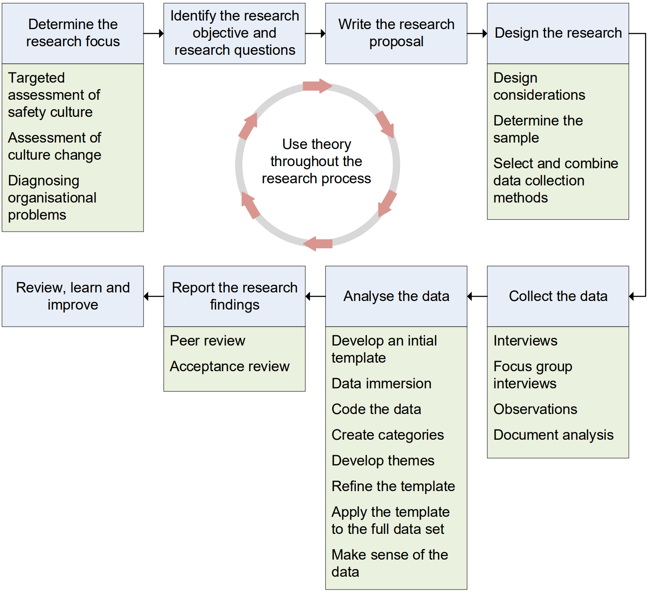
Figure 1: The Research Process

Determining the Research Focus
The first step of the research process is to determine the research focus: an important consideration which influences the research design decisions. This section provides an overview of the three primary areas of research focus: a targeted assessment of safety culture, an assessment of culture change, and the diagnosis of an organisational problem.

Targeted Assessment of Safety Culture
As an independent statutory regulator, ONR would not normally undertake a full independent safety culture assessment of a dutyholder as “the prime responsibility for nuclear safety rests with the organisation responsible for facilities and activities that give rise to radiation risks” (IAEA, 2006a, p.6), and therefore ONR expects dutyholders to periodically assess their own safety culture. ONR may however undertake a targeted assessment where it has identified shortfalls that may indicate a problem with aspects of the safety culture. Such an assessment would normally focus upon one or more typical cultural traits such as ‘questioning attitude’ or ‘raising safety concerns’ included within a safety culture model, as shown in Figure 2.
Harmonised Safety Culture Model
Individual responsibility  Questioning attitude  Communication  Leader responsibility  Decision-making | Work environment  Continuous learning  Problem identification and resolution  Raising concerns  Work planning
Figure 2: Harmonised Safety Culture Model
The five-dimension safety culture model included within IAEA Safety Standard No. GS-G-3.1 (IAEA, 2006b), IAEA’s Harmonised Safety Culture Model (IAEA, 2020), Schein’s (1990) model of organisational culture, and Cooper’s (2018) six safety culture characteristics, are some examples of models which inspectors may consider using when undertaking targeted assessments of safety culture. Inspectors should take care to ensure the dimensions of any culture model they select are properly defined.
A Targeted Culture Assessment
A delivery lead wants assurance that a dutyholder’s safety culture is sufficiently robust to justify moving it from enhanced into routine regulatory attention. Options available include commissioning a wide-ranging assessment using all ten IAEA traits or a more limited assessment targeting a handful of the traits most relevant to the dutyholder’s context and history.
Historically the dutyholder was poor at work planning, problem resolution and decision-making, and it was weaknesses in these three traits which led to it entering enhanced attention in the first place. The inspector recommends a limited culture assessment focusing on just these three traits.

Assessment of Culture Change
ONR may also want to assess culture change. Here ONR would undertake a longitudinal assessment, typically 12 to 36 months apart, so that comparisons can be made between the results of the two assessments. Culture change is challenging to assess: if an organisation improves its housekeeping, improves the quality of its written instructions, and develops a new set of organisational values, is this evidence of culture change or has the organisation simply made improvements in three discrete areas of its business? To assess culture change, ONR advocates use of the iceberg model based upon Schein’s (1990) model of organisational culture as shown in Figure 3.
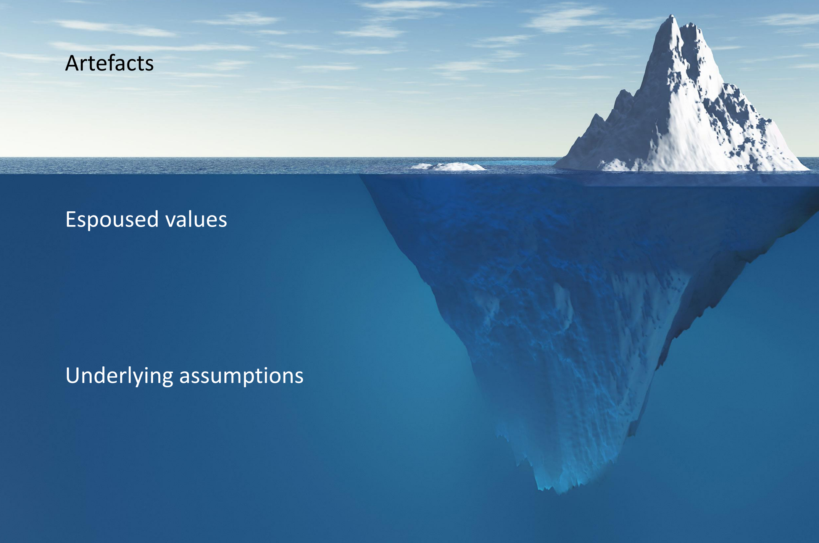
Figure 3: Iceberg model of organisational culture

Consider an iceberg observed from a nearby ship; what is observable above the water is only a small amount of the mass that makes up the iceberg. Upon closer inspection more of the iceberg can be seen just underneath the surface of the water however the bulk of the mass is too deep to be seen with the naked eye. On the surface of the iceberg model are artefacts: the observable physical and social environment of the organisation. These include behaviours, architecture, physical layout, signage and symbols, slogans and expressions, technology, rituals and routines, control systems, and organisational structures.
Just below the surface, less visible than artefacts are espoused values: the underlying meanings which explain patterns of behaviour and artefacts.
Sometimes these are found to be documented in a ‘value statement’ which comprise of both deeply held values (those which are congruent with the underlying assumptions) and aspirational values (those which the organisation hopes to one day possess and which set a cultural direction).
Hidden deep below the surface, and usually invisible, are underlying assumptions. These are the taken for granted ways in which people within the organisation perceive the world. Sometimes described as the paradigm, they are only understood by people who have become accustomed to the way the organisation works.
They are not written down, are rarely spoken about, and are difficult to unearth.
For an organisation to change its culture it must unearth and understand the underlying assumptions so that people can reflect upon them and recognise what is unconsciously driving their behaviours. It is only when deeply held assumptions have been modified, that culture change is likely to sustain. Inspectors concerned with assessing culture change should develop an understanding of the deeply held assumptions and how they affect the way safety is enacted in the organisation.
This requires reflection, analysis, and a degree of immersion in the culture of the organisation.
Culture Change: from Control to Empowerment
The relationships between leaders and the workers in a dutyholder organisation had been poor for many years. An inspector had come to realise that the health of the relationship was affecting safety performance, so they undertook research to understanding what was driving the poor quality of these relationships. By interviewing leaders and workers, and by observing interactions between people at different hierarchical grades, the inspector uncovered a fundamental belief held by management: that the workforce cannot be trusted and needs to be controlled.
This mistrust had created a work environment of conflict and poor industrial relations.
When interviewing some of the organisations’ longest serving members the inspector found that relationships between leaders and workers had deteriorated following a major accident that occurred many years earlier and which was blamed upon human error. This critical event in the organisation’s history was the catalyst for the development of a deeply held assumption: ‘hazardous processes must be tightly controlled’. Over time this had manifested into a shared belief amongst management that the route to tightly controlling hazardous processes is by tightly controlling workers. This had led to workers becoming disengaged and distrusting of senior management.
The inspector shared this finding with the organisation’s CEO who acknowledged the existence of both the assumption and the shared belief, and the detrimental impact that these were having on relationships and performance. To address this the CEO embarked upon a culture change programme to help people understand that tightly controlling workers is not the optimal way of controlling hazardous processes, and that instead a capable and competent workforce with an increased degree of autonomy leads to more reliable and safe operations.
Here the CEO didn’t challenge the underlying assumption that hazardous processes must be tightly controlled. Instead they re-articulated what this meant for the organisation: that by empowering rather than controlling people, the conditions for becoming a high reliability organisation can be established. Over time the relationships between the workers and managers improved, along with safety and business outcomes.

Diagnosing Organisational Problems
The research may not always be focussed explicitly on safety culture. An inspector may encounter a safety problem and wants to understand the underlying factors so that action can be taken to improve safety outcomes. Examples of safety problems an inspector may encounter include workers not following safety rules, failures to learn from previous events, or safety conversations that indicate complacency.
An inspector should first determine whether the safety problem they are initially presented with is the real problem or whether it is a symptom of a deeper systemic problem. This requires preliminary data collection to frame problems accurately such as a review of dutyholder documentation, informal discussions with dutyholder staff, a small number of focus group interviews, and/or observations to see the symptoms of the safety problem first-hand. Inspectors should also draw upon academic literature to understand the social processes which may be affecting safety outcomes. This differs from typical regulatory approaches which rely upon sources of relevant good practice as standards against which to judge compliance. Examples of academic literature of interest to safety include:
- Three levels of culture (Schein, 1990).
- Organisational safety culture (Guldenmund, 2016).
- Generative organisations (Westrum, 1996; Parker et al, 2006).
- Safety climate (Zohar, 1980; Flin et al., 2000; Neal et al, 2000; Cooper & Phillips, 2004).
- Safety commitment (Fruhen et al, 2019).
- Transformational and transactional leadership (Clarke, 2013).
- Empowering leadership (Martínez-Córcoles et al, 2012 & 2013).
- Leader-member exchange (Hofmann & Morgeson, 1999 & 2003).
- The S.A.F.E.R. leadership model (Wong et al, 2015).
- Attitudes at work (Cox & Cox, 1991, Henning et al., 2009).
- Motivation (Azjen, 1991; Griffin & Neal, 2000).
- Job design (Hansez & Chimel, 2010; Nahrgang et al, 2011).
- Employee engagement (Saks, 2006).
- Chronic unease (Fruhen et al, 2014).
- Biases in decision making (Janis, 2008).
Consider the example of an organisation whose leaders have been unsuccessful in their attempts to increase incident reporting. Following an exploratory study an inspector finds that the real problem may be the low safety motivation of employees who feel that safety is not a priority for the organisation. Here the low incident reporting rate is a symptom (a consequence) of a systemic safety motivation problem (an antecedent) and if these conditions were to remain, setting reporting targets may not improve reporting. This distinction is important because safety literature has established that low safety motivation can result in lower safety compliance and lower safety participation (Griffin & Neal, 2000), and therefore low incident reporting is just one of many safety problems that low safety motivation could lead to, as shown in Figure 4.
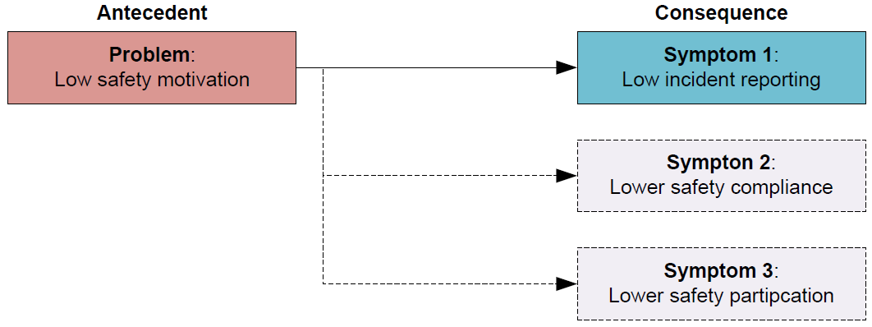
Figure 4: Antecedents and Consequences

The inspector carries out a further exploration of the problem and reviews the academic literature; in doing this they identify that safety motivation mediates the effect of safety climate on individual behaviour (Griffin & Neal, 2000), as shown in Figure 5.
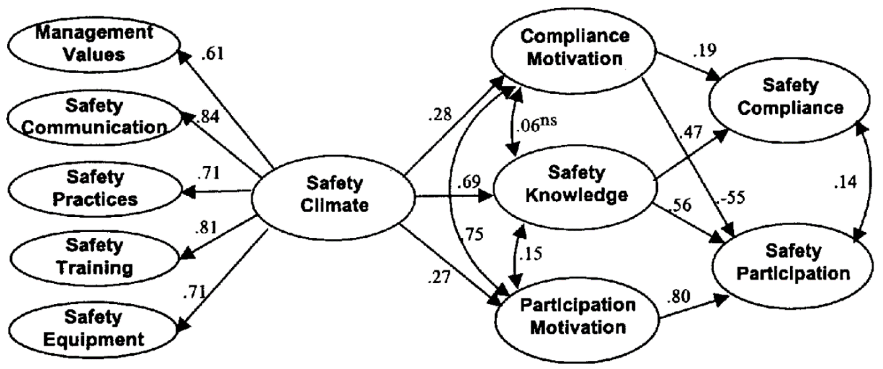
Figure 5: Linking Safety Climate to Performance, Knowledge and Motivation
From “Perceptions of safety at work: a framework for linking safety climate to safety performance, knowledge, and motivation “, by M.A. Griffin and A. Neal, 2000, Journal of occupational health psychology, 5(3), p.347. Copyright 2000 by American Psychological Association.
The inspector now uses this new knowledge to re-frame the problem from one which started out as ‘low incident reporting’ to one concerned with ‘safety climate’, and the research is now appropriately focussed. This is important because regulatory effort targeted on understanding and influencing improvements in safety climate could lead to positive transformational change across several safety outcomes.
Key point: Exploratory studies do not always lead to further research. An inspector may determine that the problem is not as complex as initially thought and that no further examination is required.

Identifying the Research Objectives and Research Questions
The second step in the research process is to identify the research objectives and research questions. A well written problem statement comprises a description of the safety problem (the real problem, not its symptoms), the research objective(s) and the research question(s). Inspectors should invest time and thought to ensure that a problem statement is written which frames the problem accurately and is both relevant (is aligned to regulatory strategy) and feasible (is achievable given the resources available).
Figure 6 shows an example of how a problem statement may be framed using the earlier example of low incident reporting.
Problem Statement
Despite both dutyholder and ONR intervention, incident reporting has not improved. Initial data gathering suggests that the safety climate within the organisation may be low and that this may be affecting the safety motivation of workforce, explaining the failure to improve incident reporting. A review of the literature indicates that safety climate affects safety motivation and safety knowledge which in turn affects safety compliance and participation (Griffin & Neal, 2000), and therefore this view is supported by theory.
Research objective
The objective of this research is to explore perceptions of safety climate using the five dimensions of management values, safety communication, safety practices, safety training & safety equipment (Griffin & Neal, 2000), to understand how this may be impacting upon safety motivation, safety knowledge and ultimately safety performance.
Research questions
- How is the safety climate shaped by the leadership?
- How is safety climate perceived by the workforce?
- How is safety climate impacting upon safety motivation, safety knowledge and ultimately safety performance?
- What can be done to improve the safety climate and ultimately safety outcomes?
Figure 6: An Example of a Problem Statement

Writing the Research Proposal
The third step in the research process is to write the research proposal. Its contents should comprise:
- A title.
- The problem statement (problem, research objective and research questions).
- The scope of the study.
- The relevance of the study to ONR’s purposes.
- An outline of how the research will be undertaken (pending detailed design).
- The timeframe.
- The resources required.
The research proposal should be recorded in a task sheet which should then be endorsed in accordance with divisional arrangements. An example of a research proposal is shown at Appendix A.

Designing the Research
The fourth step on the research process is to design the research. This section provides an overview of design considerations, how to determine the sample, and how to select and combine data collection methods.

Design Considerations
Qualitative research can be labour intensive, so inspectors should give due consideration to how much data the research team is able to analyse in the given timeframe and choose methods which are most efficient given the limit of the resources available. Inspectors will need to strike a balance between gaining general insights into the culture or safety problem (what’s important in this context), and detailed insights (how things occur in this context).

Determining the Sample
Sampling in qualitative research is concerned with gaining insight rather than representativeness. Inspectors should select cases and participants in a strategic way and from multiple sources to enhance the credibility of any insights found.
Key point: Do not rely solely on volunteers as people who choose not to volunteer often hold views which are of high research value. To avoid this, send out targeted invites.

The number of interviews required will vary from study to study. As a guide an inspector should consider six focus group interviews or twelve one-to-one interviews to be minimum numbers. In some limited circumstances it may be acceptable to reduce these numbers further when these methods are combined, however too great a reduction may adversely impact upon the dependability and credibility of the insights gained.
Sampling should continue until no new findings are generated; known as ‘saturation’ this indicates that an adequate sample has been undertaken. If at the end of the planned sampling findings relevant to the research are still being uncovered, then further sampling is required. Here the inspector should expand the sample size by carrying out further data collection until saturation is achieved.

Selecting & Combining Data Collection Methods
Data collection methods should be selected and combined to provide the best insights for the given problem. Inspectors undertaking a safety culture assessment may, for example, use the following four methods, as follows:
- Semi-structured interviews with senior managers to explore their safety leadership, how they resolve the safety-production conflict, their views on the adequacy of risk management and safety systems, their understanding of competence and its role in nuclear safety, and their views on the efficacy of procedures and rules.
- Focus-group interviews to explore worker perception of management commitment to safety, the effectiveness of leadership visibility programmes, how risk is perceived by the workforce, relationships between management and the workforce, and beliefs as to the efficacy of procedures, rules, and training.
- Observations of day-to-day operations, a shift handover, setting to work, a plan of the day meeting, and a safety committee meeting.
- Document analysis of procedures, rules, the competence management system, risk assessment processes, safety policies and safety campaign material.
These can be combined in several ways:
- Merge: The simplest way to combine methods is to merge all the data and analyse it together as a whole.
- To explain: Data may be collected to elaborate on the findings of data that was collected and analysed earlier on.
- To explore: Data may be collected and analysed as preparation for later data collection, for example to frame a problem and aid the formulation of well-defined research questions.
Key point: Triangulation involves using multiple methods or sources of data to provide greater confidence in the findings. The cross-checking of findings from different methods and data sources also aids the development of a richer understanding of the social processes being explored.
The selection and combination of data collection methods should be deliberate and planned. The inspector should explain their rationale for selecting and combining data collection methods in the research proposal.

Collecting the Data
The fifth step in the research process is to collect the data. This section provides an overview of interviews, focus group interviews, observations, and document analysis.

Interviews
Interviews are the most widely used method for gathering data in qualitative research. Inspectors may choose to undertake two types of interview: unstructured and semi-structured. In an unstructured interview an inspector uses a short aide-memoire covering a range of topics and retains a great degree of flexibility in what to ask and when. The aim is to generate a conversation and a rich discussion about the interview topics. In a semi-structured interview, the inspector develops and uses a pre-prepared interview guide to give greater structure to the interview. Interview guides comprise of a list of questions on the topics to be covered and normally all questions in the guide will be asked during the interview. The inspector may also ask questions that are not included in the interview guide as they respond dynamically to the interviewee’s answers. In both types of interview, the interviewee retains a great degree of freedom in how they respond.
The choice of which interview method to use depends upon the following two factors:
- Level of understanding. When the inspector has a clear understanding of the information sought and knows what topics they want to address, semi-structured interviews are preferred, whereas when the inspector has less of an understanding of the information sought and wants to gather initial data to properly frame the safety problem, unstructured interviews are preferred.
- Degree of comparability. When several inspectors are each undertaking interviews, semi-structured interviews are preferred as the use of the interview guide makes it easier to compare the data gathered by each inspector.
The inspector must first consider what information is needed to answer each of the research questions when developing an interview guide. The interview questions should assist in answering the research questions, but they should not be too specific: do not convert the research questions directly into interview questions.
The order of the questions should be planned so that the interview flows naturally; it is however acceptable to change the order of the questions during the interview if this is thought to be of help. Think about the questions from the perspective of the interviewee and use language which they will understand and is relevant to them.
It is good practice to record general information such as name, age, gender, job role, years working for the company, etc., as this can help to put answers into context later.
The structure of an interview guide comprises an introduction, a main body, and wrap-up questions. The main body normally comprises both general questions aimed at gaining a broad understanding of an issue or context, and direct questions aimed at gaining a more specific understanding of an issue or context. An example of a semi-structured interview guide is at Appendix B.
Good interviewing skills take time to develop. A good interviewer will be thoroughly briefed about the research and will know how to start the interview, how to ask questions, how to motivate interviewees to answer questions, what to look for in answers, and how to properly close an interview. This requires good planning, effective training, and clear guidelines for those conducting the interviews. Tips for carrying out a successful interview are shown in Figure 7.
Interviews can be carried out face-to-face, by videoconference, or over the telephone. Face-to face interviews are the most effective as these enable the interviewer to build rapport and pick-up on non-verbal cues much easier than by videoconference or telephone. Telephone and videoconference interviews can however be conducted from the home or the office, enabling several people to be contacted in a short period of time and avoiding travel. Inspectors may consider undertaking a combination of interviews: some remote to save on time and some face-to-face interviews to retain interview quality.
Key point: Dutyholders have different IT security and software limitations which can make video-conferencing compatibility and connectivity challenging. Early testing is essential to ensure interviews can go ahead as planned.
Where possible interviews should be recorded and transcribed as this has the following advantages over note taking (Heritage, 1984):
- It helps to correct the limitations of intuition and recollection.
- It enables repeated and detailed examination to be undertaken.
- It increases the range and precision of the insights which can be gained.
- It enables other researchers to access and scrutinise the data to protect from biases being introduced into the analysis.
- It enables the data to be re-used, for example in exploring other safety problems.

Tips for a Successful Interview
Purpose | Explain the purpose of the interview clearly
Quality of questions | Ask questions which are easy to understand and answer  Present questions in a logical order  Questions should prompt open discussion  Use language which reflects the understanding and everyday experiences of the interviewee
Quality of interview process | Listening & empathy  Show an interest in the interviewee’s responses  Explore silences and laughter  Be empathetic and sensitive to the issues expressed  Be patient  Understanding  Follow up or clarify the meanings of the interviewee’s answers throughout the interview  Clarify things not understood  Corroborate and interpret the interviewee’s responses  Be critical and don’t take responses at face value  Direction & flexibility  Be open to the articulation of unexpected phenomena  Ensure the interview is neither too structured and directive nor too unstructured and free flowing  Remembering & connecting  Refer to earlier discussions and connect points throughout the interview
Quality of information & discussion | Seek detailed qualitative descriptions  Seek descriptions of specific events, processes and practices  Seek nuanced comparative descriptions  Facilitate a conversation which is spontaneous, rich and specific  Seek answers which are relevant to the questions asked  Ask short questions and encourage long responses
Figure 7: Tips for a Successful Interview

ONR has a small stock of voice recorders available from the divisional delivery support (DDS) teams. DDS can also provide a transcription service upon request. Inspectors wanting to use a voice recorder on site should engage early with the dutyholder to ensure that security requirements can be addressed. A dutyholder may be able to provide access to an approved voice recorder for use in secure areas and arrange for the interviews to be transcribed on ONR’s behalf however assurances would need to be given that the interviewees’ confidentiality and anonymity would be respected.
Potential issues with interviews include:
- The uncommunicative interviewee who may be reluctant to participate in the interview, may be anxious, or may be of a quiet disposition.
- The over-communicative interviewee who may talk more than anticipated and may stray from answering the questions onto topics which are not relevant to the research objective.
- The high-status interviewee who is used to chairing meetings and may try and take charge of the interview, making it difficult to steer the interview in the direction originally intended. They are often highly political in their answers, so it is important for the interviewer to be critical and not to take responses at face value.
- The high-status interviewer who creates an imbalance in power between interviewer and interviewee. ONR’s inspectors have legal power and are ‘high-status interviewers’ so it is important to reassure interviewees by clearly explaining the purpose of the interview, by empathising with them, and by establishing rapport.
Participants should be willing to participate in the interviews. On occasions participants may turn up for an interview having been provided with little or no information by their management and some may find this daunting. The inspector should outline the purpose of the interview and explain how this differs from inspection. They should build rapport with the participants and answer any questions they may have about the interview process and the use of their data. Participants should be provided with a participant information sheet which can be used to brief them. A participant information sheet prepared for a semi-structured interview is provided at Appendix C.

Questioning Technique
Use the funnelling technique. At the beginning of an interview it is advisable to ask open-ended questions to get a broad idea and form some impression about the situation, for example: “What are your feelings about working for this organisation?” From the responses to this broad question, further questions that are progressively more focussed may be asked as the interviewer processes the interviewees’ responses and notes some possible key issues relevant to the situation.
Ask unbiased questions, for example: “Tell me your experiences of having to follow nuclear safety rules” is a better questions than: “It must be a nightmare having to comply with all these nuclear safety rules – tell me about your experiences of this”.
Clarify issues. Restate or rephrase important information given by the respondent to ensure you understand it. For instance, if the interviewee says: “Production always takes priority over safety rules; getting the job done is number one – it’s always those who get the job done that get rewarded”, the interviewer may interject: “So are you saying that people get rewarded for completing a task even if it is known they haven’t followed the safety rules?” Rephrasing in this way clarifies the issue of whether people are rewarded when it is known that they are violating rules.
Help the respondent to think through issues. If the respondent is not able to verbalise their perceptions, or replies: “I don’t know”, then ask the question in a simpler way or rephrase it.
Take notes. Make clear and comprehensive written notes throughout; this is essential if an interview is not being recorded. Kvale (1996) identifies nine types of questions / questioning tools:
- Introducing questions: “Please tell me about your role”.
- Follow-up questions: “You mentioned that you felt the task was not safe. Could you say more about that?”
- Probing questions: “Can you give me a further example of this?”
- Specifying questions: “What did you do then?”, or “How did your manager react to what you said?”
- Direct questions: “Do you find it easy to follow the work instructions?”, or “Are you happy with the amount of on-the-job training you have received?”
- Indirect questions: “What does most of the workforce think about how safety is prioritised by management” this can be followed by “Do you share that view?” to gain an understanding of the interviewee’s own views.
- Structuring questions: “I would now like to move onto the final question. Can you tell me about…?”
- Silence: To give the interviewee time to gather their thoughts before answering a question.
- Interpreting questions: “Do you mean that you don’t mind raising near miss reports, but when you get no feedback you feel more reluctant to do it?”

Focus Group Interviews
A focus group interview is a type of group interview that seeks the opinions of several people about an issue or topic. They allow inspectors to examine how a group of people interpret and make sense of topics of interest to the research. Inspectors may observe group members probing and challenging each other’s reasons for holding a view, offering different perspectives, voicing their agreements and disagreements, or justifying the reasons for their views. This group interaction produces more fully articulated accounts, and provides inspectors with insights into diversity of perspectives, collective sense-making, and the opportunity to observe culture in action: something which cannot easily be attained by other methods.
A focus group interview normally involves small groups of six to twelve participants and a moderator who manages the interview process and facilitates group discussion. Smaller sized groups are preferred when the topics are sensitive or controversial, or when detailed personal accounts are sought. Larger groups are preferred when numerous brief suggestions are sought. It is normally a good idea to over-recruit in anticipation of no-shows.
Focus group interviews can take a topic-based approach using a short aide-memoire like those used for unstructured interviews, or a question-based approach using an interview guide like those used for semi-structured interviews. As it is a method of interview, much of the guidance in the earlier section on interviews is also relevant here. The advantages and disadvantages of focus group interviews in comparison to semi-structured interviews are summarised in Figure 8.
The moderator is essential to the success of the focus group interview and their role is to generate a good discussion by moderating the degree of control and intervention they exert on the group. Moderators should allow the participants to have a degree of freedom in what they discuss whilst steering the discussion back on track if it veers off too far at a tangent. Allowing the participants freedom to discuss what they feel like discussing gives the moderator insights into what the participants see as interesting or important. Moderators should ensure the psychological safety and comfort of all participants and avoid conflict within the group. The moderator has an essential role in monitoring the process by ensuring all participate and by paying attention to what is said and what is not said, or who is spoken about and who is not spoken about. The moderator should always remain neutral.
Moderators should consider the nature of the interactions between the participants and not just what was said as this may provide insights relevant to the research questions. The success of a focus group interview can be evidenced by the level of participation and openness, the emergence of unexpected and divergent views, and the group reflecting on its own understanding.
Focus Group Interviews | Semi-Structured Interviews
Advantages:  - Different perspectives  - Voicing of agreements and disagreements  - Qualification, justification, and reasons for views  - Display of culture and group dynamics  - More fully articulated accounts  - Diversity of perspectives  - Collective sense-making  Disadvantages:  - The number of questions covered may be limited  - Less depth and detail  - Careful moderation of the group is required to ensure that views are heard, and conflict is managed  - Confidentiality can be a problem in a group of people  - Potential for groupthink | Advantages:  - Allow sensitive or personal topics to be explored  - Greater control over the selection of the participants  - Depth and comprehensiveness of responses to questions  - Free from group pressures  Disadvantages:  - Time consuming  - Lacks the opportunity to observe interactions with others
Figure 8: A Comparison of Focus Group and Semi-Structured Interviews
The mix of participants is an important consideration. A homogenous group is one where all participants are of a similar kind: they may all be front-line workers, or all health physicists, or all middle managers. A heterogeneous group is one where participants differ in some way: they may be from different professional disciplines, different licensed sites, or be of different hierarchical grades. Inspectors must give careful thought to the mix of the participants in the group to not stifle debate, for example a homogenous group where all workers are of the same grade may elicit more honest responses than a heterogenous group with participants of differing grades.
Video recording can aid data collection during focus-group interviews. The policy and communications team has video recording equipment which inspectors may be able to loan upon request. Dutyholders may also be able to provide a video recording service upon request. The use of voice recorders is not advised as without video it can be difficult to retrospectively establish who is speaking.

Observations
Observations involve going into a workplace, watching what people do, and describing, analysing, and interpreting what one has seen. This could be observing day-to-day operations at a dockside, observing shift changeovers in a power-plant control room, or observing a board meeting.
Observations can be structured or unstructured. Unstructured observations focus upon what people do, how things get done or don’t get done, the work environment, cultural artefacts, relationships, or how people talk and interact. They generate a deep understanding of context, reveal novel behaviours, and aid the identification of cultural symbols. They do however require extensive resources and time.
Symbols as an Insight into Organisational Culture
The superior location and quality of the directors offices on the top floor of the most modern building on-site, reserved car-parking spaces for the directors but no-one else, and a hot-desking policy which applied to everyone except the most senior management, were found to be symbols of an organisational culture which placed great importance on hierarchy.
Structured observations focus on pre-specified tasks, events, situations, or interactions. Often an observation guide is used to guide the data collection; an example of a structured observation guide is at Appendix D. Structured observations can generate deep understanding of a specific context or issue and are useful when time and resources are limited. One limitation of structured observations is that greater structure infers a tighter focus, resulting in narrower descriptions overall.
A comparison of structured and unstructured observations is shown in Figure 9.

Structured Observations | Unstructured Observations
Advantages:  - Provides a deep understanding of a specific context or issue  - Less time and resources required  - Can provide quantitative data (number of times something occurs / a behaviour is observed, in the context of interest)  Disadvantages:  - Narrower descriptions  - Less freedom to collect data | Advantages:  - Provides a deep understanding of a wider context  - Reveals novel aspects of behaviour  - Aids the identification of cultural symbols  Disadvantages:  - Time and resource intensive
Figure 9: A Comparison of Structured and Unstructured Observations
Normally inspectors will be ‘complete observers’: this is the most unobtrusive observation as the inspector does not interact with the people being observed nor do those being observed take the inspector into account (Gold, 1957), as shown in Figure 10. An example of this is the observation of a ‘plan of the day’ meeting where the inspector sits to the side of the room quietly observing and taking notes.
There may be occasions where an inspector adopts a ‘participant observer’ role such as attending a training course where the inspector is open with the trainer and other participants about their research and observes and collects data whilst participating fully in the social setting (Gold, 1957). As an independent statutory regulator, it would not be appropriate for inspectors to adopt a ‘complete participant’ role as this would require them to immerse themselves in the work of the dutyholder.
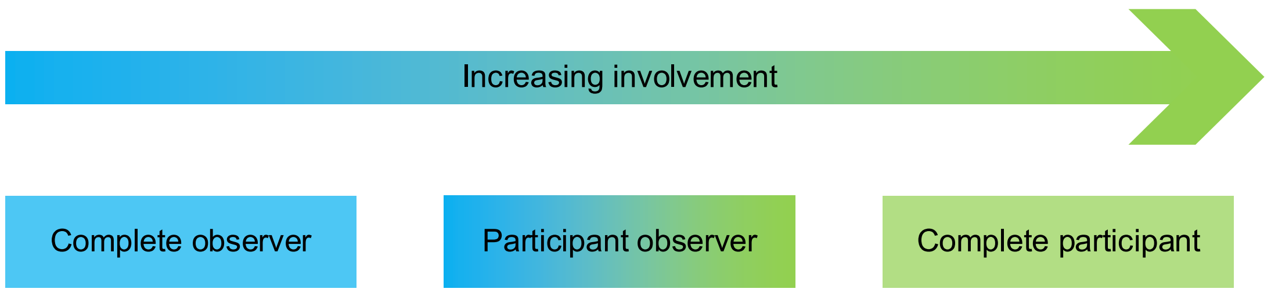
Figure 10: Observer Roles

There may be occasions where an inspector undertakes incidental observation.
This is a form of observation which is carried out unplanned and without the knowledge of other people in the social setting, for example: observing how security-focussed behaviours are enacted when collecting a site pass; observing how people interact with hazards or respond to safety rules when walking across a site; observing who sits with whom and how people engage with each other when having lunch in a canteen. Incidental observation overcomes the challenge of people adapting their behaviour if they know they are being observed (Slack & Rowley, 2001).
A final consideration is the use of field notes for recording descriptive details of what has been observed. The following are good practices for writing up field notes
(Bell et al, 2016; Schensul et al., 1999):
- Write down notes as soon as possible after observing something of interest.
- Write up full field notes at the end of each day.
- Use exact quotes where possible.
- Use pseudonyms to protect confidentiality.
- Describe activities in the order in which they occur.
- Include relevant background information to situate the event.
- Provide descriptions without inferring meaning.
- Separate one’s own thoughts and assumptions from what one observes.
- Write field notes that are clear and can be understood at a later point in time.
- Take lots of notes – it is better to write too much that not enough.
- Include details of the location, the people involved, the context and the date and time.

Document Analysis
Document analysis is a systematic method for evaluating or reviewing documents that is often carried out early on to help shape the focus and design of the research. It involves skimming, reading and interpreting documentation (Bowen, 2009). Document analysis may provide insights into hierarchy, power, authority, the degree to which safety controls and formalised, and how people value and prioritise safety. Documents to be analysed may be current, historic, private, publicly available, strategic, or tactical. Typical documents of interest to safety include:
- Corporate strategy document.
- Corporate annual plan and objectives.
- Corporate values statement.
- Safety policy statement.
- Safety and environmental management prospectus.
- Safety arrangements (licence condition) documentation.
- Safety case.
- Safety performance indicators policy and data.
- Organisational charts.
- Committee meetings terms of references and minutes.
- Job / role descriptions.
- Performance management policy.
- Behaviours framework.
- Performance appraisal forms (for safety objectives).
- Leadership development policy, training materials and data.
- Safety decision making processes.
- Visible leadership / leader in the field programmes.
- Just culture policy, arrangements, and data.
- Reward and recognition policy.
- Workplace risk assessments.
- Work instructions.
- Accident/incident investigation data and reports.
Bowen (2009) identifies five specific uses of documents within research:
- Documents can provide data on context, such as background information, historical insight, or past events.
- Information contained in documents can suggest some questions that need to be asked and situations that need to be observed as part of the research.
- Documents provide supplementary research data as information and insights derived from documents can be useful additions to a knowledge base.
- Documents provide a means of tracking change and development, for example where various drafts of a document are accessible then inspectors can compare them to identify the changes.
Documents can be analysed to verify findings or corroborate findings from other sources.

Analysing the Data
The sixth step in the research process is to analyse the data. This section provides an overview of template analysis, a form of thematic analysis which is well suited to research carried out in an applied context (King, 2012). Template analysis balances a degree of structure in the analysis process with the flexibility to adapt it to the needs of the research (Brooks et al., 2015), and comprises three phases: preparation, coding, and application, as shown in Figure 11.
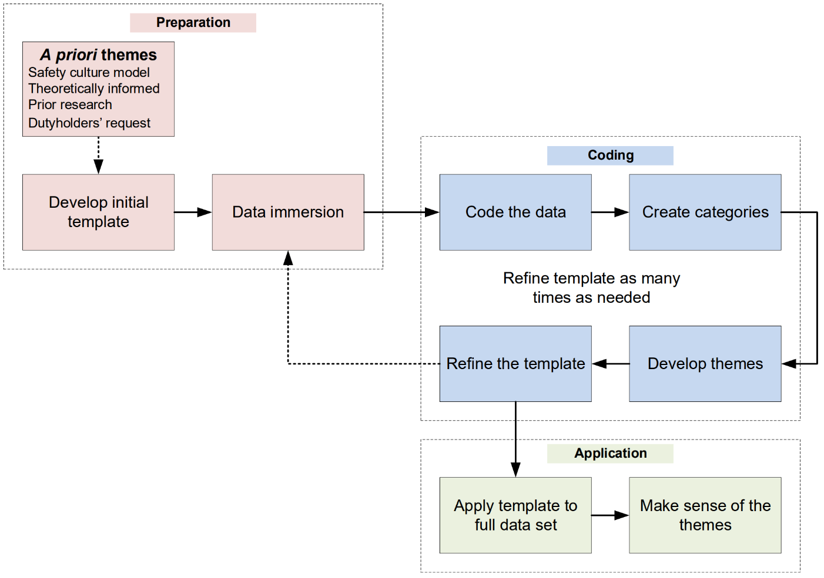
Figure 11: Data Analysis Method

Preparation Phase
This sub-section provides an overview of the activities to be carried out during the preparation phase: developing an initial template and data immersion.
      - Developing an Initial Template
For the preparation phase, the first step is selecting a priori themes for developing an initial template. The selection of a priori themes will depend upon the research focus. Normally, if the research focus is a targeted assessment of safety culture or culture change, the a priori themes should be structured upon a model of safety culture. When the research focus is concerned with diagnosing a safety problem, the a priori themes should be developed from academic literature and models relevant to the social processes being explored. Figure 12 and Figure 13 show two examples of initial templates which illustrate this.
The number of levels of hierarchy in the template will be dependent upon pragmatic considerations such as the amount of time and resources available for the analysis. As a guide two or three levels should suffice for research that is carried out by inspectors.
A priori themes may also be derived from other sources including:
- the findings of previous research carried out by ONR.
- At the request of a dutyholder.
The inspector should incorporate themes requested by the dutyholder into the template only where they broadly align with the research objective(s).
Initial template for a safety culture assessment developed from “The safety culture construct: theory and practice”, by M.D. Cooper, 2018, in Safety Cultures, Safety Models, pp.47-61.
1. Management/supervision  1.1. Leader visibility  1.2. Clarity of safety policies  1.3. Leader responsibility and obligations  1.4. Leader safety authority  1.5. Holding leaders to account  2. Safety systems  2.1. Two-way communications  2.2. Incident analyses and lessons learned  2.3. Safety in design  2.4. Asset integrity  2.5. Management of change  3. Risk  3.1. Risk appraisal  3.2. Risk assessment  3.3. Risk controls | 4. Work pressure  4.1. Managing competing priorities  4.2. Availability of resources  4.3. Safety prioritisation  5. Competence  5.1. Knowledge  5.2. Skills  5.3. Experience  6. Procedures and rules  6.1. Completeness / absence of procedures  6.2. Quality of procedures  6.3. Review of procedures
Figure 12: Initial Template for a Safety Culture Assessment

Initial template for diagnosing an organisation problem (the factors influencing workers’ beliefs about the importance of following safety rules) developed from “The theory of planned behaviour”, by I. Azjen, 2000, Organisation behaviour and human decision processes, 50(2), pp.179-211.
1. Attitudes towards behaviour  1.1. Behavioural beliefs  1.1.1. Importance of rule  1.1.2. Knowledge of safety imperative  1.2. Outcome evaluation  1.2.1. Safety benefits  1.2.2. Relative importance  1.2.3. Knowledge of consequence  2. Subjective norms  2.1. Normative beliefs  2.1.1. Attitude of management  2.1.2. Attitude of peers  2.1.3. Frequency of rule-breaking  2.2. Motivation to comply  2.2.1. Frequency of consequence  2.2.2. Severity of consequence  2.2.3. Positive reinforcement | 3. Perceived behavioural control  3.1. Control beliefs  3.1.1. Means to follow rule (resources & time)  3.1.2. Ability to follow rule (know how)  3.2. Perceived Power  3.2.1. Confidence in means to follow rule  3.2.2. Confidence in ability to follow rule
Figure 13: Initial Template for Diagnosing an Organisational Problem
      - Data Immersion
Once the initial template has been developed an inspector should immerse themselves in the data set to get a sense of the whole. This involves reading and
re-reading the interview transcripts, notes from focus group interviews, observation field notes, and documents selected for document analysis. By doing this the inspector begins to make connections between discrete data sources and develops ideas about the nature of the areas being explored.
      - Coding Phase
This sub-section provides an overview of the activities to be carried out during the coding phase: coding the data, creating categories, developing themes, and refining the template. Much of the data will be coded and grouped under the a priori themes however it is not unusual to develop several additional categories and themes that are relevant to the research questions. The process for doing this is shown in
Figure 14 and is described in the remainder of this sub-section.
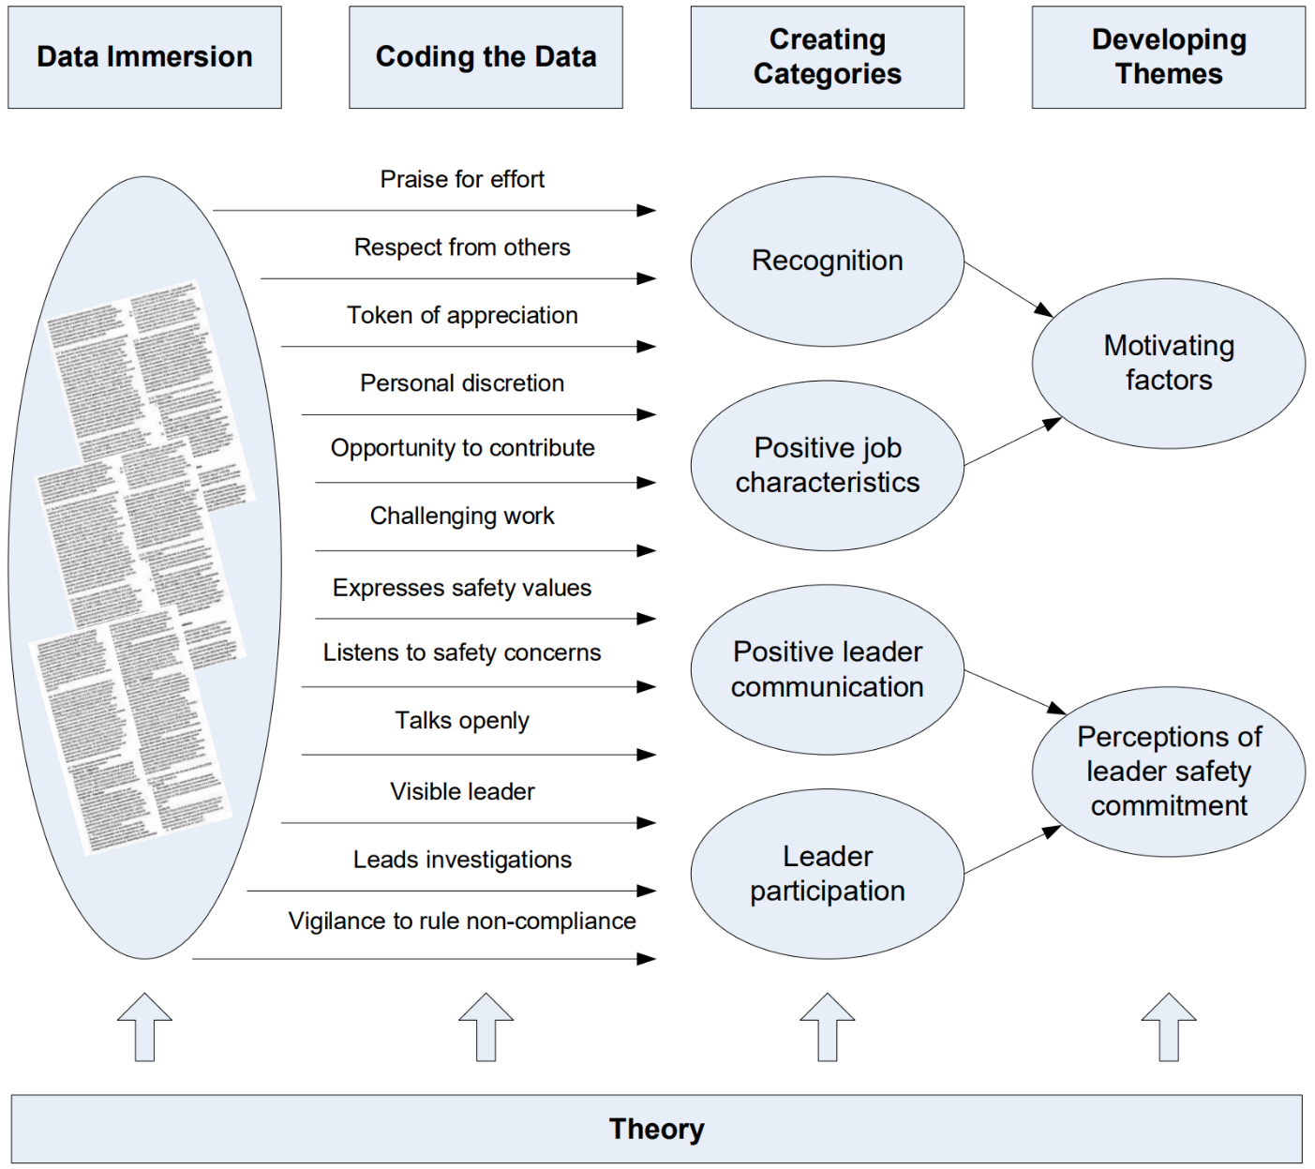
Figure 14: The Creation of Themes
(Redrawn, from Green et al, 2007)
      - Coding the Data
For the coding phase, the first step is to code a small sample of the data such as one or two interview transcripts. A code is a descriptive label that is assigned to segments of text: a single word, a phrase, or a whole paragraph. The aim of coding is to tag and sort the data. Coding can be carried out by making notes in margins, using different colour highlighter pens, or even cutting out segments of text and attaching to post-it-notes which display the assigned code.
It is good practice that the person who has carried out the data collection codes the data because they will have a richer understanding of its context. Where multiple inspectors are involved in data collection, care must be taken to ensure that assigned codes have the same meaning attributed to them by different inspectors. As further information is discovered, codes may be added, re-defined or retired.
This involves going back and forth through the data as the coding develops.
Words, phrases, or paragraphs may often be assigned more than one code.
Coding requires an active engagement with data. When coding the data, make and record reflective remarks on the meaning of what was being said, any doubts about the quality or validity of the data, ideas for a new category, a proposition about what may be happening, links to other parts of the data, what is surprising about the data or case, or where there is difficulty in clarifying an idea. Consider which things are occurring most often as this can help to confirm ideas; also search for evidence which may counter ideas and data which does not fit into existing categories.
      - Creating Categories
The next step is to group codes which fit well together and share a relationship.
This is normally done after initial coding has been completed although some find it easier to do this alongside coding. Codes should be grouped together under the a priori categories and themes of the initial template however it is not uncommon to find codes that do not share a relationship with these. These remaining codes should then be grouped to create coherent categories.
It is rare that the people within the sample have the same experiences and therefore enough categories will need to be developed to explain everything in the data that is relevant to the research questions. For example, in a study of worker compliance with safety rules, some workers may talk about rules being ambiguous, others may talk about rules being too general, and others will talk about rules being overly complex. The inspector groups the codes ‘rule ambiguity’, ‘rule detail’ and ‘rule complexity’ together under the category of ‘rule quality’.
A category is saturated when no additional data is found which develops the properties of the category. Categories therefore need enough examples of data (words, phrases, or segments of text) to identify the characteristics of concepts and emerging phenomenon.
      - Developing Themes
The next step is to group several of these new categories together to form a new theme. Themes are more than higher-order categories: they are an explanation or interpretation of what is being explored. A candidate theme should be tested in both the data and the theory to ensure it stands up as a true theme. In the earlier example of the study of workers’ compliance with safety rules, an inspector developed a category of ‘rule quality’. A theme provides a connection between ‘rule quality’ and why ‘rule quality’ is important in the context of compliance with safety rules.
The inspector finds that the quality of rules affects workers’ motivation to comply with them, and from this develops a candidate theme of ‘rule quality as a motivator’.
The inspector reviews the literature to test this candidate theme and finds that Vinodkumar & Bhasi (2010) in their study of safety management practices and safety behaviour found perceptions of safety rules to have a predictive capacity on safety compliance. This increases the generalisability of the inspector’s findings who now adds the theme to the final template.
As the analysis develops it may become clear that one or more themes seem to cut across many or all the other themes. Known as ‘integrative themes’ these are: “undercurrents running through participants’ accounts; often, perhaps, not addressed explicitly but very apparent to a careful reader” (King, 2012, p.432). These integrative themes often provide deep insights into the non-observable culture (the underlying assumptions) and can be a high value research finding.
Integrative Themes
During an assessment of safety motivation, inspectors identified an integrative theme which they named: “us and them”. The dutyholder has both an industrial workforce (workers) and a non-industrial workforce (managers) and participants referred to these groups using terms such as “the blue hats” (the colour of the safety helmets worn by workers) and “the white hats” (the colour of the safety helmets worn by managers), or “the industrials” and the “non-industrials”. This language, and the context in which it was used, indicated that there were opportunities to improve the relations between workers and managers. This finding was of significance to the research objective as workers in high quality relationships with their managers are more likely to engage in safety citizenship behaviours (Hofmann et al., 2003). This integrative theme was discussed in the research report as an important finding.
      - Refining the Template
The final step of this phase is to refine the template which involves taking the initial template of a priori themes developed during the preparation phase and merging in the categories and themes developed during the coding phase. At this point any a priori themes found to not fit the data may be redefined or removed.
Further refinements of the template may be necessary once the coding of the remaining data begins. Practical constraints will limit the number of iterations undertaken which should be just enough to ensure that any data relevant to the research questions is not left un-coded.

Development of a final template
An inspector developed an initial template for a safety culture assessment
(see Figure 12). The inspector coded three interviews and found the initial template to be a good fit for the data however a seventh theme of ‘motivating factors’ was identified as being both sufficiently distinct from the a priori themes and of direct relevance to the research objective to warrant its inclusion in the final template.
It was also found that a theme of ‘perceptions of leader safety commitment’ better represented the data than the a priori theme of ‘Management/supervision’, and ‘rule compliance’ better represented the data than the theme of ‘procedures and rules’ so these were revised. Category 1.1. ‘leader visibility’ was also modified to ‘leader participation’ and an additional category: ‘1.6. Positive leader communication’ was added. The final template is shown in Figure 15, with the changes and additions being displayed in red text.

Final template developed for a safety culture assessment developed from “The safety culture construct: theory and practice”, by M.D. Cooper, 2018, in Safety Cultures, Safety Models, pp.47-61.
1. Perceptions of leader safety commitment  1.1. Leader participation  1.2. Clarity of safety policies  1.3. Leader responsibility and obligations  1.4. Leader safety authority  1.5. Holding leaders to account  1.6. Positive leader communication  2. Safety systems  2.1. Two-way communications  2.2. Incident analyses and lessons learned  2.3. Safety in design  2.4. Asset integrity  2.5. Management of change  3. Risk  3.1. Risk appraisal  3.2. Risk assessment  3.3. Risk controls | 4. Work pressure  4.1. Managing competing priorities  4.2. Availability of resources  4.3. Safety prioritisation  5. Competence  5.1. Knowledge  5.2. Skills  5.3. Experience  6. Rule compliance  6.1. Completeness / absence of procedures  6.2. Quality of procedures  6.3. Review of procedures  7. Motivating factors  7.1. Recognition  7.2. Positive job characteristics
Figure 15: Final Template Developed for a Safety Culture Assessment

Application Phase
This sub-section provides an overview of the activities to be carried out during the application phase: applying the template to the full data set; making sense of the themes.
      - Applying the Template to the Full Data Set
For the application phase, the first step is to apply the template to the full data set. This involves grouping words, phrases, and segments of text to the hierarchical structure of the template’s categories and themes. Once the template has been applied to the full data set the inspector will have a rich body of data structured on the template’s themes and categories. Significant amounts of data that cannot be grouped to the template’s categories and themes yet are of interest to the research question(s) indicates that the template requires further refinement.

Making Sense of the Themes
The final step of data analysis is to make sense of the grouped data: to describe each theme and to draw insights to formulate answers to the research questions. This is often achieved by explaining the story within the data to establish its meaning.
Making Sense of the Theme ‘Motivating Factors’
An inspector studied the data grouped under each category and theme in turn as they sought to make sense of the data they had collected whilst undertaking a safety culture assessment. For theme 7 ‘motivating factors’ (see figure 15) the inspector developed a descriptive account of the key features of its two categories: ‘recognition’ and ‘positive job characteristics’.
- For ‘recognition’, the descriptive account explored how people perceive reward and recognition to be enacted and their perceptions of fairness and justice associated with the distribution of reward and recognition.
- For ‘positive job characteristics’, the descriptive account explored the characteristics of jobs which provide psychological meaningfulness such as how people perceive the degree to which they found their work to be challenging, the variety of their roles, the opportunities to use different skills, the degree of personal discretion, and how they felt about the importance of their contribution.
This descriptive account was accompanied by an evaluation of how these motivating factors influenced the safety culture by drawing links between the themes and showing why they are important in the context of the research objectives. Quotes and excerpts of documents were used throughout to illustrate the points being made.
Inspectors should incorporate quotes from interviews or excerpts from documents which best illustrate the essence of the categories or themes using the Setup-Quote-Comment method (Weaver-Hightower, 2018):
- Setup: The first sentence or paragraph states the ‘thesis’ and gives context for the quotation which is to follow, such as who said it (role or pseudonym) and what they were talking about at the time.
- Quote: The next element is the quote itself. Pick quotes or data excerpts which best illustrate the point being made.
- Comment: The final sentence or paragraph emphasises important parts of the quote or data excerpt.
Comment Quote Setup | The workers were generally positive about the safety commitment of their peers and immediate supervisors however they were less positive about the safety commitment of their more senior management. As is clear in this quote from a front-line worker which they made during a focus group interview, the worker perceived a clear difference in safety commitment across hierarchical grades:  “I’ve got no problem with my boss, he’s 100% on message with safety. Our safety is number one to him; he’s always banging on about it. It’s the higher up bosses that cause the problems by putting pressure on. As far as they’re concerned programme is everything especially when there’s a milestone payment due.”  This quote highlights that workers perceive the safety commitment of more senior management to be low in contrast to their immediate management and offers insight into factors which the worker considers may be influencing a senior manager’s behaviour: the milestone payment. The quote also illuminates that positive safety communications (“always banging on about it”) is perceived by the worker as a demonstration of his immediate supervisor’s safety commitment.
Links between themes and categories may also become apparent through the analysis. For example, analysis of data grouped using the template shown in Figure 15 may indicate that ‘competence’ (theme 5) and ‘motivation’ (theme 7) are antecedents of ‘rule compliance’ theme 6. This relationship is shown in Figure 16.
Griffin & Neal’s (2000) framework for linking safety climate to safety performance, knowledge, and motivation (see Figure 4), supports this relationship and thus increases the generalisability of the research findings. Identifying relationships between themes assists inspectors when making recommendations and developing regulatory strategy by ensuring actions are targeted upon the problems (antecedents) rather than the symptoms (consequences).
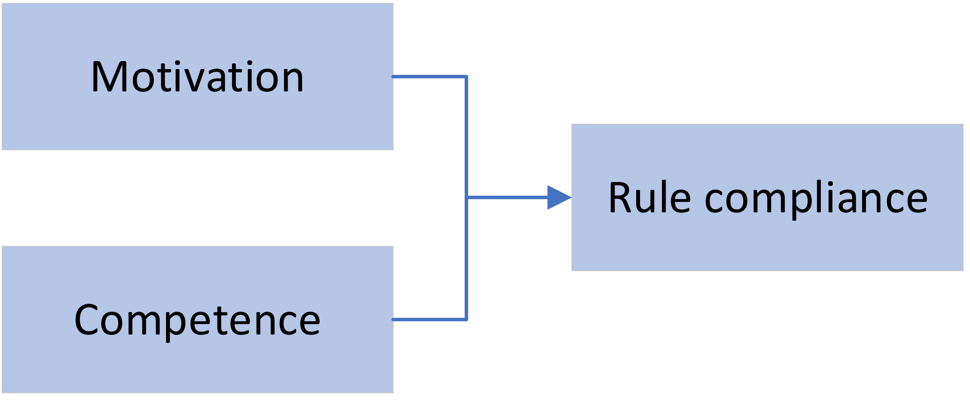
Figure 16: Relationship between Themes

Reporting the Research Findings
The seventh step in the research process is to report the research findings.
The research findings should be documented in an assessment note, the typical contents of which are shown at Appendix E. A copy of the assessment note is to be shared with the dutyholder with the key findings normally presented at a workshop so that the dutyholder can ask questions and seek clarification of points.

Peer Review
The decision on whether a peer review is required should be reached in consultation with the professional lead. Peer review should be carried out in accordance with ONR Guide NS-PER-GD-016: ‘Guidance on Peer Review and Acceptance of Reports for Permissioning’, however some flexibility in the application of this guidance will be necessary due to the differences between research and permissioning.

Acceptance Review
The acceptance reviewer for safety culture research is the professional lead. Acceptance review is required for all research which provides key support to regulatory decisions. Reports that do not require such high corporate confidence in their quality and are not key to the justification of a regulatory decision do not require an acceptance review; instead they should be copied to the professional lead when they are complete.
Acceptance review should be carried out in accordance with ONR Guide NS-PER-GD-016: ‘Guidance on Peer Review and Acceptance of Reports for Permissioning’, however some flexibility in the application of this guidance will be necessary due to the differences between research and permissioning.

Review, Learn and Improve
The eighth and final step in the research process is to carry out a review, learn and improve exercise. This exercise should consider what went well and why, what didn’t go well and why, and key lessons for future research. The output of the exercise should be recorded and made accessible to other inspectors embarking on research.

References & Supplementary Reading
Ajzen, I., 1991. The theory of planned behaviour. Organizational behaviour and human decision processes, 50(2), pp.179-211.
Bell, E., Bryman, A. and Harley, B., 2018. Business research methods. Oxford University Press.
Bowen, G.A., 2009. Document analysis as a qualitative research method. Qualitative research journal, 9(2), p.27.
Brooks, J., McCluskey, S., Turley, E. and King, N., 2015. The utility of template analysis in qualitative psychology research. Qualitative research in psychology, 12(2), pp.202-222.
Clarke, S., 2013. Safety leadership: A meta‐analytic review of transformational and transactional leadership styles as antecedents of safety behaviours. Journal of occupational and organizational psychology, 86(1), pp.22-49.
Cooper, M.D. and Phillips, R.A., 2004. Exploratory analysis of the safety climate and safety behaviour relationship. Journal of safety research, 35(5), pp.497-512.
Cooper, M.D., 2018. The safety culture construct: theory and practice. In Safety Cultures, Safety Models (pp. 47-61). Springer, Cham.
Cox, S., & Cox, T. (1991). The structure of employee attitudes to safety: A European example. Work & stress, 5(2), 93-106.
de Castro, B.L., Gracia, F.J., Peiró, J.M., Pietrantoni, L. and Hernandez, A., 2013. Testing the validity of the International Atomic Energy Agency (IAEA) safety culture model. Accident Analysis & Prevention, 60, pp.231-244.
Flin, R., Mearns, K., O'Connor, P. and Bryden, R., 2000. Measuring safety climate: identifying the common features. Safety science, 34(1-3), pp.177-192.
Fruhen, L.S., Flin, R.H. and McLeod, R., 2014. Chronic unease for safety in managers: a conceptualisation. Journal of Risk Research, 17(8), pp.969-979.
Fruhen, L.S., Griffin, M.A. and Andrei, D.M., 2019. What does safety commitment mean to leaders? A multi-method investigation. Journal of safety research, 68, pp.203-214.
Green, J., Willis, K., Hughes, E., Small, R., Welch, N., Gibbs, L. and Daly, J., 2007. Generating best evidence from qualitative research: the role of data analysis. Australian and New Zealand journal of public health, 31(6), pp.545-550.
Griffin, M.A. and Neal, A., 2000. Perceptions of safety at work: a framework for linking safety climate to safety performance, knowledge, and motivation. Journal of occupational health psychology, 5(3), p.347.
Guldenmund, 2016. ‘Organizational Safety Culture’, in Clarke, S., Probst, T.M., Guldenmund, F.W. and Passmore, J. (Eds). The Wiley Blackwell handbook of the psychology of occupational safety and workplace health (p. 437-458). John Wiley & Sons.
Hansez, I. and Chmiel, N., 2010. Safety behaviour: Job demands, job resources, and perceived management commitment to safety. Journal of occupational health psychology, 15(3), p.267.
Henning, J. B., Stufft, C. J., Payne, S. C., Bergman, M. E., Mannan, M. S., & Keren, N. (2009). The influence of individual differences on organizational safety attitudes. Safety science, 47(3), 337-345.
Heritage, J., 2013. Garfinkel and ethnomethodology. John Wiley & Sons.
Hofmann, D.A. and Morgeson, F.P., 1999. Safety-related behaviour as a social exchange: The role of perceived organizational support and leader–member exchange. Journal of applied psychology, 84(2), p.286.
Hofmann, D.A., Morgeson, F.P. and Gerras, S.J., 2003. Climate as a moderator of the relationship between leader-member exchange and content specific citizenship: safety climate as an exemplar. Journal of Applied Psychology, 88(1), p.170.
Høivik, D., Moen, B.E., Mearns, K. and Haukelid, K., 2009. An explorative study of health, safety and environment culture in a Norwegian petroleum company. Safety science, 47(7), pp.992-1001.
HSE, 2005. A review of safety culture and safety climate literature for the development of the safety culture inspection toolkit. Research Report 367. Norwich, HMSO.
IAEA, 2006a. Fundamental Safety Principles. Safety Fundamentals No. SF-1. IAEA, Vienna.
IAEA, 2006b. Application of the Management System for Facilities and Activities, IAEA Safety Standards Series No. GS-G-3.1, IAEA, Vienna.
IAEA, 2016. Safety Report Series No. 83: Performing Safety Culture Self-Assessments.
IAEA, 2018. IAEA Safety Glossary, 2018 Edition.
IAEA, 2020. A Harmonised Safety Culture Model. Available at:
Janis, I.L., 2008. Groupthink. IEEE Engineering Management Review, 36(1), p.36.
King, N., 2012. ‘Doing template analysis’ in Symon G. (ed.) & Cassell C. (ed.) Qualitative organizational research. London: Sage Publications Ltd, pp. 426-450.
Kvale, S., 1994. Interviews: An introduction to qualitative research interviewing. Sage Publications, Inc.
Martínez-Córcoles, M., Schöbel, M., Gracia, F.J., Tomás, I. and Peiró, J.M., 2012. Linking empowering leadership to safety participation in nuclear power plants: A structural equation model. Journal of safety research, 43(3), pp.215-221.
Martínez-Córcoles, M., Gracia, F.J., Tomás, I., Peiró, J.M. and Schöbel, M., 2013. Empowering team leadership and safety performance in nuclear power plants: A multilevel approach. Safety science, 51(1), pp.293-301.
Nahrgang, J.D., Morgeson, F.P. and Hofmann, D.A., 2011. Safety at work: a meta-analytic investigation of the link between job demands, job resources, burnout, engagement, and safety outcomes. Journal of applied psychology, 96(1), p.71.
Neal, A., Griffin, M.A. and Hart, P.M., 2000. The impact of organizational climate on safety climate and individual behaviour. Safety science, 34(1-3), pp.99-109.
Office for Nuclear Regulation, 2019. Guide NS-INSP-GD-070, Rev. 2: Safety Culture Guide for Inspectors.
Parker, D., Lawrie, M. and Hudson, P., 2006. A framework for understanding the development of organisational safety culture. Safety science, 44(6), pp.551-562.
Reiman, T., Oedewald, P. and Rollenhagen, C., 2005. Characteristics of organizational culture at the maintenance units of two Nordic nuclear power plants. Reliability Engineering & System Safety, 89(3), pp.331-345.
Saks, A.M., 2006. Antecedents and consequences of employee engagement. Journal of managerial psychology.
Schein, E.H., 1990. Organizational culture (Vol. 45, No. 2, p. 109). American Psychological Association.
Schensul, S.L., Schensul, J.J. and LeCompte, M.D., 1999. Essential ethnographic methods: Observations, interviews, and questionnaires (Vol. 2). Rowman Altamira.
Sekaran, U. and Bougie, R., 2016. Research methods for business: A skill building approach. John Wiley & Sons.
Slack, F. and Rowley, J., 2001. Observation: perspectives on research methodologies for leisure managers. Management Research News, 24(1), pp.35-42.
Vinodkumar, M.N. and Bhasi, M., 2010. Safety management practices and safety behaviour: Assessing the mediating role of safety knowledge and motivation. Accident Analysis & Prevention, 42(6), pp.2082-2093.
Weaver-Hightower, M.B., 2018. How to Write Qualitative Research. Routledge.
Westrum, R., 1996. Human factors experts beginning to focus on organizational factors in safety. ICAO journal, 51(8), pp.6-8.
Wong, J.H.K., Kelloway, E.K., & Makhan, D.W., 2016. ‘Safety Leadership’, in Clarke, S., Probst, T.M., Guldenmund, F.W. and Passmore, J. (Eds). The Wiley Blackwell handbook of the psychology of occupational safety and workplace health (p. 83-100). John Wiley & Sons.
Zohar, D., 1980. Safety climate in industrial organizations: theoretical and applied implications. Journal of applied psychology, 65(1), p.96.

Appendix A – An Example Research Proposal
INTERVENTION / PROJECT TASK SHEET
Unique Document ID and Revision No: | ONR-OFD-123-20 | CM9 Ref: | 2020/123456
Title: | Research to understand why safety rules are not being followed.
Site/Facility/Organisation: | Dutyholder A
Operational Plan Objective /  Strategy Alignment: | This work is fully aligned to the ONR Divisional Strategy for Dutyholder A.
Project / Task Lead: | J Smith

Scope
Background |  | Problem Statement  ONR is concerned that Dutyholder A’s capability to conduct operations safely has not improved to the extent expected despite repeated enforcement actions and subsequent improvement initiatives implemented by the licensee. ONR is concerned that systemic organisational factors may be resulting in undesirable behaviours and that if these factors are not identified, understood, and addressed, safety performance will not improve (it may even decline) and future improvement efforts will be unsuccessful.  In response ONR will undertake a study to understand the factors that influence workers’ beliefs about compliance with safety rules and to investigate the possible impact that these factors have on nuclear safety.  The research questions are:  - What are the factors that influence workers’ beliefs about compliance with safety rules?  - How do these beliefs impact upon nuclear safety?  - What can be done to positively influence workers’ beliefs to enable improved compliance?
Description of Work |  | Scope  This study explores the factors influencing the beliefs of workers who are employed on the nuclear licensed site only. It does not extend to those workers who are solely employed in non-nuclear areas of the business.  Relevance  Non-compliance with nuclear safety rules may result in a nuclear or conventional accident. Non-compliance also introduces delays to the programme which subsequently reduces stakeholder confidence in the dutyholder being able to deliver its programme safely and to time. The results of this study will provide the dutyholder’s management and ONR inspectors with insights into the factors influencing workers’ beliefs about nuclear safety rules so that the dutyholder’s management team is able to better target improvement actions and ONR is able to better target future regulatory activities.  Outline Research Design  The study will be undertaken in collaboration with the dutyholder. A dutyholder employee will participate as a full member of the study team.  We will first undertake several focus group interviews with employees who are required to adhere to nuclear safety rules during their work: these will include front-line workers and first-line management. Each group will consist of six to twelve participants with a moderator leading the discussions for no longer than two hours per group.  We will then interview several managers who are required to ensure adherence to nuclear safety rules during their work. We will follow this by carrying out a series of observations of routine and non-routine work activities on two separate days. We will observe plan of the day meetings, setting to work, pre-job briefs, the work itself, post-job briefs, and shift-handovers.  Finally, we will interview Trade Union safety representatives from each of the Trade Unions represented on the site. Here we will be able to clarify our understanding of what we observed on the plant. These interviews will be semi-structured, and each interview will last no longer than one hour.  We will use a priori themes based up the Theory of Planned Behaviour (Azjen, 1991) as an initial template which we will further develop through preliminary coding and categorisation.  Timeframe  The timeframe is ten weeks as follows:  - Two weeks to create interview guides and prepare  - One week on-site to collect data  - Two weeks for transcription of interviews  - One week to develop final template  - Three weeks to apply template to full data set  - One week to write report  Resources  - ONR specialist inspectors x 3  - ONR nominated site inspector x 1  - Typist (to transcribe interviews) x 1
Anticipated Outcomes |  | Knowledge of the factors that influence workers’ beliefs about compliance with safety rules, and how these beliefs impact upon nuclear safety.  A regulatory strategy to ensure Dutyholder A takes appropriate measures to positively influence workers’ beliefs to enable improved compliance.
Assumptions/ Uncertainties |  | Covid-19 situation does not affect site-based intervention.  Interview and focus-group participants are available and willing.
Overall Duration |  | From: 01 September 2020 |  |  | To: 04 December 2020
Milestone / Key Deliverables |  |  | Target Date |  |  | Output
Report issued |  |  | 04 December 2020 |  |  | Assessment Note
ONR Specialism |  |  |  | Sub-Specialism |  |  | Est. Days Effort
Engineering |  |  |  | Mechanical
 |  |  |  | Civil
 |  |  |  | External Hazards
 |  |  |  | Chemical Engineer
 |  |  |  | Chemist
 |  |  |  | Structural Integrity
Operational Inspection |  |  |  | Project Inspection
 |  |  |  | Site Inspection |  |  | 8
Systems | Human & Organisational Capability |  |  | Human Factors
 |  |  |  | LMFS |  |  | 45
 |  |  |  | Quality Management
 |  |  |  | Licensing
 | Fault Analysis |  |  | PSA
 |  |  |  | Fuels
 |  |  |  | Fault Studies
 |  |  |  | Internal Hazards
 |  |  |  | Radioactive Waste
 |  |  |  | C&I
 |  |  |  | Electrical Engineering
Radiological Protection, Criticality, Emergency Preparedness |  |  |  | Radiological Protection
 |  |  |  | Criticality
 |  |  |  | Emergency Preparedness
Other Specialism (e.g. Conventional Safety, Transport, Security, Fire Safety (non-nuclear), Safeguards, Environmental Impact, specific support) |  |  |  | Conventional Safety  Fire Safety
Implications of not proceeding with work | Dutyholder A’s performance may not improve; it may event decline, resulting in further enforcement action.

Endorsement
 | Name | Date
Sponsor Endorsement | D Lead | 25 August 2020

Appendix B - An Example of a Semi-Structured Interview Guide
Semi-Structured Interview Guide for a Front-Line Worker
Introduction |  | Explain purpose of assessment and that we are looking to generate a good discussion with detailed descriptions of the areas being explored.
General questions
1. Describe a typical day in your role  - What do you most enjoy about your work?  - What makes your work difficult? |  | This is an icebreaker and a useful question to see what focus the respondents give to safety when asked a question that doesn’t explicitly mention it.
2. What are the greatest dangers you face at work?  - How do you know these are the greatest dangers?  - How likely do you feel a nuclear accident could be?  - What could give rise to a nuclear accident?  - What could the range of consequences be? |  | Provides insights into hazard and risk awareness and teases out knowledge of nuclear safety issues.
3. What is in place to keep you and others safe?  - People, plant and process – prompt if necessary |  | This is a useful way of understanding what respondents recall as being the salient safety controls.
4. How do people with safety responsibilities go about keeping you safe?  - Which people have the primary responsibilities for your safety?  - How do they go about exercising these responsibilities?  - How do you keep yourselves safe? |  | Provides insights into a person’s understanding of safety responsibilities of others and themselves.
5. How effective are the rules and procedures at providing clear instructions for working safely?  - What is in place to ensure you understand and can follow the procedures properly?  - How do you go about suggesting amendments to procedures?  - How confident are you that you can follow the procedures you are provided with for the task in-hand? |  | This explores a person’s belief in the efficacy of the rules and procedures, and their perceived behavioural control (the extent to which they believe they can follow the rules).
6. Can you describe how setting-to-work unfolds?  - Plan of the day, pre-job brief, work instructions, risk assessment, supervision – prompt if necessary  - How do you confirm your understanding of work you are assigned?  - How do your supervisors / managers confirm your understanding of the hazards and risks?  - What is the best feature of setting to work?  - What would you change? |  | Provides insights into their knowledge of the setting to work process, and how effective they feel it is in giving them an understanding of the hazards and risks they may face.
7. Can you describe a recent incidence of an operation being stopped in the interests of safety which impacted upon you?  - How did this make you feel?  - How did management respond? |  | Provides insight into the relative prioritisation of safety. Explores how management responded to a programme delay.
8. Describe to me the safety reporting arrangements?  - What is its purpose?  - Are you encouraged to report?  - Are you thanked for doing so?  - Are you involved in, or informed of, any subsequent actions? | Provides an insight into a person’s knowledge of the importance of safety reporting and how managers respond. Also explores the degree of worker engagement in the solutions.
9. Describe to me the relationship between top leadership and the workforce.  - Have they visited the workplace recently?  - What did they focus on?  - How did you feel about your interactions with them? | This is a useful way of understanding the efficacy of the leadership visibility initiative. It may help to explore leader authenticity, leaders’ relative prioritisation of safety, and worker perceptions of the safety commitment of top management.
10. Can you describe to me a recent occasion where yourself, or a colleague, have not felt competent to perform an assigned task?  - Do you feel the training you are provided with is enough?  - What are the best features of the training system?  - What are its weaknesses? | Provides insights into the efficacy of the competence management system. It may also help to explore the willingness of a person to have the moral courage to not undertake a task they are not comfortable with.
Wrap-Up Questions
11. If you could change any aspect of work to improve safe working, what would it be? |  | A good way to identify issues that are important to the person.
12. Is there anything else you want to tell me about safety and how it relates to your work? |  | Standard closing question.

Appendix C – An Example of a Participant Information Sheet
Interviewer
[Provide the names and roles of the interviewer here]
What is the purpose of these interviews?
The purpose of the interview is to [summarise research objective]. This will assist [insert dutyholder name] in better targeting safety improvement actions. In addition, ONR should be able to better target future regulatory activities. The overall aim is to make work safer and easier to perform. This is not a not an inspection.
What will I be asked to do?
Data collection will involve a semi-structured interview. You will be asked several questions that will aim to gather information and insights.
Who is doing these interviews?
These focus group interviews are being carried out collaboratively between [insert dutyholder name] and ONR. [Provide brief details and context of the person carryout out the interview]
Once I take part, can I change my mind?
Yes. If at any time, before, during or after the interview you wish to withdraw your support please just contact the interviewer. You can withdraw at any time, for any reason and you will not be asked to explain your reasons for withdrawing.
Are there any risks in participating?
No.
Will my taking part in this study be kept confidential?
You will be assigned a pseudonym. Collected data will be treated anonymously and held as confidential, being stored on a secure password protected computer. The interview will be recorded on official ONR equipment, transcribed on ONR’s government secure network, and made anonymous. Transcriptions will only be available to the assessment team for the sole purpose of the research objective. They will be disposed of securely once analysis of the interview data is complete. Written notes will also be destroyed once the non-attributable report has been issued.
I have some more questions; who should I contact?
[Provide ONR and dutyholder contact details – email addresses and phone numbers]
What will happen to the results of the study?
The data will not be available in the public domain. The non-attributable and aggregated results will be used to generate a report. The report will not be available in the public domain however ONR reports are subject to Freedom of Information requests and may be made publicly available should such a request be received.

Appendix D – An Example of an Observation Guide
PLAN OF THE DAY MEETING
Section 1: Descriptive
Who is present?
Discussion topics
Nature of interaction:
- Who talks?
- Who controls interactions?
- Timings
- Interaction styles
- Expressions, body language and emotions
Documentation use and type
Room layout and seating arrangements
Recurring patterns
Section 2: Evaluative
Why did individuals behave in the way they did? (context, motives, norms)
What was the purpose of the meeting?
What were the outcomes?
What impact could the meeting have on safety?
How was the safety culture expressed? (norms & values)
Are there any issues that need to be followed up?

Appendix E – Typical Assessment Note Contents
ASSESSMENT NOTE
CM9 Ref: | Insert CM9 reference here
Site: | Insert site name here
Title: | Insert title of study here

Document Acceptance

Role | Name | Position | Signature | Date
Author |  |  | This will normally be the research team lead
Peer Review |  |  | Note. The decision on whether a Peer Review is required should be reached in consultation with the Professional Lead.
Acceptance Review |  |  | Note. Acceptance Review is required for all research which provides key support to regulatory decisions; the Acceptance Reviewer for safety culture research is the Professional Lead.

Revision History

Issue No. | Date | Author(s) | Reviewed By | Accepted By | Description of Change
0

Circulation (latest issue)

Organisation | Name

Executive Summary
The executive summary is a brief account of the entire study; it summarises the problem statement, the research design, results of the data analysis, conclusions and recommendations. It should be a few paragraphs in length and no more than one page of text.
Introduction
The introduction provides information on why and how the research has been commissioned. It should articulate the reason for the study by discussing the broad problem area.
Aim and Objectives
The aim builds on the description of the broad problem area outlined in the introduction by articulating the problem statement which includes the research objective and research question(s). This section should also outline how theoretical frameworks or safety culture models will be used throughout the research.
The Scope of the Study
The scope of the study bounds the research by explaining what is and is not included in the study. The study may be bounded by geography (for example, is limited to the licensed nuclear site), job roles (for example, focuses on health physicists only), or social phenomenon (for example, is concerned only with factors influencing safety motivation).
Relevance to ONR’s Purpose
The relevance to ONR’s purpose should be outlined here. Explain why ONR, as an independent statutory regulator is carrying out this research and articulate both the safety imperative and sources of relevant good practice.
Research Design
The research design should be outlined here. This should include the focus of the research, sampling, data collection methods and how they will be combined, and the time period and key milestones for the research. The section should also contain a brief description of how the template was developed and how the data was analysed.
Results
The results should be outlined here. This should include an exploration of the themes through application of the template analysis and an interpretation of why findings are important within the context of the theme they represent. Verbatim quotes from transcripts or notes should be used to illustrate and articulate each theme.
During the research a significant amount of qualitative data will have been collected. The inspector will not be able to use most of the data when presenting the research findings otherwise the write-up would be too descriptive. Instead data which best illustrates each theme should be selected.
The inspector should only include results which relate to the research questions. Often other results may emerge which do not relate to the research questions; these may be of regulatory interest and should be followed up separately.
Conclusions
The conclusions should be outlined here. Conclusions should articulate the implications of the findings on the research questions and may suggest ways in which the findings have wider lessons for a dutyholder’s nuclear safety practices or ONR’s regulation. The conclusion section will often be where the inspector makes a regulatory judgement; in all cases the rationale for the regulatory judgement should be clearly articulated.
Drawing conclusions should not be confused with a concluding statement or a summary or the research findings.
Recommendations
The recommendations should be outlined here. These should include recommendations for ONR (to inform regulatory strategy) and recommendations for the dutyholder (to make improvements).
References
The references cited throughout the report should be listed here.
Appendices
The appendices should be included here. Typical appendices may include materials which substantiate the text in the report, the final template used for the analysis, or a synopsis of any theoretical models used in the research to aid understanding for persons unfamiliar with the theory.

ONR’s five purposes are nuclear safety, nuclear site health and safety, civil nuclear security, nuclear safeguards, and nuclear transport.
‘Safety culture’ is the assembly of characteristics and attitudes in organisations and individuals which establishes that, as an overriding priority, protection and safety issues receive the attention warranted by their significance (IAEA, 2018).
De Castro et al (2013) took steps to empirically validate the IAEA’s safety culture model composed of five dimensions further specified by 37 attributes. In doing so they found that several of the attributes of the model may not be related to their corresponding dimensions: that is, most of the attributes included in the model may not be measuring the dimensions they are intended to measure.
The term ‘safety climate’ refers to psychological characteristics of employees (i.e. ‘how people feel’), corresponding to the values, attitudes, and perceptions of employees with regards to safety within an organisation (HSE, 2005).

