|  |
| --- |
|  |
| ONR Procedure  Regulatory Permissioning |



ONR Procedure

Regulatory Permissioning

**Process Owner:** Professional Lead – Operational Inspection

**Authored by** – Principal Nuclear Safety Inspector

**Approved by** – Professional Lead – Operational Inspection

**Issue No**.: 1

**Publication Date**: Oct-23

**Next Major Review Date**: Oct-28

**Doc. Ref. No**.: ONR-PER-PROC-001

**Record Ref. No**.: 2023/54965

Table 1 - Revision commentary

|  |  |
| --- | --- |
| Issue No. | Description of Update(s) |
| 1 | New document as part of wider revision of permissioning guidance documentation.  The purpose of this document is to provide an overview of the regulatory permissioning process, irrespective of regulatory purpose.  It aims to provide a high-level summary of the purpose of permissioning and the series of activities which are to be undertaken as part of the process. |

# Introduction

Permissioning is undertaken by ONR across its core regulatory purposes of nuclear safety, security, transport and conventional health and safety.

In accordance with [ONR’s Enforcement Policy Statement](http://www.onr.org.uk/documents/2014/enforcement-policy-statement.pdf) [1], permissioning should always be proportionate to the hazard/risk associated with the proposed undertakings. Dutyholder activities of highest hazard/where risks may be least well controlled should always attract a greater degree of regulatory interest than low consequence, routine activities.

Permissioning informs a decision on whether to grant a permission/approval.   
This involves gathering evidence typically in the form of advice from specialist discipline-specific ONR inspectors via assessment [2] and inspection [3], but may include other considerations, such as those described in the ONR guidance document on the demonstration of As Low as Reasonably Practicable (ALARP) [4].

The permissioning process enables ONR to apply regulatory control to certain dutyholder undertakings, and to respond to dutyholders who require permission to commence, continue, modify or cease specified activities/plans under relevant legislation. This is typically against the requirements of the Energy Act 2013 and its applicable provisions including:

* Licensing, re-licensing and de-licensing nuclear sites;
* Assessment of proposals to satisfy the conditions attached to a nuclear site licence, or to satisfy the arrangements made by licensees in compliance with the [licence conditions](http://www.onr.org.uk/documents/licence-condition-handbook.pdf) (LCs) [5];
* Issue, modify, revise or withdraw licence instruments;
* Approval of security plans under the Nuclear Industries Security Regulations 2003 (NISR); and/or,
* Approvals under the Carriage of Dangerous Goods and Use of Transportable Pressure Equipment Regulations (CDG) Class 7 2009.

It is noted however that there are other legal provisions that allow for a permissioning regime to be applied to certain dutyholder undertakings including:

* Relevant Statutory Provisions of the Health and Safety at Work Act (HSWA), including The Control of Major Accident Hazards (COMAH) Regulations 2015 and the issueance of licenses under The Explosives Regulations 2014 and The Control of Asbestos Regulations 2014; and/or,
* Consents under The Nuclear Reactors (Environmental Impact Assessment for Decommissioning Regulations) (EIADR) 2018.

Through this legislation, ONR exercises appropriate regulatory control and oversight on such undertakings in accordance with the principles of the ONR Enforcement Policy Statement [1].

The permissioning process can also be applied to assist with making judgements on:

* The adequacy and implementation of dutyholder’s arrangements and documents   
  (e.g., security plans, emergency plans); and/or,
* Dutyholder’s design and management systems for satisfying legal compliance.

## Purpose

The purpose of this document is to provide an overview of the permissioning process, irrespective of regulatory purpose.

It aims to provide a high-level summary of the purpose of permissioning and the series of activities which are to be undertaken as part of the process.

## Scope

The scope of this document covers the basis of permissioning across ONR’s purposes.

Permissioning refers to the permissioning/licensing of dutyholder activities and/or approvals of dutyholder arrangements/plans to allow their implementation.

Guidance relating to permissioning across ONR’s regulatory purposes are described in more detail in supporting guidance documents, as set out in the following sub-sections, and as illustrated in Figure 1.

### Nuclear Safety

For nuclear safety, the Nuclear Installations Act 1965 (NIA65) and, the nuclear site licence and attached Licence Conditions (LCs) issued under it provide the principal legal basis for regulation by ONR of nuclear safety on nuclear licensed sites.

Further information relating to the permissioning of nuclear safety related activities can be found in [6].

### Transport

For transport, the ONR is the Great Britain Competent Authority for the civil inland surface transport of Class 7 (radioactive material) dangerous goods. This statutory duty is given to ONR through the CDG[1]. This regulatory framework differs from that established for nuclear installations safety due to the need to preserve consistent regulatory standards across international boundaries. Therefore, ONR has published a separate guide exclusively for transport permissioning [7].

### Security

For security, the NISR require dutyholders to comply with an approved security plan[2]. Where a dutyholder wishes to make changes to the standards, procedures or arrangements within that plan, then ONR’s approval to amend the plan is required before they are implemented using the principles outlined in ONR’s Security Assessment Principles (SyAPs) [8] and set out in associated ONR guidance [9].

### Conventional Health and Safety (CHS)

ONR regulates CHS on nuclear sites (licensed and authorised defence sites), as set out in the Memorandum of Understanding (MoU) between ONR and the HSE [11]. The purpose of the MoU is to ensure effective cooperation and collaboration in the regulation of non-nuclear CHS, including policy matters and the enforcement of health and safety law, at GB nuclear licensed, new nuclear build and authorised defence sites, arising from the transfer of regulatory responsibility from HSE to ONR under the Energy Act 2013.

ONR follows the HSEs [approach to permissioning regimes](https://www.hse.gov.uk/enforce/permissioning.pdf) to permission certain conventional (non-nuclear) high risk hazardous activities undertaken on nuclear sites [10]. This specifically includes sites where the COMAH Regulations are applicable, and those sites requiring a licence granted under the Explosives Regulations.

#### COMAH

The purpose of the COMAH Regulations is to ensure all necessary measures are taken to prevent major accidents involving dangerous substances and to limit the consequences to people and the environment of any major accidents which do occur.

The COMAH Regulations are enforced by a Competent Authority (CA), which for nuclear sites comprises of ONR acting jointly with the appropriate environment agency[3]. The details of which are captured in the associated MoU between all agencies [12].

#### Explosives

In accordance with the terms of the MoU between ONR and the HSE [10],   
HSE Explosives Unit ONR-warranted Inspectors act as ONR in the licensing and regulation of explosives manufacturing/storage. In the spirit of cooperation between ONR and HSE under Section 96(1) the Energy Act 2013, ONR has access to wider HSE specialist inspector resource support to assist with nuclear site regulatory assessment.

#### Asbestos

Asbestos licensing is a statutory function of HSE, administered and overseen by HSE’s Asbestos Licensing Unit (ALU). This permissioning regime issues asbestos licences to carry out licensable work with asbestos, as defined in Regulation 2 of the Control of Asbestos Regulations.

Licensable work is determined with consideration of the type of asbestos material and how it has been applied; where work is not sporadic or of low intensity; or where the risk assessment cannot clearly demonstrate that the asbestos control limit will not be exceeded.

ONR recognise licences granted by HSE’s ALU and regulate notifiable work with asbestos undertaken on nuclear sites.

ONR will provide regulatory intelligence concerning the work activities of asbestos licensees to the ALU to inform their oversight of the asbestos licensee.

ONR retains access to the notification database, administered by ALU, to retrieve data relevant to ONR’s work on nuclear sites.

### Nuclear Safeguards

ONR regulates compliance with The Nuclear Safeguards (EU Exit) Regulations 2019 (NSR19) Regulation 7 of NSR19 requires the operator of a nuclear facility to produce and submit an accountancy and control plan within certain timescales.   
It also makes the provision under Regulation 7(5) –

"The ONR may consider the accountancy and control plan, or any part of the plan, and may approve all or any part of the plan".

In Regulation 8(2) there is also a provision that:

"….an operator of a qualifying nuclear facility may not amend any part of the accountancy and control plan for the qualifying nuclear facility that has been approved by the ONR without the prior written consent of the ONR".

NSR19 does not create a permissioning regime for Safeguards. However, it does require operators to provide ONR with key safeguards information at specified timescales. The requirements relate to construction and active commissioning of new qualifying nuclear facilities, and modification to existing facilities.

As part of the permissioning process for nuclear safety, consideration should be given to ONR Safeguards involvement to ensure the operator has met their requirements under NSR19.

Figure 1 – Relationship between the primary documents of the permissioning process within the ONR management system.

# Permissioning Process

Permissioning at ONR is undertaken in accordance with a structured and defined internal process (Figure 2), broken down into the six key stages, following receipt of a notification/request by the dutyholder.

1. Confirmation whether a regulatory decision needs to be made before a dutyholder can proceed with its request.
2. Proportionate scoping of the work/interactions required to inform the regulatory decision to be made. This will be informed by consideration of various factors associated with the request including risk and hazard potential, complexity, novelty, margins of safety, capability of the equipment, effect on any principal/significant systems, structures or components, claims being made on human performance/response and previous regulatory history.
3. Undertaking a targeted risk-informed sampling approach of available evidence and information to inform the regulatory decision. This will be done via assessment/inspection activities.
4. Proposing a decision as to the adequacy of the dutyholders’ assertion that it is safe/secure to implement its request. Decisions are to be made in accordance with regulatory guidance and include consideration of advice from the dutyholder’s review committees (for example, licensee’s Nuclear Safety Committee or other suitable body advising on safety/security) and views of other regulators, ONR functions and dutyholder’s independent oversight functions as appropriate.
5. Ensuring that this proposed decision receives a level of internal challenge and governance proportionate to its significance and risk.
6. Communication of the formal decision in a manner that is efficient and effective.

Figure 2 illustrates the series of activities which are involved in the permissioning process, irrespective of regulatory purpose.

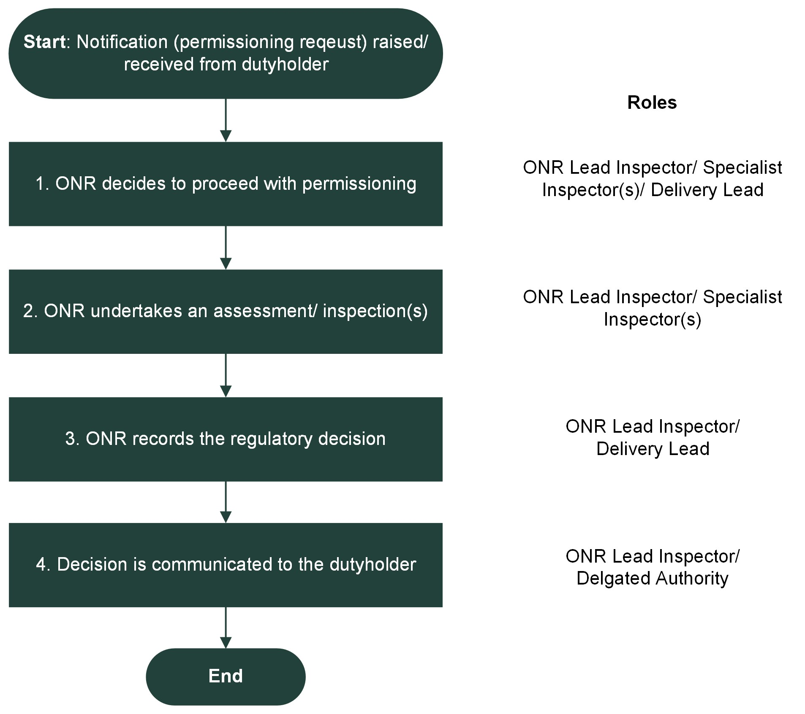

Figure 2 – Regulatory permissioning process

# References

|  |  |
| --- | --- |
| [1] | ONR, “Enforcement Policy Statement (EPS),” 2020. [Online]. Available: http://www.onr.org.uk/documents/2014/enforcement-policy-statement.pdf. |
| [2] | ONR, “NS-TAST-GD-096 - Guidance on Mechanics of Assessment”. |
| [3] | ONR, “ONR-INSP-GD-064 - General Inspection Guide”. |
| [4] | ONR, “NS-TAST-GD-005 - ONR Guidance on the Demonstration of ALARP”. |
| [5] | ONR, “Licence Condition Handbook,” 2017. |
| [6] | ONR, “NS-PER-GD-001 - Nuclear Safety Permissioning”. |
| [7] | ONR, “TRA-PER-GD-001 - Transport Permissioning Assessment”. |
| [8] | ONR, “Security Assessment Principles (SyAPs) for the Civil Nuclear Industry,” 2017. |
| [9] | ONR, “CNS-PER-GD-017 - Assessment of SyAPs Aligned Security Plans”. |
| [10] | ONR and HSE, “Memorandum of Understanding between ONR and HSE on effective cooperation in regulating conventional (non-nuclear) health and safety,” [Online]. Available: http://onr.org.uk/agency-agreements-mou.htm. |
| [11] | HSE, “Permissioning and licensing,” [Online]. Available: https://www.hse.gov.uk/enforce/permissioning-licensing.htm. |
| [12] | Multi Govt. Agencies, “Memorandum of Understanding between the HSE, ONR, EA, NRW and SEPA on the Implementation of the COMAH Regulations 2015”. |

1. Except where transport of for defence purposes. In these cases, the Defence Nuclear Safety Regulator (DNSR) is the Competent Authority for Transport matters.
2. ONR is not the statutory regulator for Defence sites. Where the site is used for Defence purposes, the Defence Nuclear Security Regulator (DefNucSyR) undertakes regulation of security.
3. Environment Agency (EA) for England, the Scottish Environment Protection Agency (SEPA) for Scotland, and the Natural Resources Body for Wales (NRW) for Wales.