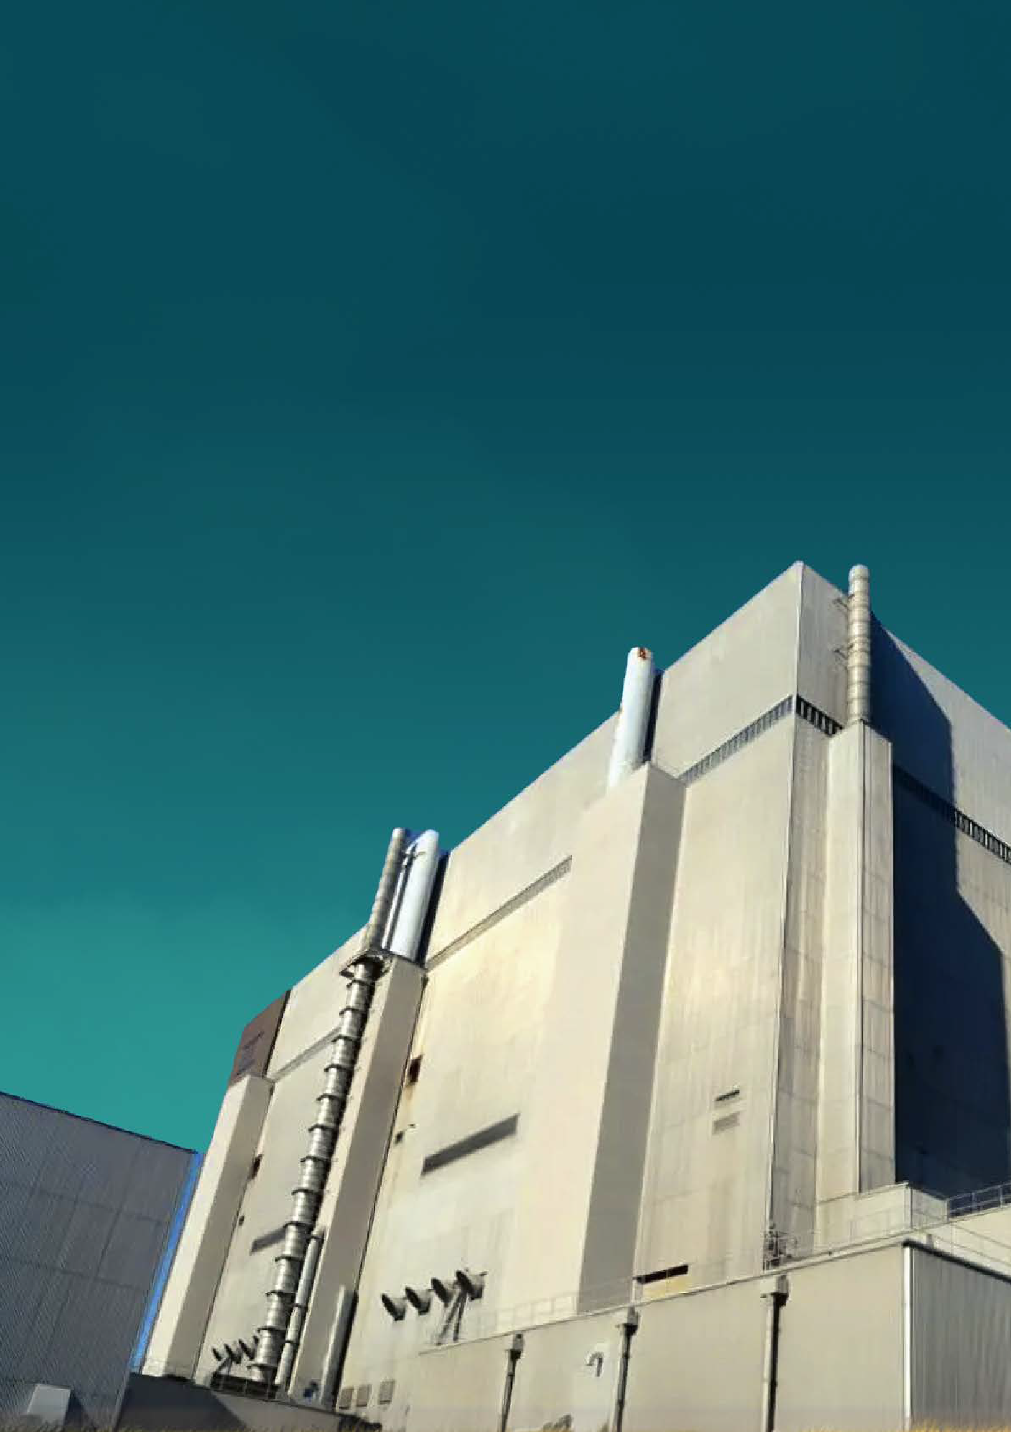

How we charge for nuclear regulation

Contents

1. Introduction 3

2. Who we are and what we do 4

2.1. ONR’s charging powers 4

3. The end-to-end charging process 6

3.1. Legislation 6

3.2. Data capture 6

3.3. Data processing 6

3.4. Invoice creation 7

3.5. Queries 7

3.6. Disputes 7

3.7. Payment 7

4. ONR’s end to end charging cycle 8

5. ONR’s costs explained 9

6. How ONR’s charging works 11

7. Disputes 13

7.1. What happens when a dispute is raised 14

7.2. Part-payment of invoices 15

7.3. Variation of the period in which action is to be taken 15

8. Looking to the future 16

9. Get in touch 16

# 

# Introduction

Established by the Energy Act 2013, the Office for Nuclear Regulation (ONR) is empowered by diverse legislation to recover the cost of its services from dutyholders.

As we strive to inspire a climate of respect, trust and confidence among our stakeholders, this booklet clearly explains how this charging system works.

ONR is funded through the full recovery of costs from our customer stakeholders. We recover most of our running costs from the nuclear industry we regulate, and from government departments to whom we provide a service. We also receive grant funding from our sponsor body, the Department for Work and Pensions (DWP), to cover activities which are statutorily prohibited from being recovered from industry.

The income generated from cost recovery funds the expenditure we incur in fulfilling our regulatory mission. We do not make any profit or surplus, and nuclear site licensees are charged only for the work undertaken in regulating them.

We are committed to providing greater transparency around our charging regime and securing continuous improvements in response to feedback from our stakeholders.

We expect our ways of working to produce efficiencies in our charging and will continue to engage with our dutyholders to improve our processes, reduce bureaucracy and ultimately make sure we provide the best possible value for money, both for industry and the public.

The income generated from cost recovery funds the expenditure ONR incurs in fulfilling its regulatory mission.

# Who we are and what we do

ONR is Great Britain’s independent nuclear regulatory authority.

In line with our mission to provide efficient and effective regulation of the nuclear industry, holding it to account on behalf of the public, we independently regulate nuclear safety, security, safeguards and conventional health and safety across all licensed nuclear sites in the UK.

We also assess generic nuclear reactor designs for potential vendors at the request of government, regulate the safety and security of civil transport of radioactive materials, and ensure that safeguards obligations for the UK are met.

## ONR’s charging powers

ONR has the legal authority to recover the full economic cost of these activities and does so on a net nil basis. This means that as well as our front-line regulatory inspection activities, we recover the costs of all other activities necessary to our regulation, such as learning and development of our staff, engagement with our international counterparts, liaising with government and delivering advice to ministers.

Our activities are carefully and rigorously planned, as detailed in statutory documents which are approved by the Secretary of State and laid before Parliament – the ONR Strategy is reviewed every five years, and the ONR Corporate Plan published annually details what we intend to achieve in the forthcoming financial year.

We plan our activities to help us forecast the charges dutyholders are likely to receive, although, inevitably, we need to be flexible and adapt our programme of work to changing demand and delivery requirements throughout the year.

You can access the ONR Strategy and Corporate Plan at [www.onr.org.uk](https://www.onr.org.uk/corporate-publications.htm).

ONR’s charging powers (cont’d)

ONR is legally empowered to recover from industry and government departments the cost of providing its services. These charging powers come from six pieces of legislation:

The Nuclear Installations Act 1965, Section 24A gives ONR the power to recover expenses from particular licensees for carrying into effect any of the activities under the Act, or for nuclear research.

The Nuclear Industries Security (Fees) Regulations 2005 give ONR the power to recover fees for security activities.

The Carriage of Dangerous Goods Regulations 2009, Regulation 27, gives ONR the power to charge for work to approve packaging used to transport radioactive material.

The Health and Safety and Nuclear Fees Regulations 2023, Regulation 16 and 17, allow ONR to charge for activities like Generic Design Assessment and pre- licensing advice, as well as enforcement of the relevant statutory provisions for activities on GB nuclear sites; and Regulation 8 allow ONR to charge for the application for registration or for a consent to carry out specified practices for the purposes of the Ionising Radiations Regulations 2017.

The Energy Act 2013 section 89 allows ONR to charge fees for providing relevant advice and relevant information requested by relevant authorities; section 88 allows ONR to charge for the provision of training in line with ONR’s purposes; and sections 90 to 100 empowers ONR to create agreements with government organisations to provide services and information (with and without remuneration), as well as providing the Secretary of State the power to create Fees Regulations under the Act.

The Nuclear Safeguards (Fees) Regulations 2021 give ONR the power to recover fees for nuclear safeguards activities.

# The end-to-end charging process

There are a number of elements to the ONR process for recovering costs from the nuclear industry, each with its own policies and procedures and subject to internal and external governance. Each element is described briefly in the following sub-sections.



## Legislation

All of ONR’s charging powers are based in legislation which details the extent of the power conferred by the statutory instrument, what can be recovered and from whom, and any limitations on those powers such as charging periods. The list of legislation which empower ONR to charge for its work is described in section ‎2.1.

## Data capture

ONR uses two systems to capture the necessary data to ensure dutyholders are charged fairly, correctly, accurately and promptly. OTiS – ONR’s time recording system – is used to capture activity and map this activity to customer recipients.

Standard Operating Platform (SOP) is our general ledger system which captures expenditure information and tracks spend to date. SOP is an Oracle based ERP system, used throughout government via a shared service provision.

## Data processing

ONR produces its charges by using charging models to process activity and cost data, drawing together data from OTiS, and SOP. The charging models are used for our full suite of charges, including safety, security, safeguards, and transport

charges, as well as our DWP grant funded and any charges for activities undertaken on behalf of the Department for Energy, Security and Net Zero (DESNZ).

The allocation of all costs, whether they be passthrough costs, or the apportionment of direct and indirect costs based on time recording data, are all handled through the charging models, together with the accurate mapping of costs incurred to the appropriate dutyholders.

The charging models also enable the reconciliation of the year-to-date data, which forms the basis of the information included on the charging breakdowns that accompany the invoices we issue.

## Invoice creation

ONR produces and issues invoices, accompanied by charging breakdown, to dutyholders. Our shared services provider raises the invoices on ONR’s behalf, and these are checked by ONR staff prior to issue. Invoices are issued approximately three weeks after the end of the month to which they relate. ONR’s end to end charging cycle is described in section ‎4.

## Queries

Sometimes dutyholders may not recognise the activity generating charges and will raise a query with ONR Finance to seek clarification before providing a purchase order number. ONR has built strong relationships with our dutyholders and seeks to ensure that charges are transparent, fair and equitable. Therefore, we allow a short period for queries to be raised and settled prior to the invoice being issued to ensure dutyholders and Government understand the basis of their charges.

## Disputes

Occasionally, where queries cannot be resolved to the satisfaction of a dutyholder,   
a more formal process needs to be utilised. ONR has a formal disputes procedure which provides dutyholders and government the opportunity to challenge charges they do not believe to be justified. This procedure involves detailed investigation and escalation. The procedure is set out in section ‎‎7.

## Payment

Invoices should be settled within ONR payment terms (30 days from date of invoice), before debt recovery procedures are instigated. As the majority of ONR’s funding is collected via cost recovery from industry, delays in payment of invoices can adversely impact ONR’s cashflow and cause significant funding issues which could potentially impact the delivery of ONR’s regulatory objectives.

# ONR’s end to end charging cycle

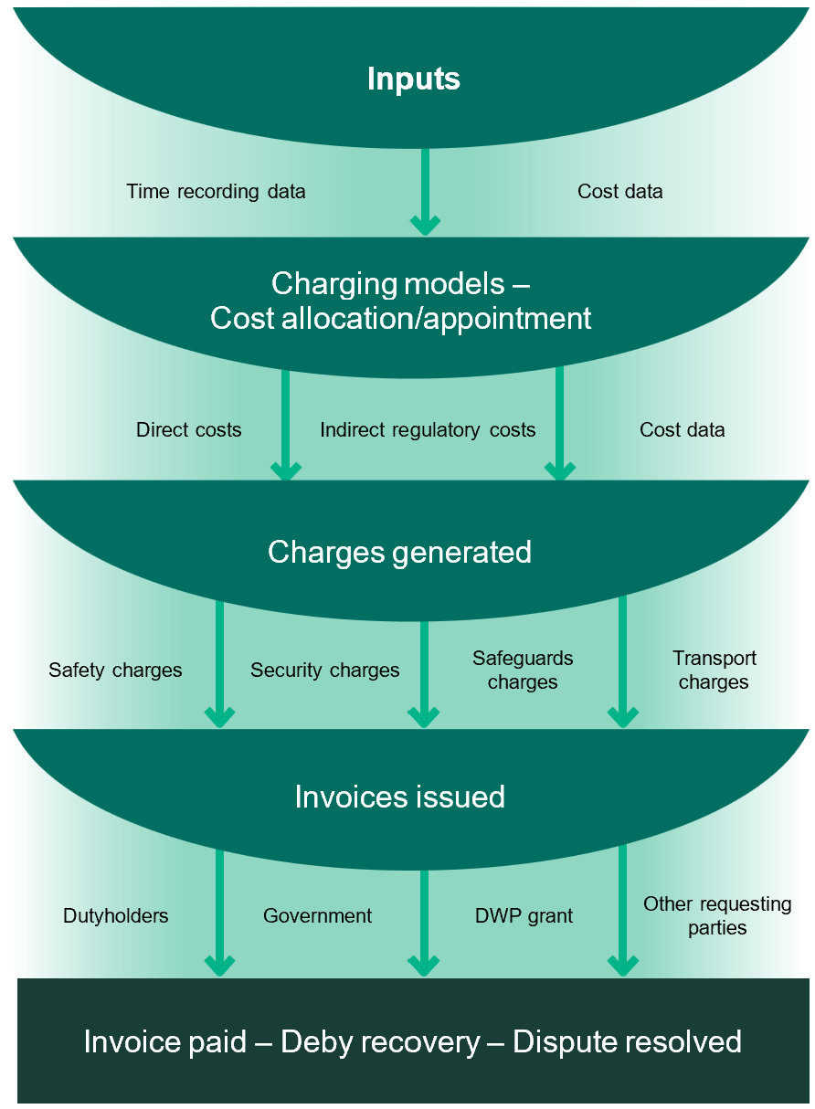

# ONR’s costs explained

ONR recovers its running costs by billing the value of these costs, monthly in arrears. Our charging powers currently preclude us from generating any working capital, so we only bill what we spend.

ONR’s costs are classified into three areas:

1. Direct costs

These are costs of activities that are directly attributable to one site or a group of sites, or the cost of work directly chargeable to a government body or other requesting parties. They are typically for front-line regulatory duties or activities relating to government or third-party requested services, together with the divisional delivery and administration support for these activities. Dutyholders, government bodies and other requesting parties pay for the time we spend on them, with costs apportioned based on the time recorded by our staff in our time recording system.

Examples of activities that incur direct costs:

* **For licensees**: inspections, enforcement activities, assessment of safety cases, and package approvals.
* **For government**: providing regulatory advice and other services to government bodies.
* **DWP grant-funded**: regulatory activities relating to transport, fire safety, Ministry of Defence and nuclear safeguards.

1. Indirect costs

These are costs which are not directly attributable to a single dutyholder or government department but are necessary for ONR to exist. These costs pay for activities that enable ONR to regulate or deliver other relevant services.

Our indirect costs are made up of:

**Indirect regulatory costs**: These are the costs of any activity which cannot be attributed directly to a site, dutyholder, group of dutyholders, requesting party or other funding stream, but is a core operational regulatory activity of ONR.

**Indirect overhead costs**: these are the cost of activities that are not directly attributable to our regulation of the nuclear industry or other directly funded services but are required to keep ONR running as an organisation.

Examples of activities that incur indirect overhead costs:

* ONR’s corporate functions (i.e., HR, finance, IT, policy and communications);
* Accommodation costs;
* Legislative activity and setting standards;
* Modernisation activity; and
* Risk mitigation activity.

In the same way as direct costs, these indirect costs are apportioned across all dutyholders based on the proportion of direct time recorded by our staff in ONR’s time recording system.

1. Pass-through costs

These are costs which are directly attributable to a particular dutyholder or government department. They are not apportioned based on time spent are charged directly ‘at cost’ to the recipient of the service. (Examples include Technical Support Contracts, research costs and security vetting costs, which are charged out to industry annually at the end of the financial year).

# How ONR’s charging works

ONR complies with HM Treasury rules and ‘Managing Public Money’ to ensure that we recover costs fairly and equitably across all dutyholders.

We are funded on a net nil basis, which means we have to recover only the value of income needed to meet our incurred expenditure, to the penny.

We take our year-to-date cost information from the general ledger and map this to the relevant year-to-date activity data recorded by our staff in the time recording system. This produces a dutyholder specific charge, details of which

appear on monthly/quarterly ONR invoices. Costs apportioned across dutyholders are updated monthly to reflect the latest year-to-date position, both in terms of time spent and expenditure. This ensures that the charge to all dutyholders is fair, avoiding any potential under or over-charging.

Costs to industry are calculated net of activity funded by the DWP grant and   
pass- through costs. Charges are based on direct activity recorded by our regulatory staff and their associated travel costs, with the balance of indirect costs apportioned based on this direct activity.



An example of how this works in practice (worked example - figures are for illustration purposes only):

|  |  |  |  |  |  |  |  |  |  |  |
| --- | --- | --- | --- | --- | --- | --- | --- | --- | --- | --- |
| Total to be apportioned | | | Pass-through costs |  | Direct costs | |  | Indirect costs |  | Total charge |
| Direct allocation |  | % of days spent | Cost apportionment |  | Cost apportionment |  | Cost apportionment |
| Total cost  £50m -  £10m  Pass-through costs =  £40m direct and indirect costs | Dutyholder 1 | | £3.0m | + | 5% | £1.5m | + | £0.5m | = | £5.0m |
| Dutyholder 2 | | £2.8m | + | 10% | £3.0m | + | £1.0m | = | £6.8m |
| Dutyholder 3 | | £4.0m | + | 20% | £6.0m | + | £ 2.0m | = | £12.0m |
| DEZNZ | Project 1 | £0.2m | + | 15% | £4.5m | + | £ 1.5m | = | £6.2m |
| Project 2 | - | + | 25% | £7.5m | + | £ 2.5m | = | £10.0m |
| Project 3 | - | + | 5% | £1.5m | + | £ 0.5m | = | £2.0m |
| DWP grant | Grant 1 |  | + | 10% | £3.0m | + | £1.0m | = | £4.0m |
| Grant2 | - | + | 2% | £0.6m | + | £0.2m | = | £0.8m |
| Grant 3 | - | + | 3% | £0.9m | + | £0.3m | = | £1.2m |
| Safeguards | - | + | 5% | £1.5m | + | £0.5m | = | £2.0m |
|  | | | £10m |  | 100% | £30m |  | £10m |  | £ 50 m |

# Disputes

A specific disputes procedure has been established to support both ONR and dutyholders. This provides a clear process for industry and government to raise disputes relating to the charges applied by ONR and to provide a route for escalation, if appropriate.

**Policy statement**

ONR cost recovery procedures aim to recover costs fairly, equitably, and promptly across all dutyholders. The ONR cost recovery disputes procedure is designed to answer queries and resolve disputes arising from ONR recovering costs for work carried out under the Energy Act 2013. The principle is to resolve queries and disputes promptly, transparently, and fairly.

ONR recovers the full economic cost of its activities on a net nil basis, i.e., recovering 100% of its cost through charges to industry and government. The duty placed on ONR to recover costs means that we cannot choose to disregard or reduce the costs associated with our activities for a dutyholder, nor can we ask some dutyholders to pay more to allow for reductions or write-off costs to support others. This is known as cross-subsidisation and is not permitted by Managing Public Money.

The key principle is to resolve queries and disputes promptly, transparently, and fairly and to have a demonstrable level of independence to protect the interest of dutyholders and government.

However, the process needs to be swift to protect ONR cash flow, efficient and not overly bureaucratic, and to ensure scarce and expensive resource is not unduly tied up in investigating disputes. It has a clearly defined timescale to reach resolution and a defined end point where the decision is final.

ONR operates a two-tier dispute process:

**Tier One** – All disputes will initially be investigated under tier one. This involves a review of the composition, calculation, time recording records and propriety of charges by the Finance Director (or appropriately delegated in line with ONR’s Scheme of Delegation) with the support of the Director of Regulation

of the respective regulatory directorate. A tier one review should confirm or correct the activity being charged for, the level of activity and the costs incurred in calculating the invoice.

**Tier Two** – escalation to ONR’s Senior Leadership Team (SLT) where tier one has failed to find a resolution and secure payment. SLT will consider if a compelling case has been made by the duty holder that the charge is not justifiable. If SLT deem the charge to be valid then it will make a decision over whether to pursue payment by further direct correspondence with the dutyholder.

For both tier one and tier two reviews, the invoice charges not in dispute will remain subject to ONR’s payment terms of 30 days from date of invoice.

## What happens when a dispute is raised

If a dutyholder considers they have cause to raise a dispute, a request to dispute the charges should be sent to:

Office for Nuclear Regulation - Finance Team  
Redgrave Court, Merton Road, Bootle, Merseyside, L20 7HS   
Email: [ONR.Cost.Recovery@onr.gov.uk](mailto:mONR.Cost.Recovery@onr.gov.uk)

Disputes should be raised by the dutyholder as soon as possible after receipt of the monthly/quarterly invoice issued by ONR, and no later than ten days after the invoice date.

Once a formal request to review the charges has been received, ONR’s charging team will acknowledge receipt of a dispute and formally suspend the 30-day payment terms until such time as the dispute is resolved.

ONR will consider queries promptly and write to the dutyholder to acknowledge receipt within ten days of receipt. Tier one consideration should reach a resolution within an additional twenty days.

Once the result of the tier one review is finalised by ONR, the dutyholder will be notified formally by letter or email. If there is no change to the charge, our terms and conditions will be reinstated and payment will be due within our standard 30- day payment terms.

If the dutyholder is still not satisfied that they are being fairly and equitably charged following the outcome of the tier one investigation, they can escalate the dispute to tier two.

Notification of a requirement to escalate is required from the dutyholder no later than ten days from the date of the tier one decision.

ONR will consider tier two queries promptly and write to the dutyholder to acknowledge receipt. Tier two cases will be considered at the next SLT meeting and should be completed within 30 days. The decision of SLT will be final.

The decision of SLT will be notified formally to the dutyholder by letter. If there is no change to the charge, the 30-day payment terms and conditions will be reinstated.

The following flow chart illustrates the steps and timescales involved in the disputes process, as described in the previous section.

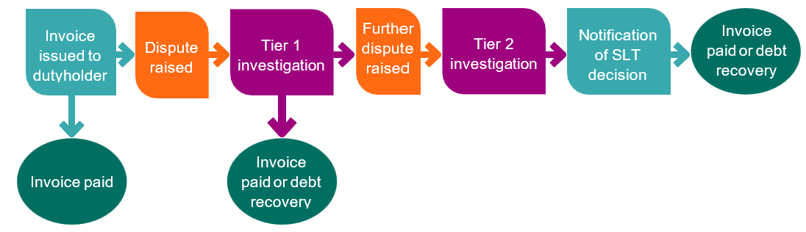

## Part-payment of invoices

It is possible that not all the costs included on an invoice or charging breakdown will be in dispute and as such the dutyholder will be required to pay the undisputed value. The dutyholder should confirm to the ONR Finance Team the value of the disputed amount. The undisputed amount remains payable within thirty days from the date of the invoice.

## Variation of the period in which action is to be taken

ONR is committed to meeting the timescales set out above. However, there may be occasions when the timescales are unachievable due to exceptional circumstances. Where such circumstances merit it, timescales may be varied by ONR at its discretion to ensure the issue(s) in dispute may be considered fairly and in full, in consultation with the dutyholder.

# Looking to the future

We will continue to recover our costs on a net nil basis. Our charging approach has received full independent assurance that it is compliant with Managing Public Money principles and presents a far less risky and more compliant option compared to fixed unit costs for all stakeholders.

We have driven significant improvements to our processes to support our charging methodology based on year-to-date actual expenditure and direct-effort apportionment.

We will continue to look for ways to improve our charging processes and methodology and respond to dutyholder concerns within the scope of our current legislative powers and to ensure our charges remain accurate and transparent.

We are also working hard to improve forecasting of our activity and charges to industry and government and aspire to provide multi-year budgets to enable dutyholders to plan their business and provide stability. Our continuous

improvement in this area aims to make our charges less volatile and provide more predictability to our dutyholders to enable and support planning.

We will continue to engage with dutyholders and seek further ways to improve transparency in our processes and charges.

# Get in touch

ONR’s finance team is on hand to help with any queries in relation to charges. Please send your queries to [ONR.Cost.Recovery@onr.gov.uk](mailto:ONR.Cost.Recovery@onr.gov.uk).

You can also visit [onr.org.uk](https://www.onr.org.uk/) for more information.



ONR Framework document

How we charge for nuclear regulation

**Framework owner**: Finance Director

**Authored by**: Head of Charging and Cost Recovery

**Approved by**: Interim Finance Director

**Issue**: 2

**Published**: September 2024

**Next scheduled review**: September 2027

**Document reference**: ONR-FIN-FW-002

**Record reference**: 2024/42517