|  |
| --- |
|  |
| ONR Project assessment report  PR-01545: DN30 Package Design – Validation of F/420/AF (Be) |



ONR Project assessment report

**Project name**: PR-01545: DN30 Package Design

**Report title**: Validation of F/420/AF (Be)

**Dutyholder/Applicant**: Urenco

**Authored by**:

**Report issue no**.: 1

**Publication date**: Feb-25

**Document ID**: ONRW-2019369590-14109

Circulation list (latest issue)

|  |  |  |
| --- | --- | --- |
| Organisation | Recipient | Date report sent |
| ONR |  | 28/11/24 |
| Urenco |  | 28/11/24 |

© Office for Nuclear Regulation, [2024]

For published documents, the electronic copy on the ONR website remains the most current publicly available version and copying or printing renders this document uncontrolled. If you wish to reuse this information visit [www.onr.org.uk/copyright](http://www.onr.org.uk/copyright) for details.

# Executive summary

In December 2023, Urenco UK Ltd (the applicant), applied to the Office for Nuclear Regulation (ONR) for a GB validation approval of F/420/AF (Be). The current validation expired on 26 December 2023. The French base certificate has recently been extended to 31 December 2028. However, the application only includes four of the five contents included within F/420/AF (Be). Due to this variance, we are unable to validate the French certificate as per our guidance for applications for UK competent authority approval. We will issue a GB certificate of approval for the four requested contents within the application.

The F/420 transport package, known as DN30, consisting of a 30B cylinder and outer Protective Structural Packaging, is designed for the carriage of uranium hexafluoride. The design was originally approved by the French Competent Authority in 2018. Modifications have been undertaken to the package that have resulted in revised certificates. Changes to the package since ONR’s previous assessment in 2019 include:

* optional use of thermal valves;
* optional use of M18 instead of M20 screws for tie down of DN30 packages on flat racks;
* changes to maintenance and inspection arrangements; and
* deletion of removable close-fitting valve housing from the design.

ONR carried out a targeted assessment of the transport safety case contained in the dutyholder’s application. Engineering, shielding and criticality aspects of the safety submission were sampled, targeting changes in regulations since the previous validation.

Following the programme of assessment, it was concluded that the safety submission from the applicant is adequate and meets applicable regulatory requirements.

This report recommends that the transport competent authority issues GB certificate of approval GB/5133/AF (Rev. 0).

Table 1: List of abbreviations.

|  |  |
| --- | --- |
| Term/Acronym | Description |
| AF | Type A package design for fissile material |
| CA | Competent Authority |
| HOW2 | (Office for Nuclear Regulation) business management system |
| ONR | Office for Nuclear Regulation |
| PSP | Protective Structural Packaging |
| SAR | Safety Analysis Report |
| SCR | Safety Case Requirements |
| SSR | Specific Safety Requirements |
| TCA | Transport Competent Authority |
| UF6 | Uranium Hexafluoride |
| UK | United Kingdom |

Table of contents

Executive summary 4

1. Permission requested 8

2. Background 8

2.1. The package 8

2.2. Related Approvals 9

2.3. Design Changes 10

3. Assessment and inspection work carried out by ONR in consideration of this request 10

3.1. Engineering Assessment (ref. [11]) 11

3.2. Criticality Assessment (ref.[12]) 11

3.3. Shielding Assessment (ref. [15]) 12

4. Matters arising from ONR’s work 13

5. Conclusions 13

6. Recommendations 14

References 15

# Permission requested

1. Urenco UK Ltd (the applicant), applied to the Office for Nuclear Regulation (ONR) for a Great Britain (GB) competent authority (CA) validation of the French CA approval F/420/AF (Be) (ref. [1]). However, the application only requests GB validation of four of the five contents included within F/420/AF (Be) (ref. [1]). Due to this variance, we are unable to validate the French certificate as per our guidance for applications for UK competent authority approval (ref. [2]). We will undertake an assessment to determine if the application supports the issue of a GB certificate of approval for the four requested contents within the application.
2. This report presents the basis of the regulatory decision by ONR, as the GB CA for the transport of UN Class 7 (radioactive material) dangerous goods, to issue a GB certificate of approval for the DN30 package.

# Background

## The package

1. The DN30 package is designed to transport Uranium Hexafluoride (UF6) with enrichments up to 5% wt. U-235. It consists of a 30B Cylinder (designed to ANSI N14.1 and ISO7195 standards) and a DN30 PSP outer packaging.
2. The DN30 PSP consists of two halves. The bottom half has integrated feet, handling attachment points suitable for the loaded package, a valve protecting device, plug protecting device, rotation preventing device and bottom half of the closure device. The top half has integrated handling attachment points suitable for the top half and the top half of the closure device.

Figure 1 DN30 Illustration (source of content - ref. [3])

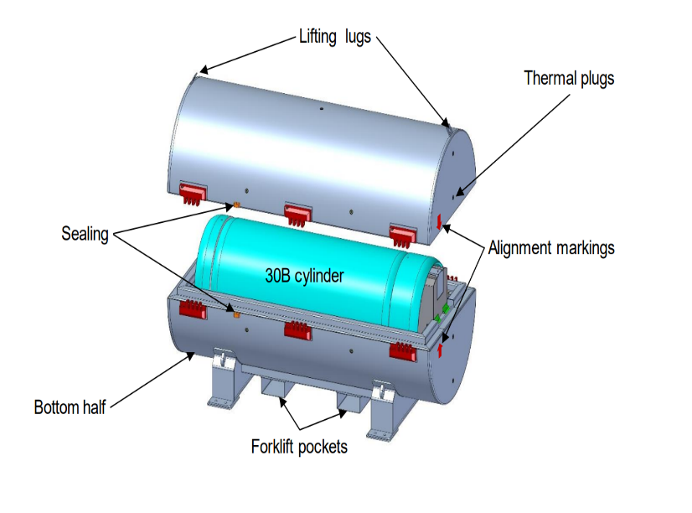

1. Full details of the package design are given in the Package Design Safety Report (ref. [3]).

## Related Approvals

1. The French CA granted package design approval for the DN30 as a new package design in 2018. We completed a full GB validation of the package design approval in 2019 against the French certificate F/420/AF (Ab) which expired in December 2023.
2. We completed a GB validation against the French certificate F/420/AF (Bd) in April 2024, for a limited period of validity (expiry end of May 2024) to allow the completion of transport of DN30 packages that were stranded at Seaforth docks by expiry of the previous GB validation (ref. [4]).
3. The package is also licenced in the United States of America as a Type AF (ref. [5]) package until 30 June 2029.

## Design Changes

1. Changes to the package since ONR’s previous assessments in 2019 (ref. [6]) include:

* optional use of thermal valves.
* optional use of M18 instead of M20 screws for tie down of DN30 packages on flat racks.
* changes to maintenance and inspection arrangements.
* deletion of removable close-fitting valve housing from the design.

1. Further details of the above changes and editorial changes are contained within (ref. [3]).

# Assessment and inspection work carried out by ONR in consideration of this request

1. A regulatory permissioning plan was devised and agreed with the Transport Competent Authority (TCA) permissioning lead. In accordance with this plan and our transport guidance (ref. [7]), a targeted assessment of the safety case was undertaken, considering previous ONR approvals and the French competent authority approval.
2. We recently undertook an inspection of the applicant (IR-52974 (ref. [8])) in February 2024. The following regulatory issues, covering the following shortfalls, were raised as a result:

* RI-11965 - Suitability of transport radiation risk assessments and emergency plans.
* RI-11957 – Transport of Class 7 dangerous goods in contravention of CDG09 regulation 5.
* RI-11941 – Radiation risk assessment – IRR17 regulation 8.

1. The applicant has satisfactorily addressed, or provided a plan to address, the identified shortfalls. This included a follow-up inspection to support the close-out of R1-11957 and RI-11941. Therefore, it was judged unnecessary to undertake a further inspection of the dutyholder in support of this application.
2. Our safety case requirements assessments sample the non-engineering means of achieving compliance with the requirements of SSR-6 (ref. [9]), such as in the operation and maintenance of the package design. I judged that a safety case requirements assessment was not required based on the following information:

* certificates have been issued by two reputable foreign competent authorities (ref. [1]) (ref. [5]);
* our previous safety case assessment in 2019 for this package did not identify any shortfalls (ref. [10]);
* our previous validation against the French certificate F/420/AF (Ab) in 2019 (ref. [6]) and F/420/AF (Bd) in April 2024 (ref. [8]); and
* the DN30 is not a novel or complex design.

1. Our assessments were undertaken in accordance with the requirements of ONR How2 Business Management System and its associated guidance.

## Engineering Assessment (ref. [11])

1. The engineering assessment targeted changes made to the DN30 package since our last approval.
2. We sampled the engineering change control for the removal of the valve protection housing. This was removed as the applicant does not consider it to provide any safety benefit due to the addition of a microporous insulation layer within the DN30 PSP design. The applicant provided information on the governance and testing undertaken to demonstrate that the removal of the housing is appropriate. This provides evidence the microporous insulation layer delivers the required thermal protection under all transport conditions as required in The International Atomic Energy Agency, Specific Safety Requirements 6 (SSR-6) (ref. [9]).
3. We were content that appropriate change control, governance, testing and verification have been undertaken by the applicant. It is recommended, from an engineering perspective, that a GB package design approval for the DN30 PSP is issued.

## Criticality Assessment (ref. [12])

1. Our previous ONR criticality assessment (ref. [13]) sampled a large number of the applicant’s calculations and judged them to be suitably conservative with regards to the potential geometrical arrangements of UF6 and impurities. Therefore, for this application, the following areas which were not previously considered were targeted:

* Are all proposed package contents bounded by the criticality calculations? – We judged that the package contents assumed in the calculations are bounding. In particular, the applicant’s use of uranium enriched to 5.0 wt.% U-235, the assumption of a higher total mass of UF6 in the package than that allowed on the certificate (4812 kg compared with 2277 kg), the use of a higher density of UF6 than typical (5.5 gcm-3 compared with a typical density of circa 5.1 gcm-3), and the assumption that all the potential impurities are hydrogenated fluorides.
* Has an appropriate criticality safety criterion been used together with an appropriate criticality calculation method? – We considered that the criticality safety criterion used (keff + 3σ ≤ 0.95) is adequate, and that the use of KENO VI together with the ENDF/BVII nuclear data library is appropriate.
* Are the criticality calculations bounding of the potential normal, routine an accident conditions of transport? – We reviewed a range of criticality calculations that consider a number of potential and hypothetical changes to the DN30 package that could impact upon the reactivity of, and hence criticality safety, of the package. We judged the calculations undertaken are appropriately bounding.

1. We judged that all proposed package contents are bounded by the criticality calculations and meet the expectations of SSR-6 (ref. [9]). Therefore, we recommend, from a criticality perspective, that a GB design certificate of approval is issued (ref. [14]).

## Shielding Assessment (ref. [15])

1. Our previous ONR shielding assessment (ref. [16]) did not identify any shortfalls as a part of the assessment sample. Therefore, for this application, we limited our assessment to those aspects of the shielding assessment within the package design safety report (ref. [3]) that are relevant to AF package requirements for SSR-6 (ref. [9]) and the validation requested. This included:

* Source specification – The shielding assessment used the ORIGEN-ARP analytical sequence in the SCALE code to generate the gamma and neutron radiation source term. We were satisfied the package Keff will be low under both routine conditions of transport and normal conditions of transport and judged the applicant’s approach to be appropriate.
* Codes and data – The ORIGEN-ARP calculations were performed using the SCALE 6.1 computer code. Whilst SCALE 6.3 was released in 2021[1], there are no identified ORIGEN errors or issues that are relevant to this application. Therefore, we judged that the use of SCALE 6.1 is acceptable.
* Calculational model – The calculation model follows guidance set out in ISO 7195. We judged that the assumptions made within the 30B cylinder models are appropriate.
* Calculated dose rates – The engineering performance of the package under NCT statutory testing is assumed to result in a 5 cm reduction in polyisocyanurate foam thickness across the DN30 PSP. The peak radiation dose rates at the package surface have been demonstrated to increase by less than 20%, as required by SSR-6 (ref. [9]) para. 648 (b). We considered this to be appropriate.

1. We are content that the DN30 PSP meets the requirements of SSR-6 (ref. [9]) with respect to radiation shielding. Therefore, we recommended, from a radiation shielding perspective, a GB design certificate of approval for the DN30 package is issued.

# Matters arising from ONR’s work

1. No matters arising.

# Conclusions

1. Based on the work carried out by ONR, I am satisfied that the safety submission (ref. [3]) from the applicant is adequate and meets regulatory requirements.

# Recommendations

1. I recommend that the GB CA grants approval for the package design by issuing GB certificate of approval GB/5133/AF (Rev. 0) (ref. [17]).

# References

|  |  |
| --- | --- |
| [1] | ASN, Certificate of Approval For A Package Design F/420/AF (Be) - ONRW-2019369590-11169. |
| [2] | ONR, “TRA-PER-GD-014 - Guidance for Applications for UK Competent Authority Approval, Issue 4 CM9:2019/335838”. |
| [3] | Orano, Package Design Safety Report for the DN30 Package Rev.10 - ONRW-2019369590-11179. |
| [4] | ONR, “WIReD Permissioning Record PR-01560”. |
| [5] | U.S. Nuclear Regulatory Commission, “Certificate of Compliance - USA/9362/AF-96 - ONRW-2019369590-14189”. |
| [6] | ONR, “ONR-SDFW-PAR-19-024 - Project Assessment Report for the Fissile Validation of DN30 package – F/420/B(U)F-96;F/420/AF-96; F/420/IF-96 - Jan 2020 - C Jones CM9: 2020/12526”. |
| [7] | ONR, “Guide TRA-PER-GD-001 Revision 3 “ONR Transport Permissioning Process Guide” CM9: 2021/14609”. |
| [8] | ONR, “Transport Permissioning Assessment - IR 52974”. |
| [9] | “IAEA - Specific Safety Requirements 6 - Regulations for the Safe Transport of Radioactive Material 2018”. |
| [10] | ONR, “F/420 (SVC4393555) - Safety Case requirements Assessment - Jan 2020 – CM9 2020/9456”. |
| [11] | ONR, “Engineering Assessment DN30 PSP - ONRW-2126615823-4985”. |
| [12] | ONR, “AR-01520 - Criticality Assessment - ONRW-2126615823-4366”. |
| [13] | ONR, “ONR-SDFW-AR-19-054, Criticality Safety Assessment for the UK Validation of DN30 Transport Package French Competent Authority Approval, Revision 0, 20 December 2019- 2019/361957”. |
| [14] | ONR, “DN30 Criticality Assessment Recommendation - ONRW-2126615823-4505”. |
| [15] | ONR, “Radiation Protection - Shielding / Dose Rate Assessment - F/420AF- GB/5133/AF - DN30 - ONRW-2126615823-4706”. |
| [16] | ONR, “F/420 Shielding Assessment", November 2019, CM9 Ref: 2019/23894”. |
| [17] | ONR, “GB/5133/AF (Rev.0) Certificate of Approval - ONRW-2019369590-14262”. |

1. The latest SCALE 6.3.1 code release was in February 2023