|  |
| --- |
|  |
| ONR Assessment Report  Generic Design Assessment of the Rolls-Royce SMR – Step 2 assessment of Management for Safety and Quality Assurance |



ONR Assessment Report

**Project Name**: Generic Design Assessment of the Rolls-Royce SMR

**Report Title**: Step 2 assessment of Management for Safety and Quality Assurance

**Authored by**: [Redacted]

**Report Issue No**: 1

**Document ID**: ONRW-2126615823-3882

**Publication Date**: Jun-24

© Office for Nuclear Regulation, 2024

For published documents, the electronic copy on the ONR website remains the most current publicly available version and copying or printing renders this document uncontrolled. If you wish to reuse this information visit [www.onr.org.uk/copyright](http://www.onr.org.uk/copyright) for details.

# Executive Summary

This report presents the outcomes of my Management for Safety and Quality Assurance (MSQA) assessment of the Rolls-Royce Small Modular Reactor (SMR) as part of Step 2 of the Office for Nuclear Regulation (ONR) Generic Design Assessment (GDA). This assessment is based upon the information presented in version 2 of Rolls-Royce SMR Limited’s Environmental, Safety, Security and Safeguards (E3S) case chapters and supporting documentation, and through targeted evaluations of the deployment of Rolls-Royce SMR Limited’s Integrated Management System (IMS) arrangements.

ONR’s GDA process calls for a step-wise assessment, which increase in detail as the project progresses. The focus of my assessment in this step was towards the fundamental adequacy of the Rolls-Royce SMR design and safety case, and the suitability of the methodologies, approaches, codes, standards and philosophies which form the building blocks for the design and generic safety and security cases.

I targeted my assessment, in accordance with my assessment plan, at the content of most relevance to MSQA against the expectations of ONR’s Safety Assessment Principles (SAPs), Technical Assessment Guides (TAGs) and other guidance which ONR regards as relevant good practice.

I targeted the following aspects in my assessment of the Rolls-Royce SMR E3S case:

* Whether the MSQA arrangements, developed and deployed, were adequate for producing Rolls-Royce SMR Limited’s generic safety case and design, in line with the objectives for GDA during Step 2, and their adequacy for the RP to enter GDA Step 3 and the associated scope of Step 3 activities.

Based upon my assessment, I have concluded the following:

* From my targeted assessment of the documented IMS arrangements, and the evidence I gathered from evaluations relating to effective deployment of the same, I have concluded that, overall, I am satisfied that the RP is making adequate progress towards establishing and deploying adequate management system arrangements to support its design and safety case development activities during Step 3.

Overall, based on my MSQA assessment to date, and subject to the provision and assessment of suitable and sufficient supporting evidence, I have not identified any fundamental safety shortfalls that could prevent ONR permissioning the construction of a power station based on the generic Rolls-Royce SMR design.

# List of Abbreviations

CAE Claims, Arguments, Evidence

DAC Design Acceptance Confirmation

DL Documentation List

DR Design Reference

DRP Design Reference Point

E3S Environment, Safety, Security and Safeguards

EA Environment Agency

GDA Generic Design Assessment

HOW2 ONR’s Management System Platform

IAEA International Atomic Energy Agency

IMS Integrated Management System

MDSL Master Document Submissions List

MSQA Management for Safety and Quality Assurance

ONR Office for Nuclear Regulation

OPEX Operational Performance and Experience

PSR Preliminary Safety Report

PWR Pressurised Water Reactor

PCP Reactor Cooling Pumps

RPV Reactor Pressure Vessel

RQ Regulatory Query

RR SMR Rolls-Royce Small Modular Reactor

SAP Safety Assessment Principle(s)

SG Steam Generator

TAG Technical Assessment Guide(s) (ONR)

TIG Technical Inspection Guide(s) (ONR

TSC Technical Support Contractor

WENRA Western European Nuclear Regulators’ Association

Contents

Executive Summary 3

List of Abbreviations 4

1. Introduction 6

2. Assessment standards and interfaces 9

3. Requesting party’s submission 12

4. ONR assessment 15

5. Conclusions 29

References 30

Appendix 1 – Relevant SAPs considered during the assessment 32

# 1. Introduction

1. This report presents the outcomes of my Management for Safety and Quality Assurance (MSQA) assessment of the Rolls-Royce Small Modular Reactor (SMR) as part of Step 2 of the Office for Nuclear Regulation’s (ONR) Generic Design Assessment (GDA). This assessment is based upon the information presented in Version 2 of Rolls-Royce SMR Limited’s Environmental, Safety, Security and Safeguards (E3S) case chapter (ref. [1]) and supporting documentation.
2. Assessment was undertaken in accordance with the requirements of the ONR Management System and follows ONR’s guidance on the mechanics of assessment, NS-TAST-GD-96 (ref. [2]). The ONR Safety Assessment Principles (SAPs) (ref. [3]), together with supporting Technical Assessment Guides (TAGs) (ref. [4]), have been used as the basis for this assessment.
3. This is a Major report (refer to NS-PER-GD-108 (ref. [5]).

## Background

1. The ONR’s GDA process (ref. [6]) calls for a step-wise assessment of the Requesting Party’s (RP) submissions with the assessments increasing in detail as the project progresses. Rolls-Royce SMR Limited is the RP for the GDA of the Rolls-Royce SMR design.
2. In April 2022 ONR, together with the Environment Agency (EA) and Natural Resources Wales, began Step 1 of the GDA for the generic Rolls-Royce SMR design. Step 1, which is the preparatory part of the design assessment process and mainly associated with initiation of the project and preparation for technical assessment in later steps, was successfully completed in 12 months.
3. Within the GDA process, the MSQA Topic is recognised as a ‘front-end loaded’ topic, whereby ONR gains assurance that the RP’s arrangements are sufficiently developed and implemented to produce adequate design and safety case submissions for ONR’s assessment. Therefore, it was considered necessary that I undertake an assessment (ref. [6]) for the MSQA Topic at the end of Step 1, albeit this was not considered necessary for the other topics.
4. My MSQA assessment for GDA Step 1 informed and supported ONR’s GDA Statement and decision to move to GDA Step 2. I judged that, overall, I was satisfied that the RP was making adequate progress towards establishing and deploying adequate management system arrangements to support its design and safety case development activities during Step 2.
5. Step 2 commenced in April 2023. This is the first substantive technical assessment step. The focus of ONR’s assessments in this step is towards the fundamental adequacy of the design and safety and security cases, and the suitability of the methodologies, approaches, codes, standards and philosophies which form the building blocks for the design and generic safety and security cases. The objective is to undertake an assessment of the design against regulatory expectations to identify any fundamental safety or security shortfalls that could prevent ONR permissioning the construction of a power station based on the design.
6. Prior to the start of Step 2, and drawing on my findings from Step 1, I prepared a detailed Assessment Plan for the MSQA Topic (ref. [7]). This has formed the basis of this assessment. It was shared with the RP to maximise openness and transparency.
7. This report is one of a series of Assessments which support ONR’s overall judgements at the end of Step 2 which are recorded in the Step 2 Summary Report (ref. [8])

## Scope

1. The assessment documented in this report is based upon the E3S case for the Rolls-Royce SMR as summarised in the E3S case chapters and supporting documentation.
2. The overall scope of the Rolls-Royce SMR GDA is described in (ref. [9]). Rolls-Royce SMR Limited has indicated that it intends to complete a three step GDA, with the objective of receiving a Design Acceptance Confirmation (DAC) from ONR, and have aligned their GDA scope with this objective. The GDA scope defines the generic plant and layout and includes all systems, structures and components that are identified as being important to safety, security and safeguards, all modes of operation, and all stages of the plant lifecycle.
3. My assessment was focussed on considering whether the MSQA arrangements were adequate for producing the generic Rolls-Royce SMR Limited safety case and design, in line with the objectives for GDA during Step 2, and their adequacy for the RP to enter GDA Step 3 and the associated scope of Step 3 activities.
4. Rolls-Royce’s Integrated Management System (IMS) covers the full range of their business activities. For GDA purposes, however, I only assessed those aspects of their IMS that relate to the delivery of GDA. The aspects of the RP’s IMS that formed part of my assessment are provided in ONR’s GDA Guidance to Requesting Parties (ref. [6]) and expanded upon in my Step 2 Assessment Plan (ref. [7]). These included:

* Assessing and evaluating the ongoing development and implementation of Rolls-Royce SMR Limited’s IMS management during Step 2, and its adequacy for delivering GDA within the wider context of Rolls-Royce SMR Limited's evolving IMS for its whole business
* Judging the design control arrangements applicable to GDA against the Safety Assessment Principles (SAPs) (ref. [3]).
* Reviewing details of the RP’s design controls and quality control arrangements to secure compliance with the design intent.
* Resolution of identified nuclear safety observations and / or identifying paths for resolution.

# Assessment standards and interfaces

1. For ONR, the primary goal of the GDA Step 2 assessment is to reach an independent and informed judgment on the adequacy of a preliminary safety, security and safeguards case for the reactor technology being assessed.
2. ONR has a range of internal guidance to enable Inspectors to undertake a proportionate and consistent assessment of such cases. This section identifies the standards which have been considered in this assessment.
3. This section also identifies the key interfaces with other technical topic areas.

## Standards

1. The ONR SAPs (ref. [3]) constitute the regulatory principles against which the RP’s case is judged. Consequently, the SAPs are the basis for ONR’s assessment and have therefore been used for the Step 2 assessment of the Rolls-Royce SMR.
2. The International Atomic Energy Agency (IAEA) safety standards (ref. [10]) and nuclear security series (ref. [11]) are a cornerstone of the global nuclear safety and security regime. They provide a framework of fundamental principles, requirements and guidance. They are applicable, as relevant, throughout the entire lifetime of facilities and activities.
3. Furthermore, ONR is a member of the Western European Nuclear Regulators Association (WENRA). WENRA has developed Reference Levels (ref. [12]), which represent good practices for existing nuclear power plants, and Safety Objectives for new reactors (ref. [13]).
4. The relevant SAPs, IAEA standards and WENRA reference levels are generally embodied and expanded on in the TAGs (ref. [4]). The TAGs provide the principal means for assessing the civil engineering aspects in practice, except where more recently published international guidance is available, and is considered to represent relevant good practice (RGP).

### Safety Assessment Principles (SAPs)

1. ONR’s SAPs provide inspectors with a framework for making consistent regulatory judgements on the safety of activities. The principles are supported by TAGs, and other guidance, to further assist decision making within the nuclear safety regulatory process.
2. The Leadership and Management for Safety SAPs: MS.1, MS.2, MS.3 and MS.4, were the key SAPs used for this assessment. These principles combine the key features of effective safety management arising from current national law and guidance. They also draw on international guidance including IAEA safety standards, relevant good practice in safety management, the lessons learned from serious incident investigations in a range of sectors, and the work of researchers who have examined the operation of resilient and high reliability organisations.
3. A list of the SAPs used in this assessment is recorded in Appendix 1.

### Technical Assessment Guides (TAGs)

1. The following TAGs have been used as part of this assessment:

* NS-TAST-GD-049 - Licensee Core Safety and Intelligent Customer Capabilities (ref. [14])
* NS-TAST-GD-077 - Supply Chain Management Arrangements for the Procurement of Nuclear Safety Related Items or Service (ref. [15])
* NS-TAST-GD-096 – Guidance on Mechanics of Assessment (ref. [2])

### National and international standards and guidance

1. The following international standards and guidance have been used as part of this assessment:

* IAEA Specific Safety Guide No. SSG-61 - Format and Content of the Safety Analsyis Report for Nuclear Power Plants (ref. [16]). This IAEA Standard includes the IAEA’s expectations for the details of oganisations’ management systems that should be included in safety analysis reports.
* [IAEA Safety Standard GSR Part 2 – Leadership and Management for Safety](https://www-pub.iaea.org/MTCD/Publications/PDF/Pub1750web.pdf) (2016) (ref. [17]). This IAEA Standard details the IAEA’s fundemental principles and expectations for nuclear dutyholders’ safety culture and integrated management systems.
* IAEA Safety Standard SSR 2/1 (Rev.1) Safety of Nuclear Power Plants: Design (ref. [18]). Requirement 2 of this standard requires that ‘the design organization shall establish and implement a management system for ensuring that all safety requirements established for the design of the plant are considered and implemented in all phases of the design process and that they are met in the final design’.
* WENRA Reference Levels, Section C3.1 (Ref. [11]), and Safety Objectives for new reactors Article 8(b), Section 2(a) (ref. [13]).
* ISO 9001:2015, Quality Management Systems – Requirements (ref. [19]). This international standard provides the fundemental management system requirements to be achieved by organisations, including the needs and expectations of their associated interested parties that are relevant to the quality management system. Rolls-Royce SMR Limited has achieved, and maintains, certification of their management system to this standard by a United Kingdom Accreditation Service Accredited Certification body.

## Integration with other assessment topics

1. Regulatory assessment of the RP’s MSQA arrangements is, by its nature, a cross cutting topic. I engaged routinely with ONR assessment topic inspectors, individually or collectively.
2. In GDA ONR’s MSQA assessment is undertaken jointly with the Environment Agency. Throughout this report, when I refer to ‘the Regulators’ I imply the joint ONR / Environment Agency, MSQA assessment team.
3. Natural Recourses Wales have deferred to the Environment Agency to conduct the GDA of the environmental design and case but have attended some engagements between the regulators and the RP in an observer capacity.

## Use of technical support contractors

1. I have not engaged Technical Support Contractors (TSCs) to support my assessment of the MSQA Topic aspects of the Rolls-Royce SMR.

# Requesting party’s submission

1. Rolls-Royce SMR Limited submitted a series of E3S chapters, or summary reports, and other supporting references, which outline the E3S case for the generic Rolls-Royce SMR design.
2. Rolls-Royce SMR Limited’s MSQA arrangements for developing the E3S case presented for GDA Step 2 are detailed in the E3S Case, Chapter 17: Management of E3S and Quality Assurance (ref. [1]). Issue 1 of this chapter was submitted to ONR at the start of Step 2.
3. I assessed Chapter 17 and concluded that it provided an adequate and accurate description of applicable GDA management system arrangements.
4. This section presents a summary of the RP’s safety case for MSQA. It also identifies the documents submitted by the RP which have formed the basis of my MSQA assessment of the Rolls-Royce SMR.

## Summary of the Rolls-Royce SMR design

1. The generic Rolls-Royce SMR design is a three loop Pressurised Water Reactor (PWR) with a target electrical power output of 470 MWe (from a thermal power of 1,358 MWth) and a design life of 60 years for non-replaceable components.
2. The Rolls-Royce SMR design has been developed by the RP based upon well-established PWR technology, in use all over the world. Innovation comes in the form of its modular approach to construction which would see the majority of the power station built in factory conditions and assembled on site.
3. The reactor itself is of a typical PWR design, including a steel Reactor Pressure Vessel (RPV) holding fuel assemblies, Steam Generators (SG), Reactor Coolant Pumps (RCP) and piping, all held within a steel containment vessel. The reactor is equipped with a number of supporting systems for normal operations and a range of safety measures are present in the design to provide cooling, control criticality and contain radioactivity under fault conditions. Passive safety features are preferred to active components, reflecting the RP’s design philosophy.

## E3S case approach and structure

1. Rolls-Royce SMR Limited has chosen to develop its cases in a holistic manner, as an Environment, Safety, Security and Safeguards (E3S) case. The overall objective for the E3S case is to demonstrate that the design will ‘protect people and the environment from harm’.
2. This means that, although the case made for each of the E3S purposes (i.e. environment, safety, security and safeguards) will inevitably be different at the top level, it will draw upon common evidence outputs (as well as other non-common outputs) to substantiate each of the purposes. This is claimed to offer benefits in terms of clarity, integration and understanding impacts from any changes to the case.
3. The E3S case is being developed using a three tier hierarchy and incorporating a Claim, Argument and Evidence (CAE) structure with the highest-level claims being derived from the RP’s own E3S principles. The highest level of the three tiers is the RP’s Tier 1 E3S chapters, with the lower tiers providing more detailed arguments and evidence (in the case of the MSQA Topic, the lower tiers comprise defined process control documentation and software tools). This is illustrated in Figure 1.

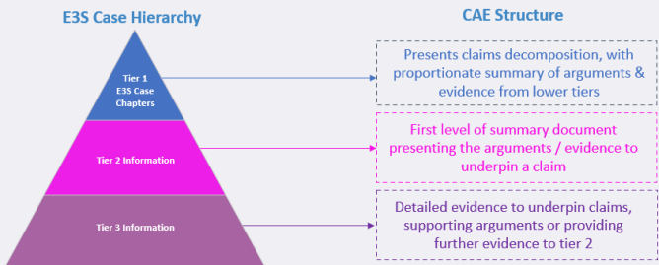

**Figure 1: Claim, Argument and Evidence (CAE) structure within the E3S hierarchy** (ref. [20])

1. The structure of the E3S case largely aligns with the IAEA guidance for safety cases, SSG-61 (ref. [20]), supplemented to include UK specific expectations and expanded to include the other E3S purposes.

## Summary of the requesting party’s E3S case for MSQA

1. Chapter 17 of the RR SMR generic E3S Case (ref. [1]) presents the overarching summary of management and organisational arrangements related to delivery of the design and E3S Case.
2. Rolls-Royce SMR Limited’s ‘Integrated Management System Manual, SMR0001351’ (ref. [21]), sets out their integrated management system for their business, including arrangements for developing the E3S Case and design. My review of the adequacy of these arrangements and my evaluations of their effective deployment were the basis of my Step 2 assessment.

# ONR assessment

## Assessment strategy

1. GDA Step 2 is the first substantive technical assessment step. The focus of ONR’s assessment in this Step was towards:

* The fundamental adequacy of the design and safety, security, and safeguards cases; and
* The suitability of the methodologies, approaches, codes, standards and philosophies which form the building blocks for the design and cases.

1. The MSQA Assessment Plan (ref. [7]) detailed my intended assessment of the ongoing development and deployment of MSQA arrangements for producing the Rolls-Royce SMR design and E3S case during Step 2.
2. To meet the workstream objectives, the MSQA Inspectors, in their engagements and assessments, focused on:

* The adequacy of the RP’s arrangements for delivery of the GDA.
* The RP’s ongoing development of management system arrangements.
* The effective deployment of these arrangements.

1. The MSQA assessment was front-end loaded. During Step 1, the focus of my assessment was primarily on the adequacy of the RP’s arrangements for the delivery the GDA. During Step 2 my focus was on the demonstration of the effective deployment of these arrangements.
2. The Regulators carried out their assessments through:

* Targeted Level 4 engagements where the RP was expected to demonstrate the adequacy of their arrangements and development plans for the MSQA topics selected, and to present their performance against their IMS metrics.
* Routine meetings as required to discuss findings, actions, forthcoming engagements etc.
* Sample reviews of selected documented information for the RP’s key arrangements and processes.
* Evaluations of the RP’s MSQA arrangements carried out throughout GDA Step 2.

1. During GDA Step 2, the MSQA Inspectors continued to monitor the RP’s control of:

* The Document List (DL).
* The Master Document Submission List (MDSL).

## Assessment

### Quality organisation

1. The RP’s quality organisation and responsibilities are described in the integrated management system manual (ref. [21]). The quality functions reside in the Regulatory Affairs and Safety Directorate.
2. The regulatory affairs group function manual (ref. [22]) was issued early in Step 2. I reviewed this document and considered it to be adequate.
3. Reporting to the Regulatory Affairs Director were:

* The Head of HSE and Quality who is responsible for the ongoing development of the Rolls-Royce SMR Limited’s Integrated Management System.
* The Head of Nuclear Assurance who is responsible for independent peer reviews of safety case documentation and for implementing the audit and assurance arrangements and programmes.

1. On the basis of the timely update and development of the RP’s IMS documentation, the filling of identified quality posts, and the planning and completion of the internal audit programme for 2023 (with no major non-conformances being reported), I judged the quality complement of the Regulatory Affairs Directorate was adequate for this stage of the GDA Project.

### Rolls-Royce SMR Limited’s Integrated Management System (IMS)

1. Rolls-Royce SMR Limited’s documented IMS is described in overview in the integrated management system manual (ref. [21]). This did not significantly change during GDA Step 2.
2. The integrated management system manual is supported by the ‘Generic Design Assessment Quality Management Plan, SMR0000963 Issue 3’ (ref. [23]). This document is the RP’s quality manual for the GDA project, and was updated in July 2023 to detail developed GDA arrangements.

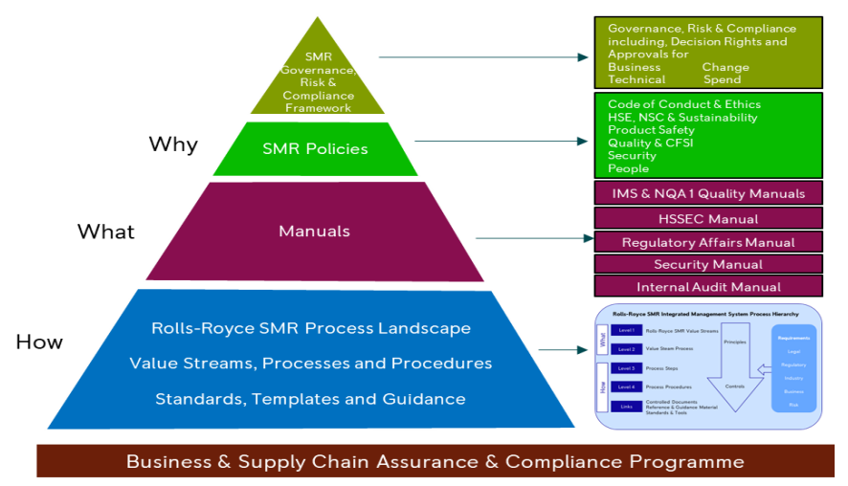

**Figure 2: Rolls-Royce SMR Limited’s IMS hierarchy** (ref. [1])

1. The IMS comprises a hierarchical document architecture similar in nature to other major contractors within the international nuclear industry, see Figure 2.
2. The IMS identifies key core and supporting processes and principles, see Figures 3 and 4.

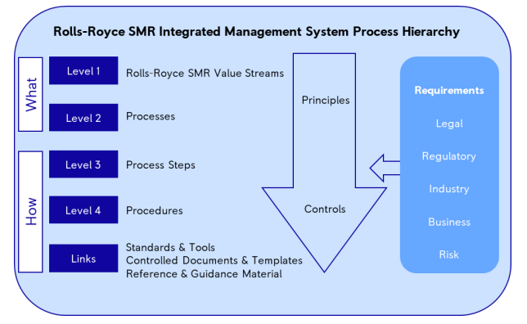

**Figure 3: Rolls-Royce SMR Limited’s IMS process hierarchy** (ref. [1])

1. The IMS Level 1 structure comprises the key business management (M), core delivery (C) and support (S) value streams, see Figure 4. The value streams arrangements are defined in process control documentation, such as procedures, guides, templates, etc.

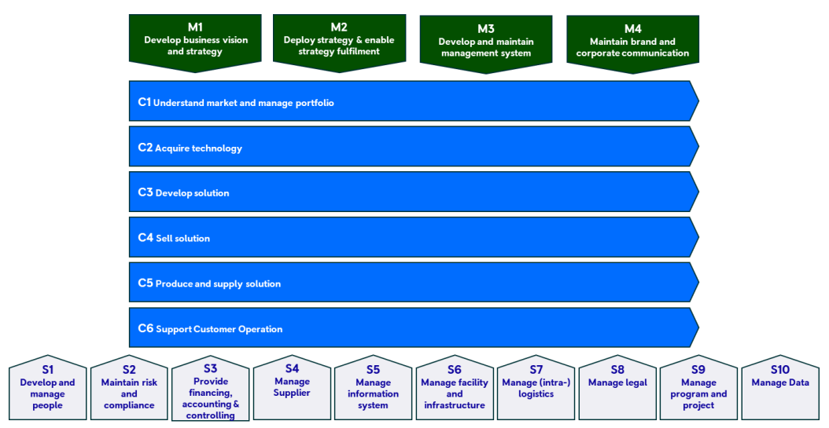

**Figure 4: Rolls-Royce SMR Limited’s Business Value Stream Landscape** (ref. [1])

1. During Step 2 I have reviewed the updates to the integrated management system manual (ref. [21]) and the GDA quality management plan (ref. [23]).
2. I am satisfied that the overarching management system arrangements align with those required by the standards and criteria used for this assessment, e.g.: quality organisation, process control and ownership, process interfaces, controlled information, ease of use, monitoring and measuring. (see Section 2.1).
3. The IMS is intranet based and made available to personnel. It was demonstrated to the regulators that it continued to be easy to navigate and held sufficient approved documented information for this stage of the project.
4. Rolls-Royce SMR Limited’s IMS continues to be developed in accordance with relevant management system standards, including:

* ISO 9001: 2015 – Quality management systems - requirements (certification was achieved in 2023).
* ISO 14001: 2015 – Environmental management systems.
* IAEA GSR Part 2 – Leadership and Management for Safety.

1. Overall, I concluded that the Rolls-Royce SMR Limited’s IMS was adequate for this stage of the GDA project.

### Arrangements for the development of the RR SMR design and safety case

1. The following high-level documents detail, in overview, the RP’s arrangements for the development of the RR SMR Design and Safety Case:

* Engineering Management Plan (EMP) for Rolls-Royce SMR, SMR0000520, Issue 3 (ref. [24]). This document describes the processes and controls for: the engineering organisation; engineering governance and the technical and engineering methods used for the RR SMR design.
* Regulatory Affairs Group Functional Manual, SMR0001328 (ref. [22]). This document describes the organisation and arrangements for delivering the E3S case and the associated peer review and governance activities deployed.
* E3S Case Development and Management Arrangements, SMR0000627 Issue 2 (ref. [25]). This document describes the arrangements for development and management of the RR SMR E3S Case.

1. I have reviewed these documents and considered them to be adequate In terms of the management system standards detailed in Section 2.1.

### Document quality, Document List (DL) and Master Document Submissions List (MDSL)

1. The RP’s document control arrangements were assessed during Step 1. The Regulators monitored these arrangements throughout Step 2 and I concluded that they remained adequate.
2. GDA specific instructions, including document control arrangements, are shown in Figure 5.

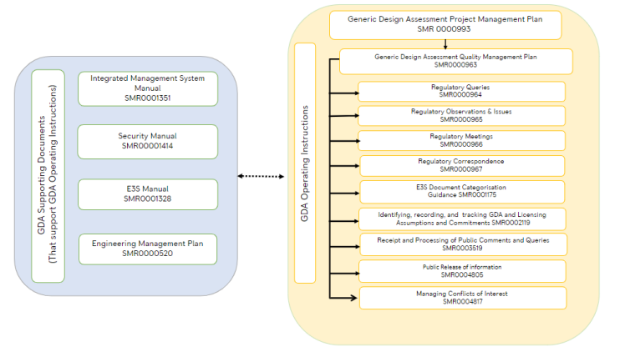

**Figure 5: GDA Operating Instructions** (ref. [23])

1. The MDSL and DL are contained in a live spreadsheet, an updated copy of which is sent to the regulators each month. The Regulators consider the format and control of the MDSL and DL to be adequate.
2. The RP’s Regulatory Interface Office and the regulator’s Joint Project Office hold regular Level 4 meetings to facilitate effective control of the DL, the MDSL, ROs and RQs, and related correspondence.
3. The Regulators monitored the quality of documents submitted during Step 2 in terms of their assessabilty (configured, complete, legible, etc.). No issues were reported in this regards. I have therefore concluded that the RP’s pre-submission checking arrangements were effective.
4. I considered that the RP’s document control arrangements remained adequate for this stage of the project in terms of the management systems standards detailed in Section 2.1.

### Evaluations of the implementation of IMS arrangements

1. As part of the engagement strategy set out in the MSQA Topic Stream’s Assessment Plan for GDA Step 2 (ref. [7]), the Regulators caried out a series of evaluations of the ongoing development and deployment of key aspects of the RP’s IMS. The Environment Agency’s MSQA Inspector and I were supported by ONR Specialist Inspectors where required.
2. I carried out the following evaluations of the RP’s IMS arrangements during Step 2.

#### **Evaluation of Rolls-Royce SMR Limited’s assurance arrangements (ref.** [26]**)**

1. The scope of this evaluation covered the RP’s internal assurance arrangements for assessing the adequacy of their IMS arrangements and their deployment.
2. The Regulators’ objective for this evaluation was to assess the adequacy and effectiveness of these arrangements.
3. The RP provided the Regulators with relevant IMS procedures prior to the evaluation, including:

* S2.3.1-1, ‘Develop Integrated Assurance Programme’.
* S2.3.1-2, ‘Conduct Assurance Activity’.
* S2.3.2-2, ‘Conduct Assurance Activity (Independent Peer Review)’.

1. I reviewed these IMS procedures prior to the evaluation and considered them to be adequate.
2. The RP’s ‘Total Assurance Model’ is described in the GDA Quality Management Plan (ref. [23]) and illustrated in Figure 6. The assurance model shows three levels of assurance activities: Self-Checking, Functional Oversight, and Independent Oversight.

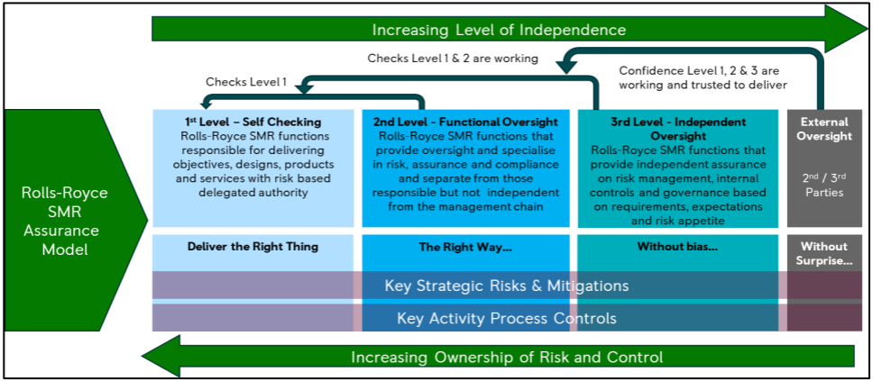

**Figure 6: Rolls-Royce Limited’s assurance model** (ref. [1])

1. The Rolls-Royce SMR Ltd. Report SMR0004844, Issue 1, ‘E3S Case Batch 1 IPR – Overarching Independent Peer Review Position Report’, highlighted challenges identified by the Peer Reviewers and points which required resolution.
2. There was alignment between the challenges identified in this position report and issues identified by the Regulators during Step 1 MSQA engagements, and subsequent assessments of the E3S submissions. However, the report did not identify specific actions to be taken, and the Regulators were concerned that the improvement opportunities highlighted by this report may not be exploited for following batches of E3S documents.
3. The Regulators noted that actions arising from assurance activities were recorded on an action tracker system. However, other assurance activity findings, such as those arising from document reviews and surveillance activities, were monitored and closed out by less formal means.
4. In response to these findings I raised RQ-01051, ‘Disposition of Internal Assurance Findings’ (ref. [27]), requesting that the RP provide details on how they were resolving the challenges highlighted in the position report, how they raise, assign, track, and close all findings from assurance activities relating to the GDA Project, and details of their proposals to consolidate and improve these arrangements. I was satisfied with the RP’s responses to this RQ.
5. Overall, I was satisfied that the RP was planning and carrying out adequate and sufficient assurance activities to evaluate the performance and effectiveness of its IMS arrangements with respect to delivering GDA

#### Evaluation of arrangements for the control of technical service contracts (ref. [28])

1. The scope of this evaluation covered the development and deployment of the RP’s arrangements used to control technical service contracts. The RP uses such contracts to procure technical services for, for instance: the production and verification of designs, technical analyses, independent reviews, etc., which support the E3S case.
2. The Regulators’ objective for the evaluation was to assess the adequacy and effectiveness of these arrangements.
3. The Regulators used the relevant criteria for the control of supply chains set out in the standards and guides listed in Section 2.1, including:

* Leadership and Management for Safety, IAEA GSR Part 2 (ref. [17]); Requirement 11 – “The Organisation shall put in place arrangements with vendors, contractors and suppliers for specifying, monitoring and managing the supply to it of items, products and services that may influence safety”.
* ONR Technical Assessment Guides):
  + NS-TAST-GD-077 - Supply Chain Management Arrangements for the Procurement of Nuclear Safety Related Items or Services (ref. [15]).
  + NS-TAST-GD-049 - Licensee Core Safety and Intelligent Customer Capabilities (ref. [14]).

1. In preparing for the evaluation I reviewed the RP’s document SMR0004843, Issue 1, ‘Supplied Products and Services Management Plan’ (ref. [29]), their ‘S4’ process, along with supporting process instructions and guidance. I considered these documents to be adequate.
2. Technical service contracts were selected by the Regulators for their evaluation, which included the sampling of the adequacy of the implementation of the RP’s Manage Supplier (S4) process.
3. The RP’s records for these contracts were examined by the regulators. The completed records examined included:

* Supplier questionnaires (TS-QS-23).
* Company profiles and capabilities (TS-SCL-05).
* Technical checking records (TS-QA-05).

1. I was satisfied from the examination of these records and interviews with the procurement work package owners that the Manage Supplier (S4) process had been followed for these contracts. Overall, I concluded that the RP’s arrangements developed and deployed for the control of technical service contracts were adequate for GDA.

#### Evaluation of the status of development and functionality of the Teamcenter project lifecycle management tool (ref. [30])

1. Towards the end of GDA Step 1 the RP embarked on the development of a computer based tool for managing the delivery of the Rolls-Royce SMR design and E3S case. This Project Lifecycle Management tool is called Teamcenter.
2. Teamcenter is currently used in RR Aerospace, but required additional functionality for the Rolls-Royce SMR. A new Rolls-Royce SMR Limited package was in development throughout 2023.
3. The regulators monitored the development of this tool throughout their Step 2 engagements with the RP.
4. The objectives for this evaluation was for the Regulators to ascertain the progress made by the RP in developing this tool, and to test its functionality in a software ‘sandbox’ environment.
5. The Regulators confirmed the status of development and deployment of Teamcenter in January 2024 as follows:

* Data migration was completed. The initial slow speed of transfer of data had caused significant delays to the ‘Go-live’ of Teamcenter .
* User testing and training was in progress in January 2024.
* It was intended that Teamcenter would go live in February 2024 (i.e.: after the major ‘drop’ of Step 2 submissions to the Regulators in January 2024).
* On go-live, Teamcenter will be the tool for managing the design configuration and development. Information to support the E3S case will also be located in Teamcenter, with linkages to the E3S case development provided by the ASCE software tool.
* Raw data feeding into Teamcenter (on structures, systems and components, and also requirements, assumptions and commitments) will still initially be captured in the extant DOORS database, but once live Teamcenter will replace much of the functionality of DOORS in terms of system configuration and design change control. Requirements will still be recorded in DOORS.
* E3S case documents will be authored and stored in Teamcenter and ASCE will be used to structure the E3S case.

1. I carried out my evaluation of the Teamcenter tool based on the design control requirements of the international standards listed in Section 2.1, and on the following RP’s E3S and design control arrangements, which I had reviewed previously and considered adequate:

* SMR0000627 Issue 2, ‘E3S Case Development and Management Arrangements’ (ref. [25]).
* Associated engineering process instructions, C3.2.1 series.
* SMR-GDN-071, ‘Guidance on the execution of the design control process for Engineering & E3S changes across the Rolls-Royce SMR business’.

1. To enable the Regulators to carry out their evaluation of the functionality of the Teamcenter tool, the RP presented three, hypothetical, representative, design change control scenarios, within the ‘sandbox’ development environment:

* Engineering Change Request (ECR) for changing the number of redundancies in the Diverse PS.
* Address a requirement to clean irradiated fuel assemblies.
* Make a change to ‘system A’ but not ‘system B’

1. The RP took the Regulators through the various activities and stages at a measured pace, answering Regulators’ questions throughout. The Teamcenter tool in a stepwise manner facilitated, for the process activities and stages, configuration control and acceptance / sentencing and approval of the design aspects and associated E3S Case. Examples of design review verifications were presented and considered adequate.
2. For all the various stages and activities, the Teamcenter Tool displays references to the relevant process instructions and guides. Suggested linked documents and interfaces are also highlighted to the users.
3. From the demonstrations and discussions I concluded that the Teamcenter Tool provides the necessary integrated controls for managing the design and E3S Case for GDA. The functions align with the RP’s documented IMS arrangements, and covers the relevant design control clauses of the international standards (detailed above).
4. The deployment of Teamcenter will necessitate a wide range of updates to the RP’s E3S case and design control process documentation. The Regulators will monitor the progress of updating and assess the adequacy of these changes early in Step 3.
5. The demonstrations of the Teamcenter functionality provided to the Regulators at this meeting enhanced their understanding of the tool and assisted them with their intervention in March 2024, see Section 4.2.5.5 below.

#### Evaluation of arrangements for the OPEX (ref. [31])

1. The scope of this evaluation covered the development and deployment of the RP’s arrangements for gathering and using OPEX for the GDA.
2. The Regulators’ objective for the evaluation was to assess the adequacy and effectiveness of these arrangements.
3. The Regulators used the following relevant good practice to determine the assessment criteria for the evaluation.

* Leadership and Management for Safety, IAEA GSR Part 2 (ref. [17]).
* Safety of Nuclear Power Plants: Design, IAEA SSR-2/1 (ref. [18]), in particular Section 4.16.’ Where an unproven design or feature is introduced or where there is a departure from an established engineering practice, safety shall be demonstrated by means of appropriate supporting research programmes, performance tests with specific acceptance criteria or the examination of operating experience from other relevant applications’.
* Quality Management Systems – Requirements, ISO 9001 (ref. [19]).

1. The RP described its OPEX arrangements, detailed in overview in SMR0005056 Issue 1, ‘ Knowledge Management Framework’ (ref. [32]). Detailed OPEX requirements were found to be included in process level IMS documents (i.e.: in decision records, design check-sheets, etc).
2. The Regulators examined the design and decision records for the following examples to assess the RP’s use of OPEX:

* Boron free chemistry justification.
* Restriction/limitation of Cobalt in the primary circuit.
* Aseismic bearings for the nuclear island.
* Reverse osmosis for treating radioactive waste discharges.

1. The arrangements described by the RP were considered to be logical and adequate overall.
2. There is a reliance on engineering judgement to identify suitable sources of OPEX, to determine the relevance of OPEX, and to establish limits on the applicability of OPEX. I considered that the balance, in this regards, between competence of staffs on one hand, and prescription in IMS documentation on the other, was appropriate for GDA.
3. The RP noted that only limited identification and consideration of OPEX had been made in the Step 2 E3S case submissions to date. Their intention is to support the E3S case claims with more detailed information on OPEX consideration via the Tier 2 and Tier 3 submissions, which will be made through GDA Step 3.
4. Overall I concluded that the arrangements for gathering and using OPEX were adequate for this stage of GDA.
5. The regulators will return to this topic in Step 3, informed by feedback from Topic Leads as they receive more detailed information from the RP on its use of OPEX in supporting ALARP claims in the E3S case.

#### Scheduled intervention: Testing implementation of the arrangements developed in response to RO-RRSMR-001, ‘Development of the generic E3S case’.

1. This intervention began in March 2024. It was a joint intervention carried out by ONR and the Environment Agency’s technical topic leads along with the MSQA Inspectors.
2. The purpose of the intervention was to evaluate Rolls-Royce SMR Limited’s implementation of arrangements for development, control and production of the E3S case for the generic Rolls-Royce SMR design.
3. These arrangements were developed and submitted in response to the shortfalls described in Regulatory Observation RO-RRSMR-001 (ref. [33]).
4. The objective of the intervention was to gain assurance that the RP had implemented those arrangements, and that they were embedded within the organisation.
5. The intervention will support ONR’s decision on whether RO-RRSMR-001 has been satisfactorily resolved, or if not, where further work may be needed by the RP to do so.
6. The intervention’s findings will inform the Regulators’ judgements on the adequacy of the implementation of key IMS arrangements, such as:- Teamcenter; the DOORs requirements tool; the ASCE E3S Case tool; and the management of requirements, assumptions and commitments, etc.
7. The timing of this intervention was too late for the findings to be fully considered in this assessment report. However, I have concluded from the Regulators’ preliminary findings that further work is required on the part of the RP to close out the MSQA aspects of RO-RRSMR-001. This entails further completion and deployment of the design and E3S Case development computer tools, and their supporting instructions and guides. If this is not achieved then the RP’s Step 3 milestones may not be met.
8. The overall findings from the intervention will be considered in ONR’s GDA Step 2 Summary Report and Project Assessment Report, and subsequently inform the ONR’s overall judgement on the readiness of the RP to enter GDA Step 3.

# Conclusions

## Conclusions

1. This report presents the Step 2 MSQA assessment for the GDA of the Rolls-Royce SMR design. The focus of my assessment in this step was towards the adequacy of the arrangements, developed and deployed, for delivering the design and E3S Case. I have assessed the MSQA case detailed in Tier 1 E3S Chapter 17 (ref. [1]), and relevant supporting documentation provided by Rolls-Royce SMR Limited, to form my judgements.
2. I targeted my assessment, in accordance with my assessment plan (ref. [8]), at the content of most relevant to MSQA against the expectations of ONR’s SAPs, TAGs and other guidance which ONR regards as relevant good practice (see Section 2.1).
3. The RP’s integrated management system has developed and matured during Step 2. The RP’s management system was certified to ISO 9001: 2015 (ref. [19]).
4. Based upon my targeted assessment of the documented IMS arrangements, and of the evidence I gathered relating to the effective deployment of the same, I have concluded that, overall, I am satisfied that the RP is making adequate progress towards establishing and deploying adequate management system arrangements to support its design and safety case development activities during Step 3.
5. Early in Step 3 however, the RP will need to close out the MSQA aspects of RO-RRSMR-001. This entails further completion and deployment of the design and E3S Case computer tools, and their supporting instructions and guides. If this is not achieved then their Step 3 milestones may not be met.
6. Overall, based on my assessment to date, and subject to the provision and assessment of suitable and sufficient supporting evidence, I have not identified any fundamental safety shortfalls that could prevent ONR permissioning the construction of a power station based on the generic Rolls-Royce SMR design.

## Recommendations

1. My recommendations are as follows:

* Recommendation 1: ONR should consider the outcomes from my assessment as part of the decision to progress to Step 3 of GDA for the generic Rolls-Royce SMR design.

# References

|  |  |
| --- | --- |
| [1] | Rolls-Royce SMR Limited, Environment, Safety, Security and Safeguards Case Version 2, Tier 1, Chapter 17: Management of E3S and Quality Assurance, SMR0004334, Issue 3, May 2024. (Record ref. ONRW-2019369590-9907). |
| [2] | ONR, Guidance on Mechanics of Assessment, NS-TAST-GD-096, Issue 1.2, December 2022. www.onr.org.uk/media/documents/guidance/ns-tast-gd-096.docx. |
| [3] | ONR, Safety Assessment Principles for Nuclear Facilities (SAPs), 2014 Edition, Revision 1, January 2020. www.onr.org.uk/media/pobf24xm/saps2014.pdf. |
| [4] | ONR, Technical Assessment Guides. www.onr.org.uk/publications/regulatory-guidance/regulatory-assessment-and-permissioning/technical-assessment-guides-tags/nuclear-safety-tags/technical-assessment-guides-tags-nuclear-safety-full-list/. |
| [5] | ONR, Guidance on the Production of Reports for Permissioning and Assessment, NS-TAST-GD-108, Issue No. 1, December 2022. (Record ref. 2022/71935). |
| [6] | ONR, New Nuclear Power Plants: Generic Design Assessment Guidance to Requesting Parties, ONR-GDA-GD-006, Revision 0, October 2019. www.onr.org.uk/media/pylbvfnz/onr-gda-gd-006.pdf. |
| [7] | ONR, Step 2 Management for Safety and Quality Assurance (MSQA) Assessment Plan for the Generic Design Assessment of the Rolls-Royce SMR, ONR-GDA-AP-22-016, Issue No. 1, March 2023. (Record ref. ONRW-2126615823-518). |
| [8] | ONR, Generic Design Assessment of the Rolls-Royce SMR - Step 2 summary, ONRW-2019369590-8980, Issue No. 1, July 2024. (Record ref. ONRW-2019369590-8980). |
| [9] | Rolls-Royce SMR Limited, Rolls-Royce SMR Generic Design Assessment Scope, SMR0002183, Issue 2, January 2023. (Record ref. ONRW-2019369590-8058). |
| [10] | IAEA, Safety Standards. www.iaea.org. |
| [11] | IAEA, Nuclear Security series. www.iaea.org. |
| [12] | WENRA, Safety Reference Levels for Existing Reactors 2020, February 2021. www.wenra.eu. |
| [13] | WENRA, WENRA Safety Objectives for New Nuclear Power Plants and WENRA Report on Safety of new NPP designs - RHWG position on need for revision. September 2020. www.wenra.eu. |
| [14] | ONR, Licensee Core Safety and Intelligent Customer Capabilities, NS-TAST-GD-049, Issue 7.2, July 2024. www.onr.org.uk/media/documents/guidance/ns-tast-gd-049.docx. |
| [15] | ONR, Supply chain managementarrangements for the procurement ofnuclear safety related items or services, NS-TAST-GD-077, Issue 6.3, July 2024. www.onr.org.uk/media/documents/guidance/ns-tast-gd-077.docx. |
| [16] | IAEA, Format and Content of the Safety Analysis Report for Nuclear Power Plants, Specific Safety Guide No. SSG-61, September 2021. www.iaea.org. |
| [17] | IAEA, Leadership and Management for Safety, General Safety Requirements No. GSR Part 2, June 2016. www.iaea.org. |
| [18] | IAEA, Safety of Nuclear Power Plants: Design, Specific Safety Requirements No. SSR-2/1 (Rev. 1), February 2016. www.iaea.org. |
| [19] | International Standards Organisation, ISO 9001: 2015, Quality management systems - Requirements, Edition 5, 2015. www.iso.org. |
| [20] | Rolls-Royce SMR Limited, Environment, Safety, Security and Safeguards Case Version 2, Tier 1, Chapter 1: Introduction, SMR0004294, Issue 3, May 2024. (Record ref. ONRW-2019369590-9881). |
| [21] | Rolls-Royce SMR Limited, Integrated Management System Manual, SMR0001351, Issue 1, December 2022. (Record ref. ONRW-2019369590-9839). |
| [22] | Rolls-Royce SMR Limited, Regulatory Affairs Group Functional Manual, SMR0001328, Issue 2, October 2023. (Record ref. ONRW-2019369590-5615). |
| [23] | Rolls-Royce SMR Limited, Generic Design Assessment Quality Management Plan, SMR0000963, Issue 3, July 2023. (Record ref. ONRW-2019369590-4171). |
| [24] | Rolls-Royce SMR Limited, Engineering Management Plan for Rolls-Royce SMR, SMR0000520, Issue 3, October 2022. (Record ref. ONRW-2019369590-9838). |
| [25] | Rolls-Royce SMR Limited, E3S Case Development and Management Arrangements, SMR0000627, Issue 2, November 2023. (Record ref. ONRW-2019369590-8061). |
| [26] | ONR, Evaluation of RR SMR’s Assurance Arrangements, ONR-NR-CR-23-210, August 2023. (Record Ref. ONRW-2019369590-3779). |
| [27] | ONR, Schedule of Step 2 Regulatory Queries, April 2024. (Record ref. ONRW-2019369590-9071). |
| [28] | ONR, Evaluation of arrangements for the control of technical service contracts, ONR-NR-CR-23-311, September 2023. (Record ref. ONRW-2019369590-4477). |
| [29] | Rolls-Royce SMR Limited, Supplied Products and Services Management Plan, SMR00004843, Issue 1, March 2023. (Record ref. ONRW-2126615823-3864). |
| [30] | ONR, MSQA12 - level 4 meeting, ONR-NR-CR-23-519, January 2024. (Record ref. ONRW-2019369590-6279). |
| [31] | ONR, MSQA014 Level 4 Evaluation of OPEX Arrangements, ONR-NR-CR-23-648, February 2024. (Record ref. ONRW-2019369590-8063). |
| [32] | Rolls-Royce SMR Limited, Rolls-Royce SMR Knowledge Management Framework Summary, SMR0005056, Issue 1, March 2023. (Record ref. ONRW-2019369590-2665). |
| [33] | ONR, Regulatory Observation - Development of the generic E3S case, RO-RRSMR-001, Revision 0, August 2023. www.onr.org.uk/media/k0odfpcf/ro-rrsmr-001.docx. |

# Appendix 1 – Relevant SAPs considered during the assessment

|  |  |
| --- | --- |
| SAP No. | SAP Title |
| MS-1 | Leadership and management for safety - Leadership |
| MS-2 | Leadership and management for safety - Capable organisation |
| MS-3 | Leadership and management for safety - Decision making |
| MS-4 | Leadership and management for safety - Learning |