ONR Assessment Report
Organisational capability proportionate reassessment of an application by Sizewell C Limited (SZC Ltd) for a Nuclear Site Licence
ONR Assessment Report
Project Name: Sizewell C Licensing
Report Title: Organisational capability proportionate reassessment of an application by Sizewell C Limited (SZC Ltd) for a Nuclear Site Licence

Report Issue No: 0
Document ID: ONRW-2126615823-2482
Publication Date: 26 April 2024

© Office for Nuclear Regulation, 2024
For published documents, the electronic copy on the ONR website remains the most current publicly available version and copying or printing renders this document uncontrolled. If you wish to reuse this information visit www.onr.org.uk/copyright for details.

Executive Summary
This report presents the findings of the organisational capability aspects of the Sizewell C Limited (SZC Ltd) application for a nuclear site licence to construct and operate two UK EPR™ reactors at Sizewell C (SZC).
An initial assessment was completed in June 2022. This report presents the findings of a proportionate reassessment conducted in late 2023, through to quarter one 2024, focused on matters that have changed, and does not repeat the earlier assessment. This proportionate reassessment has examined:
- governance and oversight;
- organisational development;
- training, suitably qualified and experienced personnel (SQEP) and appointments;
- intelligent customer;
- Design Authority; and
- quality including management systems.
The assessment is based on evidence obtained during interactions with SZC Ltd, on specific topics and arrangements, including key project enabling activities. It also draws on the significant cross cutting work carried out by the Office for Nuclear Regulation (ONR) as part of the delivering the proportionate reassessment.
The main points from this work are:
- The commitments made by SZC Ltd to address the shortfalls identified within the original licensing assessment have been adequately addressed, specifically:
  - the shortfall in the Shareholder Agreement has been addressed through the Interim Shareholder Agreement.
  - governance arrangements which are proportionate to the activities being undertaken are in place; and
  - the people and competency arrangements for the project have been implemented.
- The mechanisms for securing resources are sufficiently developed for the current stage of the project.
- SZC Ltd has applied a strategic approach to inform the development of its Design Authority (DA) and arrangements.
- SZC Ltd’s quality arrangements and resources are adequately developed.
- SZC Ltd has satisfactorily addressed all Regulatory Issues (RIs) raised during the reassessment, resulting in a number of areas of improvement.
Taking these points into account, the overall judgement is that SZC Ltd is ready to be granted a nuclear site licence for the proposed development at Sizewell C, and that from an organisational capability perspective, it is recommended that a nuclear site licence is granted to SZC Ltd to construct and operate a nuclear power station at Sizewell C.

List of Abbreviations
ARC | Audit and Risk Committee
CRF | Curriculum Review Forum
DA | Design Authority
EB | Environmental Baseline
eSHA | Enduring Shareholders’ Agreement
FAP | Forward Action Plan
FID | Final Investment Decision
FTE | Full Time Equivalent
GID | Government Investment Decision
Holding Company | Sizewell C (Holding) Limited
HPC | Hinkley Point C
HR | Human Resources
IC | Intelligent Customer
ICOG | Intelligent Customer Oversight Group
IMS | Integrated Management System
iSHA | Interim Shareholder Agreement
MD | Managing Director
NB | Nuclear Baseline
NED | Non-Executive Director
NNB GenCo | NNB Generation Company (HPC) Limited
NSA | Nuclear Skills Alliance
NSL | Nuclear Site Licence
ONR | Office for Nuclear Regulation
OPEX | Operational Experience
PAR | Project Assessment Report
RI | Regulatory Issue
SAPs | Safety Assessment Principles
SHA | Shareholders’ Agreement
SHESSC | Safety, Health, Environment, Social and Sustainability Committee
SMP | Safety Management Prospectus
SQEP | Suitably Qualified and Experienced Person/Personnel
SZC Ltd | Sizewell C Limited
SZC | Sizewell C Site
TAG | Technical Assessment Guide
TCO | Technical Client Organisation
ToR | Terms of Reference
TSO | EDF Energy (TSO) Limited
TUPE | Transfer of Undertakings Protection of Employment

Contents
Executive Summary 3
List of Abbreviations 5
1. Introduction 8
2. Assessment Standards and Interfaces 10
3. Applicant’s Submission 13
4. ONR Assessment 14
5. Conclusions and Recommendations 28
6. References 29
7. Appendices 31

Figures

Figure 1: SZC Ltd Governance Framework
Figure 2: SZC Ltd Board – Nuclear Experience and Knowledge
Figure 3: SZC Ltd Resource Profile
Figure 4: Resource Strategy Framework
Figure 5: Movement of people across Hinkley Point C and SZC

Introduction
- This report presents ONR’s findings from its proportionate reassessment of the organisational capability aspects of an application by Sizewell C Limited (SZC Ltd) for a nuclear site licence (NSL) to install and operate a twin EPR™ nuclear power station at Sizewell C (SZC) in Suffolk.

Background
- On 30 June 2020, SZC Ltd (then known as NNB Generation Company (SZC) Ltd) applied to ONR for a NSL to install and operate a nuclear installation at a site located at Sizewell on the east coast of England, near Leiston, Suffolk.
- ONR’s assessment of the evidence provided with the licence application was undertaken during the period from July 2020 to May 2022. That assessment is set out in a series of ONR assessment reports and summarised in a Project Assessment Report (PAR). These reports are all published on ONR’s website (Sizewell C Licensing Assessment) and are listed in Appendix 1 of this document.
- A statement issued on the ONR website on 11 July 2022, noted that:
- the licence assessment concludes that the application has met almost all the regulatory requirements set out in regulatory guidance; and
- there are two outstanding matters which require resolution prior to the formal granting of a licence.
- The first of those matters related to the ownership (security of tenure) of the land intended for the licensed site area. Our regulatory guidance Licensing Nuclear Installations (Ref. 1) states that a nuclear site licensee is expected to have ‘full rights of access to and control of’ the site upon which the nuclear site will operate. At that time SZC Ltd did not have such rights to the land proposed for the SZC development and this therefore needed to be resolved prior to licence grant. The details of the security of tenure reassessment are reflected in a dedicated Assessment Report (Ref. 2).
- The second matter related to the then extant shareholders’ agreement. As the licensee should be able to exercise effective day-to-day control over all activities on the licensed site, it is essential there is clarity on how that responsibility can be exercised. The then extant shareholders’ agreement for the development phase of the SZC project placed control of key policies relating to safety and security with NNB Holding Company (SZC) Ltd, rather than the licence applicant. This was inconsistent with ONR’s regulatory expectations, and we required control of such policies to rest with the applicant prior to the granting of a licence. Consequently, SZC Ltd provided ONR with a commitments letter, which set out how it intended to address this shortfall (Ref. 3).
- The ONR statement went on to note that when those matters are resolved, ONR would carry out a proportionate reassessment of the application, focused on the two outstanding matters and any other relevant matters relating to licensing that may emerge during the intervening period.
- This report sets out ONR’s findings from its reassessment of the organisational capability area, including the outstanding matter associated with shareholders’ agreement. The report’s findings will inform the PAR which will summarise ONR’s conclusions from its reassessment work and will make a recommendation to the Chief Nuclear Inspector on whether the licence should be granted.
- ONR has received an update (Ref. 4) to the commitments letter dated 8 February 2024. Evidence for each commitment has been reviewed and accepted by ONR. Further detail is discussed in this report.

Scope
- The reassessment scope for the organisational capability area includes the following topic streams:
- governance and oversight (including shareholders’ agreement);
- organisational development;
- training, suitably qualified and experienced personnel (SQEP) and appointments;
- intelligent customer;
- Design Authority; and
- quality including management systems.

Assessment Standards and Interfaces
- ONR has a range of internal guidance to enable inspectors to undertake a proportionate and consistent assessment of nuclear safety cases. This section identifies the standards which have been considered in this assessment. This section also identifies the key interfaces with other technical topic areas.

Standards
- The relevant standards and criteria adopted within this assessment are principally the Safety Assessment Principles (SAPs) (Ref. 5), internal Technical Assessment Guides (TAGs) (Ref. 6), relevant national and international standards and relevant good practice informed from existing practices adopted on UK nuclear licensed sites. The key guidance is identified below and referenced where appropriate within Section 4 of this report. Relevant good practice, where applicable, has also been cited within the body of this report.

Safety Assessment Principles (SAPs)
- The following SAPs were used as part of this assessment:
SAP Reference | SAP Title
MS.1 – Issue 1 | Leadership
MS.2 – Issue 1 | Capable organisation
MS.3 – Issue 1 | Decision making
MS.4 – Issue 1 | Learning from experience

Technical Assessment Guides (TAGs)
- The following TAGs were used as part of this assessment:
TAG Reference | TAG Title
NS-TAST-GD-027 – Issue 7 | Training and Assuring Personnel Competence
NS-TAST-GD-048 – Issue 7 | Organisational Change
NS-TAST-GD-049 – Issue 7.1 | Licensee Core Safety and Intelligent Customer Capabilities
NS-TAST-GD-065 - Issue 5 | Function and Content of the Nuclear Baseline
NS-TAST-GD-072 – Issue 4.1 | Function and Content of a Safety Management Prospectus (SMP)
NS-TAST-GD-079 – Issue 6.1 | Licensee Design Authority Capability
NS-TAST-GD-096 – Issue 1.2 | Guidance on Mechanics of Assessment
NS-TAST-GD-104 – Issue 1 | Corporate Governance for Safety

National and International Standards and Guidance
- The following international standards and guidance have been used as part of this assessment:
Reference | Title
BS EN ISO 9001: 2015 | Quality management systems — requirements
IAEA GSR Part 2 | Leadership and Management for Safety
ONR Website | Licensing Nuclear Installations

Integration with Other Assessment Topics
- The Organisational Capability topic streams assessed in this report form part of an integrated assessment with the following cornerstones:

- Site activities & compliance arrangements
- Nuclear site health & safety and & life fire safety
- Design & safety case
- Security and safeguards
- The outcomes of each of these assessments will be summarised in the PAR.

Use of Technical Support Contractors
- No technical support contractors have been used in this assessment.

Applicant’s Submission
- This reassessment considered the revised versions of the documents submitted as part of SZC Ltd’s NSL original application dossier.
Table 1 : Relevant Document Versions for Assessment
Relevant Document | Version Assessed
Company Manual | 6 (Ref. 7)
Nuclear Baseline Statement | 2 (Ref. 8)

ONR Assessment

Assessment Strategy
- ONR’s strategy for the proportionate reassessment of SZC Ltd’s licence application (Ref. 9) affirms that the principles by which ONR would undertake and reach a conclusion on its reassessment would be the same as those applied during the original assessment during 2020-22 (Ref. 10). It notes that as we have already undertaken a robust and extensive assessment of SZC Ltd’s case for licence grant, in undertaking a reassessment we will target our re-examination only on the two outstanding matters and those areas of the application where we consider that there are or may be:
- changes in the applicant company impacting the basis for aspects of our previous licensing judgement (e.g., resource, capability, arrangements, tools etc); and/or
- new information that may warrant a re-examination of relevant areas of the application, including relevant operational experience (OPEX) from other EPR™ or relevant new reactor projects.
- The reassessment strategy is supplemented by a licensing assessment plan (Ref. 11), which identifies the areas for proportionate reassessment in Appendix 1. This document provides information and guidance to ONR’s specialist inspectors involved in the assessments, including a timetable for production of reports required to inform the PAR.
- The reassessment strategy noted that in addition to engagements directly relating to a decision on granting a licence, ONR would continue to engage with SZC Ltd on the Forward Action Plan (FAP). The FAP is a live extract of the Integrated Work Schedule (IWS), and has been subject to revision since the version that was reported in the 2022 licensing PAR.
- This report covers the proportionate reassessment of the organisational capability area identified above.

Assessment Outcomes

Governance and Oversight
- As set out in Relevant Good Practice (RGP) e.g., NS-TAST-GD-104 – Issue 1, effective corporate governance, is essential for maintaining the appropriate level of safety focus across an organisation from the senior leadership, through into the front-line staff. There are unique challenges for new organisations like SZC Ltd, which has competing objectives which can challenge the organisation’s ability to maintain safety focus.
- ONR therefore considered it appropriate to undertake targeted engagements to seek assurance in the development of the overarching governance and oversight model for the project and ensure SZC Ltd has met the seven commitments made by the SZC Ltd Managing Director to ONR in a letter dated March 2022 (Ref. 3). ONR conducted a systematic review of the evidence trail and is now satisfied that the seven commitments have been appropriately addressed, as set out in a letter from SZC Ltd dated February 2024 (Ref. 4).
- The outcome of the targeted engagements, which were held between November 2023 and February 2024, are captured in dedicated Contact Records and have been summarised in the sub-sections below:

Governance Framework
- To gain assurance in the robustness of the governance framework, a desktop review of the Terms of Reference (ToR), and previous meeting minutes for key committees/forums was conducted (Ref. 12). This led to a subset of four committees/forums, where there are safety related matters being considered, being selected for more detailed review, which included meeting observations and sample interviews of key personnel. ONR observed three of these committees/forums to gain assurance that safety related topics were given due consideration during the meeting and in decision making.
- The governance framework (Figure 1) which has been in-place since the ISHA in November 2022, has continued to evolve in line with the project’s development.During the desktop review, it was noted that the ToRs for three of the committees were beyond their review date, but once raised with SZC Ltd these shortfalls have been addressed with the documentation being appropriately updated.
Figure 1: SZC Ltd Governance Framework
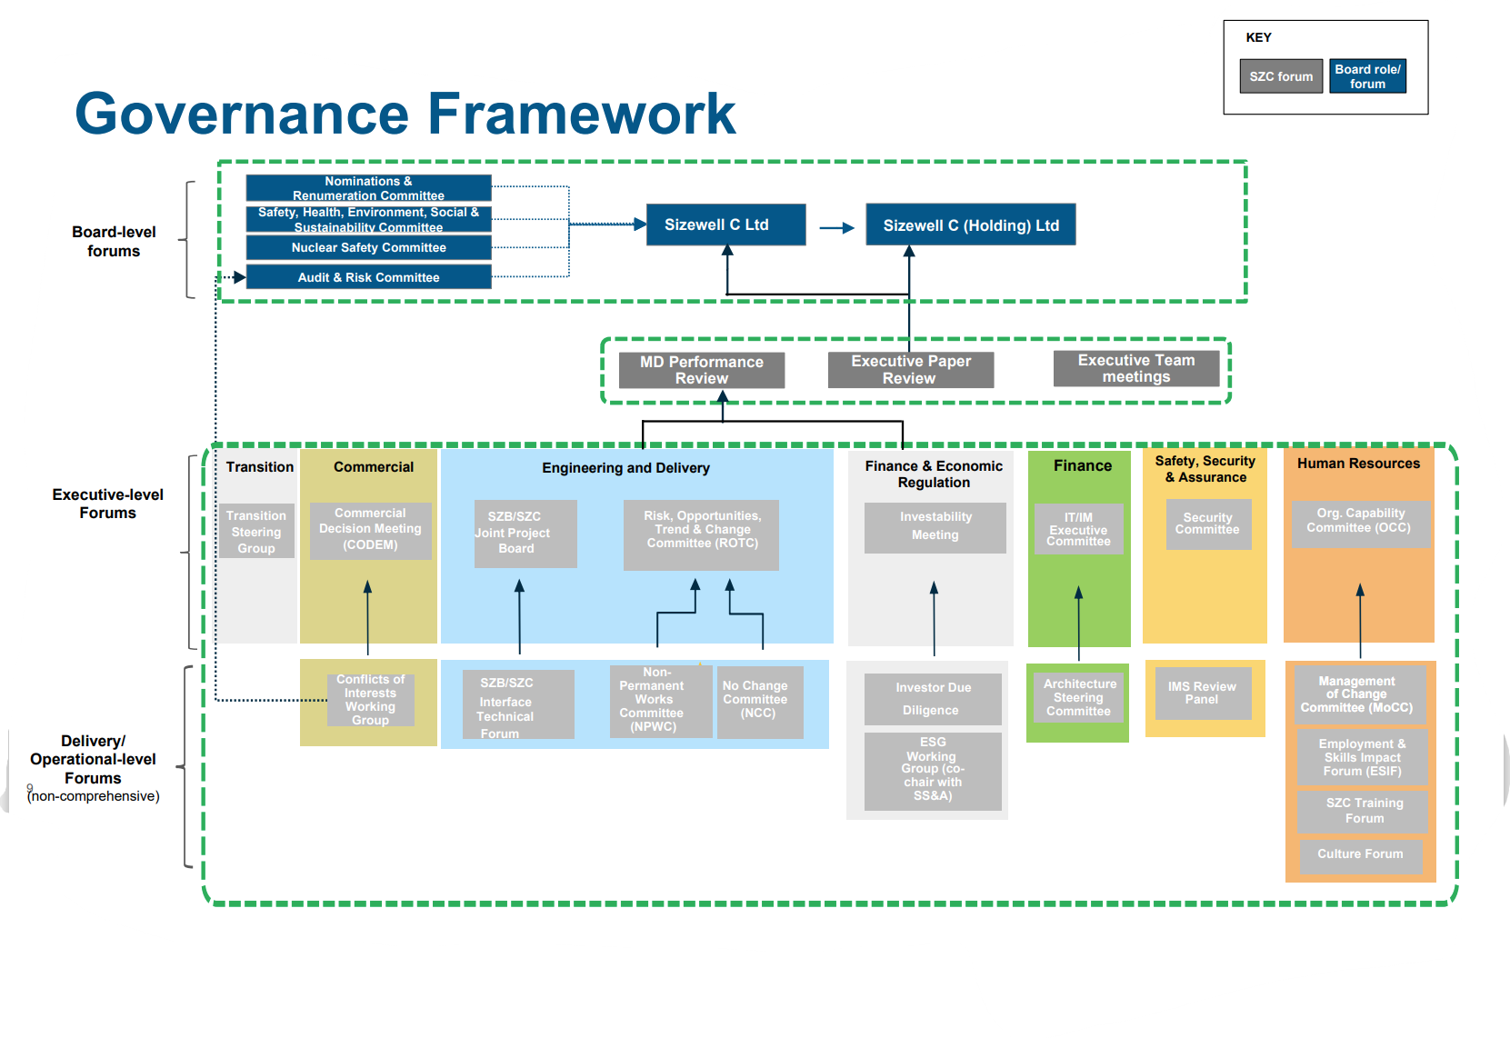
- Three meetings were observed as part of the targeted governance engagements were:
- Audit and Risk Committee (ARC);
- Managing Director (MD) Performance Review; and
- SZC Ltd Board.
- In addition to the observation, interviews were held with the chair of the ARC (iNED), the Managing Director (Project Delivery), the Chair of the Board (iNED) and other selected personnel (Ref. 16).
- Overall, the governance framework was considered to be adequately mature for the current phase of the project, with safety being provided at the appropriate level of focus for the risks currently being presented. However, a number of potential areas for improvement relating to the flow of information between committees, and the application of learning, were identified, with verbal feedback being given to SZC Ltd at the time of the engagement. Therefore, this matter will be followed-up through normal regulatory engagements.

Company Manual and Safety Management Prospectus (SMP).
- SZC Ltd has adopted the approach of combining its Company Manual to cover the relevant governance and organisational elements usually contained within a SMP, which is an approach recognised by ONR.
- The Company Manual version 6.0 (Ref. 7) was reviewed against NS-TAST-GD-072 – Issue 4.1 and demonstrates that the gaps previously identified in version 4.0 of the Company Manual, have been adequately addressed, and provides a clearer alignment with a SMP. Further minor areas for improvements have been provided by ONR to SZC Ltd, which will be progressed in the next version.
- The Company Manual will be maintained as a ‘live’ document, and therefore further iterations will be required as the project develops, e.g., to take account of changes to the organisational structure and resources.

Shareholders’ Agreement (SHA)
- The then extant shareholder agreement for the development phase of the project was reviewed by ONR in December 2021. It placed control of key policies relating to safety and security with the Holding Company, rather than the licence applicant. This was inconsistent with our expectations, due to a risk of undue influence from the Holding Company over the future licensee. This issue was a key factor in ONR’s decision not to grant the NSL in June 2022.
- The Managing Director at the time committed to addressing this risk of undue influence from the Holding Company through an interim Shareholder Agreement (iSHA) which was finalised when Government made its decision to invest in the organisation (known as Government Investment Decision (GID)) in November 2022. ONR gained assurance from reviewing the document, and in February 2023 (Ref. 13), concluded that the key policies relating to safety and security were within the remit of the future licensee, in line with ONR expectations.
- Following our review in February 2023, we were content that the original shortfall identified had been adequately addressed in the iSHA. The iSHA formed the basis of the proportionate reassessment.
- However, at the point of FID, the eSHA will supersede the iSHA. We therefore sought assurance in the eSHA’s direction of travel (Ref 14), to ensure SZC Ltd retains control of key policies relating to safety and security. We will continue to engage with SZC Ltd on the eSHA ahead of FID, noting this will be subject to a Management of Change (MoC) prior to implementation.

Board Level Skills and Experience
- SZC Ltd has conducted an updated assessment of the Board competency, which we have reviewed in detail during the targeted engagements. The approach aligns to the Institute of Directors competency matrix, while incorporating nuclear specific elements. The process is a facilitated self-assessment, which is moderated by the Human Resources (HR) Director and provides a good visualisation of skills strengths and weaknesses for the collective senior team.
- SZC Ltd has written to ONR (Ref. 15) summarising the approach followed and providing an anonymous summary of the assessment outcome, which is shown in Figure 2.
Figure 2: SZC Ltd Board – Nuclear Experience and Knowledge
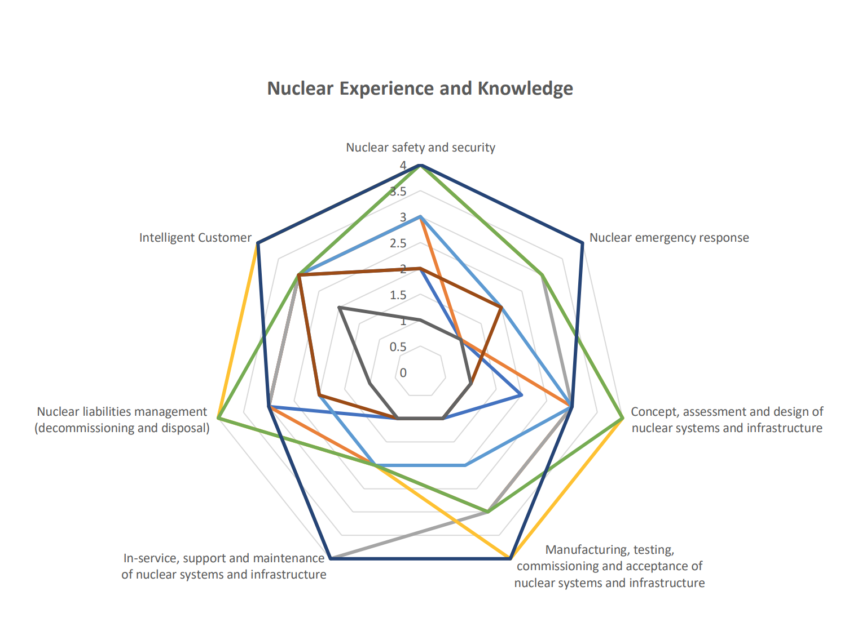
- The outcome provides confidence in the current SZC Ltd Board, which has changed considerably since the last assessment. The figure above displays the strengths in all the key areas of interest from a nuclear safety perspective based on this analysis.
- In addition, a series of interviews was conducted with a selection of the SZC Ltd senior team to gain further confidence in the overall Board competency, its decision making and focus on nuclear safety related matters. The outcomes of the interviews with the Managing Director (Delivery), Safety, Security and Assurance Director (as a new Board Member), and a selection of independent and shareholder NEDs, are captured in a Contact Record (Ref. 16).
- It is noted that SZC Ltd has postponed its 2023 annual review of Board effectiveness until 2024 to allow for the completion of changes to the Board constitution, noting there are two INEDs which have recently joined the Board. However, based on the reassessment undertaken, we consider the collective Board provides an appropriate level of skills, experience and knowledge for the current phase of the project.

Employment Model
- During targeted level 4 engagements with SZC Ltd, we sought to gain confidence that SZC Ltd has plans in place to secure capacity and capability by becoming an employing entity and remains committed to creating an enduring licensee and permit holder organisation that directly employs its workforce.
- In March 2022, SZC Ltd set out in a commitments letter its intent to transfer key staff into direct employment. However, several factors which included ongoing discussions with shareholders and potential investors have influenced a decision to delay transferring the staff, and these are set out in a letter (Ref. 17).
- Within the letter SZC Ltd has also confirmed that the transfer process has commenced, with the two Managing Directors becoming direct employees of SZC Ltd in January 2024 and the process will continue in a phased manner starting with a selection of the Executive Team, followed by re-commencing the Transfer of Undertakings Protection of Employment (TUPE) rights consultation with trade unions to enable the transfer of key identified roles, focusing on core capability (including key safety posts).
- This process will continue throughout 2024, with the aim of completing transfer of core safety capability by April 2025. This matter will be followed-up through normal regulatory engagements.
- Based on the evidence provided we are content that SZC Ltd is an employing entity with a commitment to secure direct capability going forward.
- We have also looked at other routes to secure adequate resources including core safety capability for the SZC project. This included a review of the secondment arrangements currently in place, and the planned changes/updates, which will be implemented in line with the project’s needs.
- The Master Secondment Agreement, which is the primary source of seconded resources, has been in place since 2016 and is based on the enduring arrangements in-place for HPC. Of note within this agreement - Clause 4.1.2 states, ‘EDF Energy (EDFE) cannot cancel the secondment to SZC Ltd’. This clause protects the SZC Ltd capability as if they were a direct employee, preventing the withdrawal of resources. Of course, a secondee is allowed to apply for an alternative appointment within EDFE or externally whilst on secondment, but this will be subject to them working a notice period under their EDFE contract of employment, which is generally 3 to 6 months.
- These arrangements provide a similar level of control that would be exercised under a standard contract of employment. Hence, there is an adequate level of confidence in securing the core safety capability going forward.

Resource Sharing
- As part of our proportionate reassessment, we have undertaken inspections to confirm the adequacy of the arrangements for resource sharing, via EDF Nuclear Services and the EPR Programme. The details of these are set out below.

EDF Nuclear Services
- The Technical Services Organisation (TSO) / Technical Client Organisation (TCO), which was considered in the previous licensing assessment and provides technical resource, has been rebranded as EDF Nuclear Services. An inspection in November 2023 confirmed phase 1 implementation of EDF Nuclear Services was operating adequately and notes that plans for phase 2 are under development. During the inspection we considered governance, including oversight by the licensees, management arrangements, control of resources and organisational competency.
- The details of the inspection are captured in a dedicated Contact Record (Ref. 18), which concluded there were no significant shortfalls in current arrangements for oversight and control of work conducted by Nuclear Services on behalf of the licensees.
- The arrangements for control and oversight of Nuclear Services are not yet sufficiently robust for implementation of the next phase of development of Nuclear Services and are part of ongoing engagements.

EPR Programme
- The EPR Programme consists of 6 functional areas (human resources, information technology, legal, supply chain, project management office and quality) which were brought together under the EPR Programme during summer 2023 to allow SZC Ltd and NNB Generation (HPC) Ltd (NNB GenCo) to share the pool of resources and learning.
- An inspection in December 2023 focused on governance and capability, seeking to gain confidence in plans for future development and assurance that they will not negatively impact on safety. The inspection noted the positive view on collaboration enabled through the EPR Programme and that plans for development of phase 2 are underway. The details of the inspection are captured in a dedicated Contact Record (Ref. 19).

Organisational Development
- SZC Ltd should have sufficient resources to lead and manage safety effectively by having a credible nuclear baseline (NB) which defines nuclear safety related posts and roles along with suitable and sufficient organisation structures, staffing and competencies, to deliver the project. This aligns with the expectations in NS-TAST-GD-065 - Issue 5, and LC36.
- Since the original licensing assessment in 2022, it was considered appropriate to seek confidence in the ongoing development of SZC Ltd’s capability to support key activities at the point of licensing and immediately post FID.
- As part of the proportionate reassessment, a targeted level 4 engagement was held in January 2024, the outcome of which is captured in a Contact Record (Ref. 20). In summary, we sampled the work undertaken by SZC Ltd since the initial assessment and observed a number of areas of development.
- A key area sampled was the interim NB check and vulnerability analysis carried out in July 2023, as part of SZC Ltd’s self-assessment process. A suitable summary update was provided of these vulnerabilities, and the action being taken to mitigate any risks.
- A review of NB vacancies was also undertaken, following a budget re-forecast in quarter 4 2023. All ‘live’ vacancies will be checked as part of the next NB update (version 3) and confirmed as live or future vacancies. Recruitment plans are in place for all NB vacancies with mitigation plans in place.
- SZC Ltd also outlined its plans for updating its current NB statement (version 2) during 2024. In the interim, SZC Ltd continues to provide ONR with monthly organisation baseline and organisation charts, which incorporate the environmental baseline (EB), detailing current posts and roles.
- In December 2023, SZC Ltd’s headcount was 655 full time equivalent (FTE) (against the medium-term plan of 717 FTE) with 323 NB posts. Of the 323 NB posts, 67 posts were being fulfilled by 21 FTE from EDF Nuclear Services.
- In relation to future resources, SZC Ltd provided a resource profile (Figure 3) which outlines the planned resources until 2036 based on estimate 5. This estimate shows a changed profile from the previous Assessment Report, with a forecast peak of 1400 occurring in 2033.
Figure 3 : SZC Ltd Resource Profile

- In addition, SZC Ltd has provided a revised version of its resource strategy, which sets out the mechanisms for securing resources up to future operations. The resource strategy framework below (Figure 4) defines the mechanisms: borrow, build, buy, reshape and release; and supports the plans to understand the project skills requirements.
Figure 4: Resource Strategy Framework
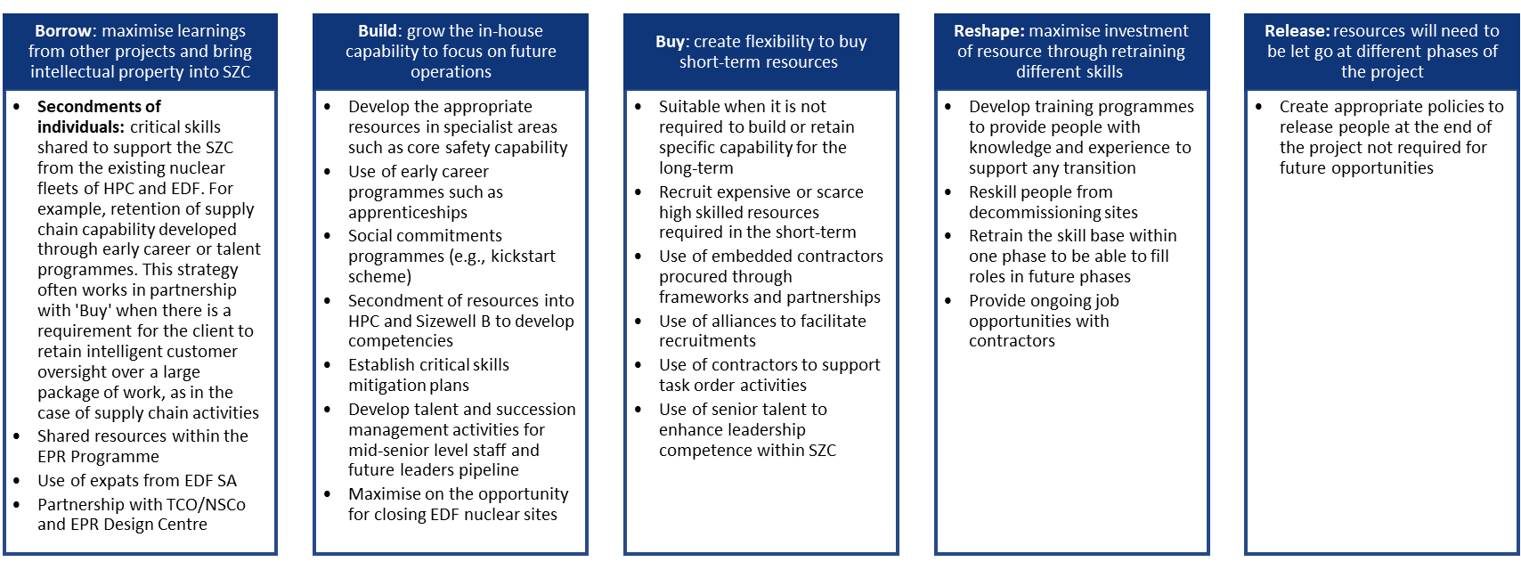
- To facilitate the framework, there is now a more collaborative approach between SZC Ltd and NNB GenCo (HPC) Ltd as represented in Figure 5.

Figure 5: Movement of people across Hinkley Point C and SZC
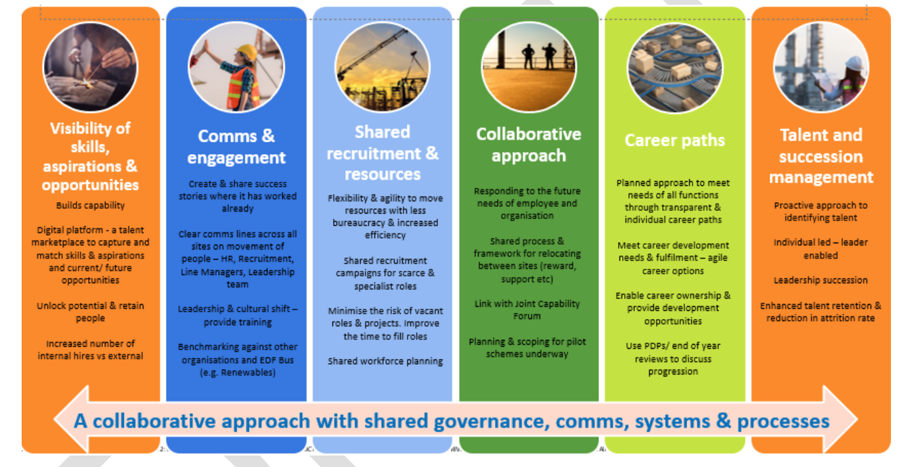
- Based on the evidence sampled, we consider SZC Ltd’s organisational development arrangements to be proportionately mature for the stage of the project, and meets the intent of LC36

Training, SQEP and Appointment
- SZC Ltd should have adequate human resources with the necessary competencies and knowledge to provide resilience and maintain the capability to govern, lead and manage safety at all times, in line with LC10 and LC12.
- Following the NSL assessment in 2022, SZC Ltd sent a commitments letter to ONR, dated March 2022 (Ref. 3). It included two specific commitments relating to competency and training, which are set out below.
- The first commitment was to provide a single point of executive accountability for the competency and training of the organisation. Consequently, SZC Ltd transferred these accountabilities via the Management of Change process in May 2022, from the Safety, Security and Assurance Director to the HR Director, and by virtue, the ownership of the associated Licence Conditions 10 and 12.
- The second commitment was to fully demonstrate the adequacy of the competency compliance arrangements, and validate the master common competency matrix, the NB role profiles and the competency of role holders, and to have plans in place to address any shortfalls.
- In response to the second commitment, the common competency project was established between SZC Ltd and NNB GenCo (HPC) in July 2022 and the following actions were taken:
- Role owners revised the Master Competency Matrix, and it was reviewed and approved by the Joint Role and Oversight Forum (created as part of the common competency project).
- Following the review of the Master Competency Matrix, a number of in use role training profiles were updated.
- In May 2023 role holders were reassessed against any changes to their roles they held, with any additional training requirements identified. The Nuclear Skills Alliance (NSA) and the Joint Role and Oversight Forum provided oversight for completion of the competency gaps by December 2023.
- A targeted level 4 engagement was held in October 2023 to seek assurance in the ongoing development of SZC Ltd’s competency arrangements, and the status of the commitments since the original licensing assessment in 2022. The outcome of the engagement is captured in a dedicated Contact Record (Ref. 21).
- The work undertaken by SZC Ltd since the initial assessment was recognised, including the work to close the commitments. Examples of the work undertaken included the appointment of a SZC Ltd Training Lead, which enabled a training strategy to be put in place and development of a training plan to underpin it.
- In addition, the governance arrangements have further matured with the Curriculum Review Forum (CRF) and the Training Forum now stood up.
- However, there were also a number of areas for improvement identified, relating to: the need for a periodic review of post holder competency, a review of the local governance arrangements and a forward training strategy, which resulted in three Regulatory Issues being raised to secure the necessary improvements.
- These Regulatory Issues (RI-11725, RI-11726 and RI-11727) have since been satisfactorily addressed by SZC Ltd and have now been closed.
- In addition, in February 2024 SZC Ltd provided ONR with a written response to the original March 2022 commitments letter (Ref. 3) setting out how SZC Ltd has addressed the commitments and its evidence for closure (Ref. 4). We are satisfied that this also provided a clear route to how the commitments regarding training had been addressed.
- Based on the progress that has been observed, the closure of the Regulatory Issues and the response to the commitments letter, we consider SZC Ltd’s training arrangements are proportionately developed for the current stage of the SZC project, and the intent of LC10 and LC12 has been met

Intelligent Customer (IC)
- SZC Ltd needs sufficient suitably qualified and experienced personnel (SQEP) intelligent customer resource and management arrangements as set out in NS-TAST-GD-049 – Issue 7.1. For those activities currently being undertaken and those planned post FID, SZC Ltd should specify, oversee and accept products or services undertaken by contractors on their behalf.
- Since the original licensing assessment in 2022, SZC Ltd has matured its organisation and arrangements, and it was considered appropriate to seek confidence in the ongoing development of SZC Ltd’s IC capability, and a targeted level 4 engagement was held in November 2023. The outcome of the engagement is captured in a Contact Record (Ref. 22).
- Progress has been made in strengthening the governance arrangements with the setting up of the Intelligent Customer Oversight Group (ICOG), to provide IC leadership and engagement across the project. In addition, an IC Working Group has been established to provide support to the IC community and to share learning and good practices, as well as provide support and advice. In addition, the SZC Ltd Board members are briefed on IC as part of their assigned board role training profile. We determined that these are potential areas of good practice to be shared.
- Training is another area where significant progress has been made. In 2022, SZC Ltd was training IC practitioners using the NNB GenCo training course, which was suitable for SZC Ltd at the time. This training course has since been revised for use by SZC Ltd, NNB GenCo and EDF Nuclear Operations, with SZC Ltd specific scenarios included as part of the training solution, while maintaining the benefits of sharing learning.
- In addition, SZC Ltd in conjunction with NNB GenCo and EDF Nuclear Operations, have developed common IC guidance in order to promote greater consistency in the application of their IC management arrangements.
- However, there were two areas for improvement identified relating to the need for the IC guidance to be incorporated in the arrangements and the targeting of IC training, which resulted in two Regulatory Issues being raised to secure timely improvements. These Regulatory Issues (RI-11761 and RI-11762) have since been satisfactorily addressed by SZC Ltd and have been closed.
- Based on the progress that has been made and the closure of the Regulatory Issues we consider SZC Ltd’s intelligent customer arrangements are proportionately developed for the current stage of the SZC project.

Design Authority (DA)
- During ONR’s initial NSL assessment, ONR reviewed and assessed the resourcing within the DA, the external resources supporting the DA and SZC Ltd’s forward strategy.
- The DA is a defined function within the prospective licensee. The organisational structure is comparable with Hinkley Point C (HPC), and the lines of reporting to the Technical Director are clear. Since the assessment in 2022, SZC Ltd has conducted an analysis of the work required to inform key design activities and the DA organisational structure, which is incorporated in a forward strategy. This activity has led to the addition of specific SQEP civil engineering and hazards resource, in relation to flooding.
- As part of our reassessment, the responsibility of the DA to approve or reject proposed design changes and concessions was reviewed, as per the expectations of NS-TAST-GD-079 – Issue 6.1. As a result, we concur with our original view, that SZC Ltd has made and implemented adequate arrangements for compliance with the requirements of Licence Condition 20, which controls the implementation of design changes during construction.
- ONR also reassessed the DA’s resource, capability and management processes. Since our assessment in 2022 the resource has increased in line with the resource plan, with a number of key posts being filled, including Head of DA, Safety Case Branch Manager and Maintain Design Integrity (MDI) Branch Manager.
- In technical areas such as internal and external hazards we have gained assurance, via routine technical engagements, that the DA is effectively being managed and demonstrates a clear understanding of these key technical areas.
- Overall SZC Ltd’s DA has applied a strategic approach to the development of its capability and taken a proportionate approach to the development of its arrangements. This will be an area of focus for future regulatory engagements.

Quality including Management Systems
- Following the initial NSL assessment in 2022, SZC Ltd encountered a number of resourcing issues within the quality function, which impacted on the delivery of planned activities. Given the risks associated with not effectively developing and deploying management arrangements, it was considered appropriate to sample the overall resourcing and delivery of the quality function as part of the proportionate reassessment.
- During routine interactions, the impact of the resourcing issues became apparent. Therefore, two Regulatory Issues (RI-11626 and RI-11627) were raised relating to shortfalls in the status and maturity of the Integrated Management System (IMS) contents, and the resourcing and delivery of the IMS Audit Programme.
- Targeted level 4 engagements as part of the reassessment (Refs. 23 and 24) were undertaken to seek assurance that SZC Ltd has established, implemented, and is maintaining management systems which give due priority to safety, and contain adequate quality management arrangements in respect of all matters which may affect safety. In addition, these engagements also provided assurance on the adequacy of its resources, in particular the nuclear baseline.
- During these interactions, SZC Ltd was able to demonstrate sufficient progress has been made to enable closure of the Regulatory Issues. Moreover, we were also able to gain confidence in the ongoing development of the management system, relevant quality management arrangements and resourcing of the quality function. Nevertheless, there were a number of areas where we consider that SZC Ltd needs to continue to develop its organisational arrangements as the project progresses.
- Based on these interactions, we consider SZC Ltd’s quality arrangements are proportionately developed for the current stage of the SZC project and meet the intent of LC6 and LC17. The future development of the arrangements will be an area of focus in future regulatory engagements.

Conclusions and Recommendations

Conclusions
- This report presents the proportionate reassessment of the organisational capability area of SZC Ltd’s application for a nuclear site licence.
- The commitments made by SZC Ltd to address the organisational capability shortfalls identified within the original licensing assessment (Ref. 3), have been adequately addressed (Ref. 4), specifically:
- the shortfall in the SHA has been addressed through the iSHA.
- governance arrangements which are proportionate to the activities being undertaken are in place; and
- the people and competency arrangements for the project have been implemented.
- SZC Ltd’s License Condition compliance arrangements are sufficiently developed for the activities being undertaken at this stage of the project, namely LC 6, 10, 12, 17 and 36.
- SZC Ltd has applied a strategic approach to inform the development of its DA and arrangements.
- SZC Ltd’s quality arrangements and resources are adequately developed.
- SZC Ltd has satisfactorily addressed all Regulatory Issues raised during the reassessment, resulting in areas of improvement which will be followed up through normal regulatory engagement.
- The overall conclusion, therefore, is that from an organisational capability perspective SZC Ltd is ready to be granted a nuclear site licence for the proposed development at Sizewell C.

Recommendations
- Based on the proportionate reassessment of the organisational capability area we recommend that a licence is granted to SZC Ltd to permit the construction and operation of a twin EPR™ power station at Sizewell C.

References
- ONR, Licensing Nuclear Installations, November 2021. (https://www.onr.org.uk/licensing-nuclear-installations.pdf)
- ONR, Security of Tenure proportionate reassessment of an application by Sizewell C Limited (SZC Ltd) for a Nuclear Site Licence, Revision 0. April 2024.
- Sizewell C, ONR-SZC-21672N, Governance and Arrangements Commitments Letter from SZC to ONR. 24 March 2022. (2022/19719)
- Sizewell C, ONR-SZC-21773N, Governance and Arrangements Update Letter from SZC to ONR. 08 February 2024. (2024/6709)
- ONR, Safety Assessment Principles for Nuclear Facilities - 2014 Edition, Revision 1. January 2020. (www.onr.org.uk/saps/saps2014.pdf)
- ONR, Permissioning inspection – Technical Assessment Guides, February 2024. (https://www.onr.org.uk/operational/tech_asst_guides/index.htm)
- Sizewell C, 100200192, SZC Company manual, Revision 6. January 2024. (2024/0006976)
- Sizewell C, 100200200, Nuclear Baseline: Sizewell C Pre-Construction. 30 June 2020. (2020/263797)
- ONR, Sizewell C: ONR strategy up to licensing decision. July 2023. (2023/39194)
- ONR, Sizewell C new build project: ONR strategy up to licence grant, Revision 3. January 2022. (2021/91337)
- ONR, Sizewell C Licensing: Assessment Plan 2023/24. August 2023. (2023/41936)
- ONR, ONR-NR-CR-23-508, Sizewell C Ltd – Leadership & Governance targeted Level 4. November 2023. (2024/1809)
- ONR, ONR-NR-CR-22-508, SZC - Governance Workstream L4. February 2023. (2023/14791)
- ONR, ONR-NR-CR-23-601, Sizewell C – OC4 Governance workstream – Level 4 Meeting- Phase 2. February 2024. (2024/8079)
- Sizewell C, ONR-SZC-21762N, Board Skills Mapping Exercise Letter from SZC to ONR. 22nd December 2023. (2024/4825)
- ONR, ONR-NR-CR-23-599, Sizewell C Ltd – Leadership & Governance targeted Level 4. January 2024. (2024/8062)
- Sizewell C, ONR-SZC-21774N, People Transfer Commitment Letter to ONR. 14 February 2024. (2024/7357)
- ONR, ONR-NR-CR-23-470, Sizewell C - Nuclear Services capability provision into the Licensees inspection. November 2023. (2023/65668)
- ONR, ONR-NR-CR-23-479, Inspection of collaboration and shared services arrangements between HPC and SZC (the EPR Programme), following their post implementation review of phase 1. January 2024. (2024/1701)
- ONR, ONR-NR-CR-23-545, SZC - Sizewell C - OC3 Organisational Development – focused Level 4 Meeting for proportionate NSL reassessment. January 2024. (2024/4559)
- ONR, ONR-NR-CR-23-353, SZC - focused L4 for OC9 workstream - proportionate reassessment for NSL. October 2023. (2023/55994)
- ONR, ONR-NR-CR-23-381, Sizewell C (SZC) – OC2 Intelligent Customer workstream – Focused Level 4 Meeting for proportionate NSL reassessment. November 2023. (2023/58119)
- ONR, ONR-NR-CR-23-487, ONR / NNB GenCo (SZC) - OC5 L4 Meeting - Quality Management. November 2023. (2024/279)
- ONR, ONR-NR-CR-23-622, SZC OC5 Targeted Level 4 Meeting. February 2024. (2024/9510)

Appendices

Appendix 1: ONR licensing assessment 2020-22
ONR assessment reports available at www.onr.org.uk/civil-nuclear-reactors/sizewell-c/assessment-reports.htm
- Electrical engineering assessment - ONR-NR-AR-21-001
- Mechanical engineering assessment - ONR-NR-AR-21-003
- External hazards assessment - ONR-NR-AR-21-005
- Civil engineering assessment - ONR-NR-AR-21-006
- Nuclear site health and safety/life fire safety assessment - ONR-NR-AR-21-007
- Assessment of the safety case delivery strategy - ONR-NR-AR-21-008
- Site activities and licence compliance - ONR-NR-AR-21-009
- Organisational capability assessment - ONR-NR-AR-21-010
- Licensing and legal assessment - ONR-NR-AR-21-011
- Internal hazards assessment - ONR-NR-AR-21-035
- Management of nuclear matter and liabilities - ONR-NR-AR-21-037
- Security arrangements assessment - ONR-CNSS-AN-22-002

NNB Holding Company (SZC) Ltd now known as Sizewell C (Holding) Ltd.
At the time of the Targeted L4 Engagement (Ref. 12), the Nominations & Remuneration Committee was not in place.
The ‘Holding Company’ provides the enduring vehicle for investors to join the project and maintain assurances in their investments, without being directly involved with the delivery of the project or being held to account for the associated legal obligations of a nuclear site licence company.

