Compound Hazards Events
Exploring their influence on flood protection and risk
Research Review
Briefing Paper prepared for the Office for Nuclear Regulation under contract ONR-RRR-115
September 2024
Sayers, P.B


Report information
Report Title: Compound events: Exploring the effects of temporal sequencing on flood protection assets
Project Number: ONR-RRR-115 and SPL Project No. P1167
Date started: May 2022
Contractor: Sayers and Partners LLP
Address: 24a High Street, Watlington, OX49 5PY UK,
Contact: Phone: +44 1865 600039
Website: www.sayersandpartners.co.uk
Lead Author: Paul Sayers
Phone(s): +44 1865 600039, +44 7711 798786
E-mail(s): paul.sayers@sayersandpartners.co.uk
Usage: Distribution to ONR and open publication via ONR website
Citation suggestion:
Sayers (2024). Compound hazard events: Exploring their influence on flood protection and risk. The useful comments and contributions from Alan Gadian, Stephan Harrison, Ivan Haigh, and Vance Tan as well as the comments received from Aidan Parkers and the ONR team are gratefully acknowledged.
Approval for release to client:
Name | Position | Project Role
Paul Sayers
Client contacts:
Name | Organisation and contact
Aidan Parkes | ONR
Document revision history:
Version | Date | Author(s) | Description
Draft v1.0 | May 2022 | As above | Draft Review Report for internal review
Draft v1.2 | 26 May 2022 | As above | Draft for internal review
Draft v2.0 | 27 May 2022 | As above | Draft for ONR review
Final draft | 23 January 2023 | As above | For further review
Review comments | August 2024 | As above
Final Issued | 11 September 2024 | As above | For publication

ABSTRACT
Weather and climate display considerable natural variability. This variability influences the frequency of flooding on intra-annual, inter-annual and multi-decadal time scales. Natural variability in wave, storm surge, and rainfall respond to stochastic (random) processes as well as seasonal and longer period changes associated with regional climate drivers (e.g., the quasi-decadal cycle of the North Atlantic Oscillation). Climate change is influencing these processes.
Seeking to describe this complexity through the lens of a single storm is increasingly recognised as too simplistic and may not provide the critical design case. Significant advances have been made, and continued to be made, in assessing various aspects of compound events, including multiple hazards occurring concurrently at a site, single or multiple hazards occurring at different locations at the same time, or in succession. Such compound events can lead to more significant impacts than would occur based on consideration of a single hazard. Our understanding of at-site multivariate extremes and spatially compounding events has advanced significantly in recent years, but the potential for, and impact of, temporally compounding events remains less studied (in research and practice).
This Research Briefing presents an overview of the different types of compound hazards events with an emphasis on temporally compounding events. This reflects the gap in knowledge surrounding the potential importance of temporally compounding events is a ‘live issue’ for various infrastructure providers and presents a significant challenge to existing design and assessment approaches. This is likely to be of particular importance in the context of a dynamic coast setting, where morphological change and infrastucture deterioration during one storm can materially influence the impact of a subsequent storm (as witnessed in the collapse of the sea wall in Dawlish in 2014).
The findings suggest a review the current approach to determining the design basis. The findings highlight that the current focus on single extreme events (albeit consisting of a single or multiple variant hazard) is necessary but may not be sufficient to provide a robust safe case. A broader understanding of an ‘event’ within design process is encouraged that accepts that a ‘single design storm’ however extreme may not be the most appropriate design case. Such an approach should focus on the outcome performance (defined in functional terms) rather than input loads. This will enable the move away from an a priori assumption that single occurrences of a high magnitude load (consisting of either a single or multivariate hazard) are most important (for which classical extreme value theory would be relevant) towards consideration of sequences (uncorrelated) or clusters (correlated) of storms in which individual occurrences may not be particularly large, but nonetheless pose the most significant safety risk.
Keywords: flood, risk, climate change, design basis event, storm sequences, clusters, temporally compounding events

Table of contents
1.0 INTRODUCTION 6
1.1 Background 6
1.2 Objectives of the review 6
1.3 Structure of the review 6
2.0 RESEARCH METHOD 7
2.1 Population (the subject of study) 7
2.2 Intervention (eligibility for inclusion) 7
2.3 Comparator (the counterfactual) 8
2.4 Outcome (evidence of impact) 8
2.5 Risk of bias 8
3.0 COMPOUND EVENTS – DRIVERS AND ASSESSMENT APPROACHES 9
3.1 At-site - Multivariate single events 10
3.2 Multi-site - Spatially compounding events 11
3.3 Clusters and sequences - Temporally compounding events 15
4.0 INFLUENCE OF INFRASTRUCTURE DESIGN AND PERFORMANCE 18
4.1.1 Infrastructure interdependencies 18
4.1.2 Influence of temporal sequencing on individual asset reliability 19
4.1.3 Influence on maintenance and repair windows 22
4.1.4 Inclusion (or lack of inclusion) of the subtle influences of climate change 22
5.0 CONCLUSIONS 23
6.0 REFERENCES 24

LIST OF TABLES
Table 3-1 Typology of compound events 9

LIST OF ILLUSTRATIONS
Figure 3-1 Determination of the peak overtopping rate response given joint probability of extreme sea levels and significant wave heights 11
Figure 3-2 Examples of spatially coherent events as developed for the 2017 National Risk Assessment 13
Figure 3-3 The correlation between two locations within a spatial event 13
Figure 3-4 The distribution of flood footprints associated with present and future spatial events 14
Figure 3-5 Example events yielding an equivalent 1-in-10 year damage year for the baseline period. Return period of flood flows shown in years. 15
Figure 3-6 Proportion of events split by season for each method 18
Figure 3-7 A series of storms lead to the eventual collapse of the sea wall, Dawlish 18
Figure 4-1 Infrastructure networks are vulnerable to temporal and spatially compounding impacts of flooding 20
Figure 4-2 Snap-shot reliability analysis can failure to capture to temporally compounding influence of multiple storms 21
Figure 4-3 The effect of storm clusters on a Narrabeen Beach Australia 22
Figure 4-4 Observations of beach profile response sensitivity to storm sequences 22
Figure 4-5 Sequences of storm can erode foreshores exposing and undermining structural foundation 23
Figure 4-6 West Bay - East Beach. The beach volume varies in response to storm sequences and single events 23

INTRODUCTION

Background
Extreme weather combinations that occur concurrently at a site, across multiple sites at the same time, or in succession can lead to more significant impacts than would occur based on consideration of a single hazard. The methods used to explore at-site combinations and the impact of spatial coherence have significantly advanced in recent years and continue to do so. A focus on understanding extreme weather as a single event or response (a peak overtopping rate given the joint probability of waves and surges), however, continues to underpin design approaches. As a result, there are few studies that assess the influence of a series of events (that interact in time) even though there is strong evidence that these can be important. For example, a moderate storm may weaken defences or lower beach levels that then exacerbate the impact of a subsequent storm.
The report for ONR on Extremes Weather Events in the UK (ONR, 2021) identified storm sequences and clustering as one of several ‘live issues’ that may require ONR to have a clear perspective. This Research Briefing follows on from this to present different types of compound event before exploring in more detail how temporally sequenced events may influence the performance of flood protection infrastructure, and by extension, their design.

Objectives of the review
The review seeks to:
- Identify the meteorological evidence for storms clusters and sequences today and in a future climate.
- Examine the influence of temporal clusters and sequences on the performance of flood protection assets.
- To provide a high-level synthesis of the theories, concepts, and methods in use, or emerging, to enable the representation of the clusters and sequences within safety critical design.

Structure of the review
The research review is structured as follows:
- Chapter 2 – Research method: Sets out research method.
- Chapter 3 – Compound events – Drivers and assessment methods: Explores the definition of a compound event and the approaches to assessment methods typically applied (where they exist).
- Chapter 4 – Influence on infrastructure design and assessment: Explores potential inadequacies in existing design approaches and the evidence for the influence of compound events on infrastructure performance.
- Chapter 5 – Considerations: Provides suggestions for next steps.

RESEARCH METHOD
To provide a rapid, but structured, assessment of the evidence two approaches are drawn upon:
- the ‘rapid review assessment’ approach set out by Tricco et al., 2015; and
- the ‘rapid systemic evidence review’ set out by Collins et al., 2015.
These approaches have been tailored here using the PICO (Population, Intervention, Comparator, Outcome) framework of Collins et al., 2015 to help the identification and assessment of the peer-reviewed and grey literature and support the presentation of an expert-driven evidence review presented in Chapters 3 and 4 and the conclusions presented in Chapter 5. A more formal evidence assessment (including database recording of screened abstracts) is not included as part of the review.

Population (the subject of study)
The focus here is on temporally compounding events, and how extreme storm sequences and clusters influence on infrastructure performance and design. This is further refined to focus on their influence on flood protection infrastructure, including engineered structures such as embankments, or natural defences such as dunes (Sayers et al., 2021; Temmerman et al., 2013).

Intervention (eligibility for inclusion)
To be considered for inclusion in the review, three primary considerations are applied from the grey and peer-reviewed literature:
- Reports must be written in English.
- Explicitly address issues of performance or deterioration and their relationship to temporal clusters or sequences of storms.
- The focus of the discussion includes, or is related to, the performance under extreme conditions and flood protection assets. Literature outside of these domains (for example the dams or rail sectors) is included where known to the authors as relevant.
To support the search of peer-review publications, broad search terms are used to capture the documents for review as suggested by White and Roth (2009), cited in Athukorala et al., (2014). Appropriate word truncation and spelling variations of key terms is considered through wild card searches. The search was completed using the following academic databases:
- Scopus (Elsevier B.V. 2022)
- Web of Science (Clarivate 2022)
- ProQuest Dissertations and Theses Global (ProQuest 2022)
Although the method of search necessarily varies according to requirements of the individual databases, the same basic operators where used, as follows:
- Filter: records in the English language only.
- Limit: search within the title, abstract and keywords only.
- Search string(s): (TITLE-ABS-KEY ((flood* AND asset) OR (flood* AND defenc*) OR (flood* AND ”rail embankmen*”) OR (flood* AND ”rail* embankment*”) OR (flood* AND highway*)) AND TITLE-ABS-KEY (reliabilit* OR fragilit* OR performanc* OR deteriorati* OR sequenc* OR cluster* OR optim* OR investmen* OR (construct* AND cost) OR (maint* AND cost*) OR (temporal AND correlat*)))
A standalone search of the term ‘compound events’ and ‘compound hazards’ was also used to capture the not asset related literature, more climate focused, literature.
Grey literature provides an important contribution to all reviews (Paez 2017), and this is the particularly the case here given the importance of the interface with performance and design. In recognition of this, we produced an unstructured review of selected grey (based on expert knowledge) sources, including the following websites:
- Asian Development Bank – https://www.adb.org/publications
- Defra – https://www.gov.uk/search/research-and-statistics
- Environment Agency – https://www.gov.uk/search/research-and-statistics
- European Environment Agency – https://www.eea.europa.eu/publications
- Federal Emergency Management Agency – https: //www.fema.gov/emergency-managers/risk-management/building-science/publications
- OpenGrey – https://doi.org/10.17026/dans-xtf-47w5
- The World Bank – https://documents.worldbank.org/en/publication/documents-reports
Searches were performed from 25 January 2022 to 2 February 2022.

Comparator (the counterfactual)
Throughout the review, existing approaches to extreme value analysis (including single and multiple variant approaches to definition of independent extreme events) and design (based on single design storms) are used to provide a comparator to understand the potential importance of adopting an assessment approach that incorporates issues of temporal compound events.

Outcome (evidence of impact)
The central outcome focuses on the following: should temporally compounding events (such as sequences and clusters) be considered in the assessment of coastal hazards and the design of the associated protection infrastructure, and if so, what further activities might be needed to make progress. The response is provided in the form of a narrative synthesis guided by the need to:
- provide an informed background to the issues (including the different types of compound events and their assessment).
- establish the level of scientific consensus and provide an informed view on the impact on ONR operations.
- highlight where uncertainties lie; and
- identify areas where further research would be useful.

Risk of bias
Given the initial nature of this review we rely upon our knowledge of the subject area and ongoing activities as well as the results of searches. This evidence presented can only be a subset of the available evidence and may present some reporting bias (inevitable in any review, e.g., Liberati et al., 2009). The potential for bias is mitigated through expertise of the authors and internal review of the draft findings by other members of the Expert Panel and final review by ONR themselves.

COMPOUND EVENTS – DRIVERS AND ASSESSMENT APPROACHES
Extreme weather events take various forms, occasionally acting independently but more often in combination. The in-combination influence is a central consideration within the definition of a ‘compound event’. Zscheischler et al., (2018) seeks to provide a more detailed description and defines a compound event as ‘the combination of multiple drivers and/or hazards that contributes to societal or environmental risk’ and goes on to present a ‘typology of compound events’ (Table 3-1, Zscheischler et al., 2020). These definitions are reused by the IPCC WG II (IPCC, 2022) and are built upon here alongside previous papers (e.g., Sayers et al., 2014) as discussed below.
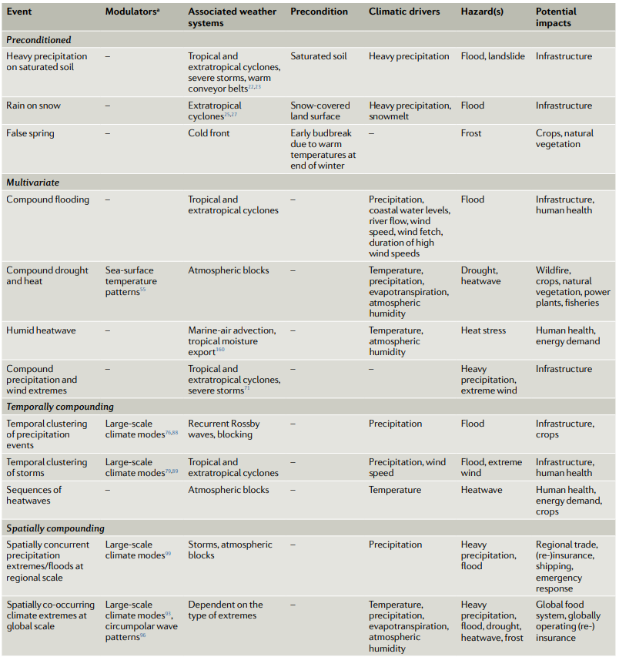
Table 3-1 Typology of compound events
Source: Zscheischler et al., 2020

At-site - Multivariate single events

Overview
How likely is it that a given location (or structure) will be exposed to multiple hazards simultaneously?
A multivariate event occurs when two or more hazards combine at a single location, and at the same time, generate a multi-hazard event. For instance, low pressure cyclonic atmospheric systems are likely to produce high rainfall and consequently high-river discharge, at the same time as producing storm surges (and waves) that can slow or block river discharge into the sea and cause inland flooding (Horsburgh et al., 2020). Multivariate events are commonly studied in the case of flooding using joint probability methods as discussed below.

Assessment method
The importance of the joint probability between two or more variables (e.g., intense rainfall and surge, waves and surge etc.) is widely recognized and has been, and continues to be, the subject of research (e.g., Hawkes et al., 2002; Wadsworth et al., 2017; Gouldby et al., 2017; Hames et al., 2019; Murphy-Barltrop et al., 2023). A joint probability assessment enables a single marginal response distribution (e.g., overtopping volume) to be determined based on the dependence in the univariate extreme values of two (or more) variables. In doing so, an extreme ‘event’ is typically defined as a peak of the event exceeding some threshold within a defined window of time (a single tide or a few hours or days). Typical joint events include consideration of coastal surge and intense rainfall (e.g., as associated with typhoon), wind and waves (as experienced during the Katrina Hurricane, 2005), earthquake loading and tsunami wave loading (e.g., as experienced by sea defences along the coast of Japan, 2011).
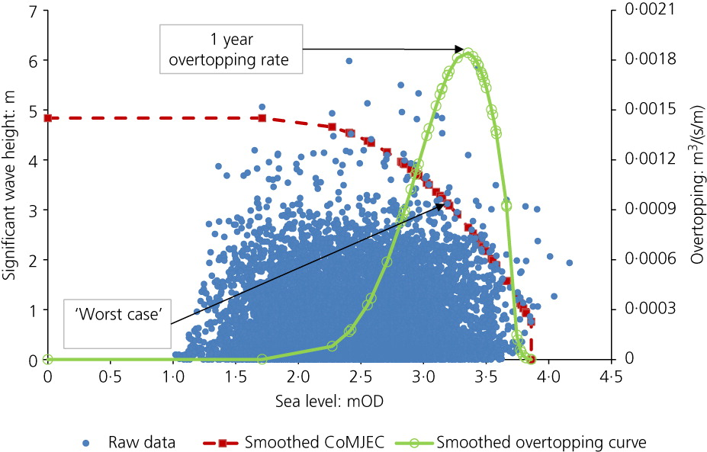
Note: The axis units are significant wave height (Hs) in metres and overtopping rate in m³ per second per metre run of defence crest. Source: Hames et al., 2019
Figure 3-1 Determination of the peak overtopping rate response given joint probability of extreme sea levels and significant wave heights

Live issues
Although a well-established concept (and widely used by the Environment Agency to support coastal risk assessments, e.g., Gouldby et al., 2017), bivariate and multivariant joint probability approaches continue to be developed and improved, particularly with a view to improving the understanding of the tail of the joint distribution (e.g., Murphy-Barltrop, 2023) and how these relationships may change with climate change (e.g. Bevacqua et al., 2019 explores future climate projections and shows an increasing probability of compound events along much of the northern European coast). These on-going efforts reflect the acknowledged importance of joint probability in existing design approaches. Implicit within these approaches, however, is that ‘compound’ refers to the compounding influence of multiple hazards occurring at the ‘same time’, and not the temporal sequence of those events or their spatial interaction. Therefore, when used alone such approaches do not tend to capture these broader (and potentially critical) aspects.

Multi-site - Spatially compounding events

Overview
How widespread is a single event likely to be? How might impacts be exacerbated by the inter-connectiveness of impacts?
Spatially coherent events occur when multiple connected locations are affected by the same hazard (e.g. a flood) or different hazards (e.g. a flood in one location and wind in another) within a limited time window. Spatially compounding events occur when spatial inter-connectiveness (either through geography, supply chains or infrastructure networks) exacerbates the impacts beyond those that would be anticipated based on an isolated site analysis. Flood hazards are both spatially coherent and have the potential to drive spatially compounding impacts.
Some hazard events can have a very large spatial footprint (as in the floods in Pakistan, 2010, or the 1953 North Sea surge) but some can be highly localized (associated with a convective storm, such as experienced in Boscastle, 2004). Some very rare widespread events have reshaped the shoreline and nearshore morphology are evident in the historical record. In 1099 (November), for example, a major North Sea storm impacted much of the North Sea coast, leading to, so reports suggest, the formation of the Goodwin Sands. In 1607 a storm surge impacted much of the south-west through the Bristol Channel (with an estimated a return period in the range of 500 to 1,000 years in a preindustrial climate, RMS (2007)).

Assessment methods
As defined above spatially coherent events impact multiple locations ‘at the same time’. In the context of flooding this does not necessarily mean at the same precise time but is typically defined in the context of a ‘time window’. As part of the 2017 National Risk Register (Cabinet Office, 2017), ‘simultaneous’ was defined using a time window of up to 7 days (Figure 3-2). Other studies have questioned the appropriateness of this window, motivated by, for example, De Luca et al., 2017 which found a window of 16 days was needed to capture the largest floods historically. At the coast, a single tide or a period of three tides is often used to define the same ‘event’.
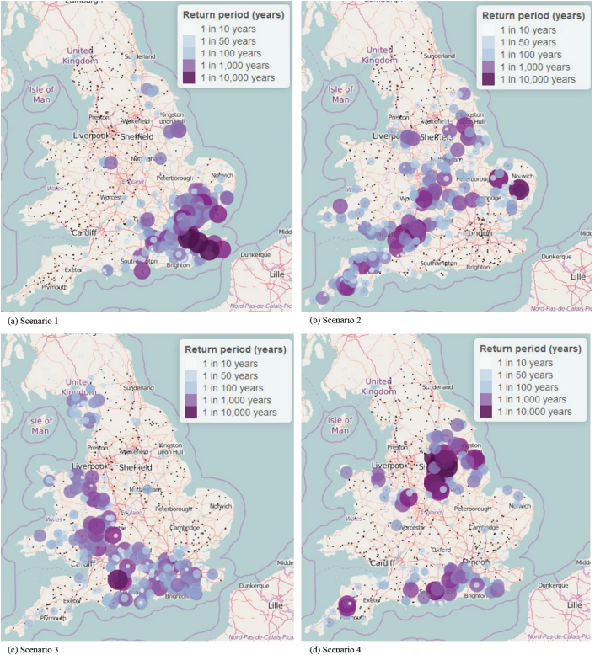
Top left: Widespread event scenario 1. Top right: Widespread event scenario 2. Bottom left: Widespread event scenario 3. Bottom right: Widespread event scenario 4. In all the size of the discs represent local return period of flows at river gauging stations. Source: Wood et al., 2017
Figure 3-2 Examples of spatially coherent fluvial events as developed for the 2017 National Risk Assessment
Methods exist to develop spatial flood events based on extending an observational record (e.g., Heffernan and Tawn, 2004; Wyncoll and Gouldby., 2015; Wyncoll et al., 2016, Tawn et al., 2018). The analysis proceeds by fitting a distribution at Location B conditional on the flow at A being above a threshold and being the most extreme value within the domain (the conditional distribution) - Figure 3-3. New events are then typically generated by:
- Selecting a location within the domain, Y₁, as the most extreme flow for this event.
- Use the marginal distribution at Y₁ to determine the flows that exceed the sampled threshold.
- Use conditional distribution to determine the flow at Y₂ conditional on the flow at Y₁.
- Flows at Y₁ and Y₂ provide a new unseen event (red dots in the figure).
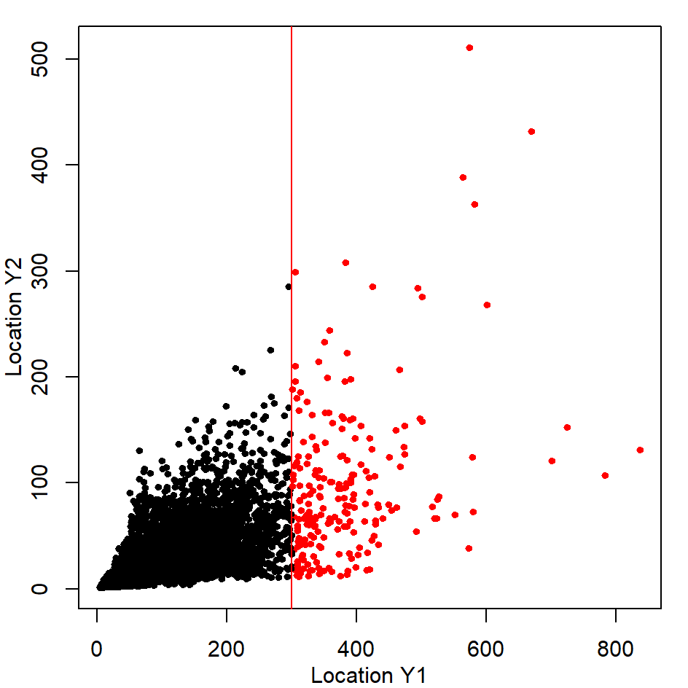Source: Griffin et al., 2022
Figure 3-3 The correlation between two locations within a spatial event
The analysis by Griffin et al explores the changing spatial structure of widespread flood events across Great Britain by extending the ‘observed’ record within the UKCP18 climate model outputs. This indicates the structure of such events is changing (Figure 3-4).
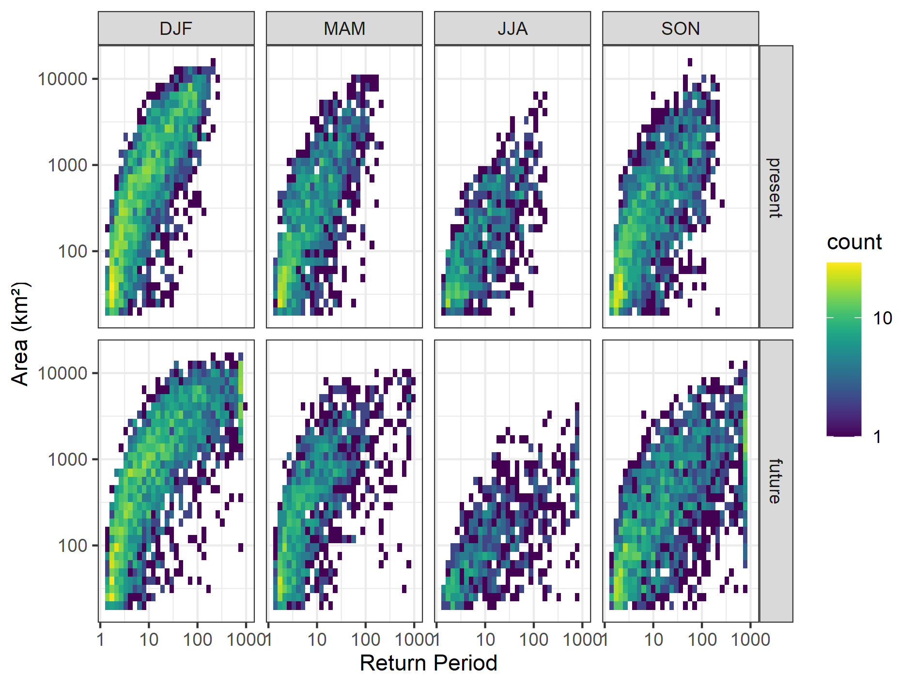
Top row: Present day climate – by season. Bottom row: Future climate (RCP8.5 – UKCP18) - by season
Source: Griffin et al., 2022
Figure 3-4 The distribution of flood footprints associated with present and future spatial events
This analysis has been used to provide an assessment of fluvial events across the Great Britain (Figure 3-5). The results suggest a failure to account for the changing spatial structure of the climate can lead to significant underestimates of future fluvial risk (Sayers et al., 2023, submitted).

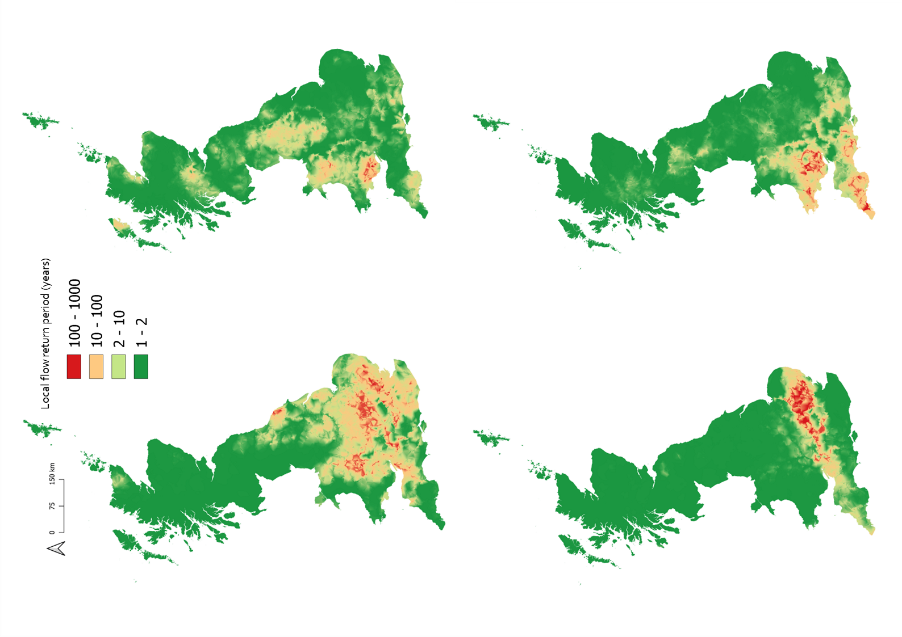
Top left: Widespread event – Example 1. Top right: Widespread event – Example 2. Bottom left: W Widespread event – Example 3. Bottom right: Widespread event – Example 1. Each figure represents one example event yielding a 1-10 year damage at the national scale. The return period of flood flows varies within each event as shown in years. Source: Sayers et al., 2023
Figure 3-5 Example events yielding an equivalent 1-in-10-year damage year for the baseline period.

Live issues
Today, the understanding of a ‘spatial event’ is commonplace within the insurance and financial sectors’ approach to understanding their exposure to flooding, but public sector understanding of risk and engineering design often ignores spatial correlations despite research on present day widespread events (e.g., Environment Agency, 2011, Wood et al., 2017; Wyncoll et al., 2017; Sayers et al., 2023). This is despite early warnings from the Foresight Future Flooding studies (in 2004) that highlighted the importance of spatial events and their potential to ‘lead to widespread and serious consequences’ (Evans et al., 2004) and the need for ‘proactive and reactive measures ..to improve resilience of (infrastructure) network’ (ibid). This is however changing, for example, following the widespread flooding of 2007 and again in the 2014/15 flood, the National Flood Resilience Review (HM Government, 2016) highlighted the importance of better understanding and managing how impacts escalate when multiple locations are flooded at the same time and the how they cascade through connected networks (reaching beyond the direct footprint of the hazard).
As with the at-site analysis, the underlying statistical methods used to generate spatial event sets continue to be developed, including the influence of climate change and to better capture the tail of the distributions. In the case of spatial compounding events however, ‘compound’ refers to the compounding influence of a hazard (one or more) impacting multiple locations (or nodes within a network), and not the temporal sequence of those events. Therefore, although important it is not discussed further here.

Clusters and sequences - Temporally compounding events

Overview
How likely is it that a series of events will impact performance? Are certain temporal combinations of events more or less critical than a larger single events?
The temporal combinations of events have numerous features without yet a mature language to describe them. There is however a general notion that temporal combinations can either be (e.g., Sayers et al., 2015):
- Clusters – A single but prolonged storm (consisting of two or more peaks within a single defined event). In this case the peaks are strongly correlated. Temporal clustering has been studied extensively for some mechanisms, including for example extratropical and tropical cyclones (Villarini et al., 2010; Pinto et al., 2013). Temporal clustering of heavy-precipitation events on sub-seasonal timescales is also commonplace within the study of the driving hazards but not in the appraisal or design of infrastructure response (as discussed in the next section)
- Sequence – A series of definable storms, either over a season, a year or multiple years that may or may not be correlated (e.g. Jenkins et al., 2022), but may (or may not) be responding to large scale atmospheric features.
- In space – A cluster or sequence of storms that do not necessarily occur at the same location but impact the same infrastructure system.
The typology presented by Zscheischler et al., 2020 focuses on the concept of preceding weather events that ‘precondition’ the system in a way that may alter its response to a future event. For example, the antecedent conditions of a catchment will influence the volume of run-off during a rainfall event. ‘Preconditioning’ by persistent rainfall was an important driver in the occurrence of large river floods in Europe (e.g., Berghuijs et al., 2019) and the USA (Berghuijs et al., 2016). Persistent rainfall can be driven by various forms of atmospheric blocking. As part of a commentary of the Climate Change Risk Assessment 3 (CCRA3), Gadian (2021) highlights the importance of European anticyclone blocking structures in driving the extensive floods across Europe in 2021 and suggests that it is possible that such conditions become more frequent in future summers. Within conventional fluvial flood modelling preconditioning is commonly captured through continuous simulation methods, for example coupled hydrological, weather and climate models (such as the Grid-to-Grid model, Bell et al., 2009). Such approaches account for changing antecedent conditions but typically assume land use and morphology to be constant.
When the preceding events act to amplify the impact of a future event that can be considered ‘temporally compounding’. Zscheischler et al., 2020 highlights that the succession of storms can be of the same type (for example, multiple tropical cyclones (Villarini et al., 2010)), heat-waves (e.g. Baldwin et al., 2019, Hughes et al., 2019) or heavy-precipitation events (Kendon and McCarthy, 2015; Barton et al., 2016) or the consecutive occurrence of different hazards (for example, a period of flooding followed by a period of drought as in 2010-12 (Marsh and Parry, 2012), or a tropical cyclone, followed by a heatwave (Matthews et al., 2019)). The individual hazard events that form part of a temporally compounding event can be correlated through a common climate driver or simply occur by chance.
Temporally compounding events links closely to the issue of storminess, the frequency and persistence of extreme storms; a characteristic that is important today and may be influenced by climate change. At the coast, as Horsburgh et al. (ONR, 2022) notes, UKCP18 argues that water-level extremes for the UK during the 21st century would come primarily from the change in the mean sea level rather than any changes in storminess (although climate models tend not to capture storminess well, so perhaps this is unsurprising). Potential changes in intensity and/or frequency of storms and storminess during the winter is however raised as a concern within the UKCCRA3 as “major storms can cause widespread damage” and are one of the “important climatic impact drivers”, (Slingo 2021, page 30, as highlighted by Gadian, 2021). “Currently the evidence base for changes in storminess is weak, but beyond the mean climate there is a growing body of evidence for changes in frequency and/or intensity of high-impact weather events”. Gadian highlights that ‘future UK winter climate extremes will be determined by the behaviour of the North Atlantic Jet stream’, noting that there is evidence for substantial increases in daily rainfall and associated flooding, as well as a higher incidence of strong winds and high waves.

Assessment methods
In addition to those presented in the previous sections, there are approaches used, or starting to be used, that seek to consider the statistical dependence between the variables in both time and space (e.g., within the dam industry, Sayers et al., 2014). Continuous simulation modelling (CSM) has been used within academic studies and applied in practice for many years (e.g., Brought and Droop, 2003; Faulkner and Wass, 2005; Falter et al., 2015). Continuous simulation enables a boundary timeseries to be transformed into continuous series of a variable of interest (rainfall to river flow, say, or flood damage) from which distributional characteristics can be deducted. Various approaches exist to generate the driving conditions for the simulation or to extend an observed record to provide extreme series. These approaches often draw upon the experience of forecasting and include:
- Box-Jenkins - Box-Jenkins (originally developed by Box and Jenkins, 1970) is an approach to modelling time series for analysis and forecasting that can also be included here as a method of developing extreme series (e.g., Breini et al., 2014). It is based on the linear autoregressive, moving average (ARMA) model. This is a general model for time series that are correlated in time (known as auto-correlated).
- Copula functions - Copula functions have been used in environmental and water resources research (e.g., Salvadori et al., 2006, Grabbert et al., 2010), including modelling the temporal dependence within a storm sequence. Within the Met Office funded research (AquaCAT) coupled climate and hydrological model outputs are used as pseudo observation inputs to an empirical copula to highlight the changing spatial structure of future flood events and indicate changing temporal structure with more widespread events, particularly in winter and autumn (Griffin et al., 2022, Figure 3-6).
- Markov chains - The archetypal example of a temporal sequence is a Markov chain, in which the probability of each event depends only on the state attained in the previous event. A semi-Markov chain is created when the conditional probability distribution depends on other variables in addition to the previous values in the sequence. Initially used in forecast models they have increasingly been applied in weather generators in developing extreme sequences (Kilsby et al., 2007).
- Conditional exceedance model for spatial and temporal joint extremes: The approaches above extended to consider the dependence in time and space are starting to emerge in real examples. Motivated by statistical theory these offer more flexibility than fixed copula function in fitting complex extreme dependence structures known to exist in hydrological data (e.g., Simpson et al., 2021, 2023).
- Non-probabilistic and semi-probabilistic storyline approaches: Extreme sequences within the observed record are often limited in number. Storyline and Bayesian Belief methods offer opportunities to overcome this issue and consider the reimagining of past events, including or excluding expert weighted probabilities, to consider the range of sequences (e.g., a prolonged winter sequence of storms, or persistent storm directions) that may or may not include a single large event. The response of the infrastructure can then be assessed in that context (e.g., Zscheischler et al., 2018, Sheperd et al., 2018, Liu et al., 2018).
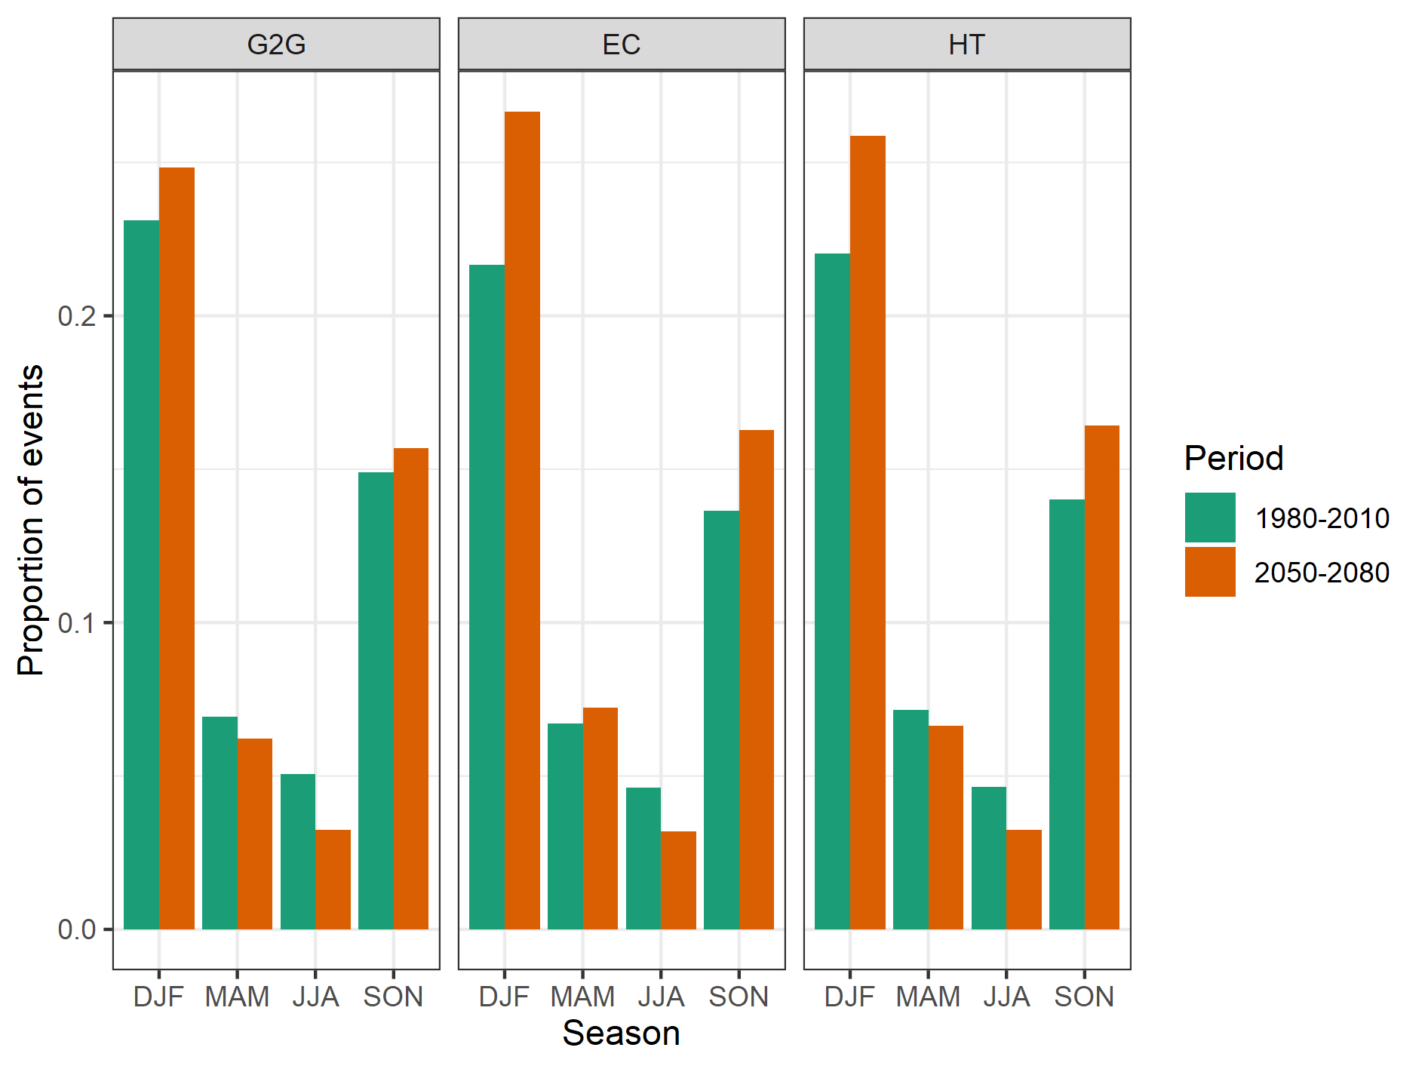
G2G – G2G-modelled events, EC – Empirical Copula, HT – Heffernan-Tawn
Source: Griffin et al., 2022
Figure 3-6 Proportion of events split by season for each method

Live issues
It is now generally accepted that the notion of a single design storm is not necessarily an appropriate basis for design (the ‘single design storm is dead’, Sayers et al., 2015). Temporally compounding events, driven by storm sequences and clusters, are important over multiple timescales. This importance is evident in the historical record. For example, during the winter of 2013-2014 much of the UK experienced a series of extreme events, resulting in some of the most significant coastal flooding since the North Sea storm surge of 1953 (Matthews et al., 2014; Haigh et al., 2016). Although no individual storm was exceptional, the persistence of storminess was very unusual (although not unprecedented). On 5th December 2013, extreme sea levels in the North Sea exceeded those of the 1953 floods at several sites (Wadey et al., 2015) resulting in damage to property and infrastructure. The subsequent storms in January and February 2014 caused widespread damage to defences, property, and infrastructure on the south-western coastlines of England and Wales (most notably the collapse of the main railway line at Dawlish in Devon; Dawson et al., 2016) - Figure 3-7. Capturing the temporally compounding influence of a series of storms, however, remains difficult. This is partly due to the complexity of the analysis but also the inertia within the assessment and design procedures. One reason for this is that existing design procedures are predicated on the notion that a single storm (albeit a multivariate storm) is likely to be associated with the most extreme response. This is at best is unlikely to be true.
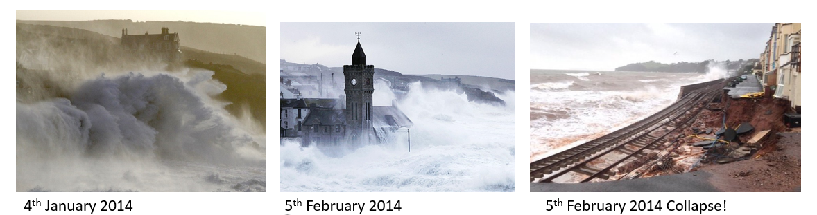
Images: Various. Copyright unknown
Figure 3-7 A series of storms lead to the eventual collapse of the sea wall, Dawlish

INFLUENCE OF INFRASTRUCTURE DESIGN AND PERFORMANCE
The storms in 2007, 2013/14 and the others highlight the need for infrastructure to continue to perform despite being exposed to repeat storms that persist for many months (Box 1). The performance of flood infrastucture, however, is often represented using a fragility function derived from structural reliability analysis (Dawson & Hall, 2006; van Gelder et al., 2008, Sayers et al., 2010). Such analysis typically provides a ‘snap shot’ of performance given material properties, failure modes and single event loading conditions (either described through a single variable load, or a multivariate loading condition, e.g., Sayers and Meadowcroft, 2005; Jane et al., 2018). Although the evidence on time-dependent deterioration processes (intra and inter storm) remains extremely limited (e.g. Buijs et al., 2009; Environment Agency, 2009, 2013, 2020) it is widely accepted, with a high degree of confidence, that the performance of flood infrastructure will be sensitive to temporally compounding events (Sayers et al., 2015) and these may change with climate change (Slingo, 2021). This presents a significant challenge for the concept of the ‘design storm’ and emphasises the performance of the infrastructure system. This perspective demands a more comprehensive view of the interactions between elements of the flood defence infrastructure (e.g., the beach and back shore embankment, the drainage and the sea wall rear toe etc.) and the temporal sequence or cluster of events. Some of these aspects are expanded upon below.
Box 1 The winter of 2013/14 highlighted the performance of flood infrastructure as highly sensitive to loading conditions outside of those considered during design
Over the winter of 2013/14 the UK experienced very large surge events, coinciding with large spring tides on the east coast, sequences of wind and wave events that battered the south and south-west coast and energetic long-period swell wave events also had an impact on the south coast. Analysis by the Met Office and the Centre for Ecology and Hydrology (CEH) concluded that although no individual storm was exceptional, the clustering and persistence of the storms was unusual (Met Office and CEH, 2014). Most river defences were shown to be capable of protecting urban conurbations from the cumulative effects of a series of significant, though not extreme, rainfall events. However, many were damaged by the succession of storms and the progressive damage caused by exposure to persistently high flow velocities and discharges. Equally the persistent storms highlighted some frailties within fluvial defences. Anecdotal evidence suggests the succession of storms drove significant toe scour, eroded surface cover and maintained persistent head differentials with the potential to drive internal erosion. Urban drainage systems (piped and surface storage services) and pumped catchments were also overwhelmed, in part reflecting the severity of individual storms but also the increased percentage of run-off from saturated soils during the more moderate storms seen in this period.
At the coast, severe gales, and long, high-energy ocean waves caused significant damage to coastal infrastructure. For example, on 5-6 December 2013 a major North Sea storm surge coincided with one of the highest tides of the year. The threat to the east coast was similar to that of 1953; however, improved coastal defences and warning systems avoided major damage. There was however evidence of increased structural damage to sea defences including soft defence features such as Chesil Beach.
In late December and early January successive deep cyclonic systems led to rainfall that triggered flash flooding, particularly in south-west England. For example, discharge in the Thames at Kingston remained above 275m³s⁻¹ for longer than in any previous flood episode. In January 2014, the Thames Barrier was raised thirteen consecutive times as high fluvial flows and high spring tides coincided (ibid). The succession of events saturated the ground leading to extensive and protracted flooding and the associated disruption of transport, which cut off some towns in the Somerset Levels (Met Office and CEH, 2014).

Infrastructure interdependencies
Few individual components of infrastructure perform alone; but rely on the performance of the infrastructure system as a whole to provide protection. Infrastructure interdependencies therefore play a very vital role in climate change risk and adaptation. In a technologically advanced world infrastructures are becoming more interdependent (Rinaldi et al., 2001) and redundant (backup) infrastructure systems are adding robustness (acting to improve resilience). Nonetheless, extreme weather events can, and do, disrupt connected systems. For example, most infrastructures depend upon electricity, which means electricity disruption has knock-on effects across other sectors leading to widespread disruptions (Pant et al., 2014). Impacts of failure of a single infrastructure asset can cascade and escalate through infrastructure systems, exacerbated by sequences in time and space (e.g., Sayers, et al., 2014, Pant et al., 2018; Thacker et al., 2017). This type of cascading impacts in time and space has also been experienced in the case of flooding (Figure 4-1) and through the cascade of hazards, as in the case of the Fukushima cascade (Box 2).
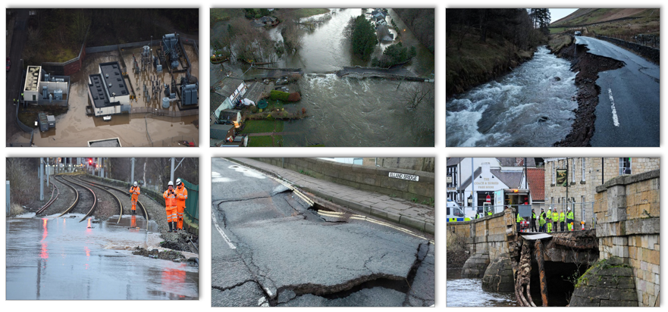
Source: Various – unknown copyright
Figure 4-1 Infrastructure networks are vulnerable to temporal and spatially compounding impacts of flooding
Box 2 Learning from other hazard clusters: Fukushima
The influence of cascading impacts through networks has been demonstrated through various events before the earthquake was centred 130 km offshore the city of Sendai in Miyagi prefecture on the eastern coast of Honshu Island (the main part of Japan) and was a rare and complex double quake giving a severe duration of about 3 minutes. An area of the seafloor extending 650 km north-south moved typically 10-20 metres horizontally. Japan moved a few metres east and the local coastline subsided half a metre. The tsunami inundated about 560 sq. km and resulted in a human death toll of about 19,000 and much damage to coastal ports and towns, with over a million buildings destroyed or partly collapsed.
The Fukushima Daiichi Incident led to significant research in External Hazards and particularly flooding, beyond design basis events and hazard combinations, noting:
- Combinations may represent a greater threat to nuclear safety than hazards acting in isolation
- There are no established methods for characterising hazard combinations
- There is a need to explore statistical methods of combining hazard curves offering insight into next generation hazard combination analysis
Although not directly analogous to the discussion of temporally compound storms, the propagation and escalation of the impacts through time experienced in response to the Fukushima Daiichi incident reinforces their importance.
Source: Parkes – ONR Presentation

Influence of temporal sequencing on individual asset reliability

Fluvial embankments
The 2013/14 floods highlight the potential damage to fluvial structures that prolonged exposure to storm loads can cause. Sustained scour of bridge piers and embankment foundations as well as persistently saturated soils are all recognised as important concerns (e.g., Allsop et al., 2007). For example, a series of exposures can progressively reduce the reliability and chance of failure, as material is degraded (e.g., soil desiccation, loss of surface cover, toe scour, etc. - Figure 4-2). Although evidence is limited from climate projections, persistent and prolonged events are likely to pose an increased threat to the performance of infrastructure.
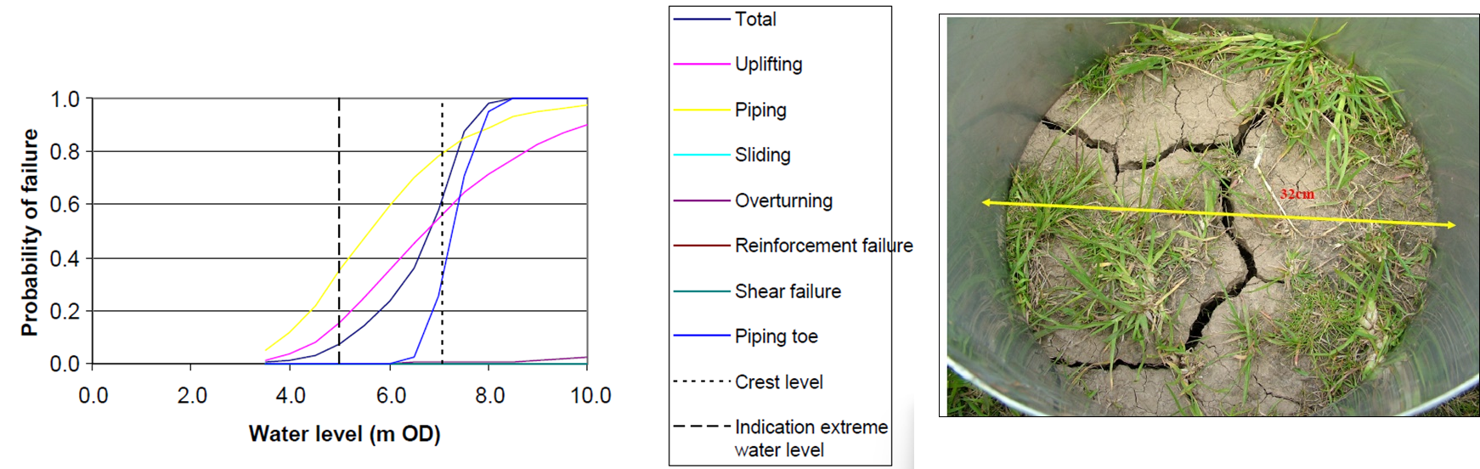
Left: A typical fragility curve based on the reliability analysis for a defence in the Thames Estuary from Sayers et al., 2010
Right: Desiccated soil surface. Image courtesy of Prof Mark Dyer.

Periods of drought can desiccate surface soils which, when subsequently loaded by flood flows, can affect the reliability of soil stability due to increased piping (as experienced in 1975/76 and 2010-12). Source: Sayers et al., 2015
Figure 4-2 Snap-shot reliability analysis can failure to capture to temporally compounding influence of multiple storms

Beaches and the protection they afford
Beaches undergo continuous and on-going morphodynamic change in response to surges, waves, tides, and wind at a range of time scales. This makes the performance of coastal infrastructure particularly sensitive to the storm sequence as introduced below.

Storm clusters
Significant erosion is typically episodic (as exemplified by the 2013/14 event) and takes place in response to a combination of wave conditions, water levels, groundwater as well as geology and presence or absence of structures (local or remote to the site). Impacts of individual storms and the impact of clusters of storms, where storms occur in close succession, are both extensively discussed in various papers. For example, storm sequence is widely recognized as having the potential to significantly influence coastal erosion (e.g., Karunarathna, et al., 2014 - Figure 4-3).
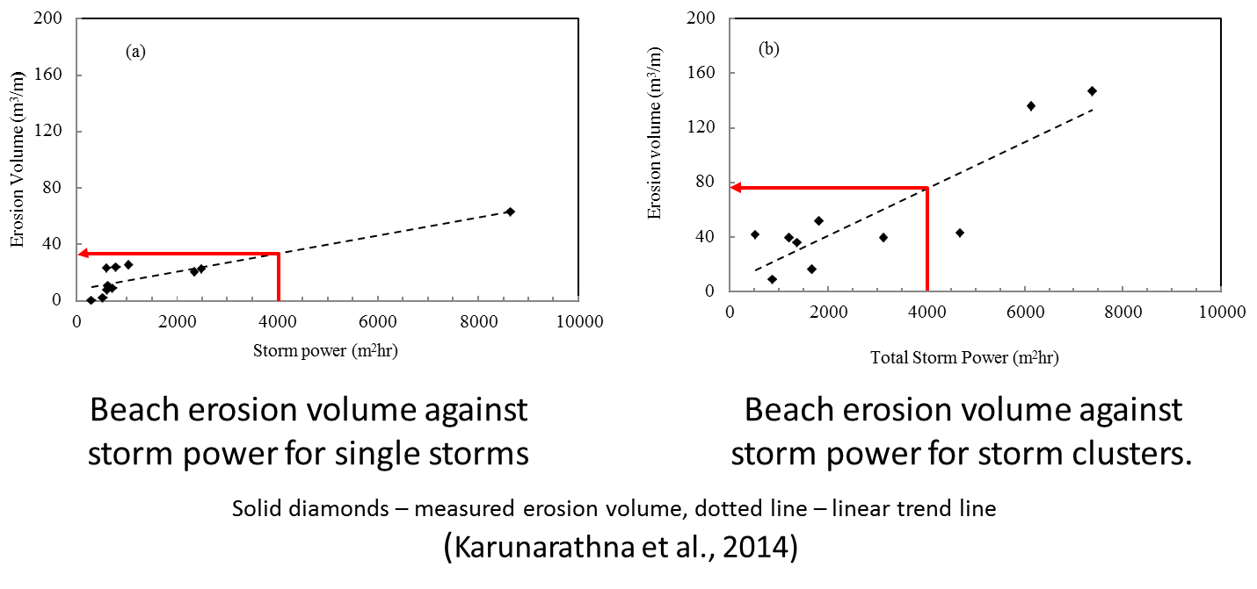
Source: Karunarathna, et al., 2014
Figure 4-3 The effect of storm clusters on a Narrabeen Beach Australia
Recent analysis in Japan reinforces the importance of storm clusters on beach profile response (and by extension the protection from flooding), indicating clustered storms (with little opportunity for recovery between storms) are a more significant design basis that a single larger storm (Figure 4-4).
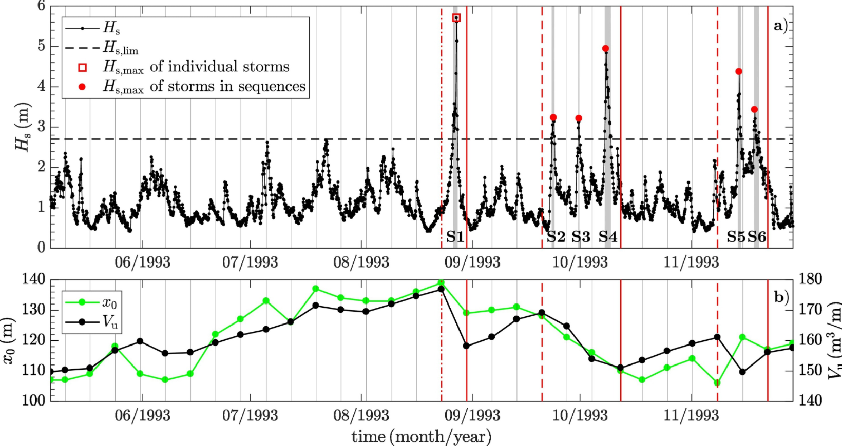
The figure above compares the beach profile response from single large event (shown as red squares in the top figure) and the response to a storm sequence (the red dots in the top figure). Despite the single storm being associated with a much larger significant wave height (Hs) the beach response (indicated by a loss in volume – the black line in the bottom figure) is much greater. The change in shoreline position (the green line in the bottom figure) also retreats further in response to the sequence of storms compared to the single, larger storm. Source: Eichentopf, et al., 2020
Figure 4-4 Observations of beach profile response sensitivity to storm sequences
The loss of foreshore protection can act to increase the loading reaching any backshore structure that may exist, both increasing the design loads and undermining the available resistance by exposing and undermining structural foundations (Figure 4-5). Given the depth limited nature of the wave conditions reaching the shoreline around much of the UK coastline this can significantly increase incident wave conditions (and potentially associated overtopping, scour and wave impacts). This negative feedback was a central cause in the Dawlish seawall collapse (as suggested in Sayers et al., 2015).
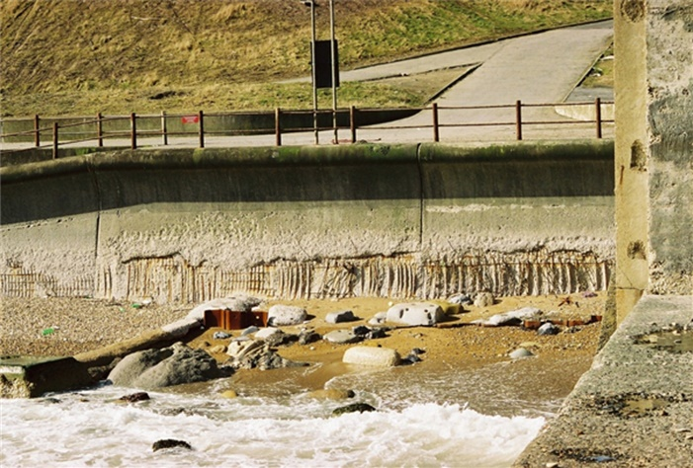
Source: Environment agency – Condition Inspection Manual
Figure 4-5 Sequences of storm can erode foreshores exposing and undermining structural foundation

Storm sequences (persistence changes in dominant wind direction)
The volume of sediment on a beach at any given time is often a function of wave climate over the preceding months or even years. The performance of backshore structures (where they exist) will often depend on the beach in the front. Seasonally and longer-term changes in wave direction can have a major influence on beach morphology (plan shape) – accretion and erosion – and hence both the management effort and the protection afforded (Figure 4-3).
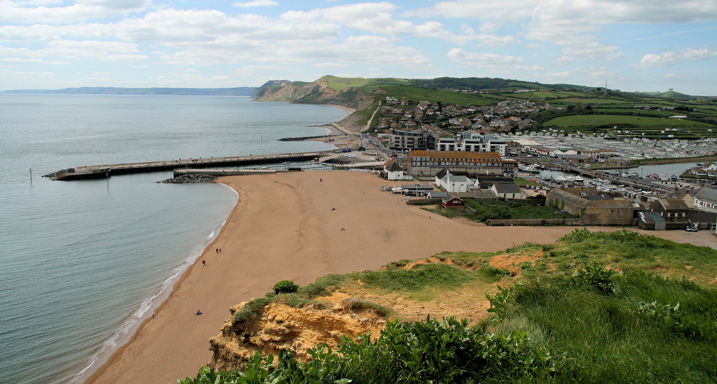
Source: Bridport, West Bay, Harbour and Beach - Field Guide by Ian West (soton.ac.uk)
Figure 4-6 West Bay - East Beach. The beach volume varies in response to storm sequences and single events

Influence on maintenance and repair windows
Frequency of ‘on-the-demand’ (seen through 2013/14), acts to restrict the window for significant maintenance and repair with potential impacts on reliability of performance. Without sufficient downtime to maintain or repair M&E assets (such as major pumps, barriers etc.) reliability on-demand is likely to decrease (Atkins, 2006 apud Sayers et al., 2015). Determining what is ‘sufficient’ will be asset specific and difficult to generalise. Changes on demand use will be influenced not only by storminess but also, in high sea level rise scenarios, areas that currently drain naturally may become tide-locked and require constant management of river and urban drainage water flows.

Inclusion (or lack of inclusion) of the subtle influences of climate change
For many infrastructure providers climate change is dealt with in a rather rudimentary fashion within the design process; often using allowances applied to basic descriptions of climate loads. Often the allowances used are considered precautionary in the sense of a single storm, but little consideration is given to changes in extreme values, storm sequencing and spatial coherence or the more subtle impacts of temperature, solar radiation or events occurring in combination. Understanding the change in extreme temporally compounding events (including changes in sequences or clusters) is seldom included.

CONCLUSIONS
The Review highlights two central aspects:
- Temporally compounding events are an importance consideration - The impact on infrastructure performance of prolonged sequences of storms is recognised (e.g. as seen during the 2013/14 storms and the collapse of the sea wall at Dawlish). There is, however, little research on how to describe or assess the impact of temporally compounding events. This is the case for today’s climate and how this may change in the future. This is an area rightfully attracting more attention, but further research and practical guidance is needed.
- The present single storm design basis is not necessarily conservative: Our understanding of the reliability of infrastructure, its time-dependent deterioration, and the impact of changing loads (and the interactions between these) is only in its infancy. Significant research will be needed to advance understanding of temporally compounding events and mainstream their consideration into the assessment, design, and management of infrastructure.
These findings challenge the basis of traditional design, highlighting that the focus on single extreme events is necessary but not sufficient to support a robust safety. Reflecting a broader understanding of an ‘event’ within design is needed. This may include recasting this definition to focus on the outcome performance rather than the input loads. This will enable the move away from an a priori assumption that single occurrences of high magnitude are most important (for which classical extreme value theory would be relevant) towards consideration of sequences (uncorrelated) or clusters (correlated) in which individual occurrences may not be particularly large, but nonetheless lead to significant damage and the most significant safety risk (for example, two or more moderate storms may be a more significant design basis than a single, larger, storm).

REFERENCES
Allsop, W., Kortenhaus, A., and Morris, M. (2007). Failure mechanisms for flood defence structures. A report from the FLOODsite project.
Athukorala, K., Oulasvirta, A., Głowacka, D., Vreeken, J. and Jacucci, G., (2014). Narrow or broad? Estimating subjective specificity in exploratory search. In Proceedings of the 23rd ACM International Conference on Conference on Information and Knowledge Management. https://doi.org/10.1145/2661829.2661904
Baldwin, J.W., Dessy, J.B., Vecchi, G.A. and Oppenheimer, M., (2019). Temporally compound heat wave events and global warming: An emerging hazard. Earth's Future, 7(4), pp.411-427.
Barton, Y., Giannakaki, P., Von Waldow, H., Chevalier, C., Pfahl, S. and Martius, O., (2016). Clustering of regional-scale extreme precipitation events in southern Switzerland. Monthly Weather Review, 144(1), pp.347-369.
Bell, V.A., Kay, A.L., Jones, R.G., Moore, R.J. and Reynard, N.S., (2009). Use of soil data in a grid-based hydrological model to estimate spatial variation in changing flood risk across the UK. Journal of Hydrology, 377(3-4), pp. 335-350.
Berghuijs, W.R., Harrigan, S., Molnar, P., Slater, L.J. and Kirchner, J.W., (2019). The relative importance of different flood‐generating mechanisms across Europe. Water Resources Research, 55(6), pp.4582-4593.
Berghuijs, W.R., Woods, R.A., Hutton, C.J. and Sivapalan, M., (2016). Dominant flood generating mechanisms across the United States. Geophysical Research Letters, 43(9), pp.4382-4390.
Bevacqua, E., Maraun, D., Vousdoukas, M.I., Voukouvalas, E., Vrac, M., Mentaschi, L. and Widmann, M., (2019). Higher probability of compound flooding from precipitation and storm surge in Europe under anthropogenic climate change. Science advances, 5(9).
Breinl, K., Turkington, T. and Stowasser, M., (2015). Simulating daily precipitation and temperature: a weather generation framework for assessing hydrometeorological hazards. Meteorological Applications, 22(3), pp.334-347.
Boughton, W. and Droop, O., (2003). Continuous simulation for design flood estimation—a review. Environmental Modelling & Software, 18(4), pp.309-318.
Buijs FA, Hall JW, Sayers PB and Van Gelder P (2009). Time-dependent reliability analysis of flood defences. Reliability Engineering and System Safety 94(12): 1942-1953.
Cabinet Office (2017). National Risk Register of Civil Emergencies 2017 edition. Published by HM Government
Marsh, T. and Parry, S., (2012). An overview of the 2010-12 drought and its dramatic termination. An interim report published by NERC https://nora.nerc.ac.uk/id/eprint/20083/
Collins, A.M., Coughlin, D., Miller, J., Kirk, S. (2015). The Production of Quick Scoping Reviews and Rapid Evidence Assessments: A How to Guide. Published by Department of Environment, Food and Rural Affairs (Defra).
Clarivate (2022). Web of Science, https://www.webofscience.com/, accessed Jan. 21, 2022.
Dawson, D., Shaw, J. and Gehrels, W.R., (2016). Sea-level rise impacts on transport infrastructure: The notorious case of the coastal railway line at Dawlish, England. Journal of Transport Geography, 51, pp.97-109.
De Luca, P., Hillier, J.K., Wilby, R.L., Quinn, N.W. and Harrigan, S., (2017). Extreme multi-basin flooding linked with extra-tropical cyclones. Environmental Research Letters, 12(11), p.114009.
Eichentopf, S., Alsina, J.M., Christou, M., Kuriyama, Y. and Karunarathna, H., (2020). Storm sequencing and beach profile variability at Hasaki, Japan. Journal of Marine Geology, 424.
Elsevier B.V. (2022). Scopus, https://www.scopus.com/, accessed 21 Jan 2022
Environment Agency (2020). Impact of climate change on asset deterioration. Report SC120005. A report for the Environment Agency led by Kevin Burgess, CH2M
Environment Agency, (2013) Technical report – FCRM assets: deterioration modelling and WLC analysis Report – SC060078. A report for the Environment Agency led by Kevin Burgess, Halcrow
Environment Agency, (2011). Spatial Coherence - Risk of Widespread Flooding. Project SC060088/S. A report for the Environment Agency led by Rob Lamb, JBA
Environment Agency, (2009). PAMS (Performance-based Asset Management System) – Phase 2 Outcome Summary Report. Report for the Environment Agency by led by HR Wallingford with Sayers, P.B., Roca, M, Bramley, M, Gouldby G, Hurford A, Flikweert, J, Simm J, Wallis, M.
Evans, E.P., Ashley, R., Hall, J.W., Penning-Rowsell, E.P., Saul, A., Sayers, PB., Thorne, C.R. and Watkinson, A. (2004). Foresight Future Flooding, Scientific Summary: Volume 2: Managing future risks. Office of Science and Technology, London.
Falter, D., Schröter, K., Dung, N.V., Vorogushyn, S., Kreibich, H., Hundecha, Y., Apel, H. and Merz, B., (2015). Spatially coherent flood risk assessment based on long-term continuous simulation with a coupled model chain. Journal of Hydrology, 524, pp.182-193.
Jenkins, L.J., Haigh, I.D., Camus, P., Pender, D., Sansom, J., Lamb, R., Kassem H. (2022). The temporal clustering of storm surge, wave height, and high sea level exceedances around the UK coastline. https://link.springer.com/article/10.1007/s11069-022-05617-z
Gadian, A (2021). Research Briefing. Office for Nuclear Regulation Expert Panel on Natural Hazards: sub-panel on meteorological and coastal flood hazards. Review of the third UK Climate Change Risk Assessment for the ONR.
Gouldby, B., Wyncoll, D., Panzeri, M., Franklin, M., Hunt, T., Hames, D., Tozer, N., Hawkes, P., Dornbusch, U. and Pullen, T (2017). Multivariate extreme value modelling of waves, winds and sea levels around the coast of England, Proceedings of the Institute of Civil Engineers – Maritime Engineering, 170(1), pp. 3-20.
Grabbert, J.H., Rainer, A., Deepen, J., Rodda, H.J.E., and Pfeifer, D. (2010). A probabilistic storm surge risk model for the German North Sea and Baltic Sea coast. Proceeding of the EGU General Assembly, Vienna.
Griffin, A., Kay, A., Stewart, E. and Sayers, P., (2022). Spatially coherent statistical simulation of widespread flooding events under climate change. Hydrology Research, 53(11), pp.1428-1440.
Hames, D.P., Gouldby, B.P. and Hawkes, P.J. (2019), June. Evolution of joint probability methods in coastal engineering practice in the UK. In Proceedings of the Institution of Civil Engineers-Maritime Engineering (Vol. 172, No. 2, pp. 45-54). Thomas Telford Ltd.
Hawkes, P.J., Gouldby, B.P., Tawn, J.A. and Owen, M.W (2002). The joint probability of waves and water levels in coastal engineering design. Journal of hydraulic research, 40(3), pp.241-251.
Heffernan, J. E. and Tawn, J. A. (2004). A conditional approach for multivariate extreme values (with discussion). Journal of the Royal Statistical Society: Series B (Statistical Methodology), 66(3):497–546.
HM Government (2016). National Flood Resilience Review. Published by HM Government
Horsburgh, K., Rennie, A. and Palmer, M. (2020). Impacts of climate change on sea-level rise relevant to the coastal and marine environment around the UK, MCCIP Science Review 2020, pp. 116–131. doi: 10.14465/2020.arc06.slr
Hughes, T.P., Kerry, J.T., Connolly, S.R., Baird, A.H., Eakin, C.M., Heron, S.F., Hoey, A.S., Hoogenboom, M.O., Jacobson, M., Liu, G. and Pratchett, M.S., (2019). Ecological memory modifies the cumulative impact of recurrent climate extremes. Nature Climate Change, 9(1), pp.40-43.
Kendon and McGarthy (2015). The UK’s wet and stormy winter of 2013/2014. Weather, 70(2), pp.40-47.
IPCC, (2022). Climate Change 2022: Impacts, Adaptation and Vulnerability. Contribution of Working Group II to the Sixth Assessment Report of the Intergovernmental Panel on Climate Change [H.-O. Pörtner, D.C. Roberts, M. Tignor, E.S. Poloczanska, K. Mintenbeck, A. Alegría, M. Craig, S. Langsdorf, S. Löschke, V. Möller, A. Okem, B. Rama (eds.)]. Cambridge University Press. Cambridge University Press, Cambridge, UK and New York, NY, USA, 3056 pp., doi:10.1017/9781009325844
Karunarathna H, Pender D, Ranasinghed O, Short A and Reeve D (2014). The effects of storm clustering on beach profile variability. Marine Geology 348: 103-112.
Kendon, M. and McCarthy, M., (2015). The UK’s wet and stormy winter of 2013/2014. Weather, 70(2), pp.40-47.
Kilsby, C.G., Jones, P.D., Burton, A., Ford, A.C., Fowler, H.J., Harpham, C., James, P., Smith, A. and Wilby, R.L., (2007). A daily weather generator for use in climate change studies. Environmental Modelling & Software, 22(12), pp.1705-1719.
Lamb, R. and Kay, A.L., (2004). Confidence intervals for a spatially generalized, continuous simulation flood frequency model for Great Britain. Journal of Water Resources Research, 40(7).
Lamb, R., Keef, C., Tawn, J., Laeger, S., Meadowcroft, I., Surendran, S., Dunning, P. and Batstone, C., (2010). A new method to assess the risk of local and widespread flooding on rivers and coasts. Journal of Flood Risk Management, 3(4), pp.323-336.
Liberati, A., Altman, D.G., Tetzlaff, J., Mulrow, C., Gøtzsche, P.C., Ioannidis, J.P., Clarke, M., Devereaux, P.J., Kleijnen, J. and Moher, D., (2009). The PRISMA statement for reporting systematic reviews and meta-analyses of studies that evaluate health care interventions: explanation and elaboration. Annals of internal medicine, 151(4), pp.W-65.
Liu, Z., Xu, W., Feng, J., Palaiahnakote, S. and Lu, T., (2018). Context-aware attention LSTM network for flood prediction. In 2018 24th international conference on pattern recognition (ICPR) pp.1301-1306.
Matthews, T., Wilby, R. L. & Murphy, C. (2019). An emerging tropical cyclone–deadly heat compound hazard. Journal of Nature Climate Change 9, 602–606 (2019)
Met Office and UKCEH (2014). The Recent Storms and Floods in the UK – February 2014. https://www.ceh.ac.uk/sites/default/files/Recent%20Storms%20Briefing.pdf
Murphy-Barltrop, C. J. R. (2023). Novel methodology for the estimation of extremal bivariate return curves. [Doctoral dissertation, Lancaster University] ProQuest Dissertations & Theses.
Murphy‐Barltrop, C.J.R., Wadsworth, J.L. and Eastoe, E.F., (2023). New estimation methods for extremal bivariate return curves. Environmetrics, 34(5).
ONR (2022). ONR TAG 013 (External Hazards) Annex 3 – Coastal Flood Expert Panel Paper. An Expert Panel Paper report for the Office of Nuclear Regulation led by Kevin Horsburgh.
ONR (2021). Extreme Weather Events in the UK. A Research Briefing for the Office of Nuclear Regulation
Paez, A., (2017). Gray literature: An important resource in systematic reviews. Journal of Evidence‐Based Medicine, 10(3), pp.233-240.
Pant, R., Thacker, S., Hall, J.W., Alderson, D. and Barr, S., (2018). Critical infrastructure impact assessment due to flood exposure. Journal of Flood Risk Management, 11(1), pp.22-33.
Pinto, J.G., Bellenbaum, N., Karremann, M.K. and Della‐Marta, P.M. (2013). Serial clustering of extratropical cyclones over the North Atlantic and Europe under recent and future climate conditions. Journal of geophysical research: Atmospheres, 118(22), pp.12-476.
ProQuest (2022). ProQuest Dissertations & Theses Global, https://www.proquest.com/, accessed Jan. 21,
Rinaldi, S.M., Peerenboom, J.P. and Kelly, T.K. (2001). Identifying, understanding, and analyzing critical infrastructure interdependencies. IEEE control systems magazine, 21(6), pp.11-25.
RMS (2007). 1607 Bristol Channel Floods: 400-Year Retrospective RMS Special Report (PDF). Risk Management Solutions (RMS). 2007. p. 17.
Salvadori, G. and De Michele, C. (2006). Statistical characterization of temporal structure of storms. Advances in Water Resources, 29(6), pp.827-842.
Sayers, P., Griffin, A., Lowe, J., Bernie, D., Carr, S., Kay, A. and Stewart, L. (2023). Beyond the local climate change uplift–The importance of changes in spatial structure on future fluvial flood risk in Great Britain. Natural Hazards, 120(4), pp.3773-3798.
Sayers, P., Gersonius, B., den Heijer, F., Jan Klerk, W., Frohle, P., Jordan, P., Ciocan, U. R., Rijke, J., Vonk, B., and Ashley, R. (2021). Towards adaptive asset management in flood risk management: A policy framework, Water Security 12/100085: 1–
Sayers, P., Walsh, C. and Dawson, R. (2015). Climate impacts on flood and coastal erosion infrastructure. Published by Institution of Civil Engineers, London. Journal of Infrastructure Asset Management. DOI: 10.1680/iasma.14.00040
Sayers P. B., Nathan R., Rodda, H., Tomlinson, E., Gippel C, Little, M and Bowles, D (2014). Comparison of Flood Hazard Estimation Methods for Dam Safety. Published by CEATI international, Montreal, Canada.
Sayers, P., Yuanyuan, L., Galloway, G., Penning-Rowsell, E., Fuxin, S., Kang, W., Yiwei, C. and Le Quesne, T. (2013). Flood risk management: A strategic approach. Published in 2013 by the United Nations Educational, Scientific and Cultural Organization 7, place de Fontenoy, 75352 Paris 07SP, France © UNESCO 2013 in association with Asian Development Bank, WWF-International and the GIWP, China. ISBN 978-92-3-001159-8.
Sayers PB, Wallis M, Simm JD, Baxter G and Andryszewski, T. (2010). Towards the Next Generation of Risk-Based Asset Management Tools. In Flood risk science and management. Editors Pender and Faulkner. Wiley Publications
Sayers PB and Meadowcroft IC (2005). RASP - A hierarchy of risk-based methods and their application. Defra Flood and Coastal Management Conference 2005, 5 - 7 July 2005, York, UK. https://eprints.hrwallingford.com/556/
Shepherd, T.G., Boyd, E., Calel, R.A., Chapman, S.C., Dessai, S., Dima-West, I.M., Fowler, H.J., James, R., Maraun, D., Martius, O. and Senior, C.A. (2018). Storylines: an alternative approach to representing uncertainty in physical aspects of climate change. Climatic change, 151(3), pp.555-571.
Simpson, E.S., Opitz, T. and Wadsworth, J.L. (2023). High-dimensional modeling of spatial and spatio-temporal conditional extremes using INLA and Gaussian Markov random fields. Extremes, 26(4), pp.669-713.
Simpson, E.S. and Wadsworth, J.L. (2021). Conditional modelling of spatio-temporal extremes for Red Sea surface temperatures. Spatial Statistics, 41, p.100482.
Slingo, J. (2021). Latest scientific evidence for observed and projected climate change. In: The third UK Climate Change Risk Assessment Technical Report [Betts, R.A., Haward, A.B. and Pearson, K.V. (eds.)].
Temmerman, S., Meire, P., Bouma, T. J., Herman, P. M., Ysebaert, T., and De Vriend, H. J. (2013). Ecosystem-based coastal defence in the face of global change. Nature 504/7478: 79–83.
Thacker, S., Barr, S., Pant, R., Hall, J.W. and Alderson, D. (2017). Geographic hotspots of critical national infrastructure. Risk Analysis, 37(12), pp.2490-2505.
Tricco, A. C., Antony, J., Zarin, W., Strifler, L., Ghassemi, M., Ivory, J., Perrier, L., Hutton, B., Moher, D., and Straus, S. E. (2015). A scoping review of rapid review methods. BMC medicine 13/1: 1–15.
Scopus (no date), Start Exploring, Available at: https://www.scopus.com/search/form.uri?display=basic&zone=header&origin=#basic&gt; (Accessed: 1 November 2021).
Tawn, J., Shooter, R., Towe, R. and Lamb, R., (2018). Modelling spatial extreme events with environmental applications. Spatial Statistics, 28, pp.39-58.
Villarini, G., Vecchi, G. A. & Smith, J. A. (2010). Modeling the dependence of tropical storm counts in the North Atlantic basin on climate indices. Mon. Weather Rev. 138, 2681–2705 (2010).
Wadsworth, J.L., Tawn, J.A., Davison, A.C. and Elton, D. (2017). Modelling across extremal dependence classes. Journal of the Royal Statistical Society Series B: Statistical Methodology, 79(1), pp.149-175.
Wadey, M.P., Haigh, I.D., Nicholls, R.J., Brown, J.M., Horsburgh, K., Carroll, B., Gallop, S.L., Mason, T. and Bradshaw, E. (2015). A comparison of the 31 January–1 February 1953 and 5–6 December 2013 coastal flood events around the UK. Frontiers in Marine Science, 2, p.84.
White, R.W. and Roth, R.A., (2009). Defining exploratory search. In Exploratory Search: Beyond the Query—Response Paradigm (pp. 9-23). Cham: Springer International Publishing.
Wood, E., Lamb, R., Warren, S., Hunter, N., Tawn, J., Allan, R. and Laeger, S. (2016). Development of large-scale inland flood scenarios for disaster response planning based on spatial/temporal conditional probability analysis. In E3S web of conferences (Vol. 7, p. 01003). EDP Sciences.
Wyncoll, D. and Gouldby, B. (2015). Integrating a multivariate extreme value method within a system flood risk analysis model. Journal of Flood Risk Management, 8(2), pp.145-160.
Wyncoll, D., Haigh, I., Gouldby, B., Hames, D., Laeger, S., Wall, A., Hawkes, P. and Hammond, A. (2016). Spatial analysis and simulation of extreme coastal flooding scenarios for national-scale emergency planning. FLOODrisk 2016 - 3rd European Conference on Flood Risk Management.
Zscheischler, J., Van Den Hurk, B., Ward, P.J. and Westra, S. (2020). Multivariate extremes and compound events. In Climate extremes and their implications for impact and risk assessment (pp. 59-76). Elsevier.
Zscheischler, J., Westra, S., Van Den Hurk, B.J., Seneviratne, S.I., Ward, P.J., Pitman, A., AghaKouchak, A., Bresch, D.N., Leonard, M., Wahl, T. and Zhang, X. (2018). Future climate risk from compound events. Nature Climate Change, 8(6), pp.469-477.

Grey literature is used here to refer to guides, manuals and reports published by organisations outside of peer reviewed journals. This includes, for example, publications by the Environment Agency and other authoritative national and international organisations.

