**Technical Report for ONR-RRR-115:**

**Tipping Points in the Climate System**

**ONR Expert Panel on Natural Hazards, sub-panel on meteorological and flooding hazards.**

**Author: S. Harrison**

**Reviewer: R. Washington.**

**August 2024**

Tipping Points (TP) are thresholds in systems that lead to irreversible changes when the threshold is exceeded. In the context of climate change, TP occur when thresholds in the climate system are exceeded leading to radically different climate states. They are of concern because major shifts in climate would have major impacts on human and ecological systems.

Given the likely impact of climate TP on nuclear sites and operation in the UK ONR has asked for this report and review to be developed. The report is in response to ONR request, and follows ONR-RRR-055.

## 

## Objectives of the review

The review seeks to:

* Assess the nature of TP in today’s and the future climate with reference to TP in the past.
* Examine some of the main TP that might impact the UK climate and the context for developing new nuclear sites and for protecting pre-existing sites.
* provide a high-level synthesis of the theories, concepts, and methods in use, or emerging, to develop a deeper understanding of TP in the climate system.

## Structure of the review

The research review is structured as follows:

* Part 1 – Research method: Sets out research method (including the grey and academic literature).
* Part 2 – Tipping Points in the climate system. Definitions of Tipping Points
* and the approaches to assessment methods typically applied (where they exist).
* Part 3 Background on Tipping Points. Explores the history of Tipping Point research
* Part 4 –The nature of Tipping Points
* Part 5 – Tipping Points and past climate change
* Part 6 – Tipping Points and future climate change
* Part 7 – Modelling and Prediction of Tipping Points
* Part 8 – Tipping Points and UK climate
* Part 9 – How close are we to a Tipping Point?
* Part 10 – Conclusions and Recommendations

# RESEARCH METHOD

To provide a rapid, but structured, assessment of the evidence two approaches were used:

* the ‘rapid review assessment’ approach and
* the ‘rapid systemic evidence review’.

## 

## Intervention (eligibility for inclusion)

To be considered for inclusion in the review, three primary considerations are applied from the grey[1] and peer-reviewed literature:

* Reports must be written in English.
* Explicitly address issues of Tipping Points in the climate system. To support the search of peer-review publications, broad search terms are used to identify relevant documents.

## Risk of bias

Given the initial nature of this review we rely upon our knowledge of the subject area and ongoing activities as well as the results of searches. This evidence presented can only be a subset of the available evidence and may present some reporting bias (inevitable in any review). The potential for bias is mitigated through expertise of the authors and internal review of the draft findings by other members of the Expert Panel and final review by ONR themselves.

**2 Tipping Points in the Climate System**

For several decades, Quaternary scientists have been exploring the nature of rapid climate change in the context of glacial-interglacial cycles, and in attempting to understanding millennial and centennial-scale shifts in climate as ice sheets melted (e.g. Coope and Brophy 1972; Lowe and Walker 1997; Rasmussen et al. 2014). Given recent climate warming and ice melt, and future expectations of this, there is now increased focus on the nature and rapidity of extreme climate change. As a result, the issue of Tipping Points (TP) in the climate system should be seen within the context of extreme climate and weather events, and in attribution studies. IPCC AR6 have defined a number of terms as follows (Collins et al. 2019):

“In discussing concepts such as abrupt changes, irreversibility, tipping points and extreme events it is important to define precisely what is meant by those terms. The following definitions are therefore adopted (based on either AR5, Special Report on Global Warming of 1.5°C (SR15) or Special Report on Climate Change and Land (SRCCL) Glossaries):

* *Abrupt climate change***:** A large-scale change in the climate system that takes place over a few decades or less, persists (or is anticipated to persist) for at least a few decades, and causes substantial disruptions in human and natural systems.
* *Extreme weather/climate event***:** An extreme event is an event that is rare at a particular place and time of year. Definitions of ‘rare’ vary, but an extreme event would normally be as rare as or rarer than the 10th or 90th percentile of a probability density function estimated from observations. By definition, the characteristics of what is called an extreme event may vary from place to place in an absolute sense. When a pattern of extreme weather persists for some time, such as a season, it may be classed as an extreme climate event, especially if it yields an average or total that is itself extreme (e.g., high temperature, drought, or total rainfall over a season).
* *Irreversibility:*A perturbed state of a dynamical system is defined as irreversible on a given timescale, if the recovery timescale from this state due to natural processes is significantly longer than the time it takes for the system to reach this perturbed state. In the context of this report, the recovery time scale of interest is hundreds to thousands of years.
* *Tipping point:*A level of change in system properties beyond which a system reorganises, often in a nonlinear manner, and does not return to the initial state even if the drivers of the change are abated. For the climate system, the term refers to a critical threshold when global or regional climate changes from one stable state to another stable state. Tipping points are also used when referring to impact; the term can imply that an impact tipping point is (about to be) reached in a natural or human system.

These above four terms generally refer to aspects of the physical climate system. Here we extend their definitions to natural and human systems. For example, there may be gradual physical climate change which causes an irreversible change in an ecosystem. An adaptation tipping point could be reached when an adaptation option no longer remains effective. In addition, there may be a tipping point within a governance structure.

We also introduce two new key terms relevant for discussing risk-related concepts:

* *Compound events*refer to the combination of multiple drivers and/or hazards that contribute to societal or environmental risks.
* *Cascading impacts*from extreme weather/climate events occur when an extreme hazard generates a sequence of secondary events in natural and human systems that result in physical, natural, social or economic disruption, whereby the resulting impact is significantly larger than the initial impact. Cascading impacts are complex and multi-dimensional and are associated more with the magnitude of vulnerability than with that of the hazard”. (Collins et al. 2019). As a result, TP should be seen within this broad structure assessing extreme climate events (Figure 1 and Figure 2).”

**3 Background on Tipping Points**

An important component of the study of extreme climate change is the concept of TP. These represent the idea of rapid shifts in system behaviour and this idea has a long history, having been developed from bifurcation theory in mathematics and used in the nineteenth century to describe shifts in chemical systems (see Hoadley 1884) and Poincare (1885). The original use of the term TP appears to have arisen from social and political theory to describe how such systems undergo rapid (and often unpredictable) change. The term is now more widely used in physical and biological sciences to describe major shifts or reorganisation of complex, many-body and dynamic systems and the point in the system’s evolution at which this occurs. Following the development of a TP the system moves quickly to another state; a move back to the previous state is usually difficult or impossible (Milkoreit et al. 2018; Heinze et al. 2021).

TP in climate systems therefore are those where the climate system undergoes a rapid change from one stable state to another. In the context of climate change, the term TP began to be used around 2005 to describe rapid, non-linear change in a sub-set of the wider climate system and was used to describe such changes in the Arctic (e.g. Lindsay and Zhang 2005). Lenton et al. (2008) were among the first to define the term in the wider climate system and this term has now gained wide currency in debates about climate impacts, adaptation and climate policy goals.

In this review, we assess first the nature of TP in physical systems, and describe how this term has been used to understand climate change. We then describe how the term has been employed to better understand past climate change, and how future climate change can be described as resulting from TP. Finally, the report discusses the challenges for modelling and prediction of TP in the future, with some focus on the UK.

**4 The Nature of Tipping Points**

TP in the climate system have a number of characteristics. They are a response to non-linearities in the climate system and the characteristics of these are well known (e.g. Rial et al. 2004). Systems displaying linearity show smooth, regular motion and functioning in space and time and can be described in terms of well-behaved, continuous functions. The response of a linear system to small changes in its parameters or to changes in external forcing is usually smooth and proportionate to the stimulation. Conversely, nonlinear systems often undergo sharp transitions (e.g. Alley et al. 2003), even in response to steady forcing and may display chaotic behaviour (Lorenz, 1963) in response to forcing on the system.

In the case of linear systems, after parts of the system that have not yet moved to a steady state (called transients) have begun to dissipate, the frequency of variability always equals that of the forcing. In other words, the spacing of surges in the forcing and the spacing of response to surges in the forcing are very similar. Conversely, in a non-linear system, the frequency of the forcing creates new frequencies in the system. For instance, the spectral response of a nonlinear system to oscillatory external forcing usually exhibits frequencies not present in the forcing (such as combination tones), phase and frequency coupling, synchronization and other indications of nonlinearity. These characteristics have regularly been detected in palaeoclimate data (e.g., Pisias et al. 1990; Rial et al. 2004).

Systems undergoing TP behaviour show at least four characteristics. First, they may show rate-independent hysteresis. Such systems show a dependence on the past but that dependence does not degrade with time once the key factors determining behaviour have passed. Many authors restrict the term hysteresis to mean only rate-independent hysteresis (Mielke and Theil 2004; Nazarimehr et al. 2018). Second, it is clear that while some TP may occur rapidly, other changes may occur slowly, involving transitions to a new state that are slower than the cause (O’Riordan and Lenton 2013). Third, TP may be reversible or irreversible. The former means that as long as the driver of the change is reduced to below the level causing the TP then the system will move back to its original state, quickly or slowly. While this may occur in principle, it does not necessarily mean that this could occur in practice. Irreversible change means that the system will not behave in this way, and may require a much larger forcing for the system to regain its original state. The system might also move to a completely new state via hysteresis. Fourth, TP are, by their very nature, difficult to predict but in recent years attempts have used the statistics of time-series and analyses from chaos theory and non-linear dynamics to begin to predict their timing and evolution (e.g. Scheffer et al. 2009, 2012; Carpenter et al. 2011).

It should also be recognised that the time scale of rapid climate change ranges from momentary to human lifetimes to millennia and geological time scales, and operates on spatial scales ranging from global to local and on systems to system components (e.g., Brook et al. 2013).

TP may occur in several steady-state configurations (see Figure 3) and each of are described by a “normal form”. In a fold bifurcation (Figure 3 A) the system exhibits an abrupt transition to a very different state. A transcritical bifurcation (Figure 3 B) usually causes a smooth transition, although it may sometimes cause an abrupt transition. A Hopf bifurcation (Figure 3C) can lead the system into a state of oscillatory behaviour via a smooth (supercritical) or abrupt (subcritical) transition (Bury et al. 2021).

**5 Tipping Points and past climate change**

*Late glacial and Younger Dryas*

Much of the research on TP in the climate system refers to past climate changes as a guide to the future (e.g. Brovkin et al. 2021).There has been a pronounced focus on the period during the last glaciation (about 115,000-11700 years BP) following the Last Glacial Maximum (LGM) at about 19-20,000 years BP. This is known as the late glacial and covers the period from about 15000 years BP to the beginning of the Holocene at around 11700 years BP. The period is well researched because of the relative abundance of evidence given that it occurred relatively recently, and it is also relatively well dated.

Climate change during this time was characterised by rapid shifts in temperature (and other climate metrics) which have been termed Dansgaard-Oeschger (D-O) events (e.g., Dansgaard et al. 1993). Twenty-five D-O events have been identified during the last glaciations, and each consisted of decadal-scale abrupt warming to near-interglacial conditions followed by gradual cooling. Their impacts can be identified globally, although most of the evidence comes from within the Arctic and, in particular, from Greenland ice cores. The coldest intervals between these D-O events are six Heinrich events, periods of rapid breakup of the marine calving margins of the Laurentide Ice Sheet that are identifiable through deposited terrestrial coarse-grained sediments in various parts of the North Atlantic as the icebergs melted (Heinrich 1988; Bond et al. 1992). The causes of these rapid events are contested with many studies focusing on potential freshwater ‘hosing’ into parts of the North Atlantic interrupting the thermohaline circulation (e.g. Broecker et al. 1985). However, recent modelling has suggested that D-O events may also be related to rapid climate oscillations arising from interactions between atmosphere-ice-ocean systems (e.g. Drijfhout et al. 2013; Li and Born 2019).

The last major cold event during the late glacial is known as the Younger Dryas (and also sometimes identified as Heinrich 0), and this provides the clearest expression of a TP in this period. The Younger Dryas (YD) was a period of very rapid cooling and associated hydroclimatic change in the climate lasting from around 12900-11700 years BP (e.g. Alley 2000; Jansen et al. 2020). The effects were most pronounced in high Northern latitudes where ocean temperatures were reduced by at least 4-7oC and Greenland temperatures by more than this (e.g. Steffensen et al. 2008; Cheng et al. 2020). These temperature fluctuations are similar to the amplitude of glacial-interglacial cycles although the latter take 100 000 years rather than a decade to be realised. The initiation of the Younger Dryas is generally hypothesised as being caused by the disruption of the Atlantic Meridional Overturning Circulation (AMOC), which is the Atlantic component of the thermohaline circulation, by the catastrophic collapse of Glacial Lake Agassiz-Ojibway and drainage of cold fresh water through the St. Lawrence seaway (e.g., Broecker 2006) although more northern freshwater routes have also been suggested (e.g. Keigwin et al. 2018).

Climate change was extremely rapid at various times during the late glacial and also at the initiation and especially at the termination of the YD. Using dð18O as a proxy for past air temperature at a Greenland ice core site, Steffensen et al. (2008) showed that the pre-Younger Dryas warming transition at 14700 BP was the most rapidly recorded at the site (which covers more than a hundred thousand years), occurring within 3 years, with the warming transition at 11700 BP (the termination of the YD) lasting around 60 years. Both of these events correspond to a warming of more than 10oC (Steffensen et al. 2008). Cooling at the initiation of the YD at 12900 BP was rather slower (occurring over more than two centuries). Steffensen et al. (2008) also produced a metric for describing ‘rapid climate change’, by characterising shifts in the climate to be significant “if the mean values of the climate states on each side of the shift differ by more than the statistical standard error of the noise of a 150-year period of these climate states” (Steffensen et al. 2008, p.680).

Previous work (e.g. Taylor et al. 1997) argued that the termination of the Younger Dryas in Greenland records occurred during three step changes spread over about 40 years, with each lasting approximately 5 years. Other metrics showed even faster changes. For example, reconstructed snow accumulation appears to have more than doubled in about three years, with most of this increase having occurred in about one year (e.g. Alley et al. 2000). Taylor et al. (1993) argue that some elements of the climate system appear to “flicker” near major transitions such as the end of the Younger Dryas. At this time some climate elements oscillate between characteristic cold stadial and warm interstadial states, eventually stabilising at one or the other. The connection to TPs is that a relatively small, regional forcing in the form of freshwater flux, had drastic, widespread, rapid, non-linear consequences for global climate. Note, however, that the effects were not irreversible. Shutdown of the thermohaline circulation, as first simulated in a coupled model (e.g., Manabe and Stoufer, 1993) were irreversible.

*The mid-Holocene Sahara drying event*

Another clear example of post-LGM rapid shift in climate is the transition of the Sahara from a hyperarid landscape to one characterised by large, permanent lakes, extensive grassland and tree cover, and an extensive river network. This occurred during the early Holocene climatic optimum around 11-5000 years BP (Tierney et al. 2017) or 9000-6000 BP (e.g. Rial et al. 2004; Cheddadi et al. 2021). This climate shift has been described as the largest climate-induced environmental change in the Holocene. It is hypothesised to have been caused by changes in orbital precession timed with increased tilt of the Earth’s axis and perihelion in July leading to increased Northern Hemisphere summer insolation and strengthening of the North African summer monsoon (Rial et al. 2004; Tierney et al. 2017) bringing rainfall into the Saharan region. It is thought that radiative and energy flux feedbacks from changing vegetation and dust were important in reinforcing the modest initial radiative forcing (see Charney et al. 1975).

As a result, this climate and land-surface change can be seen as a TP; precessional forcing enhanced the African monsoon and this was magnified by changes in atmosphere-vegetation feedbacks and eventually produced the conditions where different equilibrium states exist. These can undergo rapid changes as thresholds are crossed (e.g., Brovkin et al. 1998).

**6 Tipping Points and future climate change**

While there has been much discussion of rapid changes in the climate system during the late glacial and Holocene transition, over the past few decades TP have been identified as being of concern for policymakers trying to assess future climate change, adaptation pathways and impacts assessments. Recently, the idea of TP has also been used to accentuate the idea of a current ‘climate emergency’ (e.g. Lenton et al. 2019). Previous IPCC reports have considered that rapid changes in the climate systems would only be likely at high levels of warming (i.e. more than 5oC above pre-industrial levels) but recent studies (e.g. Drijfhout et al. 2015) and more recent IPCC reports ( Pörtner et al. 2019; Masson-Delmotte et al. 2022) have argued that TP could exist in the climate system and be triggered at relatively low levels of warming (below 2°C; see Figure 4). Such events would include disintegration of parts or all of the ice sheets (and it has been suggested that this is already underway in the case of parts of the West Antarctic Icesheet (WAIS); see Pattyn et al. 2018, and also a counter-argument by Clerc et al. 2019). Here, the area of most concern is part of the Amundsen Sea Embayment region where the two largest glaciers draining into the sea are the Pine Island and Thwaites glaciers. It is hypothesised that these glaciers are vulnerable to Marine Ice Sheet Instability (MISI) where ice sheet recession is driven by the basal configuration of the glaciers, the position of the grounding lines and sea temperatures (e.g. Favier et al. 2014; Rosier et al. 2021). This recession would be rapid (with significant ice loss and associated sea level rise occurring this century) and would be irreversible on societally-relevant timescales.

The irreversible thawing of ice-rich permafrost would also be seen as a TP (e.g. Lenton 2012; Devoie et al. 2019) and this would be associated with profound changes in Arctic earth surface processes (e.g. Aalto et al. 2017). Recently, there have been suggestions that the ability of the Amazon rainforest to recover from droughts and fires has reduced consistently in more than three quarters of the rainforest since the early 2000s. If this trend continued then it is hypothesised that the Amazon would be close to a TP which, if crossed, would trigger dieback. In time this would turn large parts of the forest to savannah, with major impacts on biodiversity, global carbon storage and climate change (Boulton et al. 2022).

One area where less research has been undertaken is in the area of future TP cascades, where interactions between climate systems could trigger irreversible changes in large-scale elements of the climate system and make large parts of the earth’s surface less habitable for humans and biological systems.

For instance, Rocha et al. 2018 showed that ecosystems which deliver important provisioning or regulating services for human societies are liable to experience cascading regime shifts. Those operating in similar ecosystems are also likely to share drivers. They analysed 30 types of regime shift from physical climate and ecological systems and demonstrated that exceeding tipping points in one system can increase the risk of crossing them in others. Such links were found for 45% of possible interactions (Rocha et al. 2018; Lenton et al. 2019).

Lenton et al. (2019) argue therefore, that important parts of the climate system are close to TP. These include the system driving Arctic sea-ice loss which is increasing regional warming and melting parts of the Greenland ice sheet. This in turn may be implicated in the recently-observed slowdown of the AMOC (e.g. Caesar et al. 2018; Zhue and Liu 2020). Further changes in AMOC could affect the West African monsoon, triggering drought in the Sahel, and slowdown of the AMOC could increase melting of the WAIS as warmth is concentrated in the Southern Ocean rather than being transported northwards across the Atlantic into the northern hemisphere. It is notable that this is consistent with our understanding of the operation of the late glacial ‘bipolar seesaw’ where warming of the Southern Hemisphere was coincident with cooling of the Northern Hemisphere at various times. This is also an example of a cascading effect, where the operation of one TP creates the trigger for others.

Finally, Lenton et al. (2019) caution that the palaeoclimate record shows multiple examples of how the climate system has undergone rapid shifts which would be irreversible on human timescales if they happened at present. Lenton et al. (2019) argue that the palaeoclimate record “highlights that the Earth system has been unstable across multiple timescales before, under relatively weak forcing caused by changes in Earth’s orbit”. For example, the amplitude of radiative forcing responsible for glacial-interglacial cycles is around 0.1 W.m-2 whereas the forcing by 2100 in one of the emission scenarios used to project future climate is 8.5 W.m-2. “Now we are strongly forcing the system, with atmospheric CO2 concentration and global temperature increasing at rates that are an order of magnitude higher than those during the most recent deglaciation” (Lenton et al., 2019).

**7 Modelling and Prediction of Tipping Points**

Given the societal importance of rapid climate change and TP there have been numerous attempts to model and predict the location, drivers, timing and impacts of TP. Several analytical tools have been developed to detect Early Warning Signals (EWS) of TP. Research has focused on identifying these in observational environmental variables (including time series data) and identifying the causal drivers of abrupt change, including connectivity and homogeneity/heterogeneity of systems, associated cascade effects, and feedbacks (e.g. Barnosky et al. 2012; Hughes et al. 2013; Bentley et al. 2014).

To date, many methods have been proposed to predict TPs using the time-series extracted from the systems (Held and Kleinen 2004; Scheffer et al. 2009; Nazarimehr et al. 2018) Near a TP, the basin of attraction of the system’s attractor becomes shallower (see Figure 5). Here, a perturbation driving the system away from the attractor is followed by a slower return to the attractor. This process is called critical slowing down, is a characteristic of the evolution of many dynamic systems close to a TP and can therefore be used as an EWS. As a result, observational time series data can be used to predict TP as studies show that critical slowing down increases the variance and temporal autocorrelation of fluctuations in the system states. Near a TP, the system state shows an increasingly high dependence on previous observations (see Scheffer et al. 2009; Scheffer et al. 2012; Nazarimehr et al. 2018).

**8 Tipping Points and UK climate**

In a recent review, Hanlon et al. (2021) identify the nature and types of TP that might be relevant for future climate change around the UK. They identify three main areas where teleconnections between system elements might impact the UK climate. These are: 1) the carbon cycle and biogeochemical feedbacks; 2) , those changes in the cryosphere which will have implications for sea level change; 3) , large-scale shifts in climate patterns causing regional climate changes. Not all the TP they identify fit into a single category, and they give the example of future Amazon dieback which is considered as a biogeochemical feedback with a global impact, but which also has local and regional impacts on rainfall and albedo. They also stress the likely interconnectedness of TP with different TP connecting with others in various combinations, the details of which and their outcomes are not well understood (Lenton et al. 2019) because there is no method/model capable of adequately simulating the interaction. Hanlon et al. (2021) review a number of areas where it has been suggested that rapid change might impact the UK, and these include the following.

*Amazon Rainforest*

Their assessment is that “there is little evidence to support the idea that there is a teleconnection (between Amazon dieback and effects in the UK) that would lead to impact in UK”.

However, Hanlon et al. (2021) did caution that there were hypotheses that Amazon dieback could change tropical moisture supply leading to a more persistent El Nino, which would lead to colder UK winters (e.g. Cai et al. 2016; Steffen et al. 2018) and weakening of the AMOC. In addition, loss of the Amazon rainforest carbon sink would likely increase global temperatures meaning that consequences of climate change including higher temperatures and extreme rainfall events in the UK would be reached more quickly than previously suggested.

*Boreal forest dieback*

The dieback of northern Boreal forests would diminish their role as a carbon sink and would, on this basis, lead to increased warming, although their ability to uptake CO2 is lower than that of the low latitude rainforests. In addition, Boreal forests play an important role in regulating snow-ice albedo. However, the importance of Boreal forests to impact regional and large-scale precipitation is lower than for rainforests because of their lower rate of evapotranspiration. They conclude: “This means it is not possible to make confident estimates of how a boreal tipping point might impact the UK or globally”.

*Sea Level change*

Rapid ice loss from the AIS and GIS would impact the UK. As a result of the gravitational effects of ice loss in near- and far-field locations, each would impact the UK differently. It is not expected that either the GIS or AIS will undergo a TP in ice loss soon (although see the discussion about the WAIS earlier). However, the report did identify the rapid slowdown of the AMOC as a TP which would impact the UK. If this happened, Hanlon et al. (2021) expected that the following could occur:

* Cooling of several degrees.
* Reduced rainfall (especially in Summer in conjunction with a negative NAO).
* Increased winter storms which penetrate further inland due to strengthened storm-tracks and localised increases to winter rainfall.
* Increase in magnitude and duration of snowfall.
* Stronger westerly winds in winter and weaker westerly winds in Summer.
* Reduced river flow and surface water runoff which could moderate future flooding impacts.
* Reduced vegetation and crop productivity due to cooling and decrease in water availability.

*AMOC changes*

Modelling of the potential cooling caused by a collapse of the AMOC has been carried out using HadGEM3 by Jackson et al. (2015) who project a 3-7°C reduction in UK average surface temperatures. However, this result is model-, and scenario, -dependent and a more gradual weakening would offset the temperature rise from global warming.

*Changes in Arctic Sea Ice*

It has long been hypothesised that changes in Arctic Amplification and sea ice could have impacts on mid-latitude Northern Hemisphere weather, by changing the position and strength of the jet stream and cyclogenesis. This could be achieved through changing the behaviour and strength of the AMOC, ITCZ, Rossby wave dynamics and other related systems (see Chiang and Bitz 2005; Francis and Vavrus 2012; Cohen et al. 2014; Sévellec et al. 2017; Smith et al. 2019; 2022).

These changes could severely impact the frequency and magnitude of extreme weather events and the persistence of particular ‘blocking’ weather systems which, in summer are associated with droughts and heat waves and in winter with snow.

However, despite these studies Hanlon et al. (2021) argue that “there remains a lack of consensus between climate modelling studies that look at the impact of reductions in Arctic sea ice. The physical mechanisms responsible for the modelling impacts are also not fully understood” and, “currently it is not possible to hypothesise the effect a tipping point leading to rapid Arctic sea-ice loss may have globally or on the UK”.

*Changes in the Jet Stream*

The report also assessed the likely TP associated with a potential southwards shift in the Jet Stream. This would amplify the expected seasonal changes in UK (increased westerly winds in winter producing mild and wetter conditions, with reduced anticyclonic precipitation in summer). However, projections are uncertain and will await further development of the Polar Amplification Model Intercomparison Project (PAMIP) under the CMIP6 (see Smith et al. 2019). We question whether these represent TP as they are firm climate change predictions from UKCP18 scenarios.

**9 How close are we to a Tipping Point?**

In the discussions above, what is often missed is the issue of “false alarms” and “missed alarms” (Lenton, 2011). False alarms occur when an indicator of a TP occurs even when no TP is likely. They arise because signals interpreted as indicative of approaching bifurcation are not statistically robust or have other causes (Lenton 2011). For instance, rising auto-correlation can occur from a range of non-TP related processes and therefore using several indicators of TP would reduce the risk of false alarms. Missed alarms would occur when a TP was crossed without any prior warning and this could happen if the internal variability in a system is high so that it changes state before a bifurcation point is reached or if the forcing is too sudden (Rosier et al. 2021).Despite this caveat, there are already predictions that TP may already have been reached (e.g. the stability of parts of the WAIS; see Pattyn et al. 2018) and that others may be unavoidable. For instance, Aalto et al. (2017) used statistical modelling of current and future distributions of major Land Surface Processes in Northern European periglacial regions and showed that even with the most optimistic CO2 emissions scenario (Representative Concentration Pathway (RCP) 2.6) a 72% reduction in the current periglacial climate realm by 2050 was likely, and that “our findings suggest a near-complete decay of periglacial climate from a climatically sensitive high-latitude area and a significant elevational shift of cryogenic ground processes” and that the “results forecast a future tipping point in the operation of cold-region LSP, and predict fundamental landscape-level modifications in ground conditions and related atmospheric feedbacks”.

Elsewhere in the European Arctic, some research (Fewster et al. 2022) has argued that even under a moderate-to-high warming scenario (Shared Socioeconomic Pathway (SSP) 2-4.5, SSP3-7.0 and SSP5-8.5) around 75% of the study area would be too warm or wet to maintain peatland permafrost by the 2060s. The total peatland area affected under these scenarios contains 37.0–39.5 Gt carbon (equivalent to twice the amount of carbon stored in European forests). While uncertainties exist concerning the rate and timing of carbon release from these peatlands, the fact that a likely near-future TP is close is of great concern.

Finally, an important paper from 2018 describes the more theoretical considerations on the likelihood and impact of future TP. Steffen et al. (2018) asked four questions: First, is there a planetary threshold in the trajectory of the Earth System that, if crossed, could prevent stabilization in a range of intermediate temperature rises? Second, given our understanding of geophysical and biosphere feedbacks intrinsic to the Earth System, where might such a threshold be? Third, if a threshold is crossed, what are the implications, especially for the wellbeing of human societies? Fourth, what human actions could create a pathway that would steer the Earth System away from the potential threshold and toward the maintenance of interglacial-like conditions?

Certainly, current climate change and TP might well have changed the earth’s climate and biosphere characteristics from the bounded Late Quaternary system with glacial and interglacial cycles (this point has been made before (see Berger and Loutre 2002)) and Steffen et al. (2018) argue that the glacial-interglacial cycles can be seen as limit cycles (see Figure 6). Current atmospheric CO2 levels are similar to those last seen during the Pliocene (about 4 million years ago) and are moving rapidly to those seen in Eocene levels around 50 million years ago with temperatures up to 14 °C higher than pre-industrial levels (Lenton et al. 2019). Climate models may not be able to simulate such climates and this makes risk assessments challenging.

Lenton et al. (2019) end by stating: “Some scientists counter that the possibility of global tipping remains highly speculative. It is our position that, given its huge impact and irreversible nature, any serious risk assessment must consider the evidence, however limited our understanding might still be. To err on the side of danger is not a responsible option”.

10 **Conclusions and recommendations**

It is clear that the climate system is capable of rapid changes in its state and this impacts a range of Earth surface systems. These changes are called Tipping Points. Future changes in the climate could create very significant problems for economic, cultural and ecological systems by overwhelming our abilities to respond to such Tipping Points over short time scales. Scientists have begun to assess the nature of future Tipping Points but our understanding of the timing of these and their impacts is still incomplete. We recommend that ONR maintain a watching brief on Tipping Points research, especially on that which impacts future sea level rise, storminess and sea temperatures.

**References**

Aalto, J., Harrison, S. and Luoto, M., 2017. Statistical modelling predicts almost complete loss of major periglacial processes in Northern Europe by 2100. *Nature Communications*, *8*(1), pp.1-8.

Alley, R.B., 2000. The Younger Dryas cold interval as viewed from central Greenland. *Quaternary Science Reviews*, *19*(1-5), pp.213-226.

Alley, R. B., Marotzke, J., Nordhaus, W. D., Overpeck, J. T., Peteet, D. M., Pielke Jr., R. A., Pier-Rehumbert, R. T., Rhines, P. B., Stocker, T. F., Talley, L. D., and Wallace, J. M.: 2003, ‘Abrupt Climate Change’, *Science* 299, 2005–2010.

Barnosky, A. D., Hadly, E. A., Bascompte, J., Berlow, E. L., Brown, J. H., Fortelius, M., et al. 2012. Approaching a state shift in Earth's biosphere. *Nature* 486, 52–58. doi: 10.1038/nature11018

Bentley, R.A., Maddison, E.J., Ranner, P.H., Bissell, J., Caiado, C., Bhatanacharoen, P., Clark, T., Botha, M., Akinbami, F., Hollow, M. and Michie, R., 2014. Social tipping points and Earth systems dynamics. *Frontiers in environmental science*, *2*, p.35.

Berger, A. and Loutre, M.F., 2002. An exceptionally long interglacial ahead?. *Science*, *297*(5585), pp.1287-1288.

Brook, B. W., Ellis, E. C., Perring, M. P., Mackay, A. W., and Blomqvist, L. 2013. Does the terrestrial biosphere have planetary tipping points? *Trends in Ecology and Evolutio,.*  28, 396–401. doi: 10.1016/j.tree.2013.01.016

Bond, G., Heinrich, H., Broecker, W., Labeyrie, L., McManus, J., Andrews, J., Huon, S., Jantschik, R., Clasen, S., Simet, C., Tedesco, K., Klas, M., Bonani, G., Ivy, S., 1992. Evidence for massive discharges of icebergs into the North Atlantic Ocean during the last glacial period. *Nature,* 360, 245–249. <https://doi.org/10.1038/360245a0>

Boulton, C.A., Lenton, T.M. and Boers, N., 2022. Pronounced loss of Amazon rainforest resilience since the early 2000s. *Nature Climate Change*, pp.1-8.

Broecker W.S., Peteet, D.M., D. Rind, D. 1985. Does the ocean-atmosphere system have more than one stable mode of operation? *Nature*, 315, pp. 21-26

Broecker, W.S., 2006. Was the Younger Dryas triggered by a flood? *Science*, *312*(5777), pp.1146-1148.

Brovkin, V., Claussen, M., Petoukhov, V. and Ganopolski, A., 1998. On the stability of the atmosphere‐vegetation system in the Sahara/Sahel region. *Journal of Geophysical Research: Atmospheres*, *103*(D24), pp.31613-31624.

Brovkin, V., Brook, E., Williams, J.W., Bathiany, S., Lenton, T.M., Barton, M., DeConto, R.M., Donges, J.F., Ganopolski, A., McManus, J. and Praetorius, S., 2021. Past abrupt changes, tipping points and cascading impacts in the Earth system. *Nature Geoscience*, *14*(8), pp.550-558.

Bury, T.M., Sujith, R.I., Pavithran, I., Scheffer, M., Lenton, T.M., Anand, M. and Bauch, C.T., 2021. Deep learning for early warning signals of tipping points. *Proceedings of the National Academy of Sciences*, *118*(39).

Caesar, L., Rahmstorf, S., Robinson, A., Feulner, G. and Saba, V., 2018. Observed fingerprint of a weakening Atlantic Ocean overturning circulation. *Nature*, *556*(7700), pp.191-196.

Cai, Y., Lenton, T. M., & Lontzek, T. S. 2016. Risk of multiple interacting tipping points should encourage rapid CO2 emission reduction. *Nature Climate Change*, *6*(5), 520–525.

Carpenter, S.R., Cole, J.J., Pace, M.L., Batt, R., Brock, W.A., Cline, T., Coloso, J., Hodgson, J.R., Kitchell, J.F., Seekell, D.A. and Smith, L., 2011. Early warnings of regime shifts: a whole-ecosystem experiment. *Science*, *332*(6033), pp.1079-1082.

Charney, J., Stone, P.H. and Quirk, W.J., 1975. Drought in the Sahara: a biogeophysical feedback mechanism. *Science*, *187*(4175), pp.434-435.

Cheddadi, R., Carré, M., Nourelbait, M., François, L., Rhoujjati, A., Manay, R., Ochoa, D. and Schefuß, E., 2021. Early Holocene greening of the Sahara requires Mediterranean winter rainfall. *Proceedings of the National Academy of Sciences*, *118*(23).

Cheng, H., Zhang, H., Spötl, C., Baker, J., Sinha, A., Li, H., Bartolomé, M., Moreno, A., Kathayat, G., Zhao, J. and Dong, X., 2020. Timing and structure of the Younger Dryas event and its underlying climate dynamics. *Proceedings of the National Academy of Sciences*, *117*(38), pp.23408-23417.

Chiang, J. C. H., & Bitz, C. M. 2005. Influence of high latitude ice cover on the marine Intertropical Convergence Zone. *Climate Dynamics*, *25*(5), 477–496.

Clerc, F., Minchew, B.M. and Behn, M.D., 2019. Marine ice cliff instability mitigated by slow removal of ice shelves. *Geophysical Research Letters*, *46*(21), pp.12108-12116.

Cohen, J., Screen, J. A., Furtado, J. C., Barlow, M., Whittleston, D., Coumou, D., Francis, J., Dethloff, K., Entekhabi, D., Overland, J., & Jones, J. 2014. Recent Arctic amplification and extreme mid-latitude weather. *Nature Geoscience*, *7*(9), 627–637.

Collins M., M. Sutherland, L. Bouwer, S.-M. Cheong, T. Frölicher, H. Jacot Des Combes, M. Koll Roxy, I. Losada, K. McInnes, B. Ratter, E. Rivera-Arriaga, R.D. Susanto, D. Swingedouw, and L. Tibig, 2019: Extremes, Abrupt Changes and Managing Risk. In: IPCC Special Report on the Ocean and Cryosphere in a Changing Climate [H.-O. Pörtner, D.C. Roberts, V. Masson-Delmotte, P. Zhai, M. Tignor, E. Poloczanska, K. Mintenbeck, A. Alegría, M. Nicolai, A. Okem, J. Petzold, B. Rama, N.M. Weyer (eds.)]. Cambridge University Press, Cambridge, UK and New York, NY, USA, pp. 589-655. https://doi.org/10.1017/9781009157964.008.

Coope, G.R. and Brophy, J.A., 1972. Late Glacial environmental changes indicated by a coleopteran succession from North Wales. *Boreas*, *1*(2), pp.97-142.

Dansgaard, W., Johnsen, S.J., Clausen, H.B., Dahl-Jensen, D., Gundestrup, N.S., Hammer, C.U., Hvidberg, C.S., Steffensen, J.P., Sveinbjörnsdottir, A.E., Jouzel, J. and Bond, G., 1993. Evidence for general instability of past climate from a 250-kyr ice-core record. *Nature*, *364*(6434), pp.218-220.

Devoie, É.G., Craig, J.R., Connon, R.F. and Quinton, W.L., 2019. Taliks: A tipping point in discontinuous permafrost degradation in peatlands. *Water Resources Research*, *55*(11), pp.9838-9857.

Drijfhout, S., Gleeson, E., Dijkstra, H.A., Livina, V. 2013. Spontaneous abrupt climate change due to an atmospheric blocking-sea-ice-ocean feedback in an unforced climate model simulation. *Proceedings, National Academy of Sciences*, 110, pp. 19713-19718

Drijfhout, S., Bathiany, S., Beaulieu, C., Brovkin, V., Claussen, M., Huntingford, C., Scheffer, M., Sgubin, G. and Swingedouw, D., 2015. Catalogue of abrupt shifts in Intergovernmental Panel on Climate Change climate models. *Proceedings of the National Academy of Sciences*, *112*(43), pp.E5777-E5786.

Favier, L., Durand, G., Cornford, S.L., Gudmundsson, G.H., Gagliardini, O., Gillet-Chaulet, F., Zwinger, T., Payne, A.J. and Le Brocq, A.M., 2014. Retreat of Pine Island Glacier controlled by marine ice-sheet instability. *Nature Climate Change*, *4*(2), pp.117-121.

Fewster, R.E., Morris, P.J., Ivanovic, R.F., Swindles, G.T., Peregon, A.M. and Smith, C.J., 2022. Imminent loss of climate space for permafrost peatlands in Europe and Western Siberia. *Nature Climate Change*, pp.1-7.

Francis, J. A., & Vavrus, S. J. 2012. Evidence linking Arctic amplification to extreme weather in mid-latitudes. *Geophysical Research Letters*, *39*(6), 1–6.

Hanlon, H., Palmer, M., and Betts R. A. 2021. Effect of Potential Climate Tipping Points on UK Impacts. [www.ukclimaterisk.org/wp-content/uploads/2021/06/Effect-of-Potential-Climate-Tipping-Points-on-UK-Impacts.pdf](http://www.ukclimaterisk.org/wp-content/uploads/2021/06/Effect-of-Potential-Climate-Tipping-Points-on-UK-Impacts.pdf)

Held, H. and Kleinen, T., 2004. Detection of climate system bifurcations by degenerate fingerprinting. *Geophysical Research Letters*, *31*(23).

Heinrich, H., 1988. Origin and consequences of cyclic ice rafting in the Northeast Atlantic Ocean during the past 130,000 years. *Quaternary Research* 29, 142–152

Heinze, C., Blenckner, T., Martins, H., Rusiecka, D., Döscher, R., Gehlen, M., Gruber, N., Holland, E., Hov, Ø., Joos, F. and Matthews, J.B.R., 2021. The quiet crossing of ocean tipping points. *Proceedings of the National Academy of Sciences*, *118*(9).

Hoadley, J. C., 1884. A tilting water meter for purposes of experiment *Journal of the Franklin Institute,* 117 273–78

Hughes, T. P., Carpenter, S., Rockström, J., Scheffer, M., and Walker, B. 2013. Multiscale regime shifts and planetary boundaries. *Trends in Ecology and Evolution.* 28, 389–395. doi: 10.1016/j.tree.2013.05.019

Jackson, L. C., Kahana, R., Graham, T., Ringer, M. A., Woollings, T., Mecking, J. V., & Wood, R. A. 2015. Global and European climate impacts of a slowdown of the AMOC in a high resolution GCM. *Climate Dynamics*, *45*(11–12), 3299–3316.

Jansen, E., Christensen, J.H., Dokken, T., Nisancioglu, K.H., Vinther, B.M., Capron, E., Guo, C., Jensen, M.F., Langen, P.L., Pedersen, R.A. and Yang, S., 2020. Past perspectives on the present era of abrupt Arctic climate change. *Nature Climate Change*, *10*(8), pp.714-721.

Joughin, I., Smith, B.E. and Medley, B., 2014. Marine ice sheet collapse potentially under way for the Thwaites Glacier Basin, West Antarctica. *Science*, *344*(6185), pp.735-738.

Keigwin, L.D., Klotsko, S., Zhao, N., Reilly, B., Giosan, L. and Driscoll, N.W., 2018. Deglacial floods in the Beaufort Sea preceded Younger Dryas cooling. *Nature Geoscience*, *11*(8), pp.599-604.

Lenton, T.M., 2011. Early warning of climate tipping points. *Nature Climate Change*, *1*(4), pp.201-209.

Lenton, T.M., Held, H., Kriegler, E., Hall, J.W., Lucht, W., Rahmstorf, S. and Schellnhuber, H.J., 2008. Tipping elements in the Earth's climate system. *Proceedings of the National Academy of Sciences*, *105*(6), pp.1786-1793

Lenton, T.M., 2012. Arctic climate tipping points. *Ambio*, *41*(1), pp.10-22.

Lenton, T.M., Rockström, J., Gaffney, O., Rahmstorf, S., Richardson, K., Steffen, W. and Schellnhuber, H.J., 2019. Climate tipping points—too risky to bet against. *Nature*, *575*(7784), pp.592-595.

Li, C. and Born, A., 2019. Coupled atmosphere-ice-ocean dynamics in Dansgaard-Oeschger events. *Quaternary Science Reviews*, *203*, pp.1-20.

Lindsay R.W., and Zhang J., 2005. The thinning of Arctic Sea ice, 1988–2003: have we passed a tipping point? *Journal of Climate.* 18 4879–94

Lorenz, E. N. 1963. Deterministic Nonperiodic Flow, *Journal of Atmospheric Science.* 20, 130–141

Lowe, J.J. and Walker, M.J., 1997. *Reconstructing Quaternary Environments*. 2nd.

Manabe, S. and Stouffer, R.J., 1993. Century-scale effects of increased atmospheric CO2 on the ocean–atmosphere system. *Nature*, *364*(6434), pp.215-218.

Masson-Delmotte, V., Zhai, P., Pörtner, H.O., Roberts, D., Skea, J. and Shukla, P.R., 2022. *Global Warming of 1.5 C: IPCC special report on impacts of global warming of 1.5 C above pre-industrial levels in context of strengthening response to climate change, sustainable development, and efforts to eradicate poverty*. Cambridge University Press.

Mielke, A. and Theil, F., 2004. On rate-independent hysteresis models. *Nonlinear Differential Equations and Applications NoDEA*, *11*(2), pp.151-189.

Milkoreit, M., Hodbod, J., Baggio, J., Benessaiah, K., Calderón-Contreras, R., Donges, J.F., Mathias, J.D., Rocha, J.C., Schoon, M. and Werners, S.E., 2018. Defining tipping points for social-ecological systems scholarship—an interdisciplinary literature review. *Environmental Research Letters*, *13*(3), p.033005.

Nazarimehr, F., Jafari, S., Hashemi Golpayegani, S.M.R., Perc, M. and Sprott, J.C., 2018. Predicting tipping points of dynamical systems during a period-doubling route to chaos. *Chaos: An Interdisciplinary Journal of Nonlinear Science*, *28*(7), p.073102.

O'Riordan, T. and Lenton, T., 2013. *Addressing tipping points for a precarious future*. Oxford University Press.

Pattyn, F., Ritz, C., Hanna, E., Asay-Davis, X., DeConto, R., Durand, G., Favier, L., Fettweis, X., Goelzer, H., Golledge, N.R. and Kuipers Munneke, P., 2018. The Greenland and Antarctic ice sheets under 1.5 C global warming. *Nature Climate Change*, *8*(12), pp.1053-1061.

Pisias, N. G., Mix, A. C., and Zahn, R. 1990, Nonlinear Response in the Global Climate System: Evidence from Benthic Oxygen Isotopic Record in Core RC13–110, *Paleoceanography* 5 (2), 147–160.

Poincare, H., 1885. Sur l’´equilibre d’une masse fluide animee d’un mouvement de rotation *Acta Mathematica.* 7 259–380

Pörtner, H.O., Roberts, D.C., Masson-Delmotte, V., Zhai, P., Tignor, M., Poloczanska, E. and Weyer, N.M., 2019. The ocean and cryosphere in a changing climate. *IPCC Special Report on the Ocean and Cryosphere in a Changing Climate*, 1155

Rasmussen, S.O., Bigler, M., Blockley, S.P., Blunier, T., Buchardt, S.L., Clausen, H.B., Cvijanovic, I., Dahl-Jensen, D., Johnsen, S.J., Fischer, H. and Gkinis, V., 2014. A stratigraphic framework for abrupt climatic changes during the Last Glacial period based on three synchronized Greenland ice-core records: refining and extending the INTIMATE event stratigraphy. *Quaternary Science Reviews*, *106*, pp.14-28.

Rial, J.A., Pielke, R.A., Beniston, M., Claussen, M., Canadell, J., Cox, P., Held, H., de Noblet-Ducoudré, N., Prinn, R., Reynolds, J.F. and Salas, J.D., 2004. Nonlinearities, feedbacks and critical thresholds within the Earth's climate system. *Climatic Change*, *65*(1), pp.11-38.

Rocha, J.C., Peterson, G., Bodin, Ö. and Levin, S., 2018. Cascading regime shifts within and across scales. *Science*, *362*(6421), pp.1379-1383.

Rosier, S.H., Reese, R., Donges, J.F., De Rydt, J., Gudmundsson, G.H. and Winkelmann, R., 2021. The tipping points and early warning indicators for Pine Island Glacier, West Antarctica. *The Cryosphere*, *15*(3), pp.1501-1516.

Scheffer, M., Bascompte, J., Brock, W.A., Brovkin, V., Carpenter, S.R., Dakos, V., Held, H., Van Nes, E.H., Rietkerk, M. and Sugihara, G., 2009. Early-warning signals for critical transitions. *Nature*, *461*(7260), pp.53-59.

Scheffer, M., Carpenter, S.R., Lenton, T.M., Bascompte, J., Brock, W., Dakos, V., Van de Koppel, J., Van de Leemput, I.A., Levin, S.A., Van Nes, E.H. and Pascual, M., 2012. Anticipating critical transitions. *Science*, *338*(6105), pp.344-348

Schellnhuber, H.J., Rahmstorf, S. and Winkelmann, R., 2016. Why the right climate target was agreed in Paris. *Nature Climate Change*, *6*(7), pp.649-653.

Sévellec, F., Fedorov, A. V., & Liu, W. 2017. Arctic sea-ice decline weakens the Atlantic Meridional Overturning Circulation. *Nature Climate Change*, *7*(8), 604–610.

Smith, D. M., Screen, J. A., Deser, C., Cohen, J., Fyfe, J. C., García-Serrano, J., Jung, T., Kattsov, V., Matei, D., Msadek, R., Peings, Y., Sigmond, M., Ukita, J., Yoon, J.-H., & Zhang, X. 2019. The Polar Amplification Model Intercomparison Project (PAMIP) contribution to CMIP6: investigating the causes and consequences of polar amplification. *Geoscientific Model Development Discussions*, 12, 1139-1164

Smith, D.M., Eade, R., Andrews, M.B., Ayres, H., Clark, A., Chripko, S., Deser, C., Dunstone, N.J., García-Serrano, J., Gastineau, G. and Graff, L.S., 2022. Robust but weak winter atmospheric circulation response to future Arctic sea ice loss. *Nature communications*, *13*(1), pp.1-15.

Steffen, W., Rockström, J., Richardson, K., Lenton, T.M., Folke, C., Liverman, D., Summerhayes, C.P., Barnosky, A.D., Cornell, S.E., Crucifix, M. and Donges, J.F., 2018. Trajectories of the Earth System in the Anthropocene. *Proceedings of the National Academy of Sciences*, *115*(33), pp.8252-8259.

Steffensen, J.P., Andersen, K.K., Bigler, M., Clausen, H.B., Dahl-Jensen, D., Fischer, H., Goto-Azuma, K., Hansson, M., Johnsen, S.J., Jouzel, J. and Masson-Delmotte, V., 2008. High-resolution Greenland ice core data show abrupt climate change happens in few years. *Science*, *321*(5889), pp.680-684.

Taylor, K.C., Lamorey, G.W., Doyle, G.A., Alley, R.B., Grootes, P.M., Mayewski, P.A., White, J.W.C. and Barlow, L.K., 1993. The ‘flickering switch’ of late Pleistocene climate change. *Nature*, *361*(6411), pp.432-436.

Taylor, K.C., Mayewski, P.A., Alley, R.B., Brook, E.J., Gow, A.J., Grootes, P.M., Meese, D.A., Saltzman, E.S., Severinghaus, J.P., Twickler, M.S. and White, J.W.C., 1997. The Holocene-younger dryas transition recorded at Summit, Greenland. *Science*, *278*(5339), pp.825-827.

Tierney, J.E., Pausata, F.S. and de Menocal, P.B., 2017. Rainfall regimes of the Green Sahara. *Science Advances*, *3*(1), p.e1601503.

Zhu, C. and Liu, Z., 2020. Weakening Atlantic overturning circulation causes South Atlantic salinity pile-up. *Nature Climate Change*, *10*(11), pp.998-1003.

**Figures**

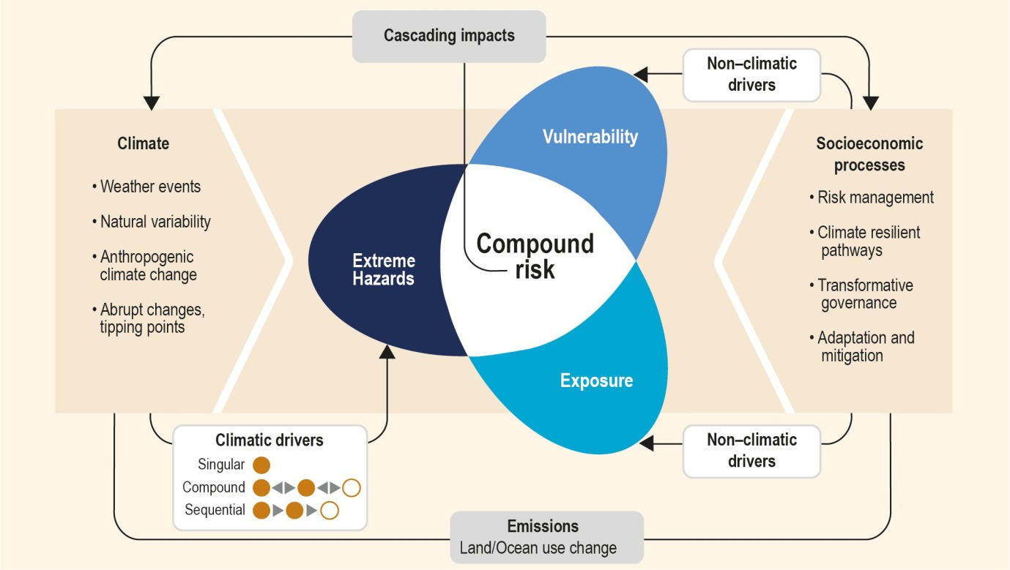

**Figure 1.** Singular or multiple climate drivers can lead to extreme hazards and associated cascading impacts. These can combine with non-climatic drivers to affect exposure and vulnerability, leading to compound risks. From Collins et al. (2019).



**Figure 2.** Necessary and non-necessary components of tipping point definitions. The four necessary conditions for defining a tipping point form the centre of these concentric circles. Other themes can be grouped (e.g., multiple themes related to causality) in additional circles. These circles’ proximity to or distance from the innermost circle might depend on additional criteria that specify their relevance for defining and understanding tipping points. (Milkoreit et al. 2018).



**Figure 3.** As a high-dimensional dynamical system approaches a bifurcation, its dynamics simplify. That is, the dynamics converge to a lower-dimensional space. Examples of a fold, (supercritical) Hopf, and transcritical bifurcation shown in A-C. From Bury et al. (2021).

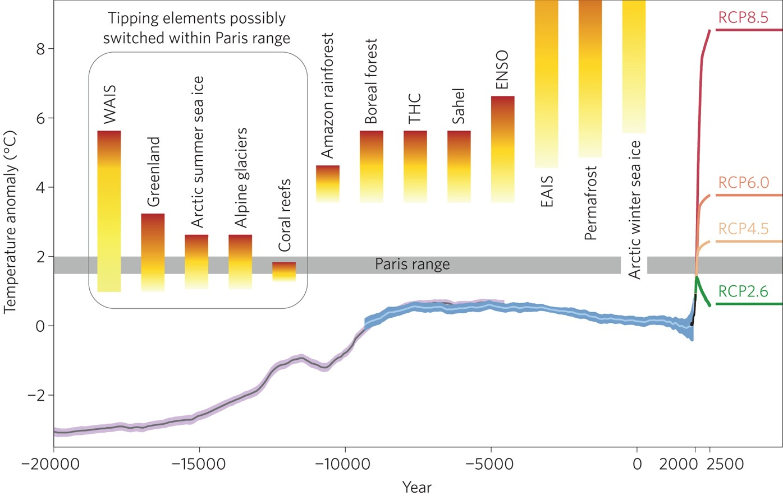

Figure 4. The global-mean surface temperature evolution from the Last Glacial Maximum through the Holocene from Schellnhuber et al. (2016) and references therein. The grey and light blue lines are based on palaeoclimate proxy data with the purple and blue shading showing one standard deviation), instrumental measurements since 1750 AD (HadCRUT data, black line) and different global warming scenarios for the future. Threshold ranges for crossing various tipping points where major subsystems of the climate system are destabilized have been added. The tipping point definition of Lenton *et al*. (2008) is followed which does not require irreversibility, so that sea ice cover is included here. The range for the West Antarctic Ice Sheet (WAIS) has been adapted to account for the observation that part of it has probably tipped already (see Joughin et al. 2014). THC, thermohaline circulation; ENSO, El Niño–Southern Oscillation; EAIS, East Antarctic Ice Sheet.

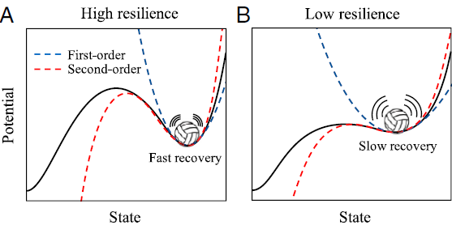

**Figure 5.** As a local bifurcation is approached, this corresponds to critical slowing down, and a flattening of the first-order approximation to the potential landscape. This allows noise to push the system farther from equilibrium, where higher-order terms become significant (Scheffer et al. 2009).

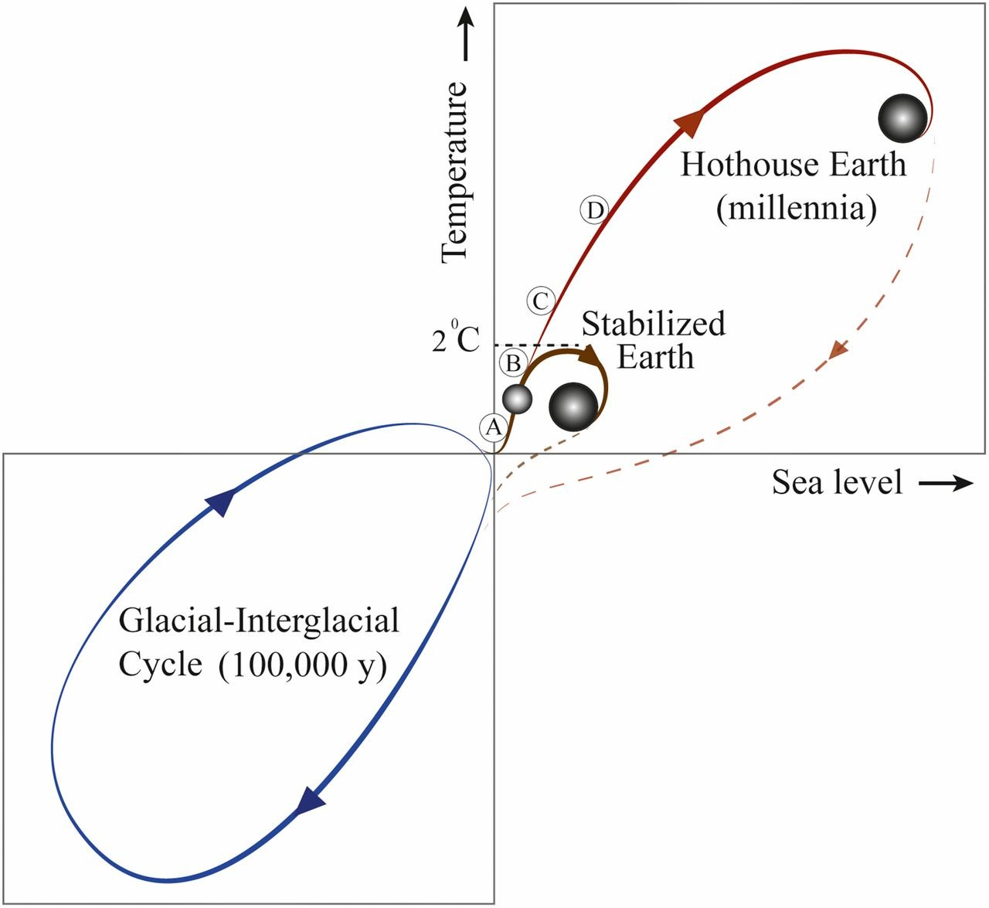

**Figure 6.** Possible future pathways of the climate against the background of typical glacial–interglacial cycles (*Lower Left*). The interglacial state of the Earth System is at the top of the glacial–interglacial cycle, while the glacial state is at the bottom. Sea level follows temperature change relatively slowly through thermal expansion and the melting of glaciers and ice caps. The horizontal line in the middle of the figure represents the preindustrial temperature level, and the current position of the Earth System is shown by the small sphere on the red line close to the divergence between the Stabilized Earth and Hothouse Earth pathways. The proposed planetary threshold at ∼2 °C above the preindustrial level is also shown. The letters along the Stabilized Earth/Hothouse Earth pathways represent four time periods in Earth’s recent past that may give insights into positions along these pathways: A, Mid-Holocene; B, Eemian; C, Mid-Pliocene; and D, Mid-Miocene. Their positions on the pathway are approximate only. Their temperature ranges relative to preindustrial are given. (Steffen et al. 2018).

1. Grey literature is used here to refer to guides, manuals and reports published by organisations outside of peer reviewed journals. This includes, for example, publications by the Environment Agency and other authoritative national and international organisations.