|  |
| --- |
|  |
| ONR Guidance  Methods for assessing culture and diagnosing organisational problems |



ONR Guidance

Methods for assessing culture and diagnosing organisational problems

**Authored by:** Principal Inspector – Nuclear Safety

**Approved by:** Head of Profession – Human and Organisational Capability

**Issue:** 1.7

**Published:** November 2024

**Next scheduled major review:** November 2029

**Document reference:** TD-HOC-GD-001

**Record reference:** 2020/320758

Revision commentary

|  |  |
| --- | --- |
| Issue | Description of update(s) |
| 1.6 | Minor update. Content transferred into latest ONR template and review date extended from December 2024 to December 2025. |
| 1.7 | Minor update to include a change of title, a reference to ONR’s Safety Culture Definition Model, and simplification of the document structure. |

Contents

1. Introduction 4

2. Purpose and scope 4

3. Further reading 5

4. The research process 6

4.1. Determining the research focus 7

4.2. Developing an initial template 14

4.3. Framing the problem statement 16

4.4. Drafting the research proposal 17

4.5. Designing the research 18

4.6. Collecting the data 19

4.7. Analysing the data 29

4.8. Reporting the research findings 36

4.9. Review, learn and improve 36

References 37

Appendix A – An example research proposal 39

Appendix B – An example of a semi-structured interview guide 41

Appendix C – An example of a participant information sheet 43

Appendix D – An example of an observation guide 44

# Introduction

The role of organisational culture in maintaining nuclear safety is well established. Reports of investigations into notable events such as Three Mile Island, Chernobyl, Davis Besse and Fukushima provide compelling evidence of the importance of establishing an effective nuclear safety culture. Much academic and business research over the past 40 years has also established the critical role of organisational culture in achieving good safety outcomes.

ONR acknowledges its role in promoting and enhancing an effective nuclear safety culture. The methods outlined in this document provides ONR’s inspectors with one means of doing this.

# Purpose and scope

The purpose of this document is to provide ONR’s human and organisational capability specialist inspectors with a flexible framework of qualitative research methods to enable them to assess safety culture and diagnose organisational problems which may be adversely impacting upon safety outcomes. It complements other ONR guidance such as ONR Technical Inspection Guide (TIG), ‘Organisational Culture Guide for Inspectors’ [1], which advocates the use of warning flags to enable inspectors to identify and record observations on attributes of organisational culture.

This document provides guidance on how to collect data using interviews, focus group interviews, observations, and document analysis, and how to analyse data using template analysis, a form of thematic analysis. ONR has found these qualitative methods to be well-suited to describing and understanding phenomena such as safety culture. These methods contained herein are broadly consistent with those published by the International Atomic Energy Agency (IAEA) [2].

This guide is written with a safety focus however the methods can be applied to all five of ONR’s purposes as set out in Part 3, Chapter 1 of the Energy Act 2013[1] [3].

# Further reading

Recommended publications for further reading on the methods outlined in this guide include:

* ‘Performing Safety Culture Self-Assessments,’ from the IAEA [2].
* ‘Business Research Methods'*,* by Bell, Bryman, and Harley [4].
* ‘Research Methods for Business: A Skill Building Approach,’ by Sekaran and Bougie [5].

# The research process

The research process shown in Figure 1 is a systematic framework that inspectors should apply flexibly and iteratively. It comprises of nine steps: determine the research focus; develop an initial template; frame the problem statement; draft the research proposal; design the research; collect the data; analyse the data; report the research findings; review, learn and improve. The remainder of this document describes how to enact each of these nine steps.

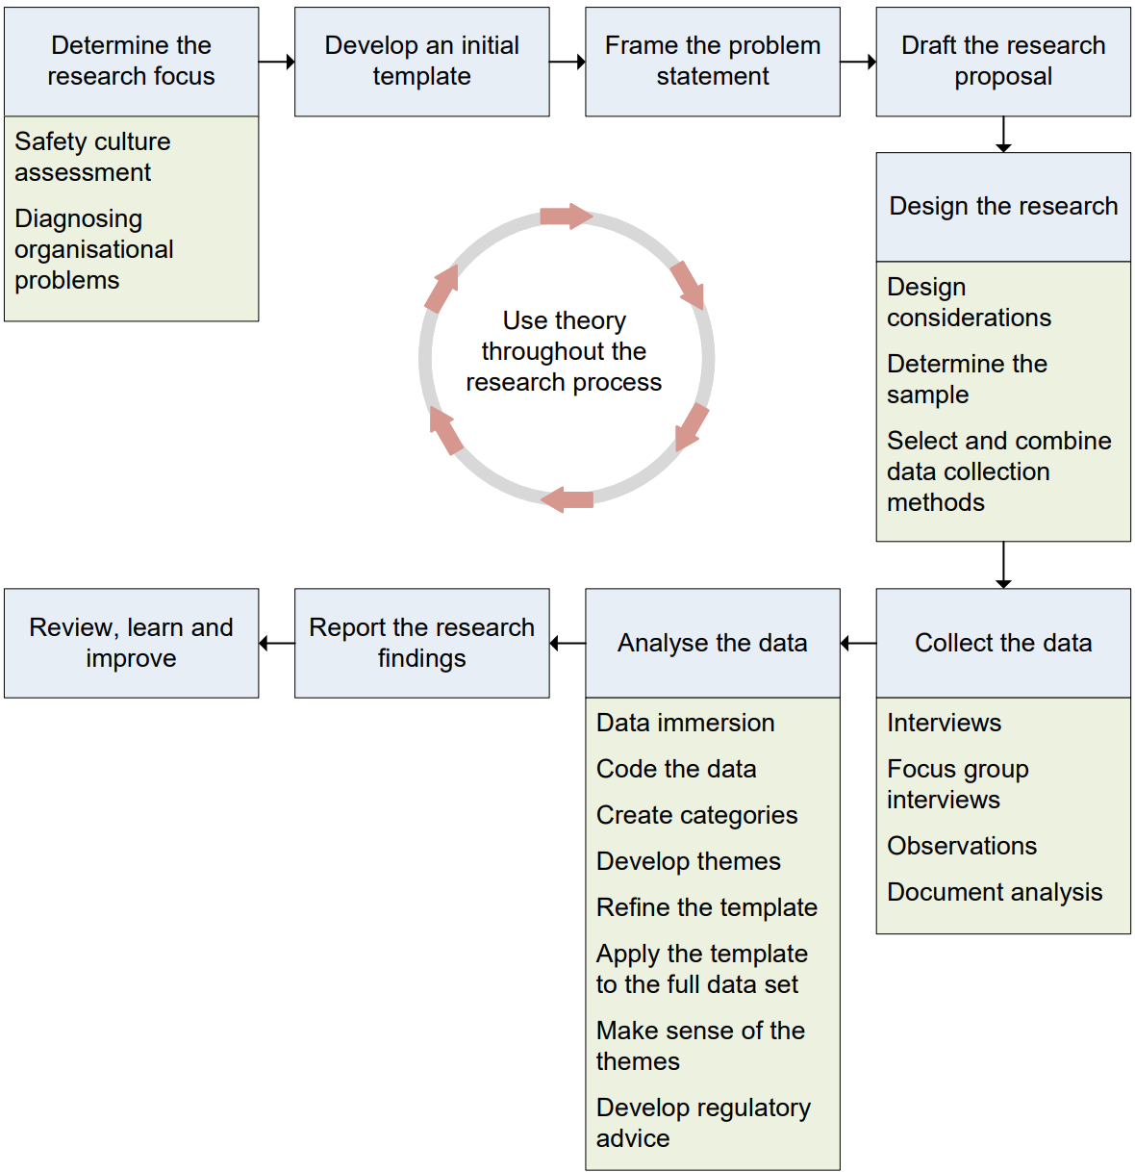

Figure 1 – The research process.

## Determining the research focus

The first step of the research process is to determine the research focus:   
an important consideration which influences the inspector’s research design decisions. This section provides an overview of the two primary areas of research focus: (1) safety culture assessment; (2) the diagnosis of an organisational problem.

### Safety culture assessment

ONR defines safety culture as: “The underlying assumptions, which underpin the value placed upon safety by every individual and group at every level of the organisation, which interacts with the organisation’s structures and management systems, resulting in behavioural norms that consistently emphasise safety over competing goals.” [6]. This definition comprises of four interrelated elements which the Figure 2 depicts:

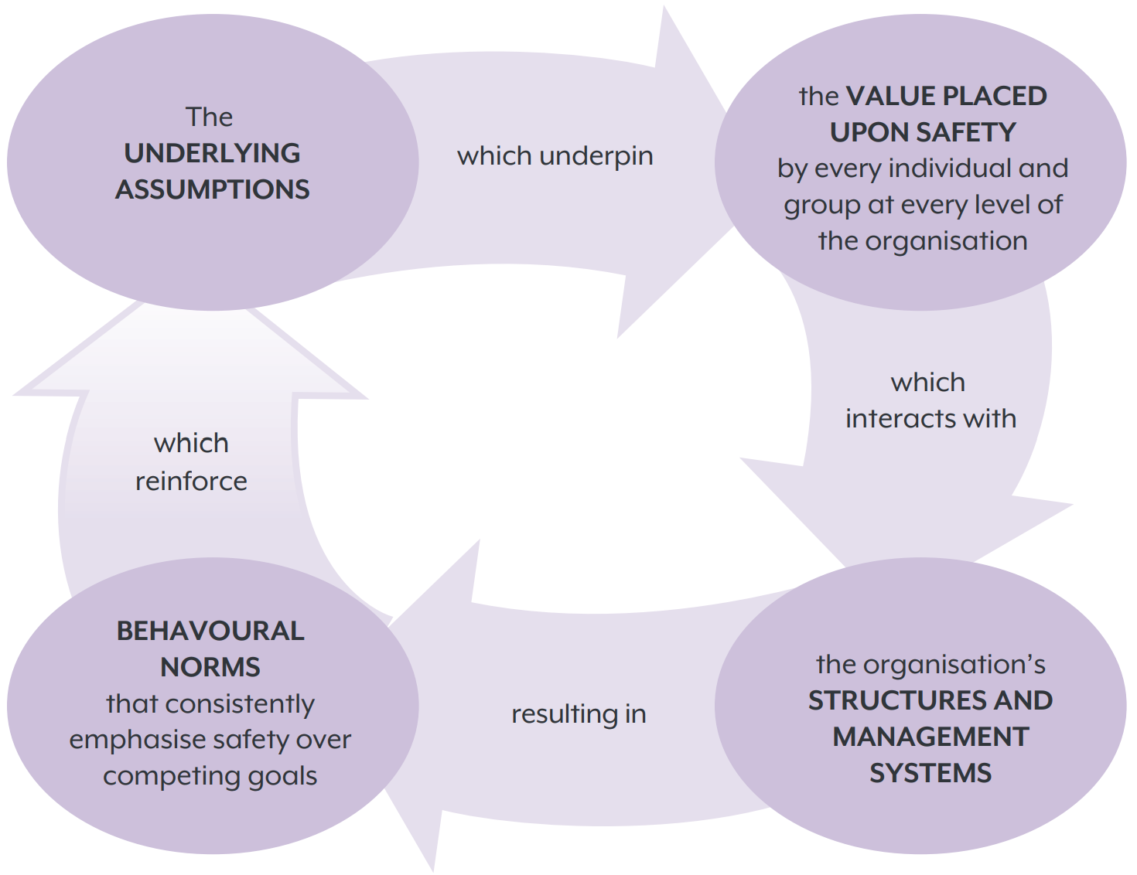

Figure 2 – The four interacting elements of ONR’s definition of safety culture.

Inspectors should explore each of these four elements when assessing safety culture. The degree to which inspectors will focus upon each element will depend upon the context of the assessment and the resources and time available to them.   
A description of each element follows:

* **The underlying assumptions**. The underlying assumptions are unconscious and unspoken elements of the safety culture which are hard to articulate as people take them for granted. They often reflect ways of working which have been successful over time and manifest themselves in “the way we do things around here.” This is the most difficult element of the culture to uncover and understand, however assumptions have a profound impact on what individuals and groups value and how they behave.
* **The value placed upon safety**. One of the key factors that influences safety behaviour is the perceived priority that leaders/managers give to safety. At times, production pressures may result in leaders/managers prioritising production over safety and this can negatively influence safety behaviours: if workers feel that leaders/managers prioritise production over safety then workers are less likely to prioritise safety, resulting in lower safety compliance and lower safety participation. When there is a safety culture, the value placed upon safety by every individual and group at every level of the organisation is enduring. People consistently emphasise safety over competing goals and behave accordingly, reinforcing the safety culture.
* **Structures and management systems**. Structures include the formal organisational structures and hierarchies, as well as informal power structures which leaders/managers have not written down but often underpin how people make decisions within a team/organisation. Management systems include policies, standards, procedures, and arrangements; for example, arrangements for reward and recognition, managing performance, dealing with disciplinary matters, and making decisions. Structures and management systems profoundly affect how people behave, and therefore it is important that leaders/managers design structures and management systems which enable the behaviours that underpin a safety culture.
* **Behavioural norms**. Behavioural norms are social rules that influence how people behave within a team/organisation. They are ways of working which people accept and can be a powerful force in influencing behaviour. In a safety culture, the behavioural norms are patterns of behaviours that are associated with safe outcomes, for example acting upon warning signs of danger, responding positively to feedback and ideas regarding safety, or challenging unsafe behaviours. People deem behaviour which is inconsistent with a behavioural norm to be socially unacceptable, and they apply social pressure to ensure that the person exhibiting the behaviour brings it back in line with the social rules.

Inspectors may undertake a comprehensive assessment of a dutyholders’ safety culture if ONR deems this to be a proportionate and efficient use of inspector resource. More commonly, inspectors will undertake targeted assessments to address specific regulatory concerns. This is often in response to evidence of poor safety performance, where a targeted assessment may enable inspectors to gain a better understanding of weaknesses in the safety culture so that they can develop regulatory strategy to influence improvements. Such targeted assessments would normally focus upon one or two of the six dimensions outlined in ONR’s model of safety culture [6] which Figure 3 depicts:

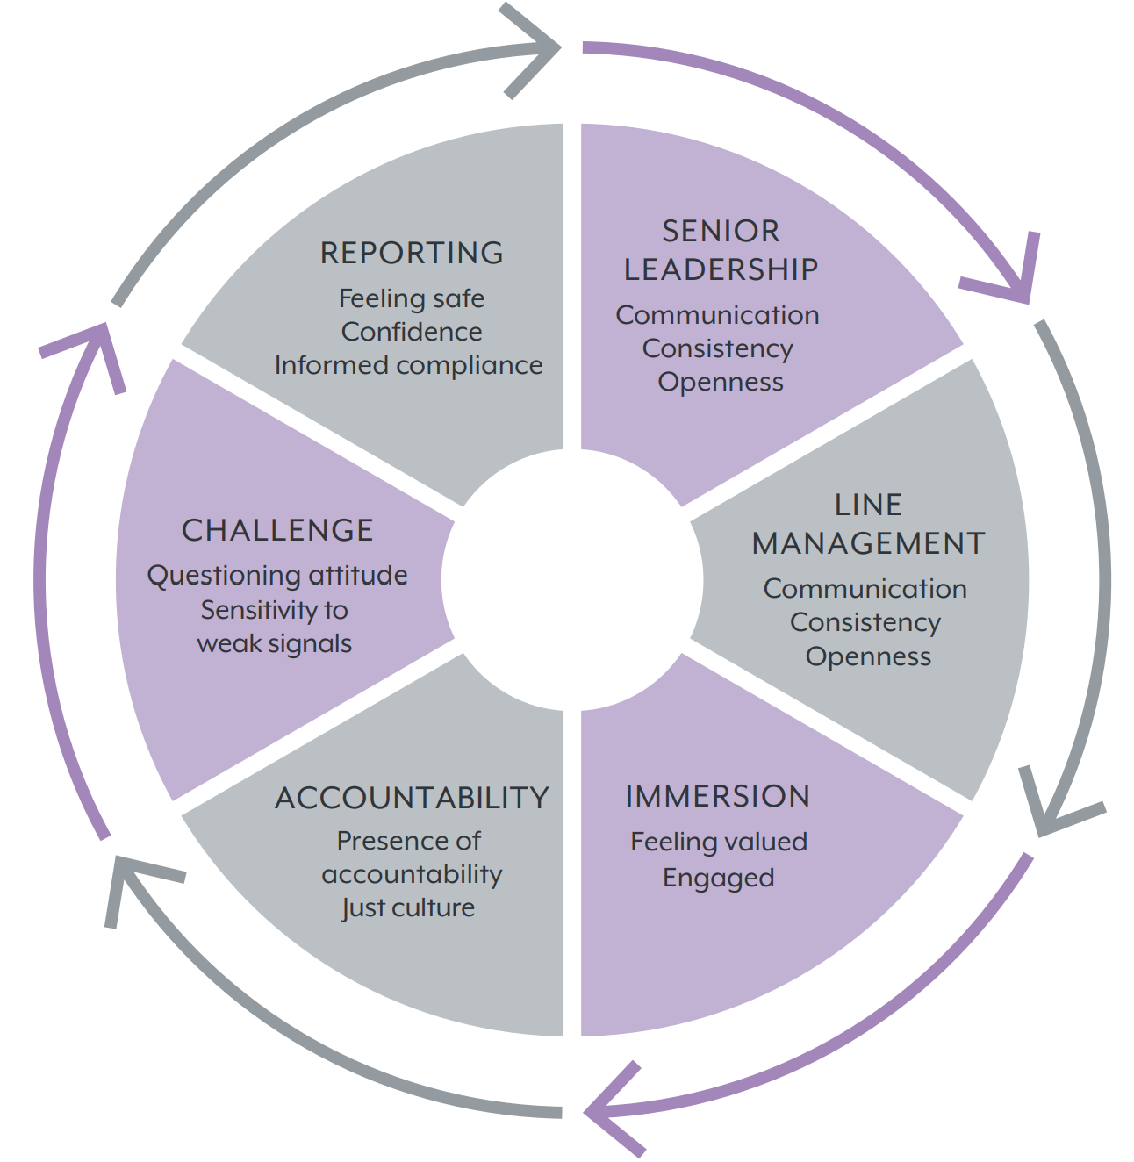

Figure 3 - ONR’s model of safety culture.

Inspectors may also want to assess culture change. Here inspectors would undertake longitudinal assessments, typically 12 to 36 months apart, so that they may compare the results of the two assessments and make a judgement upon the efficacy of the culture change.

**Assessing culture change to determine dutyholder attention levels**

A Head of Regulation wants assurance that a dutyholder’s safety culture is sufficiently robust to justify moving it from enhanced, into routine regulatory attention.

An earlier safety culture assessment found that weaknesses in senior leaders’ commitment to safety and them failing to hold people to account, were contributing to poor safety performance; these were key factors in ONR’s decision for the dutyholder to enter enhanced attention in the first place. The inspector recommends a targeted culture assessment, focusing on the Senior Leadership and Accountability dimensions of ONR’s safety culture model [6].

In the above example, the inspector assesses culture change by exploring two dimensions of ONR’s safety culture model to judge whether the dutyholder has made sufficient progress with its improvement plans. Whilst this approach is appropriate in its context, understanding culture and assessing whether it has changed is often much more challenging to assess. For example, if an organisation improves its housekeeping, improves the quality of its written instructions, and develops a new set of organisational values, is this evidence of culture change or has the organisation simply made improvements in three discrete areas of its business?

To assess culture change, ONR advises its inspectors to consider the four elements of ONR’s definition of safety culture [6] alongside the iceberg model, as shown in Figure 4, which is based upon Schein’s model of organisational culture [7].

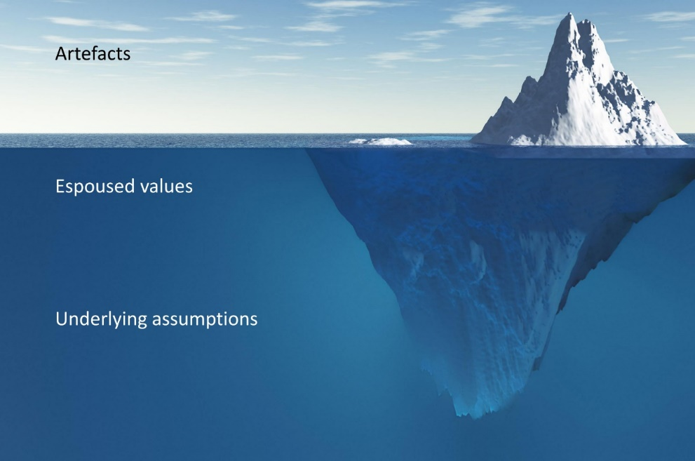

Figure 4 – Iceberg model of organisational culture.

Consider an iceberg observed from a nearby ship; what is observable above the water is only a small amount of the mass that makes up the iceberg. Upon closer inspection an observer can see more of the iceberg just underneath the surface of the water however the bulk of the mass is too deep for them to see with the naked eye.

Above the surface are artefacts: the observable physical and social environment of the organisation. These include behaviours, architecture, physical layout, signage and symbols, slogans and expressions, technology, rituals and routines, control systems, and organisational structures.

Just below the surface, less visible than artefacts are espoused values:   
the underlying meanings which explain patterns of behaviour and artefacts. Sometimes an inspector can find these written down in a ‘value statement’, an artefact which comprises of both deeply held values (those which are congruent with the underlying assumptions) and aspirational values (those which the organisation hopes to one day possess and which set a cultural direction).

Hidden deep below the surface, and usually invisible, are underlying assumptions. These are the taken for granted ways in which people within the organisation perceive the world. Sometimes described as the paradigm, only people who have become accustomed to the way the organisation works understands these.   
It is unlikely that anybody will have written these down, people will rarely speak about them, and they are difficult to unearth.

Nevertheless, for an organisation to change its culture it must unearth and understand the underlying assumptions so that people can reflect upon them and recognise what is unconsciously driving their behaviours. It is only when a critical mass of people modifies their deeply held assumptions, that culture change is likely to sustain. Inspectors concerned with assessing culture change should strive to develop an understanding of the deeply held assumptions and how they affect the way that people enact safety in the organisation. This requires reflection, analysis, and a degree of immersion in the culture of the organisation.

**Culture change: From control to empowerment**

The relationships between leaders and workers in a dutyholder organisation had been poor for many years. An inspector had come to realise that the health of the relationship was affecting safety performance, so they undertook research to understanding what was driving the low quality of these relationships.

By interviewing leaders and workers, and by observing interactions between people at different hierarchical grades, the inspector uncovered a fundamental belief which management held – that the workforce cannot be trusted and needs to be controlled.   
This mistrust had created a work environment of conflict and poor industrial relations.

When interviewing some of the organisations’ longest serving members, the inspector found that relationships between leaders and workers had deteriorated following a major incident that occurred many years earlier and which management blamed upon human error. This critical event in the organisation’s history was the catalyst for the development of a deeply held assumption: ‘hazardous processes must be tightly controlled.’ Over time this had manifested into a shared belief amongst management that the route to tightly controlling hazardous processes is by tightly controlling workers. This had led to workers becoming disengaged and distrusting of senior management.

The inspector shared this finding with the organisation’s CEO who acknowledged the existence of both the assumption and the shared belief, and the detrimental impact that these were having on relationships and performance. To address this the CEO led a culture change programme to help people understand that tightly controlling workers is not the optimal way of controlling hazardous processes, and that instead a capable and competent workforce with an increased degree of autonomy leads to more reliable and safe operations. ONR’s role was to oversee these improvements.

Here the CEO did not challenge the underlying assumption that hazardous processes must be tightly controlled. Instead, they re-articulated what this meant for the organisation: that by empowering rather than controlling people, they can establish the conditions for becoming a high reliability organisation. Over time the relationships between the workers and managers improved, along with safety and business outcomes.

### Diagnosing organisational problems

On occasions an inspector may need to understand the factors underlying a safety problem so that they can take appropriate enforcement action to influence safety improvements. Examples of safety problems an inspector may encounter include workers not following safety rules, failures to learn from previous events, or safety conversations that indicate complacency. On occasions, an inspector’s use of ONR’s safety culture model to diagnose the underlying factors may be sufficient, however sometimes the safety problem and its diagnosis requires a different analysis.

In all cases, an inspector’s first action should be to determine whether the safety problem that they have encountered is the real problem or whether it is a symptom of a deeper systemic problem. Sometimes this can be self-evident, however often the inspector will need to gather preliminary data to enable them to frame the problem accurately. This may involve them reviewing documentation, holding informal discussions with staff, conducting a small number of focus group interviews, and/or conducting field observations to see the symptoms of the safety problem first-hand. Known as an exploratory study, these do not always lead to further research. For example, an inspector may determine that the problem is not as complex as initially thought and requires no further exploration.

As an inspector develops their understanding of the problem, they should draw upon academic literature to understand the social processes which may be affecting the safety outcome. This differs from typical regulatory approaches which rely upon sources of relevant good practice as standards against which to judge compliance. The following example illustrates this approach:

**Reframing the problem**

An inspector has found that an organisation’s leaders have been unsuccessful in their attempts to increase incident reporting despite ONR’s increasing focus upon this. This is a long-standing issue and the inspector suspects that other factors may be at play. The inspector decides to undertake research to identify underlying factors so that ONR can develop regulatory strategy to secure improvements to incident reporting.

The inspector undertakes an exploratory study comprising several focus groups with workers and finds that the real problem may be that workers have both low safety motivation and feel that safety is not a priority for their leaders. Here the low incident reporting rate is a symptom (a consequence) of a systemic safety motivation problem (an antecedent) and if these conditions were to remain, setting reporting targets may not improve reporting. This distinction is important because the safety literature has established that low safety motivation can result in lower safety compliance and lower safety participation [8], and therefore low incident reporting is just one of many safety problems that low safety motivation could lead to, as shown in Figure 5.

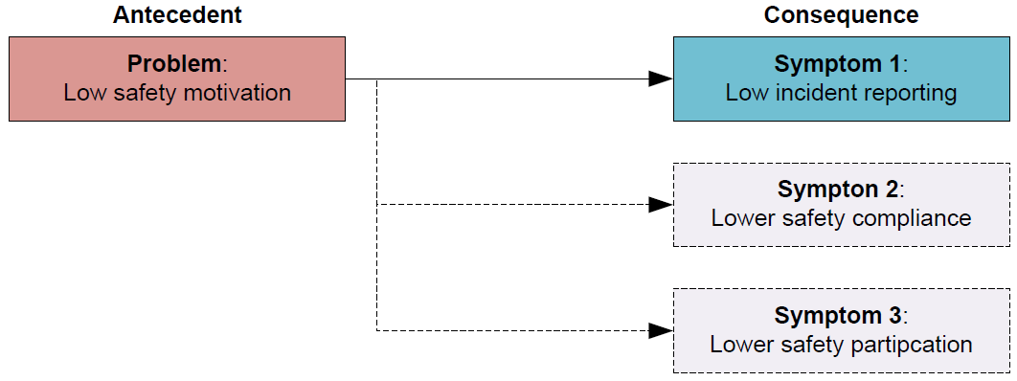

Figure 5 – Antecedents and consequences.

The inspector continues to explore the problem by further analysing the data they gathered during the exploratory study and by reviewing academic literature. In doing this they identify that safety motivation mediates the effect of safety climate[2] on individual behaviour [8], as shown in Figure 6. They also find that perceived management safety commitment as an aspect of safety climate is a key influence on safety outcomes in organisations [9]. The inspector realises that a low safety climate, exacerbated by worker perceptions of low leader safety commitment, is affecting safety motivation and now uses this new knowledge to re-frame the problem from one which started out as ‘low incident reporting’ to one concerned with ‘low safety climate.’ This is important because regulatory effort targeted on understanding and influencing improvements in safety climate could lead to positive transformational change across several safety outcomes.

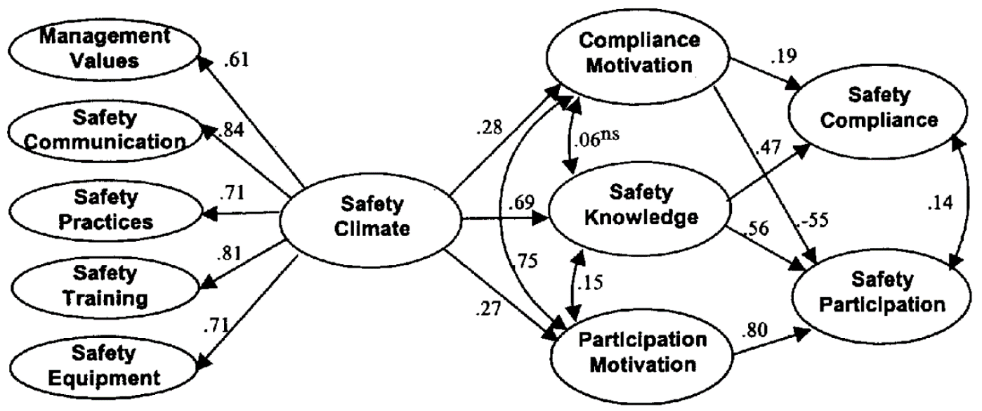

Figure 6 – Linking safety climate to performance, knowledge, and motivation [8].

Copyright 2000 by American Psychological Association.

## Developing an initial template

The second step of the research process is to develop an initial template comprising of *a priori* categories and themes. This template, which the inspector will subsequently refine, provides them with a structure for grouping data during the later analysis phase (refer to section 4.7).

The inspector’s selection of *a priori* categories and themes will depend upon their research focus:

* **Safety culture assessment**. If their research focus is safety culture assessment, then the *a priori* categories and themes should reflect some (targeted assessment) or all (full assessment) of the six dimensions and attributes of ONR’s model of safety culture (refer to the example at Figure 7).
* **Diagnosing an organisational problem**. If their research focus is diagnosing an organisational problem, then the *a priori* categories and themes will be academically informed and relevant to the social processes that the inspector wants to explore (refer to the example at Figure 8).

Inspectors may also derive *a priori* categories and themes from the findings of previous research to evaluate whether the dutyholder has made adequate progress. The number of levels of hierarchy in the template depends upon pragmatic considerations such as the amount of time and resources that an inspector has available for the analysis. As a guide two or three levels should suffice. Inspectors should consider the top-level to be *a priori* themes and the next level(s) down to be *a priori* categories/subcategories.

|  |  |
| --- | --- |
| **Initial template for a safety culture assessment** based upon ONR’s model of safety culture [6]. | |
| 1. Senior leadership  1.1. Senior leader communication  1.2. Senior leader consistency  1.3. Senior leader openness  2. Line management  2.1. Line manager communication  2.2. Line manager consistency  2.3. Line manager openness  3. Immersion  3.1. Feeling valued  3.2. Engaged | 4. Accountability  4.1. Presence of accountability  4.2. Just culture  5. Challenge  5.1. Questioning attitude  5.2. Sensitivity to weak signals  6. Reporting  6.1. Feeling safe  6.2. Confidence  6.3. Informed compliance |

Figure 7 – Initial template for a safety culture assessment.

|  |  |
| --- | --- |
| **Initial template for diagnosing an organisation problem** (the factors influencing workers’ beliefs about the importance of following safety rules) developed from “The theory of planned behaviour,” by Azjen, [10]. | |
| 1. Attitudes towards behaviour  1.1. Behavioural beliefs  1.1.1. Importance of rule  1.1.2. Knowledge of safety imperative  1.2. Outcome evaluation  1.2.1. Safety benefits  1.2.2. Relative importance  1.2.3. Knowledge of consequence  2. Subjective norms  2.1. Normative beliefs  2.1.1. Attitude of management  2.1.2. Attitude of peers  2.1.3. Frequency of rule-breaking  2.2. Motivation to comply  2.2.1. Frequency of consequence  2.2.2. Severity of consequence  2.2.3. Positive reinforcement | 3. Perceived behavioural control  3.1. Control beliefs  3.1.1. Means to follow rule  (resources and time)  3.1.2. Ability to follow rule  (know how)  3.2. Perceived Power  3.2.1. Confidence in means to follow  rule  3.2.2. Confidence in ability to follow  rule |

Figure 8 – Initial template for diagnosing an organisational problem.

## Framing the problem statement

The third step in the research process is to frame the problem statement.   
A professionally written problem statement comprises:

* A description of the safety problem (the real problem, not its symptoms);
* The research objective(s); and
* The research question(s).

Inspectors should invest time to ensure that they draft a problem statement which frames the problem accurately and is both relevant (is aligned to regulatory strategy) **and** feasible (is achievable given the resources available). Figure 9 shows an example of how an inspector may frame a problem statement for diagnosing an organisational problem using the earlier example of low incident reporting.

|  |
| --- |
| **Problem statement** |
| **Problem**  Despite both dutyholder and ONR intervention, incident reporting has not improved. Initial data gathering suggests that the safety climate may be low, exacerbated by worker perceptions of low leader safety commitment. These factors may be affecting the safety motivation of the workforce, explaining the failure to improve incident reporting. A literature review indicates that safety climate affects safety motivation which in turn affects safety compliance and safety participation [8], and that perceived management safety commitment as an aspect of safety climate is a key influence on safety outcomes in organisations [9]. Therefore, theory supports this view.  **Research objective**  The objective of this research is to explore employees’ perceptions of safety climate using the five dimensions of management values, safety communication, safety practices, safety training, and safety equipment [8], to understand how this may be impacting upon safety motivation and ultimately safety performance.  The inspector will then use the research findings to develop regulatory strategy to secure improvements to the safety climate which should positively affect a range of outcomes including incident reporting.  **Research questions**   * How is the safety climate shaped by the leadership? * How is the safety climate perceived by the workforce? * How is the safety climate impacting upon safety motivation? * What can the dutyholder do to improve the safety climate? |

Figure 9 – An example of a problem statement.

## Drafting the research proposal

The fourth step in the research process is to draft the research proposal. Its contents should comprise:

* A title.
* The problem statement (problem, research objective and research questions).
* The scope of the study.
* The relevance of the study to ONR’s purposes.
* How inspectors will undertake the research (pending detailed design).
* The timeframe.
* The resources required.

The inspector should record the research proposal in the ‘Plan’ section of the Assessment module of WIReD. Appendix A shows an example of the content of a research proposal.

## Designing the research

The fifth step of the research process is to design the research. This section provides an overview of design considerations, how to determine the sample, and how to select and combine data collection methods.

### Design considerations

Qualitative research can be labour intensive, so inspectors should:

* Consider how much data the research team can analyse in the available time.
* Choose methods which are most efficient given the limit of the resources available.
* Strike a balance between gaining general insights (what is important in this context) and detailed insights (how things occur in this context) into the safety culture or safety problem.
* Design the research in such a way that it enables them to efficiently draw out insights from which they can provide regulatory advice and develop regulatory strategy.

### Determining the sample

Sampling in qualitative research is concerned with gaining insight rather than representativeness. Inspectors should select cases and participants in a strategic way and from multiple sources to enhance the credibility of any insights found.

**Key point:** Do not rely solely on volunteers as people who choose not to volunteer often hold views which are of high research value. To avoid this, send out targeted invites.

The number of interviews (or focus group interviews) required to achieve saturation will vary from study to study; the research skills of those conducting the data collection will also affect this number – an inspector with well developed research skills will be able to elicit more insights from a smaller data set. As an approximate guide, eight focus group interviews or 16 one-to-one interviews may be sufficient for an skilled inspector to achieve saturation. In some circumstances it may be acceptable for inspectors to reduce these numbers when they combine these methods, however too great a reduction may adversely impact upon the dependability and credibility of the insights gained. In some circumstances inspectors may need to plan a larger sample size from the outset, for example when undertaking research in organisations with multiple sites.

An inspector should continue sampling until they are unable to generate new findings; known as ‘saturation’ this indicates that an inspector has undertook adequate sampling. If at the end of the planned sampling the inspector is still uncovering findings relevant to the research, then the inspector should expand the sample size by conducting further data collection until they achieve saturation.

### Selecting and combining data collection methods

An inspector should select and combine data collection methods to provide the best insights for the given problem. The four data collection methods outlined in this guidance are semi-structured interviews, focus-group interviews, observations, and document analysis. Inspectors can combine these in several ways:

* **To explore**: The inspector collects and analyses data as preparation for later data collection, for example to properly frame a problem or to aid the formulation of well-defined research questions.
* **To explain**: The inspector collects data and uses it to elaborate on the findings of data that they collected and analysed earlier on.
* **Merge**: The inspector merges all the data and analyses it together as a whole.

**Key point:** Triangulation involves an inspector using multiple methods or sources of data to provide greater confidence in the findings. The cross-checking of findings from different methods and data sources also aids an inspector in developing a richer understanding of the social processes that they are exploring.

The inspector’s selection and combination of data collection methods should be deliberate and planned. The inspector should explain their rationale for selecting and combining data collection methods in their research proposal.

## Collecting the data

The sixth step in the research process is to collect the data. This section provides an overview of interviews, focus group interviews, observations, and document analysis.

### Interviews

Interviews are the most widely used method for gathering data in qualitative research. Inspectors may choose to undertake two types of interviews: unstructured or semi-structured. In an unstructured interview an inspector uses a short aide-memoire covering a range of topics and retains a great degree of flexibility in what to ask and when. The aim is to generate a conversation and a rich discussion about the interview topics. In a semi-structured interview, the inspector develops and uses a pre-prepared interview guide to give greater structure to the interview. Interview guides comprise of a list of questions on the topics that the inspector will cover and normally they will ask all the questions in the guide during the interview. The inspector may also ask questions that they have not included in the interview guide as they respond dynamically to the interviewee’s answers. In both types of interviews, the interviewee retains a great degree of freedom in how they respond.

The choice of which interview method an inspector should use depends upon the following two factors:

* **Level of understanding**. When the inspector has a clear understanding of the information sought and knows what topics they want to address, they should choose to undertake semi-structured interviews, whereas when the inspector has less of an understanding of the information sought or wants to gather initial data to properly frame the safety problem, they should choose to undertake unstructured interviews.
* **Degree of comparability**. When several inspectors are each undertaking interviews, they should choose to undertake semi-structured interviews as the use of the interview guide makes it easier to compare the data gathered by each inspector.

When developing an interview guide, the inspector must first consider what information they need to answer each of the research questions. The interview questions should assist in answering the research questions, but they should not be too specific: the inspector should not convert the research questions directly into interview questions. The inspector should plan the order of the questions so that the interview flows naturally; it is however acceptable to change the order of the questions during the interview if the inspector believes this to be of benefit. Inspectors should think about the questions from the perspective of the interviewee and use language which the interviewee will understand and be of relevance to them. It is good practice to record general information such as name, age, gender, job role, and years working for the company, as this can help to put answers into context later.

The structure of an interview guide comprises an introduction, a main body, and wrap-up questions. The main body normally comprises both broad questions aimed at gaining a broad understanding of an issue or context, and direct questions aimed at gaining a more specific understanding of an issue or context. An example of a semi-structured interview guide is at Appendix B.

Good interviewing skills take time to develop. A good interviewer will be knowledgeable about the research and will know how to start the interview, how to ask questions, how to motivate interviewees to answer questions, what to look for in answers, and how to properly close an interview. This requires good planning, effective training, and clear guidelines for those conducting the interviews.   
Table 1 shows tips for conducting a successful interview.

Inspectors can conduct interviews face-to-face, by videoconference, or over the telephone. Face-to face interviews are the most effective as these enable the interviewer to build rapport and pick-up on non-verbal cues much easier than by videoconference or telephone. Inspectors can however conduct telephone and videoconference interviews from the home or the office, enabling them to contact several people in a brief period and avoiding travel. Inspectors may consider undertaking a combination of interviews: some remote to save on time and some face-to-face interviews to retain interview quality.

**Key point:** Dutyholders have different IT security and software limitations which can make video-conferencing compatibility and connectivity challenging. Early testing is essential to ensure interviews can go ahead as planned.

Where possible, inspectors should record interviews and transcribe them as this has the following advantages over note taking [11]:

* It helps to correct the limitations of intuition and recollection.
* It enables inspectors to repeat detailed examination of the transcripts.
* It increases the range and precision of the insights that an inspector can gain.
* It enables other inspectors to access and scrutinise the data to protect from inspectors introducing biases into the analysis.
* It enables inspectors to re-use the data, for example in exploring other safety problems.

ONR has a small stock of voice recorders available from the divisional delivery support (DDS) teams. DDS may also be able to provide a transcription service upon request. Inspectors wanting to use a voice recorder on site should engage early with the dutyholder to ensure that they can address any security requirements.   
A dutyholder may be able to provide access to an approved voice recorder for use in secure areas and arrange for a member of staff to transcribe the interviews on ONR’s behalf however the dutyholder would need to give assurances that they would respect the interviewees’ confidentiality and anonymity.

Table 1 – Tips for a successful interview

| **Purpose** | **Explain the purpose of the interview clearly** |
| --- | --- |
| Quality of questions | Ask questions which are easy to understand and answer.  Present questions in a logical order.  Questions should prompt open discussion.  Use language which reflects the understanding and everyday experiences of the interviewee. |
| Quality of interview process | **Listening & empathy**  Show an interest in the interviewee’s responses.  Explore silences and laughter.  Be empathetic and sensitive to the issues expressed.  Be patient.  **Understanding**  Follow up or clarify the meanings of the interviewee’s answers throughout the interview.  Clarify things not understood.  Corroborate and interpret the interviewee’s responses.  Be critical and do not take responses at face value.  **Direction and flexibility**  Be open to the articulation of unexpected phenomena.  Ensure the interview is neither too structured and directive nor too unstructured and free flowing.  **Remembering and connecting**  Refer to earlier discussions and connect points throughout the interview |
| Quality of information and discussion | Seek detailed qualitative descriptions.  Seek descriptions of specific events, processes, and practices.  Seek nuanced comparative descriptions.  Facilitate a conversation which is spontaneous, rich, and specific.  Seek answers which are relevant to the questions asked.  Ask succinct questions and encourage long responses |

Potential issues with interviews include:

* **The uncommunicative interviewee** who may be reluctant to participate in the interview, may be anxious, or may be of a quiet disposition.
* **The over-communicative interviewee** who may talk more than anticipated and may stray from answering the questions onto topics which are not relevant to the research objective.
* **The high-status interviewee** who chairs meetings and who may try and take charge of the interview, making it difficult to steer the interview in the direction originally intended. They are often highly political in their answers, so it is important for the interviewer to be critical and not to take responses at face value.
* **The high-status interviewer** who creates an imbalance in power between interviewer and interviewee. ONR’s inspectors have legal power and are   
  ‘high-status interviewers’ so it is important to reassure interviewees by clearly explaining the purpose of the interview, by empathising with them, and by establishing rapport.

Participants should be willing to participate in the interviews. On occasions participants may turn up for an interview with little or no information and some may find this daunting. Inspectors should outline the purpose of the interview and explain how this differs from inspection. They should build rapport with the participants and answer any questions they may have about the interview process and the use of their data. They should provide participants with a participant information sheet which they can use to brief them. Appendix C shows a participant information sheet prepared for a semi-structured interview.

|  |
| --- |
| **Questioning technique**  **Use the funnelling technique**. At the beginning of an interview, it is advisable to ask open-ended questions to get a broad idea and form some impression about the situation, for example: “What are your feelings about working for this organisation?” From the responses to this broad question, the interviewer may ask further questions that are progressively more focussed as the interviewer processes the interviewees’ responses and notes some possible key issues relevant to the situation.  **Ask unbiased questions**, for example: “Tell me your experiences of having to follow nuclear safety rules” is a better question than: “It must be a nightmare having to comply with all these nuclear safety rules – tell me about your experiences of this.”  **Clarify issues**. Restate or rephrase valuable information given by the respondent to ensure you understand it. For instance, if the interviewee says: “Production always takes priority over safety rules; getting the job done is number one – it’s always those who get the job done that get rewarded”, the interviewer may interject: “So are you saying that people get rewarded for completing a task even if it is known they haven’t followed the safety rules?” Rephrasing in this way clarifies the issue of whether managers reward people when it is known that they are violating rules.  **Help the respondent to think through issues**. If the respondent is not able to verbalise their perceptions, or replies: “I don’t know,” then ask the question in a simpler way or rephrase it.  **Take notes**. Make clear and comprehensive written notes throughout; this is essential if the interviewer is not recording the interview.  Kvale identifies nine types of questions/questioning tools [12]:   * **Introducing questions**: “Please tell me about your role.” * **Follow-up questions**: “You mentioned that you felt the task was not safe. Could you say more about that?” * **Probing questions**: “Can you give me a further example of this?” * **Specifying questions**: “What did you do then?” or “How did your manager react to what you said?” * **Direct questions**: “Do you find it easy to follow the work instructions?” or “Are you happy with the amount of on-the-job training you have received?” * **Indirect questions**: “What does most of the workforce think about how safety is prioritised by management” the interviewer can follow this with  “Do you share that view?” to gain an understanding of the interviewee’s own views. * **Structuring questions**: “I would now like to move onto the final question. Can you tell me about…?” * **Silence**: To give the interviewee time to gather their thoughts before answering a question. * **Interpreting questions**: “Do you mean that you don’t mind raising near miss reports, but when managers give you no feedback you feel more reluctant to do it?” |

### Focus group interviews

A focus group interview is a type of group interview that seeks the opinions of several people about an issue or topic. They allow inspectors to examine how a group of people interprets and make sense of topics of interest to the research. Inspectors may observe group members probing and challenging each other’s reasons for holding a view, offering different perspectives, voicing their agreements and disagreements, or justifying the reasons for their views. This group interaction produces more fully articulated accounts, and provides inspectors with insights into diversity of perspectives, collective sense-making, and the opportunity to observe culture in action: something which inspectors cannot easily attain by other methods.

A focus group interview normally involves small groups of six to twelve participants and an inspector who acts as the moderator, managing the interview process and facilitating group discussion. Inspectors should form smaller sized groups when the topics are sensitive or controversial, or when they seek detailed personal accounts, and they should select larger groups when they seek numerous brief suggestions.   
It is normally a clever idea for an inspector to over-recruit in anticipation of no-shows.

Focus group interviews can take a topic-based approach using a short aide-memoire like those used for unstructured interviews, or a question-based approach using an interview guide like those used for semi-structured interviews. As it is a method of interview, much of the guidance in the earlier section on interviews is also relevant here. The advantages and disadvantages of focus group interviews in comparison to semi-structured interviews are summarised in Table 2.

Table 2 – A comparison the advantages and disadvantages of focus group and semi-structured interviews

| **Focus group interviews** | **Semi-structured interviews** |
| --- | --- |
| **Advantages**:   * Different perspectives. * Voicing of agreements and disagreements. * Qualification, justification, and reasons for views. * Display of culture and group dynamics. * More fully articulated accounts. * Diversity of perspectives. * Collective sense-making.   **Disadvantages**:   * The inspector may only be able to cover a limited number of questions. * Less depth and detail * The inspector needs to carefully moderate the group to ensure that they hear all views and manage conflict. * Confidentiality can be a problem in a group of people. * Potential for groupthink. | **Advantages**:   * Allow inspectors to explore sensitive or personal topics. * Greater control over the selection of the participants. * Depth and comprehensiveness of responses to questions. * Free from group pressures.   **Disadvantages**:   * Time consuming. * Lacks the opportunity to observe interactions with others. |

The moderator is essential to the success of the focus group interview and their role is to generate a good discussion by moderating the degree of control and intervention they exert on the group. Moderators should allow the participants to have a degree of freedom in what they discuss whilst steering the discussion back on track if it veers off too far at a tangent. Allowing the participants freedom to discuss what they want to discuss gives the moderator insights into what the participants see as interesting or important. Moderators should ensure the psychological safety, comfort of all participants, and avoid conflict within the group. The moderator has an essential role in monitoring the process by ensuring all participate and by paying attention to what participants say and what they do not say, or who they speak about and do not speak about. The moderator should always remain neutral.

Moderators should consider the nature of the interactions between the participants and not just what the participants said as this may provide insights relevant to the research questions. The level of participation and openness, the emergence of unexpected and divergent views, and the group reflecting on its own understanding, are evidence of the success of a focus group interview.

The mix of participants is an important consideration. A homogenous group is one where all participants are of a similar kind: they may all be front-line workers, or all health physicists, or all middle managers. A heterogeneousgroup is one where participants differ in some way: they may be from different professional disciplines, different licensed sites, or be of different hierarchical grades. Inspectors must give careful thought to the mix of the participants in the group to not stifle debate, for example a homogenous group where all workers are of the same grade may elicit more honest responses than a heterogenous group with participants of differing grades.

Video recording can aid data collection during focus-group interviews, whereas a voice recording’s lack of video makes it difficult to retrospectively establish who is speaking. ONR’s communications team has video recording equipment which inspectors may be able to loan upon request. Dutyholders may also be able to provide inspectors with a video recording service.

### Observations

Observations involve going into a workplace, watching what people do, and describing, analysing, and interpreting what one has seen. This could be observing day-to-day operations at a dockside, observing shift changeovers in a power-plant control room, or observing a board meeting.

Observations can be either structured or unstructured. Unstructured observations focus upon what people do, how work unfolds or does not unfold, the work environment, cultural artefacts, relationships, or how people talk and interact.   
They generate a deep understanding of context, reveal novel behaviours, and help to identify cultural symbols. They do however require extensive resources and time.

**Symbols as an insight into organisational culture**

The superior location and quality of the directors offices on the top floor of the most modern building on-site, reserved car-parking spaces for the directors but no-one else, and a hot-desking policy which applied to everyone except the most senior management, were found to be symbols of an organisational culture which placed great importance on hierarchy.

Structured observations focus on pre-specified tasks, events, situations, or interactions. When conducting structured observations, inspectors should use an observation guide to guide the data collection; an example of a structured observation guide is at Appendix D. Structured observations can generate deep understanding of a specific context or issue and are useful when inspectors’ have limited time and resources. One limitation of structured observations is that greater structure infers a tighter focus, resulting in narrower descriptions overall.   
Table 3 shows a comparison of structured and unstructured observations.

Table 3 – A comparison of the advantages and disadvantages of structured and unstructured observations.

|  |  |
| --- | --- |
| **Structured observations** | **Unstructured observations** |
| **Advantages**:   * Provides a deep understanding of a specific context or issue * Less time and resources required * Can provide quantitative data (number of times something occurs / a behaviour is observed, in the context of interest)   **Disadvantages**:   * Narrower descriptions * Less freedom to collect data | **Advantages**:   * Provides a deep understanding of a wider context * Reveals novel aspects of behaviour * Aids the identification of cultural symbols   **Disadvantages**:   * Time and resource intensive |

Normally inspectors will be ‘complete observers’: this is the most unobtrusive observation as the inspector does not interact with the people being observed nor do those being observed take the inspector into account [13]. An example of this is the observation of a ‘plan of the day’ meeting where the inspector sits to the side of the room quietly observing and taking notes. There may be occasions where an inspector adopts a ‘participant observer’ role such as attending a training course where the inspector is open with the trainer and other participants about their research and observes and collects data whilst participating fully in the social setting [13]. As an independent statutory regulator, it would not be appropriate for inspectors to adopt a ‘complete participant’ role as this would require them to immerse themselves in the work of the dutyholder.

Figure 10 shows the various observer roles, adapted from Gold [13].

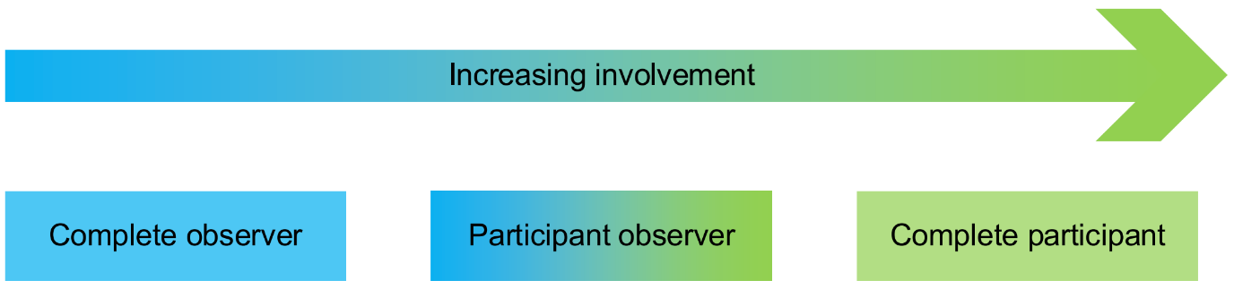

Figure 10 – Observer roles.

There may be occasions where an inspector undertakes incidental observation.   
This is a form of observation which an inspector has not planned to conduct and occurs without the knowledge of other people in the social setting, for example an inspector may observe how security-focussed behaviours are enacted when they collect a site pass, how people interact with hazards or respond to safety rules when walking across a site, or who sits with whom and how people engage with each other when having lunch in a canteen. Incidental observation overcomes the challenge of people adapting their behaviour if they know that an inspector is observing them [14].

A final consideration is the use of field notes for recording descriptive details of what the inspector has observed. The following are good practices for writing up field notes [4, 15]:

* Write down notes as soon as possible after observing something of interest.
* Write up full field notes at the end of each day.
* Use exact quotes where possible.
* Use pseudonyms to protect confidentiality.
* Describe activities in the order in which they occur.
* Include relevant background information to situate the event.
* Provide descriptions without inferring meaning.
* Separate one’s own thoughts and assumptions from what one observes.
* Write field notes that are clear and which you can understand at a later point in time.
* Take lots of notes – it is better to write too much that not enough.
* Include details of the location, the people involved, the context and the date and time.

### Document analysis

Document analysis is a systematic method for evaluating or reviewing documents that an inspector may wish to conduct early on to help shape the focus and design of the research. They can also use it to verify findings from other sources. It involves skimming, reading and interpreting documentation, as described by Bowen [16].

Document analysis may provide insights into hierarchy, power, authority, the degree to which safety controls and formalised, and how people value and prioritise safety. Documents may be current, historic, private, publicly available, strategic, or tactical. Table 4 shows typical documents of interest to safety:

Table 4 – Typical documents of interest to safety

|  |  |
| --- | --- |
| **Documents** | |
| * Mission/purpose, vision, and values. * Business strategy. * Annual reports. * Company website. * Job adverts. * Employee socialisation arrangements. * Safety policy * Results of the Nuclear Industry Safety Culture Inventory (NISCI) or other safety culture surveys. * Results of and employee engagement surveys. * Organisational charts. * Committee meetings terms of references and minutes. * Job/role descriptions. * Safety performance indicators policy and data. | * Performance management policy. * Behaviours framework. * Performance appraisal forms (for safety objectives). * Leadership development policy, training materials and data. * Safety decision making processes. * Visible leadership/leader in the field programmes. * Just culture policy, arrangements, and data. * Disciplinary policy, arrangements, and data. * Reward and recognition policy. * Workplace risk assessments. * Work instructions. * Accident/incident investigation data and reports. |

Bowen identifies five specific uses of documents within research [16]:

* Documents can provide data on context, such as background information, historical insight, or past events.
* Information contained in documents can suggest some questions that a researcher needs to ask and situations that they need to be observe.
* Documents provide supplementary research data as information and insights derived from documents can be useful additions to a knowledge base.
* Documents provide a means of tracking change and development, for example where various drafts of a document are accessible then inspectors can compare them to identify the changes.

## Analysing the data

The seventh step in the research process is to analyse the data. This section provides an overview of template analysis, a form of thematic analysis which is well suited to research conducted in an applied context [17]. Template analysis balances a degree of structure in the analysis process with the flexibility to adapt it to the needs of the research [18], and comprises three phases: preparation, coding, and application, as presented in Figure 11.

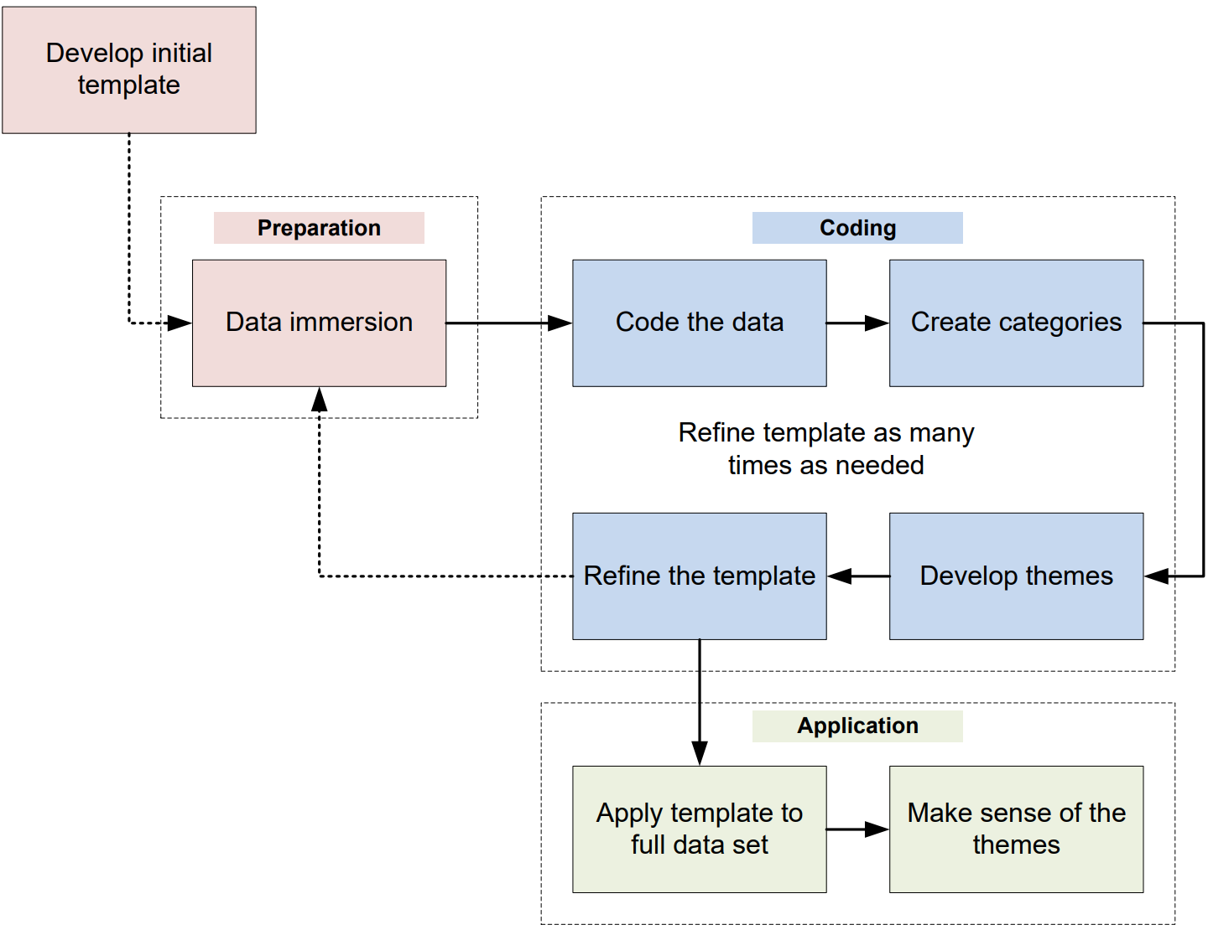

Figure 11 – Data analysis method.

### Preparation phase

Data immersion

An inspector first immerses themselves in the data set to get a sense of the whole. This involves them reading and re-reading the interview transcripts, notes from focus group interviews, observation field notes, and documents selected for document analysis. By doing this, the inspector begins to make connections between discrete data sources and develops ideas about the nature of the areas that they are exploring.

### Coding phase

Coding the data

The aim of coding is to tag and sort the data. Time pressures or other commitments may tempt an inspector to bypass the coding phase and to instead begin grouping data to the hierarchical structure of the initial template’s categories and themes. Unfortunately, this approach often results in substantial amounts of data being leftover which does not fit into the initial template’s *a priori* categories and themes. Some of this data may be important to the research objective and therefore this drive for efficiency often results in less insights. Inspectors should, therefore, follow the guidance outlined in this section as this will help them to develop an enhanced template which they will be able to use to group more of the data to later.

A code is a descriptive label that an inspector assigns to segments of text: a single word, a phrase, or a whole paragraph. An inspector’s first step should be to code a small sample of the data such as one or two interview transcripts to establish how well the data fits the initial template. They can do this by making notes in margins, using different coloured highlighter pens, or even cutting out segments of text and attaching to post-it-notes which display the assigned code.

It is good practice that the inspector who has conducted the data collection codes the data because they will have a richer understanding of its context. Where multiple inspectors participate in data collection, they must take care to ensure that assigned codes have the same meaning attributed to them by different inspectors. As inspectors discover further information, they may add codes, re-define them, or retire them. This involves going back and forth through the data as the coding develops. It is not unusual for inspectors to assign more than one code to a segment of text.

Coding requires an active engagement with data. When coding the data, the inspector may, for example, make and record reflective remarks on: the meaning of what was being said; any doubts about the quality or validity of the data; ideas for a new category; a proposition about what may be happening; links to other parts of the data; what they find surprising about the data or case; or when they find there to be difficulty in clarifying an idea. Inspectors should consider which things are occurring most often as this can help to confirm ideas. They should also search for evidence which may counter ideas and seek out and explore data which does not fit into existing categories.

An inspector’s next step is to group codes to the initial template’s *a priori* categories and themes. They will normally do this after they have completed their initial coding of one or two interview transcripts. Once complete, the inspector then needs to consider how to deal with the codes which do not fit the initial template’s *a priori* categories and themes. When this occurs, the inspector should group those remaining codes which fit well together and share a relationship into coherent categories for inclusion in a refined template (as discussed later in this section).

Creating categories

It is rare that the people within the sample will have the same experiences and therefore the inspector will have to develop enough categories to explain everything in the data that is relevant to the research questions. For example, in a study of worker compliance with safety rules, some workers may talk about rules being ambiguous, others may talk about rules being too general, and others will talk about rules being overly complex. In this example, the inspector creates the codes ‘rule ambiguity,’ ‘rule detail’ and ‘rule complexity,’ and from these develops a new category of ‘rule quality.’

A category is saturated when an inspector finds no additional data to further develop the properties of the category. Categories therefore need enough examples of data (words, phrases, or segments of text) to identify the characteristics of concepts and emerging phenomenon.

Developing themes

Once an inspector has developed new categories, their next step is to group these together to form new themes. Themes are more than higher-order categories: they are an explanation or interpretation of what an inspector is exploring. An inspector should evaluate a candidate theme in both the data and the theory to ensure it stands up as a true theme. In the earlier example of the study of workers’ compliance with safety rules, an inspector developed a category of ‘rule quality.’   
A theme provides a connection between ‘rule quality’ and why ‘rule quality’ is important in the context of compliance with safety rules. Continuing with this example, the inspector finds that the quality of rules affects workers’ motivation to comply with them, and from this develops a candidate theme of ‘rule quality as a motivator.’ The inspector reviews the literature to test this candidate theme and finds that Vinodkumar and Bhasi, in their study of safety management practices and safety behaviour, found perceptions of safety rules to have a predictive capacity on safety compliance [19]. This increases the generalisability of the inspector’s findings who now adds the theme to the final template. Figure 12 provides a pictorial overview of the process for developing themes.

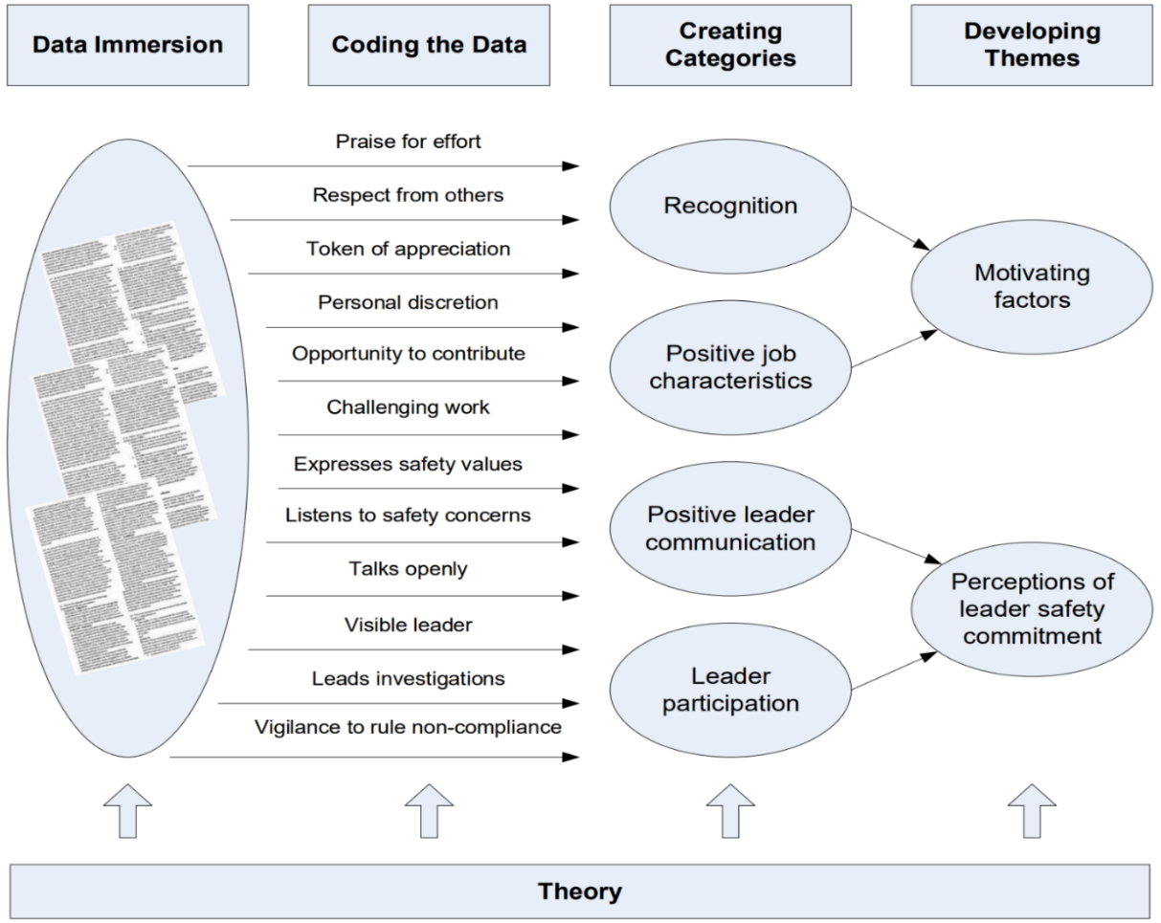

Figure 12 – The development of themes (redrawn from Green et al., [20])

As the analysis develops it may become clear that one or more themes seem to cut across many or all the other themes. Known as ‘integrative themes’ these are: “undercurrents running through participants’ accounts; often, perhaps, not addressed explicitly but very apparent to a careful reader” [17, p. 432]. These integrative themes often provide deep insights into the non-observable culture (the underlying assumptions) and can be a high value research finding.

**Integrative themes**

During an assessment of safety motivation, inspectors identified an integrative theme which they named: “us and them.” The dutyholder has both an industrial workforce (workers) and a non-industrial workforce (managers) and participants referred to these groups using terms such as “the blue hats” (the colour of the safety helmets worn by workers) and “the white hats” (the colour of the safety helmets worn by managers), or “the industrials” and the “non-industrials”. This language, and the context in which people used it, indicated that there were opportunities to improve the relations between workers and managers. This finding was of significance to the research objective as workers in high quality relationships with their managers are more likely to engage in safety citizenship behaviours [21]. The inspectors discussed this integrative theme with the dutyholder’s chief executive officer who recognised the theme and committed to improving relations between managers and the workers.

Refining the template

The last step of this phase is to refine the template. This involves an inspector taking the initial template of *a priori* categories and themes that they developed during the preparation phase and merging in the categories and themes that they developed during the coding phase. At this point, the inspector should redefine or remove any *a priori* themes and/or categories found to not fit the data.

**Development of a final template**

An inspector developed an initial template for a safety culture assessment   
(refer to Figure 7). The inspector coded three interviews and found the initial template to be a good fit for the data however the inspector identified a seventh theme of ‘Work pressure’ which was both sufficiently distinct from the *a priori* themes and of direct relevance to the research objective to warrant its inclusion in the final template.

The inspector also found that job characteristics influenced the degree to which people felt immersed in the safety culture, so they added the category of ‘Job characteristics’ to the ‘Immersion’ theme.

Figure 13 shows the final template with the additions in red text.

Further refinements of the template may be necessary once the grouping of the remaining data begins. Practical constraints will limit the number of iterations that an inspector may undertake which should be just enough to ensure that they do not leave any data relevant to the research questions un-grouped.

|  |  |
| --- | --- |
| **Final template for a safety culture assessment** based upon ONR’s model of safety culture [6]. | |
| 1. Senior leadership  1.1. Senior leader communication  1.2. Senior leader consistency  1.3. Senior leader openness  2. Line management  2.1. Line manager communication  2.2. Line manager consistency  2.3. Line manager openness  3. Immersion  3.1. Feeling valued  3.2. Engaged  3.3. Job characteristics | 4. Accountability  4.1. Presence of accountability  4.2. Just culture  5. Challenge  5.1. Questioning attitude  5.2. Sensitivity to weak signals  6. Reporting  6.1. Feeling safe  6.2. Confidence  6.3. Informed compliance  7. Work pressure  7.1. Managing competing priorities  7.2. Availability of resources |

Figure 13 – Final template developed for a safety culture assessment.

### Application phase

Applying the template to the full data set

The inspector should now apply the final template to the full data set. This requires them to group words, phrases, and segments of text to the hierarchical structure of the final template’s categories and themes. Once the inspector has done this, they will have a rich body of data structured on the final template’s categories and themes.

If the inspector finds significant amounts of data relevant to the research objective(s) that they cannot group to the template’s categories and themes, then this indicates that they need to further refine the template by repeating the coding phase. The inspector should discard any remaining data which is not relevant to the research objective.

Making sense of the themes

Once an inspector has applied the template to the full data set, an inspector’s next step is to make sense of the grouped data: to describe each theme and to draw insights to formulate answers to the research questions. Inspectors do this by explaining the story within the data to establish its meaning.

|  |
| --- |
| **Making sense of the theme ‘Motivating Factors’**  An inspector studied the data grouped under each category and theme in turn as they sought to make sense of the data they had collected whilst undertaking a safety culture assessment. For theme 3 ‘Immersion’ (refer to Figure 13), the inspector developed a descriptive account of the key features of its three categories: ‘Feeling valued’, ‘Engaged’, and ‘Job characteristics’.   * For ‘Feeling valued’ the descriptive account explored the extent to which people perceive that others value them at work and trust them to do a decent job, and why they perceive this. The descriptive account also explored how people perceive managers to enact reward and recognition, and how people felt about the recognition they receive for their efforts. * For ‘Engaged’ the descriptive account explored the extent of the vigour, dedication, and absorption that people exhibit towards safety, and how people keep safety at the forefront of their mind. * For ‘Job characteristics’, the descriptive account explored the characteristics of jobs which provide psychological meaningfulness such as how people perceive the degree to which they found their work to be challenging, the variety of their roles, the opportunities to use different skills, the degree of personal discretion, and how they felt about the importance of their contribution.   The inspector accompanied this descriptive account with an evaluation of how these motivating factors influence the safety culture by drawing links between the themes and showing why they are important in the context of the research objectives. The inspector used anonymised quotes and excerpts of documents throughout to illustrate the points they were making. |

Inspectors should incorporate quotes from interviews or excerpts from documents which best illustrate the essence of the categories or themes, using the ‘Setup-Quote-Comment’ method [22]:

* **Setup**: The first sentence or paragraph states the thesis and gives context for the quotation or data excerpt which is to follow, such as who said it (role or pseudonym) and what they were talking about at the time.
* **Quote**: The next element is the quote or data excerpt.
* **Comment**: The final sentence or paragraph emphasises important parts of the quote or data excerpt.

Relationships between categories and themes may also become apparent through the analysis. Identifying relationships helps inspectors to make recommendations and develop regulatory strategy by ensuring that they target actions upon the problems (antecedents) rather than the symptoms (consequences).

|  |  |  |  |  |
| --- | --- | --- | --- | --- |
| **Comment** **Quote** **Setup** | The workers were positive about the safety commitment of their peers and immediate supervisors however they were less positive about the safety commitment of their more senior management. As is clear in this quote from a front-line worker which they made during a focus group interview, the worker perceived a clear difference in safety commitment across hierarchical grades:   |  |  |  | | --- | --- | --- | |  | *“I’ve got no problem with my boss, he’s 100% on message with safety. Our safety is number one to him; he’s always banging on about it. It’s the higher up bosses that cause the problems by putting pressure on. As far as they’re concerned programme is everything especially when there’s a milestone payment due.”* |  |   This quote highlights that workers perceive the safety commitment of more senior management to be low in contrast to their immediate management and offers insight into factors which the worker considers may be influencing a senior manager’s behaviour: the milestone payment. The quote also illuminates that the worker perceives positive safety communications (*“always banging on about it”*) as a demonstration of his immediate supervisor’s safety commitment. |

Developing regulatory advice

The inspector should now use the insights that they have gained during this phase to develop regulatory advice and associated regulatory issues (or more formal enforcement action if they deem this to be appropriate).

## 

## Reporting the research findings

The eighth step in the research process is to report the research findings. Inspectors should document the research in an assessment note as these have a degree of flexibility in their format and are well-suited to these types of assessments (refer to the LMfS Assessment Note template for guidance on what contents should be included in such assessments [23]). Inspectors should also make a record of the executive summary and recommendations in the ‘Decision Communication’ module of WIReD. Inspectors should conduct both peer review and acceptance review in accordance with ONR document, ‘Peer Review and Acceptance of Reports for Permissioning’ [24].

Inspectors should present the research findings to the dutyholder in such a way that enables the dutyholder to ask questions and seek clarification of points. A workshop type-format is an effective means of doing this.

## Review, learn and improve

The ninth and last step in the research process is to conduct a review, learn and improve exercise that should consider what went well and why, what did not go well and why, and key lessons for future research. The inspector should record the output of the exercise and make it accessible to other inspectors embarking on research.

# References

|  |  |
| --- | --- |
| [1] | ONR, “NS-INSP-GD-070 - Organisational culture guide for inspectors”. |
| [2] | IAEA, “Safety Reports Series No. 83 - Performing Safety Culture Self-assessments,” 2016. [Online]. Available: https://www.iaea.org/publications/10742/performing-safety-culture-self-assessments. |
| [3] | HM Government, “Energy Act 2013 c. 32 - Part 3,” 2013. [Online]. Available: https://www.legislation.gov.uk/ukpga/2013/32/part/3. |
| [4] | E. Bell, A. Bryman and B. Harley, Business research methods (5th edition), Oxford University Press, 2018. |
| [5] | U. Sekaran and R. Bougie, Research methods for business: A skill building approach, John Wiley & Sons, 2016. |
| [6] | ONR, “Safety Culture: Definition and Model,” 2024. |
| [7] | E. H. Schein, “Organizational culture,” *American Psychological Association,* vol. 45, no. 2, p. 109, 1990. |
| [8] | M. A. Griffin and A. Neal, “Perceptions of safety at work: a framework for linking safety climate to safety performance, knowledge, and motivation,” *Journal of occupational health psychology,* vol. 5, no. 3, p. 347, 2000. |
| [9] | L. S. Fruhen, M. A. Griffin and D. M. Andrei, “What does safety commitment mean to leaders? A multi-method investigation,” *Journal of safety research,* vol. 68, pp. 203-214, 2019. |
| [10] | I. Ajzen, “The theory of planned behaviour,” *Organizational behaviour and human decision processes,* vol. 50, no. 2, pp. 179-211, 1991. |
| [11] | J. Heritage, Garfinkel and ethnomethodology, John Wiley and Sons, 1984. |
| [12] | S. Kvale, Interviews: An introduction to qualitative research interviewing, Sage Publications, Inc., 1994. |
| [13] | R. L. Gold, “Roles in Sociological Field Observations,” *Social Forces,* vol. 36, no. 3, pp. 217-223, 1958. |
| [14] | F. Slack and J. Rowley, “Observation: perspectives on research methodologies for leisure managers,” *Management Research News,* vol. 24, no. 1, pp. 35-42, 2001. |
| [15] | S. L. Schensul, J. J. Schensul and M. D. LeCompte, Essential ethnographic methods: Observations, interviews, and questionnaires (Vol. 2), Rowman Altamira., 1999. |
| [16] | G. A. Bowen, “Document analysis as a qualitative research method,” *Qualitative research journal,* vol. 9, no. 2, p. 27, 2009. |
| [17] | N. King, “Doing template analysis,” in *Qualitative organizational research*, G. Symon and C. Cassell, Eds., London, Sage Publications Ltd, 2012, pp. 426-450. |
| [18] | J. Brooks, S. McCluskey, E. Turley and N. King, “The utility of template analysis in qualitative psychology research,” *Qualitative research in psychology,* vol. 12, no. 2, pp. 202-222, 2015. |
| [19] | M. N. Vinodkumar and M. Bhasi, “Safety management practices and safety behaviour: Assessing the mediating role of safety knowledge and motivation,” *Accident Analysis & Prevention,* vol. 42, no. 6, pp. 2082-2093, 2010. |
| [20] | J. Green, K. Willis, E. Hughes, R. Small, N. Welch, L. Gibbs and J. Daly, “Generating best evidence from qualitative research: the role of data analysis,” *Australian and New Zealand journal of public health,* vol. 31, no. 6, pp. 545-550, 2007. |
| [21] | D. A. Hofmann, F. P. Morgeson and S. J. Gerras, “Climate as a moderator of the relationship between leader-member exchange and content specific citizenship: safety climate as an exemplar,” *Journal of Applied Psychology,* vol. 88, no. 1, p. 170, 2003. |
| [22] | M. B. Weaver-Hightower, How to Write Qualitative Research, Routledge, 2018. |
| [23] | ONR, “ONR-DOC-TEMP-404 - ONR LMfS Assessment Note”. |
| [24] | ONR, “NS-TAST-PROC-001 - Peer Review and Acceptance of Reports for Permissioning”. |
| [25] | HSE, Research Report 367 - A review of safety culture and safety climate literature for the development of the safety culture inspection toolkit, Nowich: HSE, 2005. |

# 

# Appendix A – An example research proposal

Title

A study to understand why workers are not following safety rules, and what ONR can do to influence improvements.

Problem statement

ONR is concerned that Dutyholder A’s capability to conduct operations safely has not improved to the extent expected despite repeated enforcement actions and subsequent improvement initiatives implemented by the licensee. ONR is concerned that systemic organisational factors may be resulting in undesirable behaviours and that if the dutyholder does not identify, understand, and address these factors then safety performance will not improve (it may even decline) and future improvement efforts will be unsuccessful.

In response ONR will undertake a study to understand the factors that influence workers’ beliefs about compliance with safety rules and to investigate the possible impact that these factors have on nuclear safety. ONR will then use this knowledge to develop new regulatory strategy to secure improved safety outcomes.

The research questions are:

* What are the factors that influence workers’ beliefs about compliance with safety rules?
* How do these beliefs impact upon nuclear safety?
* What can the dutyholder do to positively influence workers’ beliefs to enable improved compliance?

Scope

This study explores the factors influencing the beliefs of workers who are employed on the nuclear licensed site only. It does not extend to those workers who are solely employed in non-nuclear areas of the business.

Relevance to ONR’s purposes

Non-compliance with nuclear safety rules may result in a nuclear or conventional accident. Non-compliance also introduces delays to the programme which subsequently reduces stakeholder confidence in the dutyholder being able to deliver its programme safely and to time. The results of this study will provide the dutyholder’s management and ONR inspectors with insights into the factors influencing workers’ beliefs about nuclear safety rules so that the dutyholder’s management team is able to better target improvement actions and ONR is able to better target future regulatory activities.

Outline research design

We will undertake the study in collaboration with the dutyholder. A dutyholder employee will participate as a full member of the study team.

We will first undertake several focus group interviews with employees who must adhere to nuclear safety rules during their work: these will include front-line workers and first-line management. Each group will consist of six to twelve participants with a moderator leading the discussions for no longer than two hours per group.

We will then interview several managers who must ensure adherence to nuclear safety rules during their work. We will follow this by conducting a series of observations of routine and non-routine work activities on two separate days. We will observe plan of the day meetings, setting to work, pre-job briefs, the work itself, post-job briefs, and shift-handovers.

Finally, we will interview Trade Union safety representatives from each of the Trade Unions represented on the site. Here we will be able to clarify our understanding of what we observed on the plant. These interviews will be semi-structured, and each interview will last no longer than one hour.

We will use *a priori* categories and themes based up the Theory of Planned Behaviour [10] as an initial template which we will further develop through preliminary coding and categorisation.

Timeframe

The timeframe is ten weeks (01 September 2024 to 04 December 2024) as follows:

* Two weeks to create interview guides and prepare.
* One week on-site to collect data.
* Two weeks for transcription of interviews.
* One week to develop final template.
* Three weeks to apply template to full data set.
* One week to draft report.

Resources

* ONR specialist inspectors x 3.
* ONR nominated site inspector x 1.
* Typist (to transcribe interviews) x 1.

# Appendix B – An example of a semi-structured interview guide

**Introduction** – Explain purpose of assessment and that we are looking to generate a good discussion with detailed descriptions of the areas we are exploring.

| **Questions** | **Purpose of question(s)** |
| --- | --- |
| **1. Describe a typical day in your role**   * What do you most enjoy about your work? * What makes your work difficult? | This is an icebreaker and a useful question to see what focus the respondents give to safety when asked a question that does not explicitly mention it. |
| **2. What are the greatest dangers you face at work?**   * How do you know these are the greatest dangers? * How likely do you feel a nuclear accident could be? * What could give rise to a nuclear accident? * What could the range of consequences be? | Provides insights into hazard and risk awareness and teases out knowledge of nuclear safety issues. |
| **3. What is in place to keep you and others safe?**   * People, plant, and process – prompt if necessary | This is a useful way of understanding what respondents recall as being the salient safety controls. |
| **4. How do people with safety responsibilities go about keeping you safe?**   * Which people have the primary responsibilities for your safety? * How do they go about exercising these responsibilities? * How do you keep yourselves safe? | Provides insights into a person’s understanding of safety responsibilities of others and themselves. |
| **5. How effective are the rules and procedures at providing clear instructions for working safely?**   * What is in place to ensure you understand and can follow the procedures properly? * How do you go about suggesting amendments to procedures? * How confident are you that you can follow the procedures provided for the task in-hand? | This explores a person’s belief in the efficacy of the rules and procedures, and their perceived behavioural control (the extent to which they believe they can follow the rules). |
| **6. Can you describe how setting-to-work unfolds?**   * Plan of the day, pre-job brief, work instructions, risk assessment, supervision – prompt if necessary * How do you confirm your understanding of your assigned work? * How do your supervisors / managers confirm your understanding of the hazards and risks? * What is the best feature of setting to work? * What would you change? | Provides insights into their knowledge of the setting to work process, and how effective they feel it is in giving them an understanding of the hazards and risks they may face. |
| **7. Can you describe a recent incidence of an operation that was stopped in the interests of safety, and which impacted upon you?**   * How did this make you feel? * How did management respond? | Provides insight into the relative prioritisation of safety. Explores how management responded to a programme delay. |
| **8. Describe to me the safety reporting arrangements?**   * What is its purpose? * Are you encouraged to report? * Are you thanked for doing so? * Are you involved in, or informed of, any subsequent actions? | Provides an insight into a person’s knowledge of the importance of safety reporting and how managers respond. Also explores the degree of worker engagement in the solutions. |
| **9. Describe to me the relationship between top leadership and the workforce.**   * Have they visited the workplace recently? * What did they focus on? * How did you feel about your interactions with them? | This is a useful way of understanding the efficacy of the leadership visibility initiative. It may help to explore leader authenticity, leaders’ relative prioritisation of safety, and worker perceptions of the safety commitment of top management. |
| **10. Can you describe to me a recent occasion where yourself, or a colleague, have not felt competent to perform an assigned task?**   * Do you feel that you are provided with enough training? * What are the best features of the training system? * What are its weaknesses? | Provides insights into the efficacy of the competence management system. It may also help to explore the willingness of a person to have the moral courage to not undertake a task with which they are not comfortable. |

| **Wrap-up questions** | **Purpose of question(s)** |
| --- | --- |
| **11. If you could change any aspect of work to improve safe working, what would it be?** | An effective way to identify issues that are important to the person. |
| **12. Is there anything else you want to tell me about safety and how it relates to your work?** | Standard closing question. |

# Appendix C – An example of a participant information sheet

**Interviewer**

*[Provide the names and roles of the interviewer here]*

**What is the purpose of these interviews?**

The purpose of the interview is to *[summarise research objective]*. This will assist *[insert dutyholder name]* in better targeting safety improvement actions. In addition, ONR should be able to better target future regulatory activities. The overall aim is to make work safer and easier to perform. This is not a not an inspection.

**What is the interviewer asking of me?**

Data collection will involve a semi-structured interview. The interviewer will ask you several questions that will aim to gather information and insights.

**Who is doing these interviews?**

ONR and *[insert dutyholder name]* are conducting these interviews collaboratively. *[Provide brief details and context of the person(s) carryout out the interview].*

**Once I take part, can I change my mind?**

Yes. If at any time, before, during or after the interview you wish to withdraw your support, please just contact the interviewer. You can withdraw at any time, for any reason and nobody will ask you to explain your reasons for withdrawing.

**Are there any risks in participating?**

No.

**Will you keep my taking part in this study confidential?**

Yes. We will assign you a pseudonym. We will ensure that we anonymise the data that we collect. We will treat it as confidential, and we will store it on a secure password protected computer. We will record the interview on official ONR equipment, transcribed on ONR’s government secure network, and made anonymous. Transcriptions will only be available to the assessment team for the sole purpose of the research objective. We will disposed of these securely once we have analysed the interview data. We will destroy written notes once we have issued the non-attributable report.

**I have some more questions; who should I contact?**

*[Provide ONR and dutyholder contact details – email addresses and phone numbers]*

**What will happen to the results of the study?**

The data will not be available in the public domain. We will use the non-attributable and aggregated results to generate a report. The report will not be available in the public domain however ONR reports are subject to Freedom of Information requests, and we may have to make a report publicly available should we receive such a request.

# Appendix D – An example of an observation guide

**‘Plan of the day’ meeting**

**Section 1: Descriptive**

Who is present?

* Discussion topics
* Nature of interaction:
  + Who talks?
  + Who controls interactions?
  + Timings
  + Interaction styles
  + Expressions, body language and emotions
* Documentation use and type
* Room layout and seating arrangements
* Recurring patterns

**Section 2: Evaluative**

* Why did individuals behave in the way they did? (context, motives, norms)
* What was the purpose of the meeting?
* What were the outcomes?
* What impact could the meeting have on safety?
* How was the safety culture expressed? (norms and values)
* Are there any issues that the inspector needs to follow up?

# 

1. ONR’s five purposes are nuclear safety, nuclear site health and safety, civil nuclear security, nuclear safeguards, and nuclear transport.
2. The term ‘safety climate’ refers to psychological characteristics of employees (i.e. ‘how people feel’), corresponding to the values, attitudes, and perceptions of employees with regards to safety within an organisation [25].