GB/4122/B(U) (Rev.0)

CERTIFICATE OF APPROVAL OF PACKAGE DESIGN
FOR THE CARRIAGE OF RADIOACTIVE MATERIAL

This is to certify that for the purposes of the Regulations of the International Atomic Energy Agency

- The Competent Authority of Great Britain in respect of inland surface transport, being the Office for Nuclear Regulation;
- The Competent Authority of the United Kingdom of Great Britain and Northern Ireland in respect of sea transport, being the Secretary of State for Transport;
- The Competent Authority of the United Kingdom of Great Britain and Northern Ireland in respect of air transport, being the Civil Aviation Authority; and
- The Competent Authority of Northern Ireland in respect of road transport, being the Department of Agriculture, Environment and Rural Affairs - Northern Ireland

approve the package design specified in Section 1 of this certificate, as submitted for approval by Gesellschaft für Nuklearservice mbH (GNS) (see Section 5)

as: Type B(U)

by: Road and rail.

Packaging identification: MOSAIK® 11-15 EI (UK) and MOSAIK® 11-15 U EI (UK)

Packages manufactured to this design meet the requirements of the regulations and codes on pages 3 and 4, relevant to the mode of transport, subject to the following general condition and to the conditions in the succeeding pages of this certificate.

In the event of any alteration in the composition of the package, the package design, the management system(s) associated with the package or in any of the facts stated in the application for approval, this certificate will cease to have effect unless the Competent Authority is notified of the alteration and the Competent Authority confirms the certificate notwithstanding the alteration.

Expiry Date: This certificate cancels all previous revisions and is valid until the end of January 2028 (see Section 5).

COMPETENT AUTHORITY IDENTIFICATION MARK: GB/4122/B(U)

Signature: Date of Issue: 8 February 2023

Head of GB Transport Competent Authority
Office for Nuclear Regulation
Redgrave Court, Merton Road
Bootle, Merseyside
L20 7HS

on behalf of the Office for Nuclear Regulation; the Secretary of State for Transport; the Civil Aviation Authority; and the Department of Agriculture, Environment and Rural Affairs - Northern Ireland.

This certificate does not relieve the consignor from compliance with any requirement of the government of any country through or into which the package will be transported.
REGULATIONS GOVERNING THE TRANSPORT OF RADIOACTIVE MATERIALS

INTERNATIONAL

International Atomic Energy Agency (IAEA)
SSR-6 Regulations for the Safe Transport of Radioactive Material 2018 Edition

United Nations Economic Commission for Europe (UNECE)
Agreement concerning the International Carriage of Dangerous Goods by Road (ADR) 2021 Edition

Intergovernmental Organisation for International Carriage by Rail (OTIF)
Regulations concerning the International Carriage of Dangerous Goods by Rail (RID) 2021 Edition

International Maritime Organization (IMO)
International Maritime Dangerous Goods (IMDG) Code 2020 Edition incorporating Amendment 40-20

International Civil Aviation Organization (ICAO)
Technical Instructions for the Safe Transport of Dangerous Goods by Air 2021-2022 Edition

UNITED KINGDOM

ROAD
GREAT BRITAIN ONLY:
The Energy Act 2013 (2013 c. 32); The Carriage of Dangerous Goods and Use of Transportable Pressure Equipment Regulations 2009 (SI 2009 No. 1348); The Energy Act 2013 (Office for Nuclear Regulation) (Consequential Amendments, Transitional Provisions and Savings) Order 2014 (SI 2014 No. 469)

NORTHERN IRELAND ONLY:
The Carriage of Dangerous Goods and Use of Transportable Pressure Equipment Regulations (Northern Ireland) 2010, (SR 2010 No 160)

RAIL
GREAT BRITAIN ONLY:
The Energy Act 2013 (2013 c. 32); The Carriage of Dangerous Goods and Use of Transportable Pressure Equipment Regulations 2009 (SI 2009 No. 1348); The Energy Act 2013 (Office for Nuclear Regulation) (Consequential Amendments, Transitional Provisions and Savings) Order 2014 (SI 2014 No. 469)

SEA
British registered ships and all other ships whilst in United Kingdom territorial waters:
The Merchant Shipping Act 1995 (1995 c. 21); The Merchant Shipping (Dangerous Goods and Marine Pollutants) Regulations 1997 (SI 1997 No. 2367); Merchant Shipping Notice MSN 1906 (M) The Carriage of Dangerous Goods and Marine Pollutants: Amendments to International Standards, Including Amendment 40-20 to the IMDG Code and amendments to the IBC Code and BCH Code

AIR
The Air Navigation Order 2016 (SI 2016 No. 765); The Air Navigation (Dangerous Goods) Regulations 2002 (SI 2002 No.2786)
- DESIGN SPECIFICATION
Package Design
      - The package design specification shall be in accordance with the Safety analysis Report, comprised of the documentation detailed in:
- Part I - Document Index Part 1- Design - Packages of type B of the MOSAIK® 11-15 EI (UK) and MOSAIK® 11-15 U EI (UK) series, GNS B 003/2018 Rev. 1, dated 5 September 2019.
- Part II - Construction - Packages of type B of the MOSAIK® 11-15 EI (UK) and MOSAIK® 11-15 U EI (UK) series, GNS B 004/2018 Rev. 0, dated 29 May 2018.
- Part III- Operation/Maintenance - Packages of type B of the MOSAIK® 11-15 EI (UK) and MOSAIK® 11-15 U EI (UK) series, GNS B 005/2018 Rev. 1, dated 5 September 2019.
Design Drawings
      - The design is specified in the following drawings.
Design No. | Title (number of components) | Drawing / Drawing List | Issue
4122 | Transport & Storage Cask Assembly MOSAIK® II-15 EI (UK) / U EI (UK) | 621.1008-001 | a
4122 | Impact Limiter  MOSAIK® II-15 EI (UK) / U EI (UK) | 621.1008-100 | 0
4122 | Parts List - Transport & Storage Cask  MOSAIK® II-15 EI (UK) | 621.1008 | 2
4122 | Parts List - Transport & Storage Cask  MOSAIK® II-15 U EI (UK) | 621.1009 | 2
4122 | Document Index Part II - Construction  MOSAIK® II-15 EI (UK) / U EI (UK) | GNS B 004/2018 | 0

Package Description and Materials of Manufacture
      - The package design comprises of a cylindrical container body and lid which are manufactured from ductile cast iron with nodular graphite. This is retained within an impact limiter, which is constructed of Spruce wood, for transport purposes.
      - Casks consist of a monolithic, cylindrical cask body and a corresponding lid system. For improved shielding, an additional lead insert in different wall thicknesses (from 20 mm to 120 mm, in steps of 5 mm) can optionally be assembled in the cask cavity and below the lids of the casks.
      - The leak-tight containment is formed by the cask body, the lid, the closure lids, the threaded connections and the seals assembled in grooves. All seals are designed as double seals (main seal and test seal), which surround a test volume. The lid is screwed to the cask body with 24 socket head cap screws (M36).
      - The MOSAIK® 11-15 EI (UK) cask has been designed for loading outside a pool in a nuclear power plant by means of a conditioning facility, loading in a hot cell or in other nuclear facilities. The MOSAIK® 11-15 U EI (UK) cask has been designed primarily for underwater loading in a pool of a nuclear power plant.
      - See Appendix 1 for package illustration.
Package Dimension and Weights
      - Nominal dimensions: 2300mm (diameter) x 2316mm (height)
      - Maximum authorised gross weight: 18710kg
Authorised Contents
      - The authorised contents shall be in accordance with section 2.8 of “lnventory report for the type B packages of the MOSAIK® 11-15 EI (UK) and MOSAIK® 11-15 U EI (UK) series”, GNS B 020/2018 Rev. 1 dated 20 August 2019. Specifically:
        - PG1.1: Water treatment cartridges and filters
        - PG2.1: Sludge from the fuel pond/vault. The activity inventory is to be limited in accordance with “Instruction for the proof of admissible loadings for the type B packages of the MOSAIK® II-15 EI (UK) and MOSAIK® II-15 U EI (UK) series”, GNS B 023/2018 Rev. 1, dated 19 August 2019.
        - PG4.1: Miscellaneous activated components
        - PG4.2: Leaking fuel element bottle
        - PG4.3: Fuel and fuel corrosion products
      - The contents may contain fissile nuclides if the contents do not fall under the definition of fissile materials according to Section 2.2.7.1.3 ADR or if they fulfil one of the conditions according to Section 2.2.7.2.3.5 ADR/RID or subsection 6.4.11.2 ADR/RID. Radionuclides Np-237, Pu-238, Pu-240, Pu-242, Am-241, Am-242m, Am-243, Cm-243, Cm-244, Cm-245, Cm-247, Cf-249 and Cf-251 which have the potential for criticality are permitted provided the activity inventory limits specified in 1.10 b) above are adhered to.
Restriction on Contents
      - Transport of leaking fuel element bottles is restricted to the bottle described in section 2.6 of “lnventory report for the type B packages of the MOSAIK® 11-15 EI (UK) and MOSAIK® 11-15 U EI (UK) series”, GNS B 020/2018 Rev. 1 dated 20 August 2019.
Containment System
      - The containment system is formed by the cask body and the closure lid.
- use of package
Information Provided in Safety Report on Use of Packaging
      - The operation, maintenance and periodic inspection of the package shall be in accordance with the documentation listed in “Document Index Part III - Operation/Maintenance - Packages of type B of the MOSAIK® 11-15 EI (UK) and MOSAIK® 11-15 U EI (UK) Series”, GNS B 005/2018 Rev. 1, dated 5 September 2019.
Actions Prior to Shipment
      - Administrative controls shall ensure that the contents are in accordance with Section 1 of this certificate, and that the consignor and consignee hold a copy of the certificate and instructions on the use of the packaging.
Supplementary Operational Controls
      - No more than one package shall be carried per conveyance.
Emergency Arrangements
      - Before shipment takes place, adequate emergency arrangements must be made, copies of which shall be supplied to the GB Competent Authority on demand.
      - Within Great Britain, if the consignor’s own, or other approved emergency plans, cannot be initiated for any reason, then the police shall be informed immediately.
- management systems
      - The management system(s) assessed as adequate in relation to this design by the authorities named on page 1 of this certificate, at the date of issue, comprise the following:
- QMP 001E, GNS Quality Management Plan for Packages Requiring Approval, Revision 5, dated 17 May 2011.
- M-001, Magnox Ltd Company Organisational Manual, Issue 12, Dated 2 September 2019
- S-142, Magnox Ltd Standard Procedure, Dangerous Goods (including Radioactive Materials) Transport, Issue 8, dated 7 July 2021
- S-075, Magnox Ltd Standard Procedure, Licensing/Approval of Radioactive Material Transport Packages, Issue 3, dated 30 April 2020
      - No alteration may be made to any management system confirmed as adequate in relation to this design, unless:
        - the authorities named on page 1 of this certificate have confirmed the amended management system is adequate prior to implementation or use; or
        - the alteration falls within the agreed change control procedures set out in the management system(s).
      - Other management systems for design, testing, manufacture, documentation, use, maintenance, inspection, transport and in-transit storage operations may be used providing they comply with international, national or other standards for management systems agreed as acceptable by the authorities named on page 1 of this certificate.
- ADMINISTRATIVE INFORMATION
Related Approvals
      - The design specification in Section 1 is based on the safety case used for revision 8 of the German Package Design Approval D/2090/B(U)-96 which was issued on 21 July 2015 and was valid through 31 July 2020.
Shipment Approval
      - Not applicable.
Packaging Serial Numbers
      - For the purpose of compliance with ADR / RID, the owner of the packaging shall be responsible for informing ONR of the serial number of each packaging manufactured to this design.
Additional Technical Data / Information
      - Not Applicable
- CERTIFICATE STATUS
Design approval issued to:
Gesellschaft für Nuklearservice mbH (GNS)
Frohnhauser Straße 67
45127 Essen
Germany

Issue / Revision Number | Date of Issue | Date of Expiry | Reason for Revision
0 | 08 February 2023 | 31 January 2028 | First approval of MOSAIK® package design as GB specific variant.

Appendix 1 – package illustration

Impact Limiter + Cask

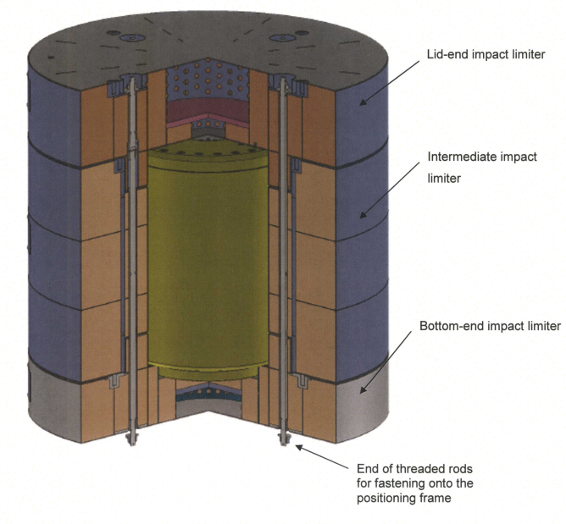
Cask

