|  |
| --- |
|  |
| ONR Project Assessment Report  PR-01191 Nautilus MK VI – Renewal of Package Design Approval, GB/2727A/B(U) |



ONR Project Assessment Report

**Project Name**: PR-01191 Nautilus MK VI

**Report Title**: Renewal of Package Design Approval, GB/2727A/B(U)

**Dutyholder/ Applicant**: SXSUBSEA Limited

**Authored by**:

**Report Issue No**.: 1

**Publication Date**: Feb-25

**Document ID**: ONRW-2019369590-6583

Table 1: Circulation (latest issue)

|  |  |  |
| --- | --- | --- |
| Organisation | Recipient | Date Report Sent |
| ONR |  | 31/01/2024 |
| SXSUBSEA Limited |  | 31/01/2024 |

© Office for Nuclear Regulation, 2024

For published documents, the electronic copy on the ONR website remains the most current publicly available version and copying or printing renders this document uncontrolled. If you wish to reuse this information visit [www.onr.org.uk/copyright](http://www.onr.org.uk/copyright) for details.

# Executive Summary

SXSUBSEA Limited has applied to the Office for Nuclear Regulation (ONR) for renewal of the package design approval for the Nautilus MK VI package design for transport by road, rail, sea and air.

The Nautilus MK VI transport package is used for the transport of an industrial radiography projector containing a special form metallic Ir-192 source. The principal hazard is external radiation and the package includes shielding within the design.

The Nautilus MK VI package design was first approved more than 40 years ago. Ownership and design authority of the package has changed over time and now lies with the applicant. The applicant substantially redesigned the package to improve package performance under the Type B statutory tests and submitted it for package design approval. We assessed the revised design as an effectively new package design and granted approval in 2019 under the GB/2727A/B(U)-96 (Rev.0) certificate.

We have undertaken a proportionate and targeted assessment for this renewal application, assessing the claims, arguments and evidence in the applicant’s Package Design Safety Report (PDSR) and supporting documentation. We have completed a review of the previous package design approval to confirm that there are no outstanding issues.

It is concluded that the Nautilus MK VI transport package continues to meet the requirements of the relevant modal regulations as enacted in UK law.

It is recommended that the competent authority grants approval of the Nautilus MK VI package design for transport by road, rail, sea and air for a period of five years by issuing certificate of approval GB/2727A/B(U) (Rev.1).

Table 2: List of abbreviations

|  |  |
| --- | --- |
| Term/Acronym | Description |
| ADR | Agreement Concerning the International Carriage of Dangerous Goods by Road |
| CA | competent authority |
| CDG | The Carriage of Dangerous Goods and Use of Transportable Pressure Equipment Regulations 2009 |
| CoA | Certificate of Approval |
| GB | Great Britain |
| HTSL | High Technology Sources Limited |
| IAEA | International Atomic Energy Agency |
| ONR | Office for Nuclear Regulation |
| PAR | Project Assessment Report |
| PDSR | Package Design Safety Report |
| RID | Regulations Concerning the International Carriage of Dangerous Goods by Rail |
| RPA | Radiation Protection Adviser |
| SCR | Safety Case Requirements |
| TCA | Transport Competent Authority |
| UK | United Kingdom |
| WIReD | (ONR) Well Informed Regulatory Decisions |

Table of Contents

Executive Summary 3

1. Permission Requested 6

2. Background 6

2.1. Overview of Package Design 6

2.2. Regulatory History 7

3. Assessment and Inspection Work Carried out by ONR in Consideration of this Request 8

3.1. Engineering Assessment 9

3.2. Review of Previous Approval 9

3.3. Review of Operational Experience & Relevant Transport Incidents 10

4. Matters Arising from ONRs Work 10

5. Conclusions 10

6. Recommendations 10

References 11

# Permission Requested

1. SXSUBSEA Limited has applied (ref. [1]) to the Office for Nuclear Regulation (ONR) as the Great Britain (GB) competent authority (CA) for renewal of the package design approval for the Nautilus MK VI transport package.
2. This Project Assessment Report (PAR) presents the basis of our regulatory decision for the package design approval.

# Background

## Overview of Package Design

1. The Nautilus MK VI transport package is used for the transport of an industrial radiography projector containing a special form metallic Ir-192 source compliant with USA/0392/S-96 (Model 875) or similar (ref. [2]). The package consists of the Nautilus MK VI projector in a cork-lined stainless steel drum, as shown in Figures 1 and 2 below.

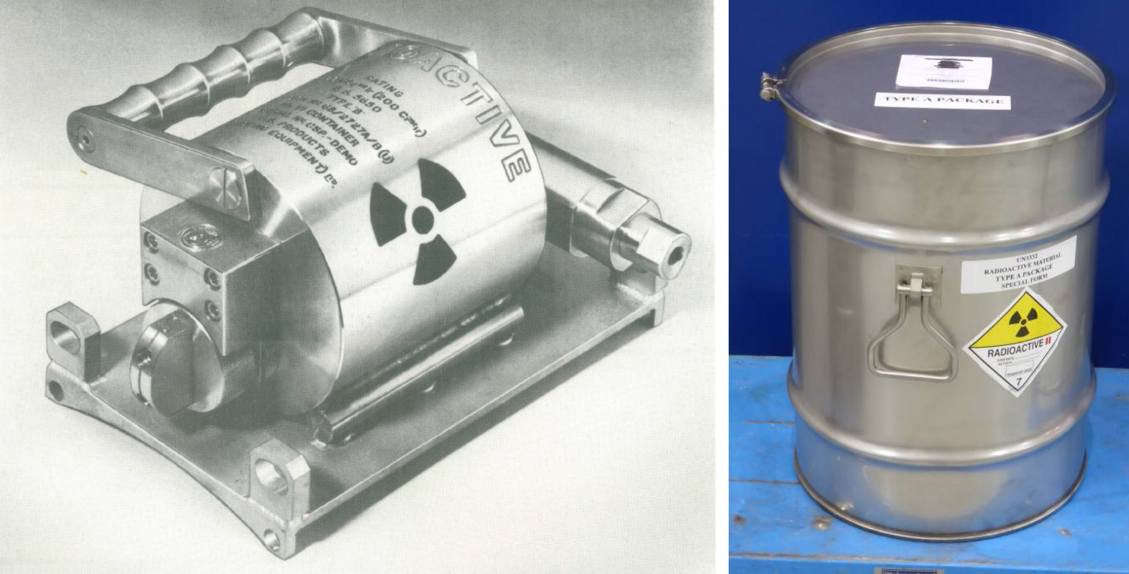

Figure 1. Nautilus MK VI Projector and Nautilus MK VI Transport Package

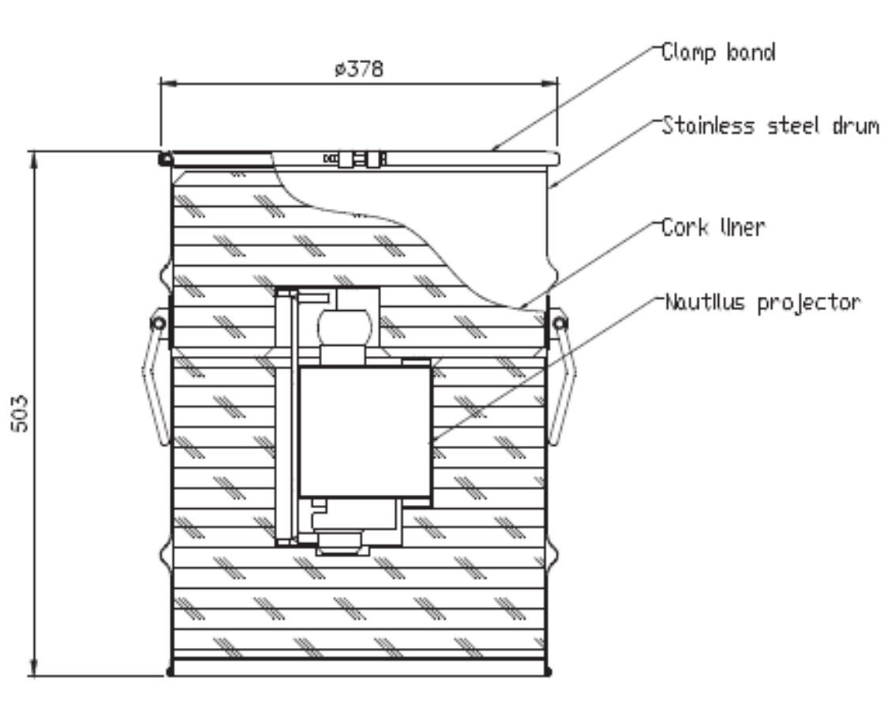

Figure 2. Nautilus MK VI Transport Package

1. The Nautilus MK VI package design is described in detail in the Package Design Safety Report (PDSR) (ref. [2]) accompanying the request for approval.

## Regulatory History

1. The package was originally designed and licensed more than 40 years ago. Ownership and design authority of the package has changed over time and now lies with the applicant. The applicant substantially redesigned the package beginning in 2013 to incorporate a larger stainless steel drum and modified cork liner to improve package performance under the Type B statutory tests. The Ir-192 maximum source activity was also increased to 12.2 TBq to meet commercial requirements.
2. The redesigned package was submitted for package design approval by the applicant in 2018. We assessed this design as an effectively new package design and granted package design approval in 2019 under the GB/2727A/B(U)-96 (Rev.0) certificate for transport by road, rail, sea and air (ref. [3]).

# Assessment and Inspection Work Carried out by ONR in Consideration of this Request

1. In accordance with the regulatory permissioning strategy (ref. [4]), we have carried out targeted and proportionate assessments of the applicant’s request for renewal of the package design approval.
2. We have performed a mechanical engineering assessment of the PDSR and supporting documents to confirm that the impact of package ageing has been adequately addressed as required by the 2018 Edition of SSR-6 (ref. [5]).
3. The package contents are non-fissile and hence a criticality assessment was not required.
4. We completed a full radiation shielding assessment for the previous package design approval. There have been no changes to the package design that impact our previous assessment and there have been no changes in shielding methodology, standards or nuclear data. I therefore judged that a radiation shielding assessment was not required.
5. The package design is non-complex and contains a special form metallic Ir-192 source. The projector requires pneumatic pressure to operate and the package closing system is non-complex, i.e. a clamp band and bolt. The operating and handling instructions meet relevant good practice and clearly identify how to load and secure the packaging. I therefore judged that a human factors assessment was not required.
6. We undertook a comprehensive safety case requirements (SCR) assessment of the package design as part of the previous package design approval. I judged that it was not proportionate to perform further assessment for this permissioning request since:

* there are no changes to the package design that would impact our previous conclusions;
* the applicant has undertaken a periodic design review; and
* there is a positive history of general transport compliance by the package consignor, High Technology Sources Limited (HTSL).

1. The applicant’s quality and management system was assessed for the previous package design approval. There have been no changes to that system and it was recertified compliant with ISO 9001:2015 in 2023 (ref. [1]). I therefore judged that it would not be proportionate to undertake inspection of the applicant’s arrangements as part of this assessment.
2. All our assessments were undertaken in accordance with the requirements of ONR’s How2 Business Management System and its associated guidance, principally ONR’s transport permissioning assessment guidance (ref. [6]).

## Engineering Assessment

1. Our mechanical engineering assessment for the Nautilus MK VI package was reported in an assessment report (ref. [7]).
2. The engineering assessor considered the applicant’s submission, focusing on changes to the PDSR since the previous package design approval. In particular, this targeted the applicant’s periodic design review and their assessment of package ageing effects as required by paragraph 613A of SSR-6 2018 Edition (ref. [5]).
3. The engineering assessor confirmed that the PDSR adequately addressed the effects of wear, fatigue, corrosion, thermal stresses and radiation. The assessor accepted the argument that any parts subject to ageing mechanisms would be periodically replaced following regular inspection or as part of routine annual maintenance.
4. Our engineering assessor concluded that the claims, arguments and evidence in the Package Design Safety Report (PDSR) justify a recommendation for renewal of the package design approval.

## Review of Previous Approval

1. There are no outstanding issues from the previous package design approval relating to the applicant as the package owner and design authority (and operator of the Nautilus MK VI projector).
2. The PAR from the previous approval (ref. [8]) recommended that HTSL and Aurora Health Physics Services be added to our non-nuclear transport compliance inspection plan (as consignor and Radiation Protection Adviser (RPA)/emergency responder respectively).
3. The compliance history of HTSL and Aurora Health Physics Services is not strictly relevant to the package design approval. However, it provides evidence that relevant dutyholders are operating and managing the package compliantly to support our judgement on the inspection work necessary for this permission.
4. A general transport compliance inspection of HTSL was undertaken in October 2022 and we concluded that the dutyholder was compliant with its duties under ADR, RID (by inference) and CDG (refs. [9, 10, 11]). We rated the inspection as Green and there are no outstanding regulatory issues (ref. [12]). I therefore judged that inspection of Aurora Health Physics Services (as the RPA) would be of no value to this package design approval.

## Review of Operational Experience & Relevant Transport Incidents

1. We have not received any notifications of operational issues or transport incidents involving the Nautilus MK VI package or similar transport package designs since the previous approval.

# Matters Arising from ONRs Work

1. There are no matters arising from our assessment of this application for package design approval.

# Conclusions

1. Based on the assessments conducted by ONR, I conclude that the Nautilus MK VI transport package continues to meet the requirements of the relevant modal regulations as enacted in UK law.

# Recommendations

1. I recommend that the Competent Authority grants approval of the Nautilus MK VI package design for transport by road, rail, sea and air for a period of five years by issuing certificate of approval GB/2727A/B(U) (Rev.1) (ref. [13]).

# References

|  |  |
| --- | --- |
| [1] | SXSUBSEA Limited, 0005-22-227-ONR-HW-TE-SXSUBSEA Nautilus MK VI DSR, July 2023, WIReD Ref: ONRW-2019369590-3719. |
| [2] | SXSUBSEA Limited, R-14-186-033, "Design Safety Report - Nautilus MK VI Package for Gamma Radiography, GB/2727A/B(U)-96", Revision 1, June 2023, WIReD Ref: ONRW-2019369590-3361. |
| [3] | ONR, "Certificate of Approval of Package Design for the Carriage of Radioactive Material, GB/2727A/B(U)-96 (Rev.0)", CM9 Ref: 2018/351888. |
| [4] | ONR, WIReD Permissioning Record PR-01191. |
| [5] | International Atomic Energy Agency, IAEA Safety Standards for Protecting People and the Environment, Specific Safety Requirements No. SSR-6, ‘Regulations for the Safe Transport of Radioactive Material’, 2018 Edition. www.iaea.org. |
| [6] | ONR, TRA-PER-GD-001 Revision 3, "Transport Permissioning Assessment", February 2021, CM9 Ref: 2021/14609. |
| [7] | ONR, "Mechanical Engineering Assessment (AR-01266) in Support of the Permissioning (PR-01191) of Transport Package GB/2727A/B(U) Nautilus MK VI", WIReD Ref: ONRW-2126615823-1730, November 2023. |
| [8] | ONR, ONR-TD-PAR-18-005 Rev 0, "Project Assessment in Support of the Permissioning of a Transport Package GB/2727A/B(U)-96 Nautilus MK VI as a Type B(U) Package", CM9 Ref: 2018/403494, January 2019. |
| [9] | United Nations Economic Commission for Europe (UNECE), Agreement Concerning the International Carriage of Dangerous Goods by Road (ADR) 2023 Edition, www.unece.org. |
| [10] | Intergovernmental Organisation for International Carriage by Rail (OTIF), Regulations concerning the International Carriage of Dangerous Goods by Rail (RID) 2023 Edition, www.otif.org. |
| [11] | The Carriage of Dangerous Goods and Use of Transportable Pressure Equipment Regulations (CDG) 2009, (SI 2009 No. 1348). www.legislation.gov.uk. |
| [12] | ONR, WIReD Inspection Record IR-51840. |
| [13] | ONR, "Certificate of Approval of Package Design for the Carriage of Radioactive Material, GB/2727A/B(U) (Rev.1)", WIReD Ref: ONRW-2019369590-6424. |