
ONR Project Assessment Report
Generic Design Assessment of the Holtec SMR-300 – Step 1 Summary

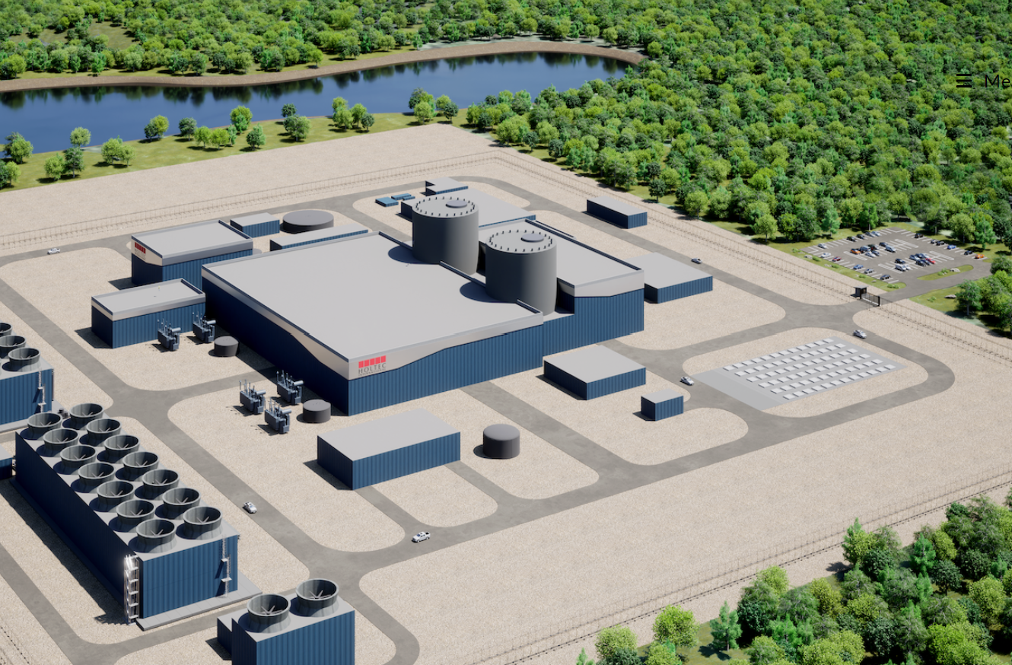

ONR Project Assessment Report
Project Name: Generic Design Assessment of the Holtec SMR-300
Report Title: Step 1 Summary

Dutyholder/Applicant: Holtec International

Authored by: [Redacted], Principal Inspector, ONR
[Redacted], Principal Inspector, ONR
ONR Report Ref. No.: ONRW-2019369590-11052
Report Issue No.: 1
Publication Date: August-24
Table 1: Circulation (latest issue)
Organisation | Recipient | Date Report Sent
ONR | [Redacted], Director of Regulation  [Redacted], Delivery Lead  [Redacted], Assessment Group Lead  [Redacted], Assessment Group Lead  [Redacted], Programme Manager | 01/07/2024
Environment Agency | [Redacted], Delivery Lead | 01/07/2024
Natural Resources Wales | [Redacted], Senior Specialist Advisor, Evidence, Policy and Permitting | 01/07/2024
Holtec International | Regulatory Interface Office | 01/07/2024

© Office for Nuclear Regulation, 2024
For published documents, the electronic copy on the ONR website remains the most current publicly available version and copying or printing renders this document uncontrolled. If you wish to reuse this information visit www.onr.org.uk/copyright for details.
All images © Holtec International, used with permission.

Executive summary
In October 2023, the Office for Nuclear Regulation (ONR), together with the Environment Agency and Natural Resources Wales, began Step 1 of the Generic Design Assessment (GDA) of the Holtec SMR-300 design. During the last 10 months, we have undertaken activities to initiate and establish the project and to prepare for technical assessment in Step 2. These activities are defined within our GDA guidance document, Guidance to Requesting Parties.
This report has been produced:
- to document the completion of and outcomes from Step 1
- to summarise the activities undertaken by both Holtec and ONR during the step
- to summarise ONR’s judgements, particularly regarding whether the objectives for Step 1 have been met
- to document the basis for the decision on whether to proceed to Step 2, or not
Holtec International is the Requesting Party. However, Holtec International have designated Holtec Britain to manage the GDA project, including providing the Regulatory Interface Office, Project Management Office and transmitting all documentation between Holtec International and the Regulators. Holtec Britain is a wholly owned UK subsidiary of Holtec International.
The Holtec SMR-300 is a 300 MWe (net) pressurised water reactor which uses well-established technology in operation all over the world. The GDA is being conducted on a twin unit design, comprising two SMR-300 reactors and associated plant. Innovation comes from the extensive use of passive safety systems and using a single steam generator per reactor. The design is at an advanced concept stage of development and is being further developed during the GDA in parallel with the RP’s safety, security, safeguards (and environmental) cases. A recent significant change prior to entering GDA increased reactor power from 160 MWe to 300 MWe and introduced two Reactor Coolant Pumps for use during normal operation. Holtec International are undertaking pre-licencing engagement with the United States Nuclear Regulatory Commission (US NRC), however we are the first regulator to undertake formal assessment of the SMR-300 design.
We have undertaken activities which have allowed us to fulfil the objectives for Step 1. These are for ONR and the RP to agree:
- the GDA scope
- the documentary basis for the generic safety and security cases that will be submitted for assessment throughout GDA
- the gaps that have been identified by the RP in meeting regulatory expectations and the resolution plans for how these may be resolved
- the RP’s arrangements necessary to undertake the GDA
- the schedule and associated programme for subsequent steps
During Step 1 we have undertaken more than 100 engagements and assessed more than 20 submissions. Whilst there were initial concerns around the capability of the RP to complete Step 1 and enter Step 2 of GDA, following an extension to Step 1 timescales, increased engagement on a number of topics, and resubmission of Step 1 submissions, we have been able to conclude that the information submitted within Step 1 met all the requirements from our guidance and demonstrated a good understanding of UK practice and regulatory expectations. We take confidence from these submissions that the RP has a clear view of what is needed to progress through the GDA and how it will justify its design.
Holtec International has confirmed that it only intends to complete GDA up to the end of Step 2.
The overall duration for GDA is expected to be 24 months, completing in October 2025.
We have agreed a defined GDA scope with the RP. This is consistent with previous GDAs, taking into account the RPs intention to only complete Steps 1 and 2 of GDA. Where aspects are declared as being out of scope, we are content that these are justified and appropriate. Overall, we are satisfied that the agreed GDA scope will allow for a meaningful assessment of the generic design.
We have assessed the arrangements that the RP has developed to undertake the GDA, which included specific interventions by our Management of Safety and Quality Assurance specialists. The RP has developed considerably in this regard during Step 1. The integration of GDA specific arrangements into its wider business and engineering arrangements is a particular strength. Overall, we are content that sufficient progress has been made in this regard during Step 1 and plans for further development and implementation during Step 2 are sufficient.
Holtec Britain are developing the Safety, Security, Safeguards and Environmental Case (SSEC) to demonstrate that the generic SMR-300 can be constructed, operated, and decommissioned on a generic site in the UK in a way that is acceptably safe and secure. The SSEC will take substantial input from material being developed in the US, however the SSEC will be submitted to UK regulators prior to any formal Safety Report Submission to the US NRC. The SSEC submitted during GDA will comprise a Preliminary Safety Report, Generic Security Report, Preliminary Safeguards Report and Preliminary Environment Report. An initial revision of the SSEC will be submitted at the beginning of Step 2. An updated SSEC is planned for later in Step 2 to include additional information developed or made available during Step 2. The SSEC will provide the primary basis for any regulatory judgements made in Step 2. The SSEC scope includes all expected technical topics. We are satisfied that the proposed SSEC approach is logical and suitably structured.
We have agreed a submission schedule with the RP, which includes the submission of more than 140 SSEC documents during Step 2. We are content that this aligns with our assessment plans, the agreed GDA scope and the RP’s declared schedule for GDA. The RP has stated it has sufficient resource to deliver the submissions identified for Step 2 to the agreed schedule.
We have used the knowledge gained during Step 1 to inform our detailed planning within the 20 assessment plans we have developed for Step 2.
In line with our guidance, the RP undertook a self-assessment and review of its own readiness to proceed to Step 2. We judge that the process undertaken by the RP was reasonable, proportionate and sufficiently robust for this step of GDA. The conclusion of the RP’s readiness review is that it considers itself ready to begin Step 2.
We undertook a review of our own readiness to proceed to Step 2. We conclude that, based on the agreed GDA scope and submission schedule, the assessment will remain meaningful during Step 2 and warrants the continued deployment of regulatory resource. Our readiness review demonstrated that we are ready to proceed to Step 2 of GDA for the Holtec SMR-300.
In summary:
- The RP has completed all the requirements for Step 1 from our guidance;
- Interactions with the RP throughout Step 1 have been professional and constructive, and we have confidence that this will continue;
- The RP has made good progress in developing its organisation and arrangements to support GDA;
- The agreements necessary to undertake the GDA are in place, or have developed sufficiently for this point in the project with clear plans for further development;
- The RP has demonstrated a good understanding of our regulatory expectations and has confidence that these can be met by its design and safety, security and safeguards case;
- We have improved our understanding of the generic Holtec SMR-300 design and safety, security and safeguards case, and have used this to inform our planning for further assessment activities; and
- We, and the RP, are ready to proceed to Step 2 of the GDA.
Based on our work during Step 1, we recommend that ONR should proceed to Step 2 of the GDA for the generic Holtec SMR-300 design.

List of abbreviations
ALARP As low As Reasonably Practicable
C&I Control and Instrumentation
CAE Claim, Argument and Evidence
CARs Commitments, Assumptions and Requirements
DAC Design Acceptance Confirmation
DR Design Reference
DRP Design Reference Point
GB Great Britain
GDA Generic Design Assessment
GSE Generic Site Envelope
GSR Generic Security Report
IMS Integrated Management System
ITA Independent Technical Assurance
ISO International Organization for Standardization
LOCA Loss of Coolant Accident
MDSL Master Document Submission List
MS Management System
MSQA Management of Safety and Quality Assurance
NISR 2003 Nuclear Industries Security Regulations 2003
NPP Nuclear Power Plant
NRW Natural Resources Wales
ONR Office for Nuclear Regulation
OPEX Operational Experience
PCC Passive Containment Cooling
PSA Probabilistic Safety Analysis
PSR Preliminary Safety Report
PSyR Preliminary Security Report
PWR Pressurised Water Reactor
RCS Reactor Coolant System
RGP Relevant Good Practice
RI Regulatory Issue
RO Regulatory Observation
RP Requesting Party
RPV Reactor Pressure Vessel
RQ Regulatory Query
SSEC Safety, Security, Safeguards and Environmental Case
SGE Steam Generator
SMR Small Modular Reactor
SNI Sensitive Nuclear Information
SSC Structure, System and Component
TAG Technical Assessment Guide (ONR)
TEP Topic Engagement Plan
TRL Technology Readiness Level
UK United Kingdom
US United States of America
Contents
Executive summary 4
List of abbreviations 7
1. Purpose 11
2. Background 12
2.1. Generic Design Assessment 12
2.2. Objectives for Step 1 13
2.3. Requesting Party 14
2.4. Holtec SMR-300 design 15
2.4.1. Design status 15
2.4.2. Design overview 16
2.4.3. ONR’s familiarity with the technology used in the Holtec SMR-300 26
2.5. Safety, security and safeguards cases 26
3. Work carried out by ONR in consideration of this request 28
3.1. Assessment of submissions 28
3.2. Interactions with the requesting party 28
3.3. Step 2 assessment plans and submissions schedule 29
3.4. Gap analysis 29
3.5. Readiness reviews 29
3.6. Joint working with the Environment Agency and Natural Resources Wales 30
4. Matters arising from ONR’s work 31
4.1. RP’s arrangements for undertaking GDA 31
4.1.1. Management system 31
4.1.2. Interface arrangements and information access 33
4.1.3. Master document submission list 33
4.1.4. Regulatory questions 34
4.1.5. Design reference 34
4.1.6. Change control 35
4.1.7. Capturing requirements, assumptions and commitments 36
4.1.8. MSQA intervention 36
4.1.9. Summary 37
4.2. Agreement of the GDA scope 37
4.3. Status of the design and safety, security and safeguards cases 38
4.3.1. Design 38
4.3.2. Safety, security and safeguards case 40
4.4. Information submitted during Step 1 42
4.4.1. Design familiarisation 42
4.4.2. Fundamental design philosophy and engineering design principles 42
4.4.3. Demonstration of ALARP 43
4.4.4. Compliance with NISR 44
4.4.5. Regulatory framework and principles 45
4.4.6. Site characteristics 46
4.4.7. Codes and standards 46
4.4.8. Gap analysis 47
4.5. ONR’s Step 2 assessment plans 49
4.6. Readiness reviews 49
4.6.1. Holtec readiness review 49
4.6.2. ONR 51
5. Conclusions 52
6. Recommendations 53

Tables
Table 1: Step 1 requirements from Guidance to Requesting Parties
Figures
Figure 1: SMR-300 conceptual plant layout
Figure 2: Arrangement of the Containment Enclosure Structure, Annular Reservoir and Containment Structure
Figure 3a: Reactor Coolant System layout – isometric view
Figure 3b: Reactor Coolant System layout – plan view
Figure 4: SMR-300 Passive Core Cooling Systems
Figure 5: An overview of the Containment Structure
Figure 6: Overview of the HI-STORM UMAX
Figure 7: Holtec International Quality Assurance documented information hierarchy
Figure 8: SSEC production quality arrangements and documented information summary
Figure 9: SMR-300 Overall Design and SSEC Development
Figure 10: Holtec Step 2 Readiness Review Process

Purpose
- A request was received from the Department of Energy Security and Net Zero (DESNZ), in June 2023 for the Office for Nuclear Regulation (ONR), the Environment Agency and Natural Resources Wales (NRW) to undertake Steps 1 and 2 of a Generic Design Assessment (GDA) for Holtec International’s SMR-160 design. The request was contingent on the outcome of Holtec International’s application to the Future Nuclear Enabling Fund (FNEF), which was resolved later in 2023. ONR, the Environment Agency and NRW entered Step 1 of GDA with Holtec International, the Requesting Party (RP), in October 2023.
- During the last 10 months we have undertaken those activities identified for Step 1 within our GDA guidance document, Guidance to Requesting Parties (ref. [1]). These are mainly associated with initiation of the project and preparation for technical assessment in later steps.
- This report has been produced:
- to document the completion of and outcomes from Step 1
- to summarise the activities undertaken by both Holtec International and ONR during the step
- to summarise ONR’s judgements, in particular regarding whether the objectives for Step 1 have been met
- to document the basis for the decision on whether or not to proceed to Step 2

Background

Generic Design Assessment
- ONR is the UK’s independent nuclear regulator, with the legal authority to regulate nuclear safety, civil nuclear security and safeguards, and nuclear site health and safety at the 36 licensed nuclear sites in Great Britain (GB). We also regulate the transport of civil nuclear and radioactive materials by road, rail and inland waterways. ONR’s mission is to protect society by securing safe nuclear operations.
- The environmental protection aspects of the generic design are assessed and reported separately (ref. [2]) by the environment agencies (the Environment Agency and NRW) with whom we work closely during GDA. The Environment Agency has also published separate guidance on the process it follows (ref. [3]).
- The GDA process was developed in response to the Government's 2006 Energy Review; in particular lessons learnt from experience with new Nuclear Power Plants (NPPs) indicated that the use of a standardised design, where the design and safety case are well developed much earlier in the project, would facilitate a reduction in the time for regulatory assessment. It would also minimise any potential regulatory uncertainty for a future site licensee wishing to build such a design. Although GDA is not a mandatory process, because of its inherent benefits it is expected that it will usually be requested for new NPPs intended for construction in GB.
- The objective for GDA is to provide confidence that the proposed design is capable of being constructed, operated and decommissioned in accordance with the standards of safety, security, safeguards and environmental protection required in GB. For the Requesting Party (RP), the organisation(s) who requested the GDA, this offers a reduction in uncertainty and project risk regarding the design and safety, security, safeguards and environmental cases so as to be an enabler to future licensing, permitting, construction and regulatory activities.
- To fulfil this objective, GDA progresses in steps, with the regulatory assessments becoming increasingly detailed. The assessment considers the majority of ONR’s purposes, using inspectors from the full range of technical topics as defined in Guidance to Requesting Parties (ref. [1]).
- The GDA process has three steps, noting that earlier GDAs had four steps. This was a change resulting from lessons learnt and efficiency improvements implemented in 2019. The overall intent is that:
- Step 1 is the initiation step where matters such as the GDA scope and timescales are agreed, and ONR’s knowledge of the design and the RP’s safety, security and safeguards cases increases. Further details on Step 1 are provided in Section 2.2;
- Step 2 is the fundamental assessment of the generic design and safety, security and safeguards cases, to identify any potential ‘showstoppers’ that may preclude deployment of the design; and
- Step 3 is the detailed assessment of the generic safety, security and safeguards cases on a sampling basis.
- In this case Holtec International has indicated that it intends to complete a two-step GDA ending with the provision of a Step 2 Statement. A Design Acceptance Confirmation (DAC) will not be awarded as the GDA will conclude at Step 2 without a detailed assessment being undertaken. This is the first GDA being conducted with the intention to end at Step 2.
- The Holtec SMR-300 design is the eighth design to begin a GDA. The first round of GDA started in 2007 when ONR and the Environment Agency began assessment of four designs, although two of these first-round designs were withdrawn by the RP part-way through the assessment process. The remaining two designs, the EDF and AREVA UK EPR™ and the Westinghouse AP1000® designs, subsequently completed GDA in 2012 and 2017 respectively (noting the latter included a pause of several years). In 2013, the Hitachi-GE UK ABWR entered the GDA process and this was completed in 2017. Also in 2017, the CGN/EDF/GNI UK HPR1000 started a GDA which was completed in 2022. Full details of completed GDA projects are available on the joint regulators’ website (ref. [4]). At the time of writing, there are two other GDAs currently ongoing for the Rolls-Royce SMR, started in 2022, and the GE Hitachi BWRX-300, started in 2024.

Objectives for Step 1
- Step 1 is the project initiation part of the design assessment process. This involves the RP establishing its project management and technical teams, its arrangements for undertaking a GDA and preparing and submitting documentation during Step 1 and for the commencement of Step 2. It also involves discussions with the RP to ensure a full understanding of the requirements and processes that will be applied.
- The objectives for Step 1 are for ONR and the RP to agree:
- the GDA scope
- the documentary basis for the generic safety, security and safeguards cases that will be submitted for assessment throughout GDA
- the gaps that have been identified by the RP in meeting regulatory expectations and the resolution plans for how these may be resolved
- the RP’s arrangements necessary to undertake the GDA
- the schedule and associated programme for subsequent steps
- Appendix 2 of Guidance to Requesting Parties (ref. [1]) provides further details of what the RP is required to do and what ONR will do during Step 1. Where we have made a judgement against a requirement placed on the RP from this appendix, these are specifically cited in this report.
- A number of the requirements on the RP are to submit information to ONR. These cover matters which are necessary for undertaking GDA (such as project management controls, cost recovery arrangements and demonstration of adequate resources) along with matters of a more technical or regulatory nature. They are targeted at ensuring that both the RP and ONR are prepared for the more detailed assessments to be undertaken in later steps.
- During Step 1 our assessment of the RP’s submissions has been limited. The purpose of our assessment was to form a judgement on whether the requirements in Appendix 2 of Guidance to Requesting Parties (ref. [1]) have been met and to provide us with confidence going forwards with the GDA. Where submissions were of a technical nature we did not fully consider the detailed adequacy of the content, nor how it has been applied to the Holtec SMR-300 design or safety, security and safeguards cases, which will be the focus for later steps. We provided feedback to the RP and highlighted any obvious omissions or gaps in meeting regulatory expectations.

Requesting Party
- For the purposes of the GDA, Holtec International is the RP. Holtec International has designated Holtec Britain to manage the GDA project, including providing the Regulatory Interface Office, Project Management Office and transmitting all documentation between Holtec International and the Regulators. Holtec Britain is a wholly owned UK subsidiary of Holtec International. Holtec Britain is the primary point of contact for the regulators.
- Holtec International is the designer of the SMR-300, supported by organisations including Framatome and Mitsubishi Electric Company. Holtec Britain is supported by a number of technical support contractors, principally Mott MacDonald who is assisting Holtec Britain in the development of the Safety, Security, Safeguards and Environment case (SSEC) and other technical documents for the GDA.
- Holtec International is a privately held company, founded in 1986, with primary offices in Camden, New Jersey in the United States of America (US). Holtec is a supplier and exporter of large nuclear components, such as fuel transport casks, pond racks, steam generators, heat exchangers and condensers. This includes supplying the Dry Fuel Store for Sizewell B to store used reactor fuel assemblies on site in Holtec designed and manufactured casks.
- Further details of the RP’s capacity, capability and organisation to support GDA are given in Section 4.1.

Holtec SMR-300 design

Design status
- Holtec claims that the SMR-300 is based on proven technology and minimises first-of-a-kind engineering to minimise technology development and licensing risks. Holtec has set out to regulators that the design draws on the operating experience and lessons learned from six decades of operating nuclear power plants, resulting in a simplified plant with respect to construction, operation, inspection, and maintenance as compared to previous generations of Light Water Reactors (LWR).
- The Holtec SMR has been in development since 2011, undergoing several design evolutions. Many fundamental aspects have remained unchanged, such as the use of Pressurised Water Reactor (PWR) technology, reliance on passive decay heat removal systems and using an Annular Reservoir as an ultimate heat sink. However some fundamental aspects have recently undergone significant modification. In 2023 Holtec implemented a significant design modification to increase reactor power from 160 MWe to 300 MWe and introduce two reactor coolant pumps (RCPs) to provide forced flow in the reactor coolant system (RCS) during normal operation. Following this modification the reactor design was rebranded from SMR-160 to SMR-300. Evolution and modification of the SMR-300 design continues, with some key design decisions being unresolved by the end of Step 1, such as the water level in the Annular Reservoir.
- The RP intends for the first SMR-300 to be a twin unit facility deployed at the Palisades Nuclear Site in Michigan in the US. Holtec is intending to submit a Construction Permit Application to the US Nuclear Regulatory Commission (NRC) in 2026. Holtec has explained that the SMR-300 is designed to meet US NRC regulatory requirements and that design and safety analysis to support the Construction Permit Application will be a significant input to the GDA. Holtec is undertaking pre-licensing engagement with US NRC on the SMR-300, however to date there has been no formal assessment or regulatory decisions made by US NRC on the SMR-300 design.
- The SMR-160 was subject to the Canadian Nuclear Safety Commission (CNSC) Vendor Design Review (VDR) Phase 1. VDR is a high-level review of the conceptual design information against CNSC requirements. However, the RP has not engaged further with CNSC since or indicated any intentions to progress to VDR Phase 2. There is currently no active engagement between Holtec and CNSC.
- The Holtec SMR-300 design has not yet been built and is not currently under construction elsewhere in the world. This means that there is no “reference site” for the purposes of GDA, and the generic design will continue to be developed in parallel with our regulatory assessments. Our assessment of the Holtec SMR-300 will also be the first time that the design is formally assessed by regulatory bodies.
- While this represents an opportunity to ensure the design, if deployed in the UK, has the potential to meet UK expectations, this does emphasise the need to have confidence in the RP’s controls and processes regarding design activities. Our work during Step 1 started to examine these aspects; see Section 4. The information provided by the RP meets requirements [1.9] and [1.14] from Guidance to Requesting Parties (ref. [1]).

Design overview
- The Holtec SMR-300 design has been developed by the RP based upon well-established PWR technology. The RP claims that the design of the SMR-300 is based upon the following principles:
- redundant and passive engineered safety features
- simplified plant design with structures designed to withstand all postulated external events
- ability to mitigate design basis accidents with no operator action
- ability to cope with an extended loss of all AC power for at least 72 hours
- defence-in-depth approach to beyond design basis accident mitigation
- highly reliable active systems to support normal plant operation
- The Holtec SMR-300 design is a PWR with a single steam generator, including an integrated pressuriser and two RCPs providing forced circulation in normal operation. The target electrical power output of each SMR-300 unit is 300 MWe (from a thermal power of 1,050 MWth) with a design life of 80 years for non-replaceable components. The SMR-300 design submitted for assessment in GDA is a twin-unit design comprising two SMR-300 reactors and associated plant.
- The following sections outline the key design features of the SMR-300 as set out by the RP in Step 1 (ref. [5] and [6]). The information does not represent a regulatory judgement and many of these key design features and associated safety claims will be subject to regulatory assessment in Step 2.

Layout
- The SMR-300 has a compact layout; a conceptual site layout is shown in Figure 1. The SMR-300 design being considered within GDA is a twin-unit design, comprising two reactors in separate containment buildings, with a common control room. This is the first time a multi-unit design is being subject to GDA.
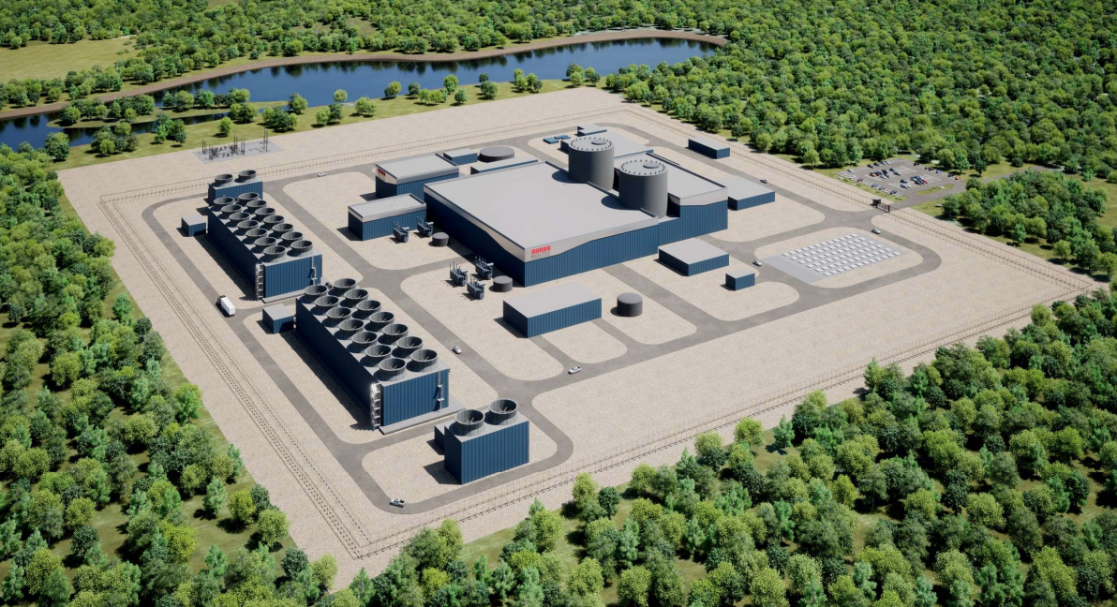
Figure 1: SMR-300 conceptual plant layout
Structures
- The SMR-300 plant site consists of two main ‘islands’. The nuclear island contains the following principal structures:
- containment structure
- containment enclosure structure
- reactor auxiliary building
- intermediate building
- radiological waste building
- The balance of plant island contains the following principle structures:
- annex building
- turbine building
- diesel generator building
- waste heat cooling tower or air-cooled condenser
- The nuclear island structures are generally within the scope of GDA, whereas the balance of plant island structures are generally out of scope of GDA. Further information on scope is contained in Section 4.2.
Containment structure, containment enclosure structure and annular reservoir
- The SMR-300 Containment Structure (CS) and Containment Enclosure Structure (CES) share a common foundation and are connected to the reactor auxiliary building (RAB). The CES surrounds the CS. The site layout ensures that nuclear assets, including the reactor core, are deeply embedded below ground for protection against hazards. Unauthorised access is prevented by multiple barriers.
- The CS is a cylindrical steel containment vessel with a domed upper head and steel-lined reinforced concrete base. It is partially embedded below ground. The CS provides a leak tight barrier to contain radioactive releases and contain the energy release from a loss of coolant accident (LOCA). The CS has an equipment hatch at ground level to facilitate replacement of major components and for access during refuelling and maintenance outages. A personnel airlock provides an additional entrance during outages and power operations.
- The CS contains multiple systems, including the RCS, Passive Core Cooling System (PCC), Spent Fuel Pool (SFP) and a polar crane supported by the CS shell. The crane access and capacity are designed for refuelling operations, including handling of the reactor internals and equipment needed for dry storage of spent fuel using the Holtec International Storage Module Underground Maximum Capacity (HI-STORM UMAX) system. A bridge crane located in the refuelling/operating deck is used for fuel movements in and between the SFP and the Reactor Pressure Vessel (RPV).
- The CES is a modular steel-concrete structure that shares a common foundation with the CS. Two concentric steel shells form the inner and outer faces of the modules, with interconnecting plates providing support. The CES protects the CS from external hazards, provides shielding from radioactive sources and hazards within the CS, provides support and protection for the main feed and steam systems exiting the CS, forms the outer wall of the Annular Reservoir (AR) and provides a vent for the AR to facilitate evaporative cooling.
- The AR water inventory provides passive containment heat removal. The AR is contained in the annulus between the CS and CES; the CS and CES form the inside and outside wall of the AR, respectively. A watertight seal is provided at ground level between the CS and CES to form the bottom of the AR. The AR contains a large body of water, and its primary function is to provide a heat sink in the event of an accident. The RP claims that the AR has sufficient capacity to accept heat from the core, spent fuel pool, and containment during design basis accidents.
- Figure 2 presents an overview of the CS, CES and AR structures.
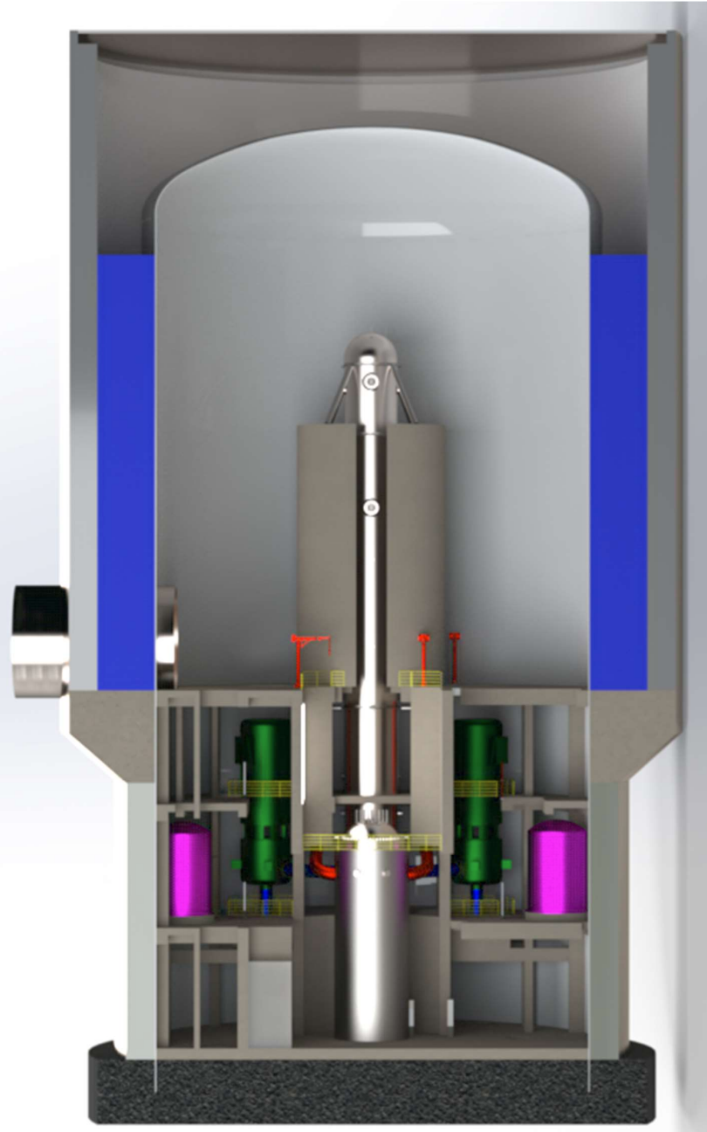
Figure 2: Arrangement of the containment enclosure structure, annular reservoir and containment structure
Reactor Core, Reactor Coolant System and Steam Generator
- The SMR-300 Reactor Coolant System (RCS) consists of one Reactor Pressure Vessel (RPV) and one Steam Generator (SGE) connected by two hot legs and two cold legs. The cold legs each have an RCP to provide RCS flow during normal operations. The major components of the RCS include the RPV, SGE with integral Pressurizer (PZR), and the RCPs. The RCS is shown in Figure 3. All the RCS equipment, piping, and components are located inside the CS.
- For normal operation, the RCS uses the RCPs as the driving force for flow. The RCS is configured to facilitate natural circulation, so the RCPs are not required for decay heat removal during accident conditions.
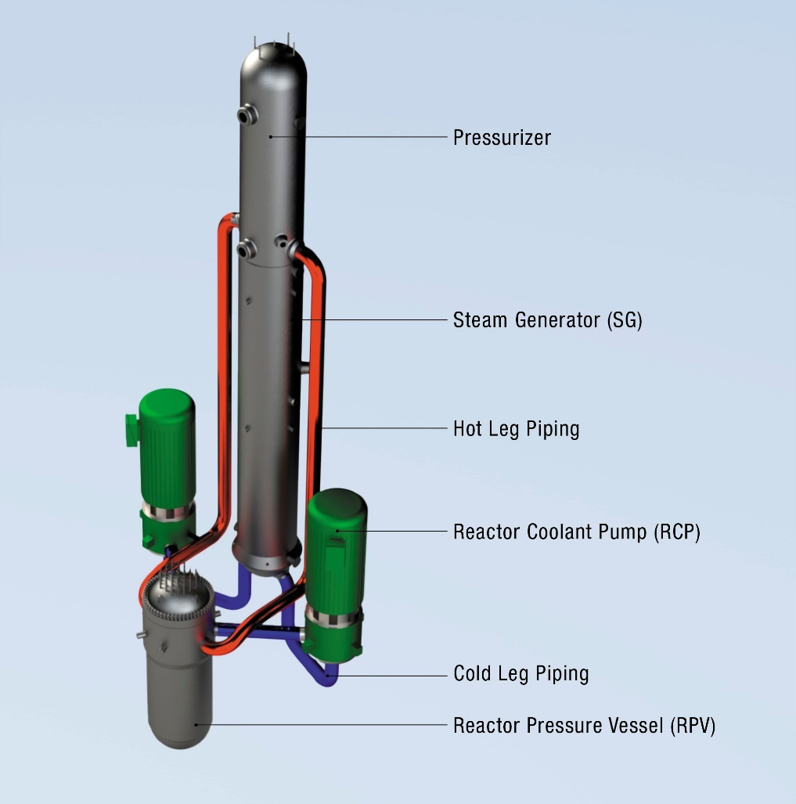
Figure 3a: Reactor Coolant System layout – isometric view
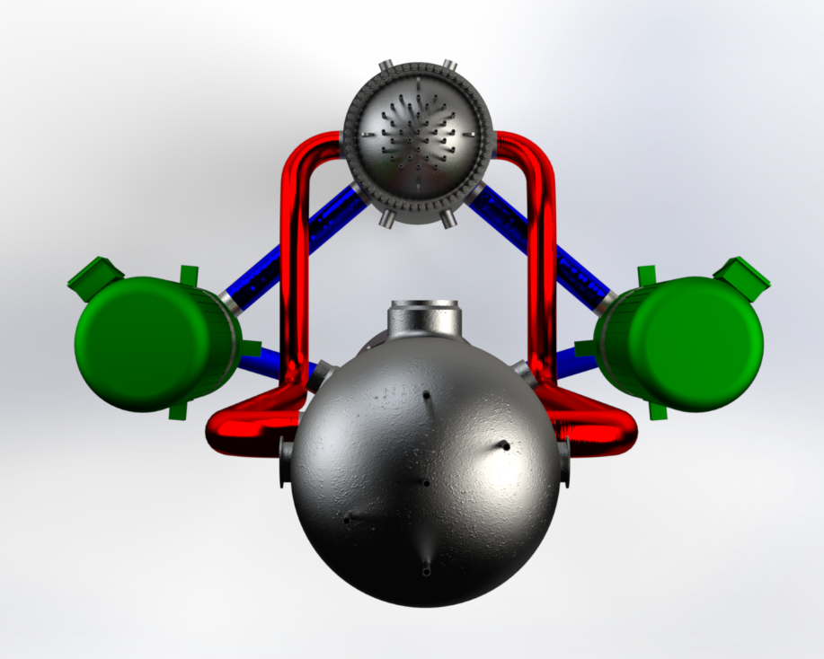
Figure 3b: Reactor Coolant System layout – plan view
- At the centre of the RCS is the RPV. The RPV is a cylindrical steel vessel designed to withstand the high temperatures, pressures and radiation of the reactor. The RPV houses the reactor core, in-core instrumentation and the reactor internals.
- The reactor core is made up of 69 fuel assemblies. The SMR-300 core employs a PWR fuel assembly of standard dimensions and utilises control rods and soluble boron to control reactivity. The core is designed for a nominal 18-month cycle length with flexibility for longer or shorter cycles depending upon utility energy requirements. Each fuel assembly is arranged in a 17x17 array of fuel rods consisting of a metallic zirconium alloy cladding housing the nuclear fuel, which is in the form of small ceramic pellets that contain up to 5% enriched uranium dioxide fuel. The hemispherical upper head of the RPV is removable to allow refuelling of the reactor.
- Water is used as the primary coolant, to extract the heat from the reactor, and as a moderator to maintain the nuclear reaction in the core. Hot water from the core outlet passes into the SGE, where it flows through heat exchange tubes which transfer the heat to the secondary coolant on the outside of the tubes, which is allowed to boil and produce steam. It is this steam produced in the secondary side of the SGE that drives a turbine that ultimately, via a generator, produces electricity. The primary coolant leaving the SGEs, which is now at lower temperature, is then pumped back into the reactor via the cold legs.
- The SMR-300 features a single, vertical, straight tube, once-through, countercurrent flow SGE with reactor coolant flowing down the inside tubes and the secondary liquid/steam flowing through the shell side of the SGE. The two RCS hot legs route reactor coolant from the RPV to the top tubesheet of the SGE. The SGE shell side contains four regions of fluid heating: subcooled preheating, nucleate boiling, film boiling, and superheating. The SGE does not employ in-tube boiling to protect against instability from constricted steam expansion space and small water inventories.
- Similar to other PWRs, the SMR-300 uses a Pressuriser (PZR) to control RCS pressure. Typically PWR PZRs are separate components, the SMR-300 PZR is integral to the SGE; an internal divider plate separates the circulating RCS volume from the saturated PZR volume. The PZR divider plate is designed to limit thermal communication between the volumes to minimise the size of the PZR heaters while allowing sufficient flow into and out of the PZR for pressure control. The PZR controls the pressure of the RCS by maintaining a saturated steam-liquid interface. Pressure changes caused by the expansion and contraction of the reactor coolant are absorbed by condensing the steam using the PZR spray or generating steam using the PZR heaters.
Safety systems
- The SMR-300 design includes engineered safety features to:
- maintain the plant in a safe shutdown configuration
- provide emergency heat removal to the core
- provide emergency makeup water to the core and SFP to prevent fuel damage
- isolate the containment from the environment to prevent radioactive effluent releases
- ensure a habitable environment for plant operators
- The SMR-300 design contains multiple passive safety systems to remove decay heat from the reactor core and containment in response to an abnormal event or fault. Connections for diverse and flexible coping strategies (FLEX) are incorporated into the design based on the lessons learned from Fukushima.
- The Passive Containment Heat Removal System (PCH) maintains the containment atmospheric pressure and temperature within design limits in the event of a postulated accident by utilising conductive heat transfer between the steel CS and the water inventory in the AR. The PCH is a completely passive system that removes heat from the containment atmosphere after an RCS energy release to containment. It does not require any actuations or an actuation signal to perform its function. As the water in the AR is heated, it rejects heat to the environment through the discharge of non-radioactive water vapour through the vent at the top of the CES. If required, the AR water inventory can be replenished during an accident using an accessible connection outside of containment as part of FLEX implementation.
- The Passive Core Cooling System (PCC) is designed to provide emergency core heat removal and makeup water. The system uses passive means such as natural circulation, gravity injection, and compressed gas expansion for core makeup and cooling without the use of active components such as pumps. However, active components such as valves are required to initiate the PCC. The PCC consists of the following sub-systems:
- primary decay heat removal system (PDH)
- secondary decay heat removal system (SDH)
- automatic depressurization system (ADS)
- passive core makeup water system (PCM)
- The PCC and PCH are designed to ensure safe shutdown conditions can be maintained and decay heat removal continues for at least 30 days without power, make-up water, or operator actions.
- The PDH provides passive core cooling for non-LOCA accidents by removing core decay heat directly from RCS and rejecting it to a large asymmetric tank of water in the PCM system (known as the PCM tank). The PDH is composed of piping that runs from the RCS hot leg to a heat exchanger located in the larger part of the asymmetric PCM tank, then returns coolant from the heat exchanger to the SGE lower head. Flow through the loop is driven by natural circulation.
- The SDH system provides additional passive core cooling for non-LOCA accidents by removing core decay heat indirectly from the RCS via the SGE shell-side coolant and rejecting it to the AR via the SDH heat exchanger located in the AR. Flow through the loop is driven by natural circulation.
- The ADS is designed to depressurise the RCS to allow for injection of water from the accumulators, gravity injection of water from the PCM tank and provide a sufficient venting path for long-term cooling to allow steam to vent from the RPV to the containment atmosphere and prevent re-pressurization of the RCS. ADS reduces RCS pressure in two stages to allow passive injection of makeup water to maintain the RCS inventory above the top of the core. The Stage 1 ADS valves are sized to reduce RCS pressure to allow the PCM accumulators to provide makeup water to the core. The Stage 2 ADS valves reduce the RCS pressure even further and are sufficiently large to allow the RCS pressure to equalise with the containment pressure. This permits gravity injection from the PCM tank to provide additional makeup water to the core.
- The PCM is designed to provide makeup water to the RCS to cool the reactor core in the event of a LOCA. There are two trains of PCM. Each train has a dedicated pressurised accumulator and both trains connect to a single large, vented PCM tank. The PCM is designed such that there is sufficient borated water in one accumulator and the PCM tank to ensure both the core and the spent fuel in the spent fuel pool remain subcritical and covered following a LOCA for a minimum of 72 hours without operator action.
- Figure 4 shows an overview of the PCC Systems.
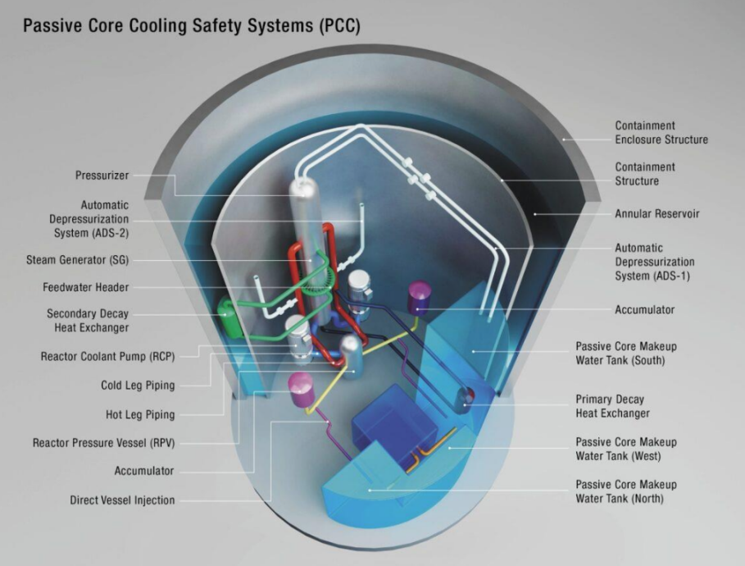
Figure 4: SMR-300 Passive Core Cooling Systems
Spent Fuel Pool and Dry Fuel Store
- The SMR-300 spent fuel pool is located inside the CS. The Spent Fuel Cooling System (SFC) removes decay heat from the SFP while maintaining the temperature, clarity, and chemistry of the SFP during all modes of plant operation. The SFC has one train of equipment consisting of one SFC pump, heat exchanger, and demineraliser with filter which continuously operates to remove decay heat and purify water in the SFP. A single train of the Residual Heat Removal System (RHR) is designed to provide backup SFP cooling when SFC is not available. The RHR is a non-safety system designed to remove decay heat and sensible heat from the RCS to reduce the reactor coolant temperature during normal shutdown and refuelling operations. Connections are provided for the addition of water to the SFP from several sources if required. Figure 5 shows the position of the SFP within the CS.
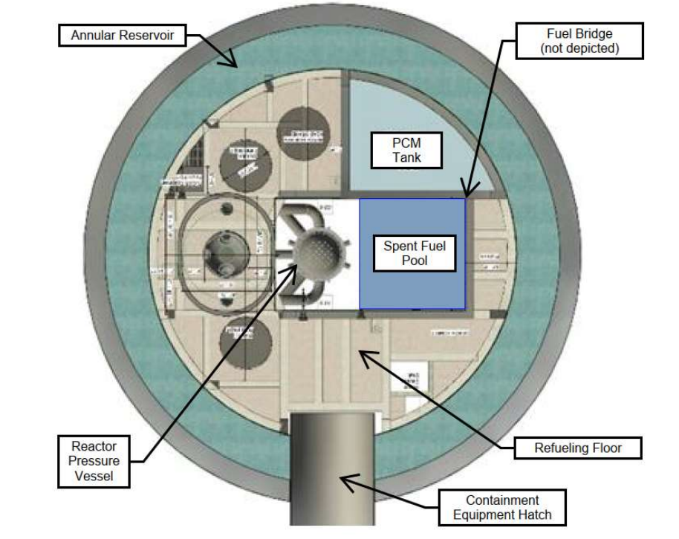
Figure 5: An overview of the containment structure
- The SMR-300 utilises onsite interim spent fuel storage within the independent spent fuel storage installation (ISFSI). The ISFSI uses Holtec’s HI-STORM UMAX system containing a multi-purpose canister (MPC). HI-STORM UMAX is an underground vertical ventilated module (VVM) dry spent fuel storage system. Each HI-STORM UMAX VVM provides storage of an MPC inside a cylindrical cavity. The MPC is a fully welded stainless steel canister providing containment of SMR-300 spent fuel onsite or for offsite transport. The MPC is tailored to balance the SFP size inside containment and the plant refuelling operational needs. The RP claims that each MPC provides sufficient capacity to transport the nominal core batch size of new fuel during refuelling and discharge spent fuel for onsite storage after 3 years of cooling in the SFP. Figure 6 shows an overview of the HI-STORM UMAX and ISFSI.

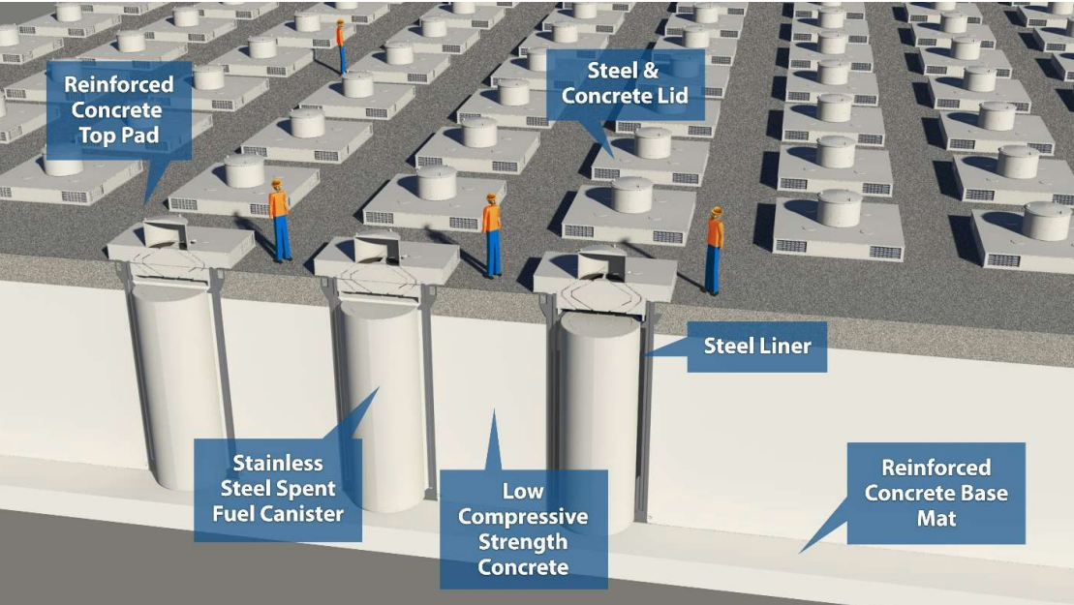
Figure 6: Overview of the HI-STORM UMAX
Control and Instrumentation
- The SMR-300 utilises the Mitsubishi Electric MELTAC platform for the plant control and instrumentation (C&I)/human system interface. The SMR-300 C&I System architecture consists of the following three top-level systems:
- Plant Control System (PCS) – comprised of one non-safety-related division, this PCS controls all the normal plant functions
- Plant Safety System (PSS) – comprised of two independent safety-related divisions, the PSS controls all the safety functions in the plant
- Diverse Actuation System (DAS) – comprised of one non-safety-related division, the DAS is provided to address the potential situation where both PSS divisions have failed

ONR’s familiarity with the technology used in the Holtec SMR-300
- ONR has extensive experience assessing and regulating PWR designs and is therefore familiar with the technologies presented. Our assessment moving forwards, while considering all aspects of the design, will pay attention to areas of novelty, of high safety or security significance, or that are unique to the Holtec SMR-300, and how their effectiveness is demonstrated by the RP.

Safety, security and safeguards cases
- The RP has submitted information on its strategy and intentions regarding the development of the safety, security and safeguards cases (ref. [7]). This was submitted to ONR during Step 1; our views on this are detailed further in Section 4.3, but some of the key points are summarised below.
- Within Step 2 Holtec intends to submit a SSEC for the SMR-300 to demonstrate that the generic SMR-300 can be constructed, operated, and decommissioned on a generic site in the UK to fulfil the future licensee’s legal duties to be safe, secure and protect people and the environment. The SSEC will comprise a Preliminary Safety Report (PSR), Generic Security Report (GSR), Preliminary Safeguards Report (PSgR), Preliminary Environment Report (PER) and their supporting documents.
- The first version (Revision 0) of the SSEC is expected at the start of Step 2. An updated SSEC (Revision 1) is expected later in Step 2. Revision 1 of the SSEC is expected to take into account ONR feedback on Revision 0, along with any additional work or analysis conducted by the RP within Step 2. Should the project be taken forward beyond GDA Step 2 the SSEC will be further updated in later project stages, for example to include a pre-construction safety report.
- All of ONR’s technical topics, as defined in Guidance to Requesting Parties (ref. [1]), are within the scope of the SSEC.

Work carried out by ONR in consideration of this request
- Guidance to Requesting Parties (ref. [1]) details the activities that both ONR and the RP are expected to undertake. This provided the framework for ONR’s work during Step 1.
- To ensure that ONR’s activities were coordinated and delivered, we produced a delivery strategy (ref. [8]) which outlines roles and responsibilities, key activities and assurance arrangements for the project. It also served as the project assessment plan for Step 1. It is intended that this strategy will provide the overarching framework for ONR’s regulatory assessments during this GDA, including how we will coordinate assessments across each of our technical topics. It will be kept live and updated as the GDA progresses.

Assessment of submissions
- Appendix 2 of Guidance to Requesting Parties (ref. [1]) sets requirements on the RP for information to be submitted during Step 1. The requirements are summarised in Table 1 of this report along with reference to where they are documented, as appropriate.
- To meet those requirements the RP submitted multiple documents to ONR covering all of the major topics expected in Step 1.
- As described in Section 2.2, ONR assessed the RP’s submissions to form a judgement on whether the requirements had been met during Step 1. Details of ONR’s assessment of these submissions is in Section 4.

Interactions with the requesting party
- During Step 1 we held more than 100 meetings with the RP at project and individual technical topic level. This included a number of workshops and briefings provided by the RP to improve our understanding of the design as well as the RP’s arrangements and processes. We also started the assessment for the Management of Safety and Quality Assurance (MSQA) topic area, which included a specific targeted intervention to look at the RPs arrangements and capability to support the GDA.
- Overall, the purpose of these engagements was:
- to seek assurance on the adequacy of the RP’s arrangements to undertake the GDA
- to develop our understanding of the Holtec SMR-300 design
- to understand the structure and strategy for developing the SSEC
- to discuss submissions made during Step 1
- to agree the GDA scope
- to plan our assessments in each technical topic area for Step 2, including development of a schedule of submissions required from the RP
- The outcomes from these interactions are discussed in Section 4.
- We had some concerns around the capability of the RP to complete Step 1 and enter Step 2 of GDA on initially agreed timescales. However there was significant improvement and increased confidence following an extension to Step 1 timescales, expansion of the RP’s organisation in the UK and increased engagement on a number of topics. We found the RP to be professional, responsive and open throughout our interactions. We have confidence that this constructive working relationship will continue throughout GDA.

Step 2 assessment plans and submissions schedule
- The main deliverable produced from each of ONR’s technical topics is the assessment plan for Step 2. These outline the areas we intend to focus on to make a judgement on the fundamental adequacy of the design and SSEC, and the suitability of the methodologies, approaches, codes, standards and philosophies which form the building blocks for these areas. As part of this we have explicitly considered how our risk-informed and targeted assessment activities support the delivery strategy (ref. [8]) and the objectives for Step 2, such that we will produce a holistic, joined up assessment of the overall design and SSEC.
- To inform these plans, we have agreed with the RP a submission schedule which defines all of the documents we expect to receive throughout Step 2 (ref. [9]); this meets requirement [1.19] from Guidance to Requesting Parties (ref. [1]). This schedule will be maintained as live by the RP throughout GDA.

Gap analysis
- A specific requirement during Step 1 is for the RP to undertake a gap analysis of its safety, security and safeguards cases and the submissions it plans to support Step 2 against regulatory expectations, proposing how any gaps would be resolved. The RP undertook such a review and we engaged on plans for how any self-identified gaps will be resolved. The details of the review is provided in Section 4.

Readiness reviews
- As required by Guidance to Requesting Parties (ref. [1]) we undertook a readiness review to determine if the RP should proceed to Step 2. This included a review of our own readiness, but also considered the evidence provided by the RP of its readiness to proceed. The details of these reviews and their outcomes are provided in Section 4.6.

Joint working with the Environment Agency and Natural Resources Wales
- As a joint project, we have worked collaboratively with both the Environment Agency and NRW during Step 1, as appropriate. This included joint meetings on matters of regulatory interest to each regulator, particularly for MSQA and aspects of radioactive waste management. We expect this joint working to continue and deepen for the remainder of the GDA.
- The environmental regulators assessment of the environmental aspects of the Holtec SMR-300 design are reported separately (ref. [2]).

Matters arising from ONR’s work
- The matters arising from the work carried out by ONR are summarised as follows:

RP’s arrangements for undertaking GDA
- Undertaking a GDA represents a significant undertaking for both the RP and the regulators. One of ONR’s priorities during Step 1 is to determine that the working arrangements needed to facilitate the GDA are developed, agreed and embedded. These aspects are specified in Appendix 2 of Guidance to Requesting Parties (ref. [1]), as they are important enabling activities for conducting the technical assessments in later steps of GDA.
- For this reason, we initiated our work under the MSQA topic during Step 1. This involved a targeted intervention combined with assessment of a sample of key documents from the RP. The objectives were to assess the adequacy and deployment of the RP’s Management System (MS), and to provide confidence that the RP has the controls and arrangements in place to deliver the GDA. The following summary is consistent with ONR’s MSQA assessment (ref. [10]).

Management system
- During Step 1 Holtec Britain has developed and implemented a management system for delivery of the GDA which builds upon, and is integrated with, the Integrated Management System (IMS) used by Holtec International for its project worldwide.
- Holtec International holds multiple quality certifications including ISO 9001:2015, ISO 14001:2015 and ISO 45001:2018. Holtec Britain maintains separate ISO 9001:2015 certification specific to its scope, of which GDA activities are not currently listed although these will be added during recertification this year.
- Figure 7 below illustrates the overall quality assurance program initially identified in the Holtec International IMS, subsequently extended by the project-specific Holtec Britain MS.
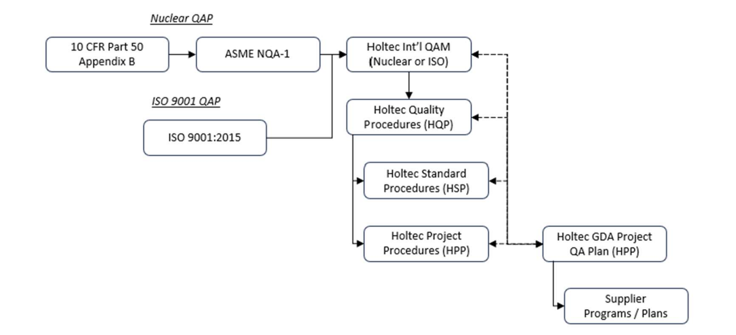
Figure 7: Holtec International quality assurance documented information hierarchy
- Holtec Britain has produced a specific Project Management Plan (ref. [11]) and Project Quality Plan (ref. [12]) for the delivery of the GDA, supported by a suite of GDA-specific procedures. The hierarchy of these documents, and their relationship to the SSEC deliverables, is shown in Figure 8 below.

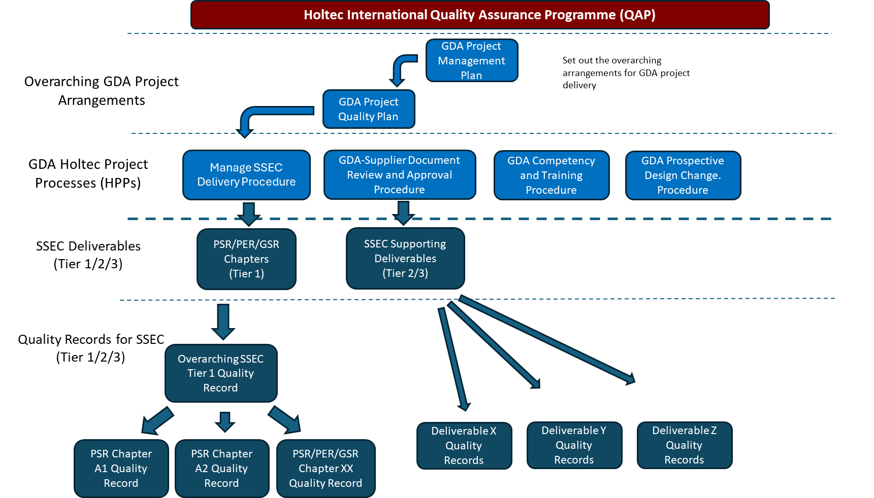
Figure 8: SSEC production quality arrangements and documented information summary

- Several aspects covered by the MS and IMS were sampled during Step 1 and were found to align with expectations from Guidance to Requesting Parties (ref. [1]) and ONR’s GDA technical guidance (ref. [13]).
- The development of the MS, and the overall arrangements described therein align with relevant standards. Whilst it has been developed during Step 1 and continues to evolve, it is sufficiently mature to provide a foundation for the GDA activities, and the defined architecture will facilitate further development, improvement and implementation during Step 2 of the GDA.

Interface arrangements and information access
- Interface arrangements (ref. [14]) have been agreed with the RP during Step 1, which details the working level interfaces between the RP and regulators. This includes the agreed system for transmission and tracking of submissions, correspondence, meetings, and regulatory questions. These arrangements have been successfully implemented during Step 1, considered as part of the readiness review for entry to Step 2, and are judged adequate. Any amendments to these will be part of normal business for the remainder of the GDA.
- As part of implementing the interface arrangements, the RP has put arrangements in place that allows the regulators access to commercially confidential information. It is noted that establishing arrangements to allow access to third party information from the Holtec supply chain remains ongoing; this will be dealt with as normal regulatory business as the project progresses.
- With regard to export control, transfer of controlled information between the UK and US is required to support the GDA. The RP has confirmed that Holtec International have the ability to transfer controlled information from the US to the UK under 10CFR Part 810 General Authorisation and that Holtec Britain hold export licence GBOIE2023/00188 for the transfer of controlled information from the UK to the US. To support technical engagement activities, ONR has also obtained an export licence to allow for transfer of controlled information from ONR to Holtec International in the US.
- We judge that this information is sufficient to meet requirement [1.1], [1.4], [1.7] and [1.26] from Guidance to Requesting Parties (ref. [1]).

Master document submission list
- During GDA the RP will make numerous submissions to ONR. Given the longevity of the project, and the ongoing development of the design and SSEC, the RP needs to have arrangements to keep track of the documents submitted, any subsequent changes to these documents, and any documents withdrawn. This also includes responses to regulatory questions and their incorporation within the SSEC documents. Key to these arrangements is a Master Document Submission List (MDSL), which is a live document that allows ONR to understand and reference the latest versions of the GDA submissions. The MDSL will be a key reference from any subsequent GDA output provided (GDA statement at Steps 1 and 2, or Design Acceptance Confirmation (DAC) if the RP elects to undertake Step 3 of the GDA at a later date). During Step 1 we worked with the RP to establish its arrangements to control and manage the MDSL.
- The MDSL (ref. [15]) is a version-controlled document. The first version was submitted to ONR during Step 1, with routine updates supplied. The arrangements for the development and maintenance of the MDSL are described in the Project Quality Plan (ref. [12]). The scope and contents of the MDSL are consistent with ONR’s expectations. Maintenance of the MDSL will be an important activity for the remainder of GDA.

Regulatory questions
- Guidance to requesting parties (ref. [1]) defines a hierarchy for regulatory questions that may be asked of the RP during GDA, which includes regulatory queries (RQ), regulatory observations (RO) and regulatory issues (RI). During Step 1 we sought confidence that the RP had arrangements in place to receive, process, respond and control these questions.
- The RP has documented arrangements for managing RQs, ROs and RIs (ref. [16]) which are consistent with the agreed interface arrangements (ref. [14]). These include the responsibilities for checking and approving the responses. They include a range of metrics to monitor performance. During Step 2, when an increase in both the number and significance of regulatory questions is expected, we will monitor the ongoing implementation of these arrangements.
- During Step 1, ONR raised 28 RQs. Responses received to date have been in accordance with the interface arrangements and the RP’s procedures, demonstrating the overall adequacy of these arrangements.

Design reference
- In accordance with Guidance to Requesting Parties [1] the RP needs to have suitable arrangements to document and control the design against which ONR is assessing; in simple terms the generic safety, security and safeguards cases must align with the generic design. The RP is therefore required to submit a Design Reference (DR) which lists all the documents that define the design of the NPP. The RP is also expected to freeze the design at a specific date known as the Design Reference Point (DRP).
- The RP describes the arrangements for the SMR-300 design evolution and design reference in the GDA Scope Report (ref. [17]), including identification of the GDA reference design documents.
- The RP has also confirmed its intention to set the DRP at the start of Step 2 of the GDA and has scheduled submission of a design reference report accordingly. The RP has stated that the DRP for the GDA will align with a design freeze in the US and that, whilst a degree of design optioneering and justification that risks have been reduced as low as is reasonably practicable (ALARP) may take place to address matters arising from the GDA, any prospective design changes will not be implemented within GDA timescales. Any prospective design changes identified during GDA will be identified as commitments to be addressed post-GDA. This therefore means that there will be no further DRP other than that at the start of Step 2.
- We are content that this approach is adequate for a two-step GDA, although it is recognised that any prospective design changes, and their underpinning safety and security justifications, would need to be revisited post-GDA if the SMR-300 design were to be deployed in GB.

Change control
- We expect the RP to put arrangements in place to control changes to the generic design and SSEC. From a GDA perspective the regulators’ expectations are to ensure we have clarity over what is assessed and what any regulatory judgements and GDA outputs are made against.
- As stated in section 4.1.5, the intent for the RP during GDA is not to implement any changes of the reference design beyond the DRP. The Holtec SMR-300 GDA Reference Design Process and GDA Prospective Design Change Register document (ref. [18]) presents a process for managing prospective design changes that may occur during the GDA project. The GDA reference design has been developed in the US by Holtec International to meet US codes and standards and there are known differences between US and UK regulatory expectations and requirements which are referred to in the documentation as UK compliance gaps. This process defines the arrangements for managing identified UK compliance gaps.
- During and beyond GDA changes to the SMR-300 design are expected as a result of ongoing design development activities. Prospective design changes arising from either the UK or US project are intended to follow the process described in ref. [18] to demonstrate that any design changes to be incorporated into a future UK reference design after GDA will continue to meet UK regulatory requirements.
- Risks to the validity of the SSEC and reference design, and therefore the meaningfulness of the ONR GDA assessments as a result of prospective design changes are managed through a technical risk register. This register will be monitored routinely through regulatory engagements throughout Step 2.
- During the MSQA engagements in Step 1 the RP demonstrated sufficient understanding of the importance of maintaining a meaningful GDA, particularly with regard to the intent not to make changes during Step 2. The RP stated that it would undertake optioneering and ALARP analysis in support of prospective design changes where it considered this to be required to achieve a meaningful outcome.
- SSEC changes are managed through the process described in the Holtec SMR-300 GDA Management of Safety, Security and Environmental Cases document (ref. [19]) where prospective changes are recorded on the SSEC forward action tracker to be addressed as revisions in the SSEC or taken forward as a commitment.
- Overall, we are satisfied that the Holtec arrangements for managing prospective design and SSEC changes meet our expectations for a two-step GDA.

Capturing requirements, assumptions and commitments
- During GDA, and indeed outside of its GDA activities, the RP will identify requirements, assumptions and commitments. These could come via development of the design or SSEC. The organisation responsible for discharging these commitments could be the RP, or a future licensee. It is important that the RP has arrangements in place to record and control these, such that they can be fulfilled. In Step 1 we sought to understand how these important topics will be addressed.
- Holtec SMR-300 Generic Design Assessment Capturing and Managing Commitments, Assumptions and Requirements (CARs) procedure (ref. [20]) details the arrangements for forward management of CARs and defines the meaning of each.
- The Holtec International design process is described in these arrangements at a high level and a sample of the spent fuel pool cooling System Description Document and requirements notebook was reviewed during an MSQA intervention to evidence this as an output.
- Whilst the arrangements for the management of CARs was found to be adequate for this stage of the GDA, it is recognised that further work will be required in this area in Step 2.

MSQA intervention
- In addition to assessing the RP’s arrangements for undertaking GDA, our MSQA intervention also considered related aspects regarding the RP’s quality function and organisation, competency, intelligent customer capability, operational experience (OPEX) and knowledge management. These aspects are much broader than the arrangements for GDA, but are important enablers for the RP to be successful.
- In general we were content that the RP is making adequate progress with all of these aspects. There remains work to do, but the development is consistent with our expectations for this step of GDA and we note several areas of good practice being developed.
- Throughout Step 2 of GDA we will continue to assess the RP’s arrangements for developing the design, including monitoring management of technical risks associated with prospective design changes in order to ensure the continued validity of the GDA assessments. We will also focus on the implementation of the arrangements for managing commitments, assumptions and requirements.

Summary
- During Step 1 the RP has demonstrated a good understanding of the arrangements needed to undertake the GDA. It has developed many processes and guidance documents, under an overarching IMS. We consider it a positive that the RP has integrated many GDA specifics into its wider business and engineering arrangements.
- Overall, we are content that sufficient progress has been made during Step 1, and plans for further development and implementation during Step 2 are acceptable.
- We judge that this information, in combination with other information described in Section 4 of this report, is sufficient to meet requirements [1.1], [1.21], [1.22], [1.23], [1.24] and [1.27] from Guidance to Requesting Parties (ref. [1]).

Agreement of the GDA scope
- A fundamental objective of Step 1 is to agree the GDA scope between the RP and the regulators (ref. [1]). The GDA scope defines the boundaries of the GDA, and therefore influences both the submissions produced by the RP and the assessment undertaken by ONR. Throughout Step 1 we have therefore engaged with the RP to discuss and agree the GDA scope and the associated schedules.
- Based upon these engagements, the RP has documented the agreed GDA scope in an overall SMR-300 UK Generic Design Assessment Scope report (ref. [17]) and also in 26 individual topic-specific Topic Engagement Plans (TEPs). The scope report documents the physical and functional scope of the NPP that is proposed for consideration in the GDA, as well as the means by which that scope has been identified. The TEPs identify the detailed scope for each technical topic, along with a list of the documents to be submitted in Step 2.
- The Requesting Party has stated that it intends to complete a two-step GDA. The current schedule is for a 14 month Step 2; this corresponds to a total duration of GDA of 24 months from October 2023 to October 2025. We have agreed this overall GDA schedule which therefore fulfils requirement [1.3] of the Guidance to Requesting Parties [1].
- In summary, the GDA scope report (ref. [17]) confirms:
- the generic design is for a twin unit site
- the generic design is located within a site environment bound by the defined Generic Site Envelope (GSE) (ref. [21]). The GSE is discussed further in Section 4.4.6
- the GDA scope includes, as a minimum, all SSCs that are identified as being important to safety (according to the Holtec SSC Classification Standard), security and safeguards. A list is documented within the report
- all modes of operation are considered, from power operation through shutdown and refuelling
- plant states considered include:
  - normal operation
  - anticipated operational occurrences
  - design basis accidents
  - design extension conditions
- all stages of the plant lifecycle will be considered, although the level of detail will vary as appropriate for a two-step GDA
- those SSCs and documents that comprise the reference design
- As would be expected, a number of exclusions from the GDA scope are declared. These typically comprise those buildings and associated SSCs that are not part of the nuclear island.
- Through our assessment of the scope report we identified that a number of those SSCs considered by the RP to be out of scope may have a fundamental effect on the design due to the potential for initiating faults or hazards to arise from them. We therefore raised RQ-01308 (ref. [22]) to clarify this situation. In its response to the RQ Holtec confirmed that the potential hazards arising from out of scope items would be within scope for the hazard and fault analysis, but the SSCs themselves were out of scope from a design assessment perspective.
- We are content that the agreed GDA scope defined in ref. [17] and the TEPs is sufficient to undertake a meaningful assessment of the generic SMR-300 design. Further refinements or changes to the agreed GDA scope can be agreed as normal business for the remainder of the GDA.
- We judge that this information is sufficient to meet requirements [1.2] and [1.3] from Guidance to Requesting Parties (ref. [1]).

Status of the design and safety, security and safeguards cases

Design
- The evolution of the Holtec SMR-300 design from the original SMR-160 design is outlined in section 2.4 of this report. The SMR-300 UK Generic Design Assessment Scope report (ref. [17]) explains this process in further detail, describing how pre-application discussions with the USNRC resulted in modifications to the primary circuit to include forced cooling during normal operations.
- Holtec took the decision to undertake these modifications in September 2023 and has since been developing the revised design using the design change control procedures discussed in section 4.1.6 of this report. This work will culminate in a design freeze, corresponding to the GDA Design Reference Point, immediately prior to Step 2.
- At this point the SMR-300 UK Generic Design Assessment Scope report (ref. [17]) characterises the design submitted for GDA as equivalent to a ‘conceptual full plant design’. Whilst design development will continue in the US, the Design Reference basis of the GDA is clearly stated in the scope report.
- Figure 9 below illustrates how the RP intends to develop the design post-GDA, in parallel with that developed for the US Palisades plant.
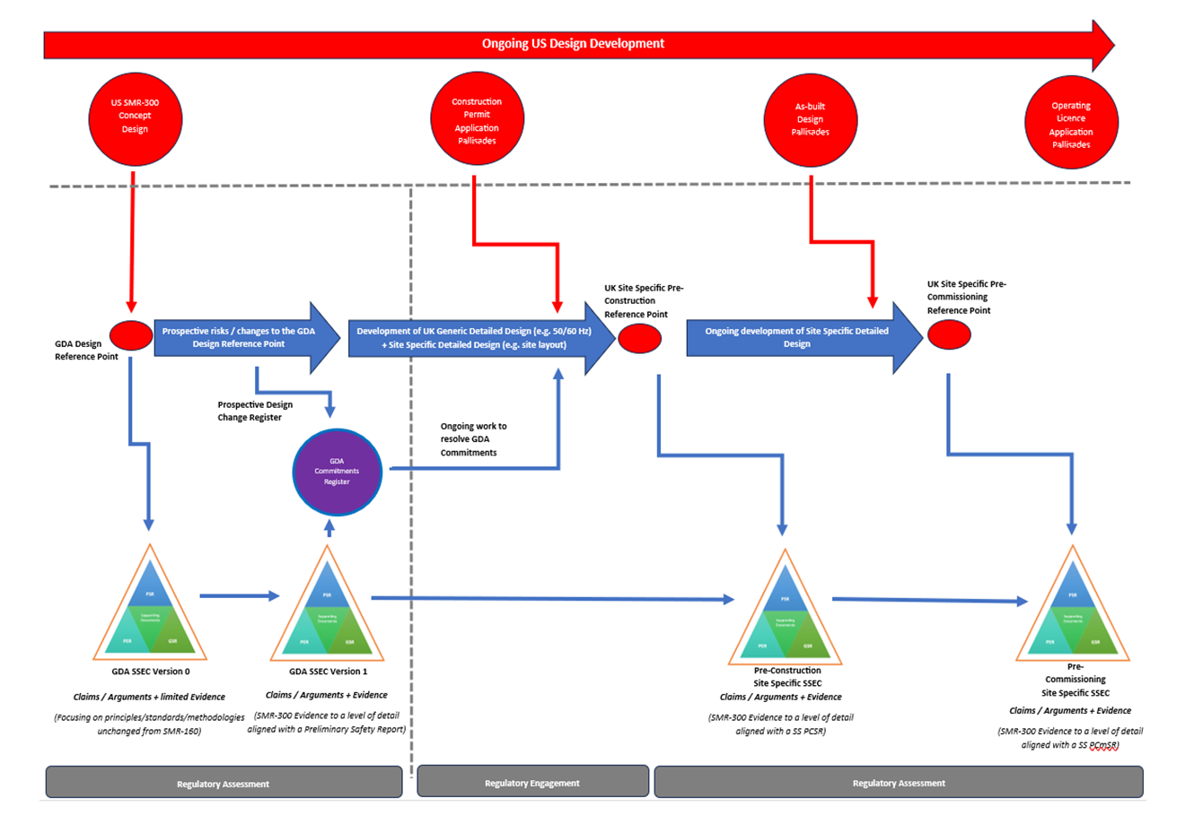
Figure 9: SMR-300 overall design and SSEC development
- It is acknowledged that as the design continues to develop in parallel with the GDA there is potential for divergence from the fundamental Design Reference. This risk will be managed and monitored using the design change and risk management processes discussed earlier.
- With regard to the design maturity of specific SSCs, the GDA scope report (ref. [17]) describes how Technology Readiness Levels (TRL) were assigned to the plant systems, where TRL 9 refers to demonstrated system operations and TRL 1 refers to a set of basic principles of operation. SSCs of a low TRL were screened out of the scope of the GDA.
- We are content that all SSCs that are identified as being important to safety, security and safeguards have been included within the scope.
- We are content that the RP has established an adequate baseline design for the GDA and this will be captured in the Design Reference. The potential for the ongoing design development in the US to diverge from this Design Reference will remain an area of focus and be monitored throughout Step 2.

Safety, security and safeguards case
- Figure 9 above illustrates how the SSEC will be issued at or before the start of Step 2, and subsequently updated towards the end of Step 2 to reflect the assessments undertaken during the GDA. Figure 9 also illustrates how the SSEC will be further developed post-GDA and aligned with major milestones as the plant approaches operational status.
- For the safety case, a PSR will be submitted at the start of Step 2 and be aligned with the DRP. For the security and safeguards cases, a PSyR and PSgR were submitted during Step 1.
- The SMR-300 GDA Safety, Security and Environmental Case Structure document (ref. [7]) was submitted during Step 1 and describes the fundamental purpose and scope of the SSEC, the integrated structure of the PSR, GSR, PSgR and PER and supporting documents such as the MDSL and chapter descriptions.
- All of the principal PSR documents are structured using a claims – arguments – evidence approach. It is understood that the availability of the evidence layer will be limited in a two-step GDA, however, it is expected that evidence will be provided on a sample basis as agreed through the development of the GDA scope.
- The objective of the PSR is stated as “to summarise the safety standards and criteria, safety management and organisation, claims, arguments and intended evidence to demonstrate that the SMR-300 generic design risks to people are likely to be tolerable and ALARP.”
- The PSR structure has been informed by ONR guidance in this regard; it has been split into two parts with distinct chapters:
- Part A is intended to be a summary of the safety case for the SMR-300 and includes chapters covering:
  - a description of the generic site definition
  - the key safety claims and the trail through arguments to evidence
  - the safety case management framework
  - an ALARP summary.
- Part B is intended to focus on the reactor design and its safety assessment and includes chapters covering:
  - a description of the design and main operating systems
  - the normal operational aspects of the reactor
  - the environmental protection features that are claimed within the PSR
  - the safety assessments undertaken for the SMR design
  - specific technical topic areas such as structural integrity, control and instrumentation etc.
- The PSyR (ref. [23]) has been provided to ONR in Step 1 to give confidence that it will provide the basis of a ‘meaningful assessment’ of the security topic during Step 2. It lays out in broad terms what the high level format of submissions will be and the content that will meet expectations for security in a two-step GDA. The PSyR will be updated to become the GSR submitted towards the end of Step 2 to incorporate the findings from the ONR assessments.
- Within the Guidance to RPs (ref. [1]) there are a number of points contained within Appendix 2 that relate to security. Of these [1.12], [1.18] and [1.19] are applicable here. These outline continued compliance with the Nuclear Industry Security Regulations (NISR) 2003 (ref. [24]), the format and content of the Generic Security Report (GSR), and the schedule of submissions for Step 2 of the GDA.
- Security inspectors have reviewed the PSyR. We judge that the document contains sufficient detail to have confidence that requirement [1.12] can be met in that there will be continued compliance with NISR 2003.
- Through a series of workshops with the RP and its technical support contractor Risktec, and through development of the TEP for the security topics, agreement was reached regarding a proportionate demonstration of the security methodologies during Step 2. This included agreement on the SSCs against which they will be demonstrated. This satisfies requirements [1.18] and [1.19] of (ref. [1]).
- The PSgR (ref. [25]) was submitted in Step 1 to demonstrate the RP’s understanding of safeguards requirements at the generic (international/national) level and how they will be accommodated in the generic design.
- From our assessment of the PSgR we found that the RP has demonstrated an adequate understanding of these requirements, and that whilst it is recognised that there is more work to do in Step 2, there are no fundamental concerns with the RP’s approach at this stage.
- Overall, we judge it to be positive that the RP has developed a detailed approach to the development and management of the PSR and has provided early versions of the GSR (in the form of a PSyR) and PSgR for assessment at this early stage of the project.
- In summary, we judge that this information is sufficient to meet requirements [1.12], [1.18] and [1.19] from the Guidance to Requesting Parties (ref. [1]).

Information submitted during Step 1
- The guidance to requesting parties (ref. [1]) contains several requirements for the RP to submit information to ONR during Step 1. This information is essential to enable us to gain familiarity with the RP’s design and safety, security and safeguards cases and approach, and for the RP to demonstrate an understanding of the regulatory expectations for GDA.
- This section summarises the information that has been submitted during Step 1 against each of those specific requirements. Note that the intention for such submissions was primarily to inform subsequent assessments in Step 2 and to build confidence in the RP’s ability to meet regulatory expectations. The technical content of these submissions has been reviewed to gain a view on maturity, relevance and consistency with our expectations. Where necessary we have raised Regulatory Queries to clarify the content of the submissions; in a number of cases the documents were revised and resubmitted to reflect the responses to these queries.

Design familiarisation
- During Step 1 ONR has undertaken several design familiarisation activities to prepare for and aid the planning of the technical assessments in Step 2.
- To facilitate this the RP submitted a Plant Overview Report (ref. [5]) , the PSyR (ref. [23]) and the PSgR (ref. [25]) and held two design familiarisation meetings to brief the regulators on the generic design. These were supplemented by topic-specific Level 4 meetings where the regulators took the opportunity to develop their understanding of the design in their topic area in more depth.
- Collectively these have increased ONR’s understanding of the design and provided useful information regarding the design, functions, justifications, and approaches likely to be adopted in future SSEC submissions. They formed the basis of the initial technical discussions between ONR and the RP during Step 1, towards agreement of the GDA scope and production of ONR’s assessment plans for Step 2.
- We judge that this information is sufficient to meet requirement [1.8] from Guidance to Requesting Parties (ref. [1]).

Fundamental design philosophy and engineering design principles
- To allow ONR to understand the SMR-300 design philosophy, the main design features, main safety and security claims including identification of hazards, control measures and protection systems, the RP submitted a Fundamental Design Philosophy report (ref. [26]) and the Plant Overview report (ref. [5]).
- The Fundamental Design Philosophy report also provided an insight into how the RP’s own design, security and safety principles are adopted in the proposed design.
- The report describes how the RP claims the design of the SMR-300 is predicated on the following basic design principles and practices:
- redundant and passive engineered safety features
- simplified plant design with structures designed to withstand all postulated external events
- ability to mitigate design basis accidents with no operator action
- ability to cope with an extended loss of all AC power for at least 72 hours
- defence in depth approach to beyond design basis mitigation
- highly reliable active systems to support normal plant operation
- The document also describes how the RP has developed outline engineering design principles which will be further developed and defined in Step 2.
- The engineering design principles take account of ONR safety, security and safeguards assessment guidance as well as UK environmental principles and general design criteria requirements from the US NRC. These principles will be supplemented by a review of international and UK relevant good practice in Step 2.
- The submissions were reviewed by all of the ONR specialist inspectors, with comments captured through regulatory queries. In both cases the reports were revised and resubmitted to reflect the responses to the queries.
- Whilst it is recognised that the safety, security and safeguards cases are maturing, we consider that the Plant Overview (ref. [5]) and Fundamental Design Philosophy report (ref. [26]) and the individual TEPs were sufficient to develop ONR’s understanding of this area during Step 1.
- Specifically, we judge that this information is sufficient to meet requirements [1.10] and [1.15] from the Guidance to Requesting Parties (ref. [1]).

Demonstration of ALARP
- In response to requirement [1.11] from the Guidance to Requesting Parties (ref. [1]) the RP submitted the ALARP Design Process report (ref. [27]) in Step 1.
- The submission presents an overview of the process that the RP intends to apply to demonstrate that the SMR-300 reference design (and any prospective design changes to the reference design) reduces risks to ALARP. The document also presents an overview of the design development that has been undertaken in the US regulatory context and how this design will be reviewed by the RP to determine whether it satisfies the UK regulatory expectations.
- The submission was reviewed by a number of ONR specialist inspectors with applicable comments captured through regulatory queries. The report was revised and resubmitted to reflect the responses to the queries.
- Following this review we consider that the description of the process for determining and demonstrating that the risks from the SMR-300 design are reduced ALARP outlined in the report is adequate to meet requirement [1.11] from Appendix 2 of (ref. [1]).
- Consideration of the application of the ALARP design process and whether the SMR-300 design can be demonstrated to reduce risks ALARP will be an important Step 2 activity for all ONR inspectors on the GDA project.

Compliance with NISR
- NISR 2003 (ref. [24]) places requirements on dutyholders regarding physical security measures for facilities, cyber security, nuclear material and the security of Sensitive Nuclear Information (SNI). The expectation is for the RP to proportionately demonstrate in a two-step GDA that its generic design can meet such requirements. This is addressed within the PSyR (ref. [23]) and associated TEP, and it is the RP’s stated intention to proportionately address relevant matters during GDA.
- For the security topics, we are content that we have all the information, or agreement on delivery of that information, to conduct a meaningful assessment for security of the Holtec SMR-300 design in Step 2 of this GDA.
- We judge that, for the security topics, this information is sufficient to meet requirement [1.12] from Guidance to Requesting Parties.
- NISR 2003 also places requirements on dutyholders for handling and protecting security marked documentation, including identifying any Sensitive Nuclear Information (SNI). To this end the RP established arrangements under procedure Holtec SMR-300 GDA – Handling and Protecting Security Marked Documentation (ref. [28]).
- Following our review of this procedure we raised RQ-01290 (ref. [29]) identifying concerns regarding classification guidance. In response to the RQ the RP established the Holtec Britain Classification Policy and Guidance document (Ref. [30]).
- Whilst there remain some minor issues regarding the explicit security marking of documents and integration with other document protection processes, these relate more to confidence in implementation rather than the process itself.
- We therefore conclude that the two documents referenced above meet the requirements of NISR 2003 in this regard and the expectations of requirement [1.5] of the Guidance to Requesting Parties (ref. [1]).
- Requirement [1.6] of Appendix 2 of the Guidance to Requesting Parties requires the RP to obtain all necessary personnel security clearances for all staff who will be supporting the GDA.
- The RP has developed the standards, procedures and arrangements (ref. [31]) and (ref. [32]) as required by NISR 2003 for staff to obtain the required level of vetting should they need it.
- We have confirmed that the personal security clearances needed at this stage of the GDA are in place.
- We have reviewed the RP’s arrangements and have not identified any fundamental concerns, although minor improvements are required to address some issues. As part of the continued regulation under NISR 2003 this area will be subject to a proportionate inspection regime as with any other dutyholder.
- We can therefore confirm that requirement [1.6] of the Guidance to Requesting Parties has been fulfilled.

Regulatory framework and principles
- Requesting Parties are expected to demonstrate understanding of the UK regulatory framework and principles, including how these will be considered within the design and safety/security/safeguards cases. In Step 1 the RP submitted its UK/US Regulatory Framework and Principles Report (ref. [33]) in order to demonstrate this understanding.
- The report presents a tabular overview of key UK regulations and ONR Safety Assessment Principles. Environmental, security and safeguards principles are also considered. The report goes on to review differences in US/UK approaches across nuclear safety, nuclear security, nuclear safeguards, environmental protection, radiation protection and radioactive waste.
- The report also presents a section on “Regulatory Issues of Concern Relevant to the SMR-300 Design”. The issues raised in this section are those identified by the RP in the Step 1 UK Gap Analysis report (ref. [34]). The assessment of this report is discussed in section 4.4.8 below.
- The UK/US Regulatory Framework and Principles report was reviewed by ONR specialist inspectors, with comments captured through regulatory query RQ-01298 (ref. [35]).
- The report was initially produced by Mott MacDonald, the RP’s principal technical support contractor in the UK. Given that the purpose of the report, and requirement [1.13] of the Guidance to Requesting Parties, is to confirm the RP’s understanding of the UK regulatory context, one of the key issues raised in RQ-01298 surrounded the RP’s ability to act as an intelligent customer in this regard.
- In the response to RQ-01298 the RP stated that its GDA Project Management Plan (ref. [11] and Project Quality Plan (ref. [12] set out the relevant processes for how documentation is accepted for use on the project and subject to appropriate review and approval. The RP added that it is reasonable for an organisation developing its intelligent customer capability to seek specialist support in this area. This report acts as an information resource to bolster the RP’s ability to act as an intelligent customer across all regulated technical areas in the scope of the GDA and beyond into licensee space.
- It is noted that the RP’s knowledge and understanding of regulatory frameworks is expected to be included as part of its Suitably Qualified and Experienced Persons (SQEP) arrangements. This will be a specific focus for the MSQA assessment in Step 2 engagements.
- Following our review of the responses to RQ-01298, we are content that they are appropriate or are being adequately addressed via topic-specific regulatory engagements. Specifically, we are content with these being addressed as part of routine document updates to the UK/US Regulatory Framework and Principles report within Step 2.
- We are therefore content that this report and the RP’s responses to RQ-01298 meet the expectations of requirement [1.13]. of the Guidance to Requesting Parties (ref. [1]).

Site characteristics
- The RP submitted its GSE (ref. [21]) which bounds the site characteristics of a potential GB site.
- We are content that the scope and coverage of the GSE is reasonable, that it is suitably representative of a generic GB site, and is consistent with previous GDAs. The GSE is intended to bound the declared candidate sites for deployment of the SMR-300 within national policy. During Step 2 we will assess the adequacy of the values proposed by the RP.
- We judge that this information is sufficient to meet requirement [1.16] from Guidance to Requesting Parties (ref. [1]).

Codes and standards
- In Step 1 the RP submitted a Codes and Standards report (ref. [36]) in order to introduce the codes and standards used in the design of the SMR-300, and to establish a strategy for the evaluation of the relevance, applicability, adequacy and sufficiency of the codes and standards of the SMR-300.
- The report notes that the codes and standards used for the design of the SMR-300 were selected to meet the requirements of the USNRC and applicable code of regulations, and the RP claims that they are mature, established and internationally recognised. In particular, those applied to the design of the nuclear safety-related SSCs are nuclear-specific, with many recognised as relevant good practice in the UK, as established from existing practices on British nuclear licensed sites and application in previous GDAs.
- The report provides a comprehensive list of those codes and standards used in the SMR-300 design, with many organised on a topic-specific basis.
- The RP’s evaluation of the codes and standards used for the design will be undertaken and reported by the RP in Step 2 of the GDA. The evaluation strategy is informed by the expectations described in ONR’s Safety Assessment Principles (ref. [37]), Security Assessment Principles (ref. [38]) and Technical Assessment Guides (ref. [39]) and seeks to fulfil the following objectives:
- identify the principal codes and standards applied on the SSCs
- identify whether the principal codes and standards represent Relevant Good Practice (RGP) and commensurate with the classification and importance of the safety functions being delivered
- identify significant gaps between the applied US codes and standards and UK expectations
- establish a forward action plan to eliminate gaps identified
- The Codes and Standards report was reviewed by ONR specialist inspectors, with comments captured through regulatory query RQ-01297 (ref. [40]).
- From our review of the Codes and Standards report (ref. [36]) and the RP’s response to RQ-01297, we are satisfied that requirement [1.17] from Guidance to Requesting Parties (ref. [1]) has been fulfilled.
- The codes and standards applied to the SMR-300 design will continue to be of regulatory interest and will form an important part of ONR’s Step 2 assessment. Furthermore, it is anticipated that the topic will be progressed by the individual ONR specialist inspectors within Step 2.

Gap analysis
- Guidance to Requesting Parties (ref. [1]) requires the RP to undertake a gap analysis of the submissions planned to support Step 2 against regulatory expectations and to propose how any identified gaps will be resolved. This requirement was included based on lessons learnt from previous GDAs with non-UK based requesting parties. In those instances, gaps commonly existed due to lack of familiarity and experience with UK regulatory expectations, and the generic designs or safety, security or safeguards cases were not developed with these in mind.
- The RP’s gap analysis report (ref. [34]) provides a narrative of its review in this regard. As the SMR-300 is being designed by a US-based organisation with limited familiarity with current UK requirements and expectations, the gap analysis was considered an important submission to improve regulatory confidence for readiness to progress to Step 2.
- The report is supported by reviews from UK organisations engaged by the RP for this purpose, and consideration of differences in US and UK regulatory/legislative requirements as captured by the RP in the UK/US Regulatory Framework and Principles report (ref. [33]). It presents the RP’s views of the high level and topic specific technical gaps, with production of topic specific TEPs to capture forward actions. TEPs identify risks and potential gaps by topic area and the submissions intended to address these, which have informed the individual topic assessment plans.
- The identified gaps are mainly associated with fault analysis topics, demonstration that the design meets the UK regulatory context, and capability of the RP’s organisation to deliver the design and SSEC on timescales proposed by the RP and agreed by regulators.
- The high level gaps identified by the RP include a number of topics that will be a focus of our assessments in Step 2. These include but are not limited to:
- metrication – the reference design is based on US Customary units rather than SI (International System) units
- 60/50 Hz difference in the electrical infrastructure design
- fault studies initiating faults – differences between UK and US expectations
- safety function categorisation and SSC classification – differences between UK and US expectations
- ALARP justification – recognition of UK statutory requirements in this regard
- diversity between the Primary Protection System and the Diverse Actuation System
- As an activity and output to respond to requirement [1.20] from the Guidance to Requesting Parties (ref. [1]) to undertake such a review, the RP’s gap analysis (ref. [34]), submission schedule (ref. [9]) and supporting TEPs are considered adequate and requirement [1.20] has been met. The RP has undertaken a systematic review, considering a reasonable range of inputs and has identified a number of gaps and developed plans for how they can be resolved.

ONR’s Step 2 assessment plans
- ONR has produced a total of 20 assessment plans for Step 2. These cover each of the technical topics that will assess the RP’s submissions, in addition to a project assessment plan that covers matters needing coordination and assessment at a strategic level. All the plans are consistent with our delivery strategy (ref. [8]).
- Our assessment plans have been informed by:
- the agreed GDA scope
- our understanding of the generic design and SSEC
- discussions with the RP to understand the scope and maturity of submissions planned for Step 2
- the items identified in the RP’s gap analysis
- The TEPs developed by the RP
- The SSEC submissions we need to undertake our assessments during Step 2 have formed the basis of the RP’s submission schedule (ref. [9]). The provision of this schedule satisfies requirement [1.19] of the Guidance to Requesting Parties (ref. [1]).

Readiness reviews

Holtec readiness review
- In accordance with requirement [1.30] of Guidance to Requesting Parties (ref. [1]), the RP undertook a self-assessment and review of its readiness to proceed to Step 2 of the GDA. The evidence presented to ONR to support the outcomes of this review is captured in the SMR-300 Step 2 Readiness Review report (ref. [41]).
- The report describes the scope of the readiness review including:
- readiness against ONR/EA/NRW Step 1 requirements
- satisfaction of pre-requisites against ONR/EA/NRW expectations for Step 2
- the processes and working arrangements required for GDA (management arrangements maturity, including organisational capability)
- assessment of each topic area to assess topic plans, technical issues, risks and readiness to achieve a meaningful Step 2
- SSEC maturity
- The determination of the RP’s readiness for Step 2 entry was undertaken by Holtec staff and an Independent Technical Assurance Panel comprising members taken from the RP’s technical support contractors who were considered sufficiently independent for the activities they reviewed.
- The process by which the review took place was informed by a mid-step readiness review conducted in February 2024 and a ‘dry run’ review conducted in March 2024. The process itself is illustrated in Figure 10 below.

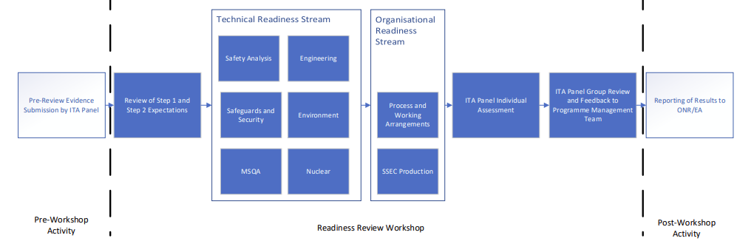
Figure 10: Holtec Step 2 readiness review process
- Figure 10 shows how a workshop approach was taken to determine the RP’s readiness against each of the requirements identified in Appendix 2 of the Guidance to Requesting Parties (ref. [1]) on a technical and organisational basis.
- A review of each technical topic also considered readiness to proceed, the significance of any gaps between UK and US expectations, and the risks associated with those gaps. In considering readiness to proceed, the following aspects were addressed:
- scope – would this allow for a meaningful assessment
- deliverables
- schedule
- availability of information
- resource capacity and capability
- The Technical Readiness Stream addressed requirements [1.2] and [1.25] from the Guidance to Requesting Parties while the Organisational Readiness Steam considered the remaining requirements apart from [1.30] which is addressed by the readiness review itself.
- The outcome of the readiness review is described in the report. This includes a statement of readiness against each technical topic area, key discussion points raised during the review, and any risks identified. Each of the risks is recorded in the project risk register such that mitigations may be identified, progressed and monitored during Step 2.
- The outcome of the review of each of the requirements of the Guidance to Requesting parties was provided separately (ref. [42]). This included a statement on the status against each requirement, and reference to the evidence to support that status.
- In the case of requirement [1.28], the RP provided procedure Holtec SMR-300 GDA – Managing Public Enquiries (ref. [43]). The RP also provided website and electronic documents showing examples of the website content. We have reviewed these and confirmed that requirement [1.28] has been fulfilled.
- For requirement [1.29] of the Guidance to Requesting Parties, the charging agreement between ONR and the RP (ref. [44]) addresses any extended or revised cost recovery agreements for the remainder of the GDA.
- Having reviewed the SMR-300 Step 2 Readiness Review report (ref. [41]) and supporting information, and discussed its contents, approach and outcomes at Level 4 meetings, we are content that the information provided is sufficient to satisfy requirements [1.25] and [1.30] from Guidance to Requesting Parties.

ONR
- In line with the requirements of Guidance to Requesting Parties (ref. [1]), we undertook a review of our own readiness to progress to Step 2 (ref. [45]). In addition to considering the outcomes from the RP’s readiness review, we also confirmed that we:
- agree that the RP has met requirements [1.1] to [1.30] of Guidance to Requesting Parties, see Table 1, as described in this report;
- have completed all of the requirements against us as defined in Appendix 2 of Guidance to Requesting Parties, namely [1.31] to [1.40];
- have implemented suitable project management and arrangements to undertake the GDA;
- have secured sufficient internal resources to undertake the activities identified in our assessment plans for Step 2
- have taken account of the outcome of the Environment Agency’s own readiness review; and
- consider that, based on the agreed GDA scope (ref. [17]) and submission schedule (ref. [9]), the assessment will remain meaningful during Step 2, and warrants the continued deployment of regulatory resource.
- The outcome from our readiness review was that we consider we are ready to proceed to Step 2 of GDA for the Holtec SMR-300.

Conclusions
- This report is ONR’s first to summarise our assessment of the Holtec SMR-300, produced at the end of Step 1 of the GDA. In this step we have initiated the project and developed our understanding of the design, the safety, security and safeguards case, and the RP. We have agreed the GDA scope and schedule and a submission schedule for Step 2. This has allowed us to plan for our fundamental assessment to begin in Step 2 and to develop detailed assessment plans for each of our technical topics.
- Based on the work carried out by ONR, we are satisfied that:
- The RP has completed all the requirements for Step 1 from our guidance;
- Interactions with the RP throughout Step 1 have been professional and constructive, and we have confidence that this will continue;
- The RP has made good progress in developing its organisation and arrangements to support GDA;
- The agreements necessary to undertake the GDA are in place, or have developed sufficiently for this point in the project with clear plans for further development;
- The RP has demonstrated a good understanding of our regulatory expectations and has confidence that these can be met by its design and safety, security and safeguards case;
- We have improved our understanding of the generic Holtec SMR-300 design and safety, security and safeguards case, and have used this to inform our planning for further assessment activities; and
- We, and the RP, are ready to proceed to Step 2 of the GDA.
- A vital element of delivery of Step 2 in line with the agreed schedule relies on the timely production of high quality safety, security and safeguards submissions. This may challenge the RP, and it will need to exercise a high level of control to ensure that the quality of submissions is not undermined by delivery at pace.
- We will continue to rigorously assess the RP’s submissions in line with our assessment plans and will address any potential matters of concern should they arise. We will continue to assess the effectiveness of the RP’s arrangements to deliver an adequate, holistic safety, security and safeguards case for its generic design. We have planned our assessments across the 20 technical topics we will assess to ensure we deliver a holistic fundamental assessment of the generic Holtec SMR-300 design during Step 2.

Recommendations
- Based upon the work described in this report, we recommend that ONR should proceed to Step 2 of the GDA for the generic Holtec SMR-300 design.

References

[1] | ONR, New Nuclear Power Plants: Generic Design Assessment Guidance to Requesting Parties, ONR-GDA-GD-006, Revision 0, October 2019. www.onr.org.uk/new-reactors/onr-gda-gd-006.pdf.
[2] | www.gov.uk/guidance/new-nuclear-power-stations-assessing-reactor-designs.
[3] | EA, New Nuclear Power Plants: Generic Design Assessment Guidance to Requesting Parties, October 2019. www.gov.uk/government/publications/new-nuclear-power-plants-generic-design-assessment-guidance-for-requesting-parties.
[4] | www.onr.org.uk/new-reactors/index.htm.
[5] | HI-2240077 Holtec, SMR-300 Plant Overview, Rev. 0, January 2024 (Record Ref: ONRW-2019369590-6582).
[6] | RQ-01470 ONR, Plant Information for Summary Report, July 2024.
[7] | HI-2240064 Holtec, SMR-300 GDA Safety, Security and Environmental Case Structure, Rev 0, January 2024 (Recoord Ref: ONRW-2019369590-6480).
[8] | Delivery Strategy for the Generic Design Assessment of the Holtec SMR-300, Issue No. 1, May 2024. (Record ref. ONRW-2019369590-9783 ).
[9] | HI-2240122 Holtec, Holtec SMR-300 GDA Step 1 & 2 Schedule, Rev 3.1, June 2024 (Record Ref: ONRW-2019369590-10227).
[10] | ONR, Step 1 Assessment of Management for Safety and Quality Assurance of the SMR-300, Issue 1, June 2024. (Record ref. ONRW-2126615823-3653).
[11] | HPP-3295-0001 Holtec, Generic Design Assessment Project Management Plan, Rev 3, April 2024 (Record Ref: ONRW-2019369590-9119).
[12] | HPP-3295-0002 Holtec, SMR-300 Generic Design Assessment Project Quality Plan, Rev.1, April 2024 (Record Ref: ONRW-2019369590-9120).
[13] | ONR-GDA-GD-007, New Nuclear Power Plants: Generic Design Assessment Technical Guidance, Rev. 0, May 2019.
[14] | ONR, Generic Design Assessment Interface Arrangements with Holtec, ONR-GDA-IN-001, Issue 1, July 2024. (Record ref. ONRW-2019369590-7603).
[15] | HI-2240061 Holtec, SMR-300 GDA Master Document Submission List for GDA, Rev. 3, July 2024 (Record Ref: ONRW-2019369590-10727).
[16] | HPP-3295-0015 Holtec, Managing Regulators' RQs, RIs and ROs, Rev. 0, April 2024 (Record Ref: ONRW-2019369590-9126).
[17] | HI-2240121 Holtec, SMR-300 UK Generic Design Assessment Scope, Rev. 1, May 2024 (Record Ref: ONRW-2019369590-9727).
[18] | HPP-3295-0017 Holtec, SMR-300 Generic Design Assessment Reference Design Process and GDA Prospective Design Change Register, Rev. 1, May 2024 (Record Ref: ONRW-2019369590-9576).
[19] | HPP-3295-0012 Holtec, SMR-300 GDA Management of Safety, Security and Environmental Cases, Rev. 0, April 2024 (Record Ref: ONRW-2019369590-9127).
[20] | HPP-3295-0013 Holtec, SMR-300 Generic Design Assessment Capturing and Managing Commitments, Assumptions and requirements, Rev. 0, April 2024 (Record Ref: ONRW-2019369590-9124).
[21] | HI-2240069 Holtec, Generic Site Envelope Report for SMR-300 UK GDA, Rev. 1, February 2024 (Record Ref: ONRW-2019369590-7827).
[22] | RQ-01308 ONR, SMR-300 UK Generic Design Assessment Scope, April 2024.
[23] | HI-2240261 Holtec, GDA Step 1 - SMR-300 Preliminary Security Report, Rev. 1, February 2024 (Record Ref: ONRW-2019369590-7726).
[24] | H.M. Government, Nuclear Industry Security Regulations (NISR) 2003 (as amended). www.legislation.gov.uk/uksi/2003/403/contents/made.
[25] | HI-2240260 Holtec, GDA Step 1 - Preliminary Safeguards Report, Rev. 0, February 2024 (Record Ref: ONRW-2019369590-7725).
[26] | HI-2240120 Holtec, Fundamental Design Philosophy Report, Rev.1, May 2024 (Record Ref: ONRW-2019369590-9575).
[27] | HI-2240125 Holtec, ALARP Design Process, Rev. 1, May 2024 (Record Ref: ONRW-2019369590-9574).
[28] | HPP-3295-0011 Holtec, Holtec SMR-300 GDA - Handling and Protecting Security Marked Documentation, Rev. 0, February 2024 (Record Ref: ONRW-2019369590-7724).
[29] | RQ-01290 ONR, Holtec SMR300 Handling and Protecting Security Marked Documentation missing Classification Guidance, March 2024.
[30] | HPP-3295-0019, Holtec Britain Classification Policy and Guidance, Rev. 0, April 2024 (Record Ref: ONRW-2019369590-9091).
[31] | HPP-3295-0021 Holtec, Personnel Security Aftercare Company Practice, Rev. 0, April 2024 (Record Ref. ONRW-2019369590-9120).
[32] | HPP-3295-0022 Holtec, Holtec Britain Personnel Security Company Practice, Rev.0, April 2024 (Record Ref: ONRW-2019369590-9090).
[33] | HI-2240127 Holtec, US/UK Regulatory Framework and Principles Report, Rev.0, February 2024 (Record Ref: ONRW-2019369590-7825).
[34] | HI-2240124 Holtec, Step 1 - UK GDA Gap Analysis Report, Rev. 1, May 2024 (Record Ref: ONRW-2019369590-9572).
[35] | RQ-01298 ONR, Queries relating to the Framework Report [HI-2240127], March 2024.
[36] | HI-2240126 Holtec, GDA Step 1 - Codes and Standards Report, Rev. 0, February 2024 (Record Ref: ONRW-2019369590-7727).
[37] | SAPs ONR, Safety Assessment Principles - 2014 Edition, Rev. 1, January 2020 (https://www.onr.org.uk/publications/regulatory-guidance/).
[38] | SyAPs ONR, Security Assessment Principles for the Civil Nuclear Industry - 2022 Edition, Version 1 (https://www.onr.org.uk/publications/regulatory-guidance/).
[39] | TAGs ONR, Technical Assessment Guides (https://www.onr.org.uk/publications/regulatory-guidance/).
[40] | RQ-01297 ONR, Codes and Standards, March 2024.
[41] | HI-2240809 Holtec, SMR-300 GDA Step 2 Readiness Review, Rev. 0, June 2024 (Record Ref: ONRW-2019369590-10539).
[42] | Holtec, GDA Requirements Management, June 2024 (Record Ref: ONRW-2019369590-10561).
[43] | HPP-3295-0030 Holtec, Managing Public Enquiries, Rev 0, May 2024 (Record Ref: ONRW-2019369590-9717).
[44] | Holtec, SMR-160 - ONR Charging Agreement, 2023. (Record Reference: 2023/51102).
[45] | ONR, Holtec SMR-300 Emergency Regulatory Review Meeting Minutes - Step 2 Readiness Review, 20th July 2024 (Record Ref: ONRW-2019369590-11018).

Table 1
Step 1 requirements from Guidance to Requesting Parties (ref. [1])
 | Requirement on the RP during Step 1 | Section
[1.1] | Agree with ONR interface arrangements to be applied throughout GDA | 4.1.2
[1.2] | Agree with ONR the GDA scope, to ensure that the assessment is meaningful | 4.2
[1.3] | Agree with ONR the overall GDA timescales and associated schedule, including subsequent steps | 4.2
[1.4] | Put arrangements in place to ensure that ONR will have full access to any commercially confidential information necessary for it to complete its assessments at each step; this must also include relevant commercial information which is the property of third parties. ONR expects this information to be made available in ONR’s offices | 4.1.2
[1.5] | Put arrangements in place for handling and protecting security marked documentation, including identifying any SNI. ONR expects the RP’s document classification scheme to be compatible with the Government Security Classifications | 4.4.4
[1.6] | Obtain all necessary personnel security clearances for all staff who will be supporting GDA | 4.4.4
[1.7] | Obtain all necessary export licenses to ensure that information can be transferred to and from the UK, and other relevant countries where information transfer is necessary as part of GDA | 4.1.2
[1.8] | Submit to ONR design familiarisation information. This should include sufficient information to provide ONR with an overall understanding of the safety and security of the proposed design, in line with the agreed scope for GDA. This should also include information on the current status of the design and the identification of any aspects where development is still required, alongside an indication of what this may entail and likely timescales. The RP should identify any distinguishing features of the design | 4.4.1
[1.9] | Submit to ONR information on assessments performed by other regulators on the proposed design, including the current status of any reviews, any findings and any changes made or proposed as a result, including a judgement on their significance | 2.4.1
[1.10] | Submit to ONR a description of the fundamental design philosophy and identification of the main safety and security claims including identification of hazards, control measures and protection systems | 4.4.2
[1.11] | Submit to ONR a description of the process being adopted by the RP to demonstrate compliance with the legal duty to ensure that the risks to human health arising from the operation of a power station based on the proposed design are reduced to ALARP | 4.4.3
[1.12] | Submit to ONR a description of the process being adopted by the RP to demonstrate compliance with the requirements of the Nuclear Industries Security Regulations (NISR) | 4.4.4
[1.13] | Submit to ONR evidence of the RP’s understanding of the nuclear regulatory framework and regulatory principles and how these have been (or will be) considered as part of the design and generic safety and security cases for the proposed design. This should include matters such as:  - the approach to categorisation of safety functions and classification of structures, systems and components  - the development of a schedule of faults (including internal events and internal and external hazards), including protection and mitigation measures and the links this has to the associated engineering  - an understanding of the approach adopted to defence in depth and the hierarchy of controls, including consideration of matters such as common cause failure, segregation, redundancy and diversity | 4.4.5
[1.14] | Submit to ONR information about the reference design (or designs) on which the generic safety and security cases are based, if appropriate | 2.4.1
[1.15] | Submit to ONR the RP’s own design, security and safety principles adopted in the proposed design | 4.4.2
[1.16] | Submit to ONR a definition of the site characteristics to be used as the basis for the safety analysis (the 'generic site envelope') | 4.4.6
[1.17] | Submit to ONR a description of the codes and standards which have been used as part of the proposed design, including the identification of any non-conformances | 4.4.7
[1.18] | Put arrangements in place for development of the safety and security cases. Agree with ONR the approach for structuring the generic safety and security cases and their format, including the intentions for using existing information throughout GDA. This should include details of existing safety and security case information and its availability. Where existing information is to be used the scope, background and regulatory basis of this information should be specified | 4.3
[1.19] | Agree with ONR a schedule of generic safety and security case information which will be submitted to ONR ahead of, and during Step 2. Submit to ONR any information agreed for submission during Step 1 | 3.3  4.3.2
[1.20] | Undertake a gap analysis of the submissions identified to support Step 2 against regulatory expectations. Where gaps are identified the RP should agree with ONR a resolution plan which identifies what those gaps are, how they may be resolved and the timescales for doing so. | 4.4.8
[1.21] | Agree with ONR the scope and contents (template) of the Master Document Submission List (MDSL) and any required arrangements for handling it, including provision of routine updates. Submit to ONR the MDSL in accordance with the RP’s arrangements and any updates necessary throughout the step | 4.1.3
[1.22] | Agree with ONR the scope and contents of the Design Reference (DR) and any required arrangements for handling it, including routine updates, and the intent for the Design Reference Point (DRP) | 4.1.5  4.1.6
[1.23] | Put arrangements in place for capturing commitments, assumptions and requirements identified in the generic safety and security cases | 4.1.7
[1.24] | Submit to ONR responses to any questions raised by ONR during its assessment (RQs, ROs and RIs) | 4.1.4
[1.25] | Obtain sufficient resources to support completion of GDA. This should include technical, regulatory, front office, interface and management resources, as necessary, and may include third-party support. The RP should submit to ONR information regarding its intentions for evolution of its GDA resources and a demonstration of the on-going sufficiency of resources to be applied through the step | 4.6.1
[1.26] | Put arrangements in place to facilitate meetings between ONR and relevant RP’s personnel to share information and discuss technical matters | 4.1.2
[1.27] | Submit to ONR a demonstration of the adequacy of the RP’s arrangements, including:  - project management arrangements and quality management system  - the DR change control process to be applied during GDA, including the RP’s decision making arrangements for safety and security related matters  - arrangements and timescales for responding to ONR assessment  - arrangements for ensuring that the designers, and generic safety and security case authors and approvers are suitably qualified and experienced persons  - the generic safety and security case developer's quality control, including peer review arrangements | 4.1
[1.28] | Put arrangements in place to facilitate a public comment process which should run for the duration of GDA. This should include:  - Host a public website containing information on the proposed design and generic safety and security cases, and including the means to submit comments  - Agree with ONR what information will be published on the RP’s website (following removal of commercial and security related information) to allow comments to be made by the public during GDA, including updates when a significant change is made to the information submitted to ONR  - Agree with ONR the process and timescales to be adopted for responding to public comments | 4.6.1
[1.29] | Agree with ONR any extended or revised cost recovery agreements. This should cover the remainder of all subsequent steps | 4.6.1
[1.30] | Undertake a review of its readiness to begin Step 2 and submit to ONR evidence to support the outcomes | 4.6.1

The SMR-160 was later rebranded to SMR-300 as explained in further detail in Section 2.4

