=
ONR Assessment Report
Security of tenure proportionate reassessment of an application by Sizewell C Limited (SZC Ltd) for a Nuclear Site Licence

ONR Assessment Report
Project Name: Sizewell C Licensing
Report Title: Security of tenure proportionate reassessment of an application by Sizewell C Limited (SZC Ltd) for a Nuclear Site Licence

Authored by:
Report Issue No: 0
Document ID: ONRW-2126615823-2358
Publication Date: 26 April 2024

© Office for Nuclear Regulation, 2024
For published documents, the electronic copy on the ONR website remains the most current publicly available version and copying or printing renders this document uncontrolled. If you wish to reuse this information visit www.onr.org.uk/copyright for details.

Executive Summary
This report presents the findings of the security of tenure aspects of the Sizewell C Limited (SZC Ltd) application for a nuclear site licence to construct and operate two UK EPR™ reactors at Sizewell C (SZC).
An initial assessment was completed in June 2022. This report presents the findings of a proportionate reassessment, focused on matters that have changed, and does not repeat the earlier assessment. This proportionate reassessment focuses exclusively on security of tenure matters, in other words it examines whether SZC Ltd has full rights of access to, and control of, the site so that it can satisfy the demands placed on it by the licence and the Nuclear Installations Act 1965 (NIA65). It also covers finalised Licence Condition 3 (Control of Property Rights) arrangements, which ensure that SZC Ltd maintains control and rights of access over its nuclear licensed site by proactive assessment of property transactions.
Statutory consultations with the Environment Agency and the Department for Energy Security and Net Zero (for financial standing and nuclear liability insurance) and safeguards are covered in the Project Assessment Report (PAR).
The assessment is based on evidence obtained during interactions with SZC Ltd, on specific topics and arrangements, including key project enabling activities. It also draws on the significant cross cutting work carried out by the Office for Nuclear Regulation (ONR) as part of delivering the proportionate reassessment.
The main points from this work are:
- SZC Ltd has freehold ownership of the land required for the full construction of the nuclear power station; and
- Licence Condition 3 arrangements are now approved
Taking these points into account, the overall judgement is that SZC Ltd. has sufficient rights and control over the land, and that from a security of tenure perspective, it is recommended that a nuclear site licence is granted to SZC Ltd to construct and operate a nuclear power station at Sizewell C.

List of Abbreviations
DESNZ | Department for Energy Security and Net Zero
GLD | Government Legal Department
LC3 | Licence Condition 3
NGL | EDF Nuclear Generation Limited
NIA65 | Nuclear Installations Act 1965
NSL | Nuclear Site Licence
ONR | Office of Nuclear Regulation
OPEX | Operational Experience
PAR | Project Assessment Report
SAPs | Safety Assessment Principles
SZB | Sizewell B
SZC Ltd | Sizewell C Limited
SZC | Sizewell C
TAG | Technical Assessment Guide
TIG | Technical Inspection Guide

Contents
Executive Summary 3
List of Abbreviations 4
1. Introduction 6
2. Assessment Standards and Interfaces 8
3. Applicant’s Submission 10
4. ONR Assessment 10
5. Conclusions and Recommendations 13
6. References 14
7. Appendices 16
Appendix 2: Leaseback Land 17

Introduction
- This report presents ONR’s findings from its proportionate reassessment of the ownership (security of tenure) aspects of an application by Sizewell C Limited (SZC Ltd) for a nuclear site licence (NSL) to install and operate a twin EPR™ nuclear power station at Sizewell C (SZC) in Suffolk.

Background
- On 30 June 2020, SZC Ltd (then known as NNB Generation Company (SZC) Ltd) applied to ONR for a NSL to install and operate a nuclear installation at a site located at Sizewell on the east coast of England, near Leiston, Suffolk.
- ONR’s assessment of the evidence provided with the licence application was undertaken during the period from July 2020 to May 2022. That assessment is set out in a series of ONR assessment reports and summarised in a Project Assessment Report (PAR). These reports are all published on ONR’s website (Sizewell C Licensing Assessment) and are listed in Appendix 1 of this document.
- A statement issued on the ONR website on 11 July 2022, noted that:
- the licence assessment concludes that the application has met almost all the regulatory requirements set out in regulatory guidance; and
- there are two outstanding matters which require resolution prior to the formal granting of a licence.
- The first of those matters related to the ownership (security of tenure) of the land intended for the licensed site area. Our regulatory guidance Licensing Nuclear Installations [1] states that a nuclear site licensee is expected to have ‘full rights of access to and control of’ the site upon which the nuclear site will operate. At that time SZC Ltd did not have such rights to the land proposed for the SZC development and this therefore needed to be resolved prior to licence grant.
- The second issue relates to the then current shareholder agreement. As the licensee should be able to exercise effective day-to-day control over all activities on the licensed site, it is essential there is clarity on how that responsibility can be exercised. The then current shareholder agreement for the development phase of the SZC project placed control of key policies relating to safety and security with NNB Holding Company (SZC) Ltd, rather than the licence applicant. This is inconsistent with our regulatory expectations, and we would require control of such policies to rest with the applicant prior to the granting of a licence. Consequently, SZC Ltd provided ONR with a commitment letter, which set out how it intendeds to address this shortfall.

- The ONR statement went on to note that when those matters are resolved, ONR would carry out a proportionate reassessment of the application, focused on the two outstanding matters and any other relevant matters relating to licensing that may emerge during the intervening period.
- This report sets out ONR’s findings from its reassessment of the security of tenure area. The report’s findings will inform the PAR which will summarise ONR’s conclusions from its reassessment work and will make a recommendation to the Chief Nuclear Inspector on whether the licence should be granted.

Scope
- For reassessment the scope for the security of tenure topic includes:
- freehold land ownership: whether SZC Ltd. has full rights of access to, and control of, the site so that it can satisfy the demands placed on it by the licence and the Nuclear Installations Act 1965 (NIA65).
- Licence Condition 3 (LC3) control of property transaction arrangements (i.e. how SZC Ltd. maintains control and rights of access over its nuclear licensed site by proactive assessment of its property transactions); and
- leaseback of the North Car Park to EDF Nuclear Generation Ltd (NGL) (part of the LC3 arrangements at licence grant)
- This report covers the proportionate reassessment of the security of tenure area identified above.
- The following aspects are out of scope of this assessment:
- As the phase 2 land [2] will not be within the SZC NSL at point of licence grant, SZC Ltd is not required to demonstrate control of this land. This land will immediately be leased back to the NGL for the Sizewell B (SZB) site [3] and the EDF Nuclear Generation licensee has demonstrated that it retains sufficient control of this land. The licensee (ENGL) has been granted an LC3 Consent to transfer the freehold ownership of this land (Licence Instrument: Consent No: 562).
- Statutory consultations with the Environment Agency and DESNZ (for financial standing and nuclear liability insurance) and safeguards are covered in the Project Assessment Report (PAR).

Assessment Standards and Interfaces
- ONR has a range of internal guidance to enable inspectors to undertake a proportionate and consistent assessment of nuclear safety cases.
This section identifies the standards which have been considered in this assessment. This section also identifies the key interfaces with other technical topic areas.

Standards
- The relevant standards and criteria adopted within this assessment are principally the Licensing Nuclear Installations Guide [1]; permissioning guides and Technical Assessment Guides (TAGs). We have also reviewed Licence Condition 3 (control of property transactions).

Permissioning Inspection Guides
- The following permissioning inspection guides have been used as part of this assessment:
- NS-PER-PROC-002 (Issue 5.1) – The Processing of Licence Applications for New Nuclear Sites

Technical Assessment Guides (TAGs)
- The following TAGs has been used as part of this assessment:
- NS-TAST-GD-087 (Issue 2.1) – Control of Property Transactions on Licensed Sites

Integration with Other Assessment Topics
- The topic streams assessed in this report form part of an integrated assessment with the following cornerstones:
- site activities and licence compliance
- design and safety case
- nuclear security
- nuclear site health and safety and life fire safety
- organisational capability

- The outcomes of each of these assessments will be summarised in the PAR.

Use of Technical Support Contractors
- The Government Legal Department (GLD) has supported me in reviewing the legal documents from a public law perspective.

Applicant’s Submission
- This reassessment considered the revised versions of the documents submitted as part of SZC Ltd’s NSL original application dossier.
- Security of Tenure Report [4] which details all land party interests and third-party rights to the site; and
- Licence Condition 3 arrangements [5]
- This reassessment also considered a number of documents that were not available at the time of the original assessment:
- Option Agreement [6] an option for SZC Ltd to acquire the freehold interest in land owned by NGL at Sizewell for the construction and operation of a new nuclear power station at a pre agreed purchase price.
- The Transfer Document [7] which effects the lawful transfer of freehold land, and establishes associated covenants binding successors in title and enabling registration of title transfer with the Land Registry. This is the source of overarching obligations on both parties for all land transferred and retained, both licensed and non-licensed land.
- Leaseback [3] a leaseback of SZB operational land is required until such time as certain replacement facilities are built and commissioned. The leaseback land includes the SZB National Grid Electricity Transmission sub-station land.

ONR Assessment

Assessment Strategy
- ONR’s strategy for the proportionate reassessment of SZC Ltd’s licence application affirms that the principles by which ONR would undertake and reach a conclusion on its reassessment would be the same as those applied during the original assessment during 2020-22 (Section 2 of Sizewell C new build project: ONR strategy up to licence grant [8]). It notes that as we have already undertaken a robust and extensive assessment of SZC Ltd’s case for licence grant, in undertaking a reassessment we will target our re-examination only on the outstanding matters and those areas of the application where we consider that there are or may be:
- changes in the applicant company impacting the basis for aspects of our previous licensing judgement (e.g., resource, capability, arrangements, tools etc); and/or
- new information that may warrant a re-examination of relevant areas of the application, including relevant operational experience (OPEX) from other EPR™ or relevant new reactor projects.
- The reassessment strategy is supplemented by a licensing assessment plan [8] This document provides information and guidance to ONR’s specialist inspectors involved in the assessments, including a timetable for production of reports required to inform the PAR.

Assessment Outcomes

SZC Ltd Security of Tenure
- At the initial assessment completed in June 2022, we indicated to SZC Ltd that either freehold ownership or a long lease is a prerequisite for obtaining a site licence. This condition allows the licensee freedom to undertake all activities necessary for the safe operation of the site. SZC Ltd was unable acquire the SZC site prior to that point.
- I have held extended engagements with SZC Ltd since October 2023 and SZC Ltd has continually updated ONR on the journey to land ownership. [9] [10]
- The Option Agreement primarily concerns commercial terms and costs allocation between the parties (i.e. purchase price, contamination liabilities, etc.). The transfer document [7] effects the lawful transfer of freehold land, establishes associated covenants binding on successors and enables registration of title transfer with the Land Registry. I am satisfied that this document provides evidence of SZC Ltd’s ownership of the land. The property plan [12] shows the entirety of the land transfer, including land both inside and outside the NSL area.
- The site acquisition programme [11] occurred as follows: SZC Ltd Board considered the main site transaction on 29 February 2024, with approval being subject to completion of all corporate resolutions. SZC Ltd and NGL exchanged and exercised the Option Agreement [6] on the 13 March. Transfer of the freehold land took place on 25 March 2024 (the signed title transfer document can be found at 2024/0015842)
- Appendix A of the Security of Tenure Report [4] sets out the residual rights which are relevant to the SZC NSL. I reviewed the titles forming the SZC site at the last assessment in June 2022 and was satisfied at that time that they will not impact on SZC Ltd’s ability to control the site. All residual property rights will be appropriately recorded in accordance with SZC Ltd’s LC3 arrangements [5], and the Security of Tenure Report will be updated to reflect this following licence grant.
- To accommodate the full SZC NSL area required, SZC Ltd also acquired land within the existing SZB NSL area. At the point of transfer of the freehold land to SZC, the land within the existing SZB NSL (marked in orange in Appendix 2) was immediately leased back [3]. This required LC3 Consent as it involved freehold sale of part of the SZB NSL site, and this was granted by ONR on 5 March 2024 (Licence Instrument: Consent No. 562).

Licence Condition 3

Arrangements
- At the assessment in June 2022, ONR concluded that the arrangements for LC3 compliance were satisfactory. The Control of Licensed Site Property Transactions [5] were formally approved in February 2024.

Lease
- There is a small part of the SZC licensed land that will need to be leased back to NGL immediately (land required for SZB’s outage /emergency arrangements). This is included in the lease agreement and is the area known as the North Car Park (shown in blue in Appendix 2). The leaseback will be granted to NGL for a term of three years with the right for the tenant to take a new lease if required. There are tenant covenants with the landlord (SZC Ltd) to comply with all regulatory requirements, and there is a right of entry by the landlord and regulators (to include ONR and the Environment Agency).
- ONR consent under LC3 is not necessary for a new lease/property licence in favour of a third-party tenant where it forms part of the basis on which the site licence is to be granted (outlined in section 7.3.3 of ONR’s guidance ‘The Processing of Licence Applications for New Nuclear Sites’ [13]). Details of this lease will be included in Section 6.2 of the Security of Tenure Report [4]
- I have reviewed this lease which is covered in the wider Leaseback Agreement [3] and judge that both the length of lease (3 years with the option to perpetually renew), and protections offered by the leaseback agreement are acceptable.

Conclusions and Recommendations

Conclusions
- This report presents the proportionate reassessment of the security of tenure area of SZC Ltd’s application for a NSL. Our regulatory guidance Licensing Nuclear Installations [1] states that a nuclear site licensee is expected to have ‘full rights of access to and control of’ the site upon which the nuclear site will operate.
- SZC Ltd and NGL exchanged and exercised the Option Agreement [6] on the 13 March 2024. Transfer of the freehold land took place on 25 March 2024 (the signed title transfer document can be found at 2024/0015842). On that basis, I judge that SZC Ltd now has freehold ownership of the site to be licensed, and can demonstrate it has full rights and access and control of the site.
- My overall conclusion, therefore, is that SZC Ltd is ready to be granted a NSL for the proposed development at Sizewell C.

Recommendations
- Based on my proportionate assessment of the security of tenure topic, I recommend that a licence is granted to SZC Ltd to permit construction and operation of a twin EPR™ power station at SZC.

References

[1] | ONR, “Licensing Nuclear Installations,” 2022.
[2] | Map of SZC Final Site Licence Area (Phase 2) CM9 2022/22916.
[3] | Leaseback Agreement, Document ID ONRW-2019369590-7675.
[4] | SZC Nuclear Site Licence Security of Tenure Report CM9 2022/22899.
[5] | Control of Licensed Site Property Transactions. CM9 2022/23464.
[6] | Option Agreement, Document ID ONRW-2019369590-7616.
[7] | Transfer HM Registry Document, Document ID ONRW-2019369590-7648.
[8] | Sizewell C: ONR strategy up to licensing decision, July 2023. (2023/39194).
[9] | ONR-NR-CR-23-584 - Extended Level 4 Meeting: Security of Tenure Workstream 080224.
[10] | ONR-NR-CR-23-383 - SZC Ltd. Extended Level 4 Meeting: Security of Tenure Workstream 02/11/23.
[11] | SZC Main Site Acquition Programme, Document ID ONRW-2126615823-2355.
[12] | SZC Property Plan, Document ID ONRW-2126615823-2349.
[13] | ONR, “NS-PER-PROC-002 The Processing of Licence Applications for New Nuclear Sites,” 2022.
[14] | ONR, “Safety Assessment Principles (SAPs) for Nuclear Facilities - 2014 Edition (Revision 1),” 2020.
[15] | ONR, “NS-TAST-GD-108 - Guidance on Production of Reports for Permissioning (previous ref.: NS-PER-GD-015)”.
[16] | ONR, “NS-TAST-GD-096 - Guidance on Mechanics of Assessment”.
[17] | “NS-TAST-GD-087 Control of Property Transactions Technical Assessment Guide,” [Online]. Available: https://www.onr.org.uk/operational/tech_asst_guides/ns-tast-gd-087.pdf.
[18] | Map of SZC Nuclear Site Licence Area CM9 2022/22914.
[19] | Governance and Arrangements Commitment Letter from SZC to ONR, ONR-SZC-21672N, 24 March 2022. (2022/19719).

Appendices

Appendix 1: ONR licensing assessment 2020/22
ONR assessment reports available at www.onr.org.uk/civil-nuclear-reactors/sizewell-c/assessment-reports.htm
- Electrical engineering assessment - ONR-NR-AR-21-001
- Mechanical engineering assessment - ONR-NR-AR-21-003
- External hazards assessment - ONR-NR-AR-21-005
- Civil engineering assessment - ONR-NR-AR-21-006
- Nuclear site health and safety/life fire safety assessment - ONR-NR-AR-21-007
- Assessment of the safety case delivery strategy - ONR-NR-AR-21-008
- Site activities and licence compliance - ONR-NR-AR-21-009
- Organisational capability assessment - ONR-NR-AR-21-010
- Licensing and legal assessment - ONR-NR-AR-21-011
- Internal hazards assessment - ONR-NR-AR-21-035
- Management of nuclear matter and liabilities - ONR-NR-AR-21-037
- Security arrangements assessment - ONR-CNSS-AN-22-002

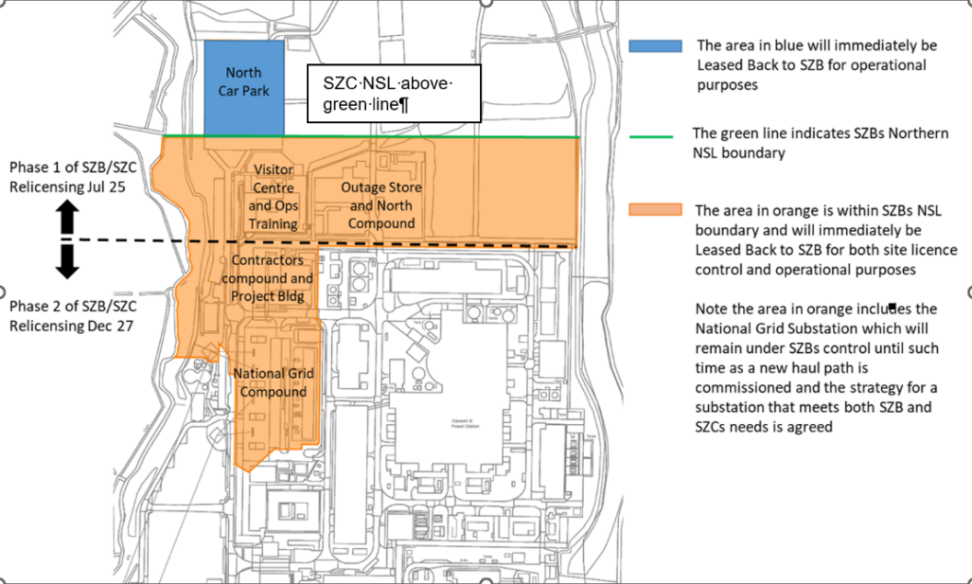
Appendix 2: Leaseback Land

Phase 2 land includes land required for the final site licenced area.

