|  |
| --- |
|  |
| ONR Framework Document  ONR Service Standards |



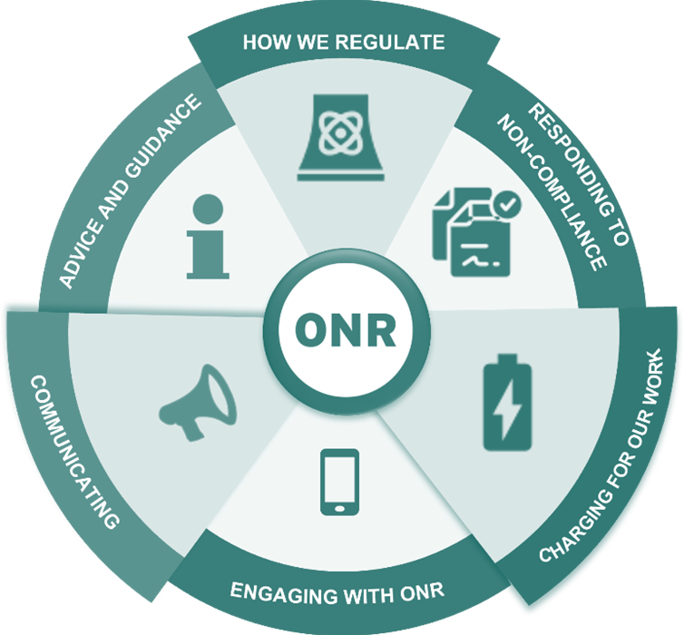

ONR Framework Document

ONR Service Standards

**Authored by**: Head of Compliance

**Approved by**: Head of Corporate Governance

**Issue**: 1.1

**Published**: September 2024

**Next scheduled review**: September 2025

**Document reference**: ONR-GOV-FW-003

**Record reference**: 2024/38346

Revision commentary

|  |  |
| --- | --- |
| Issue | Description of update(s) |
| 1 | First issue published in March 2022 |
| 1.1 | Minor update – content transposed into ONR Framework Document template. |

# Introduction

[The Regulators’ Code](https://assets.publishing.service.gov.uk/government/uploads/system/uploads/attachment_data/file/913510/14-705-regulators-code.pdf) [1] came into statutory effect on 6 April 2014 under the Legislative and Regulatory Reform Act 2006 and provides a clear, flexible, and principles-based framework for how regulators should engage with those they regulate.

Principle 6 of the Code expects regulators to publish a set of ‘ServiceStandards’which set out what those they regulate should expect from them.

Our Service Standards aim to provide transparency in our approach to regulatory activities and set out what members of the public, licensees and duty holders can expect from ONR colleagues.

The purpose of this document is to signpost you to our Service Standards which describe our approach.

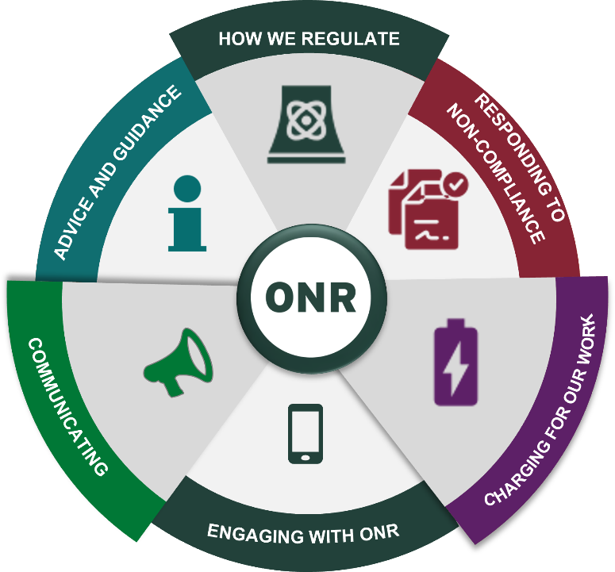

# How we communicate

The [Stakeholder Engagement Strategy 2020-2025](http://www.onr.org.uk/documents/2020/onr-stakeholder-engagement-strategy-2020-25.pdf) [2] sets our objectives and intentions for all those we engage with.

We also use a range of communication channels including, the [CNI annual report](https://www.onr.org.uk/publications/regulatory-reports/chief-nuclear-inspectors-annual-reports/), [monthly Newsletters](https://www.onr.org.uk/news/newsletter/), and [Local Liaison Committee/Site Stakeholder Reports](https://www.onr.org.uk/working-with-others/public-participation/local-liaison-committeesite-stakeholder-group-reports/). Routine regulatory enquiries are made through the nominated site inspector.

As a public body we are also required to publish our [Annual Report and Accounts](https://www.onr.org.uk/publications/corporate-publications/annual-report-and-accounts/) which summarises our performance alongside other key developments across the organisation during the previous financial year.

# How we provide advice and guidance

We provide an extensive range of [resources](http://www.onr.org.uk/resources.htm) to help those who we regulate comply.   
These include but aren’t limited to the publication of:

* [Technical Assessment Guides (TAGs)](https://www.onr.org.uk/operational/tech_asst_guides/index.htm) provide information to licensees and duty holders regarding ONR's expectations of the nature and content of relevant technical elements of safety cases and security plans.
* [Technical Inspection Guides (TIGs)](https://www.onr.org.uk/operational/tech_insp_guides/index.htm) provide information for licensees on ONR's expectations of the nature and content of their own arrangements.
* [Safety Assessment Principles (SAPs)](https://www.onr.org.uk/saps/saps2014.pdf) provide duty holders with information on the regulatory principles against which their safety provisions will be judged.
* [Security Assessment Principles (SyAPs)](https://www.onr.org.uk/syaps/security-assessment-principles-2017.pdf) provide the essential foundation for the introduction of outcome focussed regulation for all constituent security disciplines - physical, personnel, transport, and cyber security and information assurance.

Our Inspectors also routinely provide advice and guidance to enable duty holders to comply.

# 

# How we regulate

We conduct inspections of licensee’s safety cases before we permission activities against the framework published in the [SAPs](https://www.onr.org.uk/saps/saps2014.pdf).

We use the [SyAPs](https://www.onr.org.uk/syaps/security-assessment-principles-2017.pdf) to guide judgements when undertaking assessments of duty holders’ security submissions, such as site security plans and transport security statements.

We use the [Safeguard Assessment Principles](https://www.onr.org.uk/operational/other/onr-cnss-man-001.pdf) to assess operators nuclear material accountancy, control, and safeguard arrangements (NMACS), including the inspection of the implementation of these arrangements.

We check that licensees comply with their [site licence conditions](https://www.onr.org.uk/media/gixbe2br/licence-condition-handbook.pdf) [3] through planned inspections, on a sample basis according to information derived from safety cases and other operational intelligence.

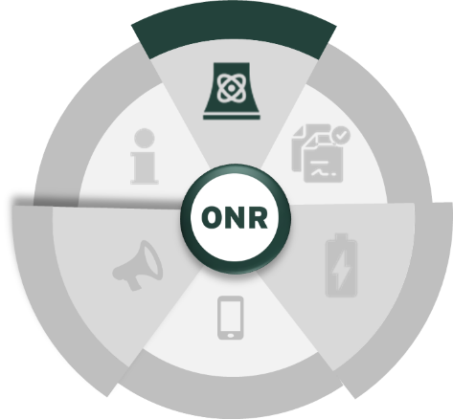We undertake the full spectrum of enforcement activities, from the provision of advice through to prosecution, in accordance with [ONR's Enforcement Policy Statement](https://www.onr.org.uk/documents/enforcement-policy-statement.pdf) [4] and the Regulators’ Code.

[The Enabling Regulation Guide](https://www.onr.org.uk/documents/2020/a-guide-to-enabling-regulation-2020.pdf) [5] explains enabling regulation as implemented by ONR, including enabling principles, enabling behaviours, and some examples of how we have enabled to secure improved safety and security outcomes. It also places enabling regulation in the context of the legal obligations on ONR and our duty holders.

# How we respond to matters of non-compliance

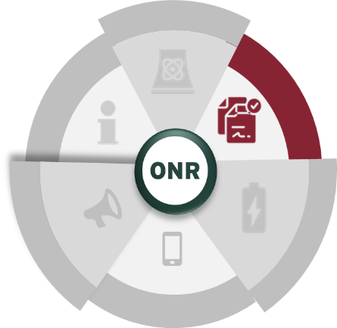Our mission is to protect society by securing safe nuclear operations. As the nuclear regulator, ONR must take enforcement action when licensees are found to be failing to meet the safety and security standards required by law. To do this ONR has been provided with a range of enforcement powers which range from providing advice to instigating court proceedings.

Our [Enforcement Policy Statement](http://www.onr.org.uk/documents/enforcement-policy-statement.pdf) explains how ONR deal with breaches of the law and we will formally apply the [Enforcement Management Model](https://www.onr.org.uk/media/documents/guidance/onr-enf-gd-006.docx) [6] to assist in regulatory decision making.

# How we charge for our work

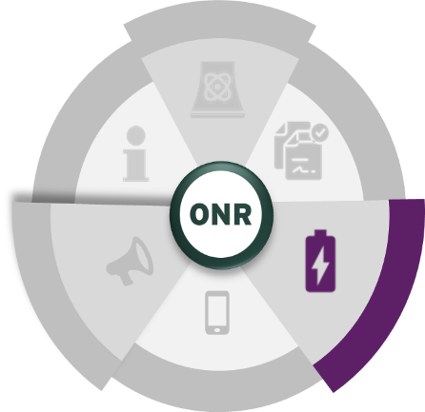ONR fully recovers costs for regulatory duties from duty holders and receives some grant funding from government.

We are funded in two ways. We recover the majority of our running costs from the nuclear industry we regulate and government departments to whom we provide a service.

The remaining costs are funded via a grant from our sponsor body, the Department for Work and Pensions (DWP), to cover activities which are statutorily prohibited from being recovered in this way.

The income generated from cost recovery funds the expenditure ONR incurs in fulfilling its regulatory mission. ONR does not make any profit or surplus, and nuclear site licensees are charged only for the work undertaken in regulating them.

We are committed to providing greater transparency around our charging regime and securing continuous improvements in response to feedback from our stakeholders.

[How we charge for nuclear regulation](http://www.onr.org.uk/documents/2018/how-we-charge-for-nuclear-regulation.pdf) [7] covers this topic in depth.

# How to engage with us

ONR is committed to providing a high standard of service to everyone we deal with. For this reason, we welcome any comments about our service, including when we get things wrong.

We want to resolve your complaint as quickly as possible. We will listen to complaints, treat them seriously, respond to them swiftly and learn from them so we can improve our service.

We treat as a complaint any expression of dissatisfaction with our service which calls for a response. This includes:

* the standard of service we provide
* the behaviour of our staff
* any action or lack of action by our staff affecting an individual or group
* any unfair treatment of stakeholders by members of our staff

All complaints are raised via the form on the [ONR website](https://news.onr.org.uk/make-a-complaint-about-onr/).

In addition to the above, ONR has in place a [decision review and appeals process](https://www.onr.org.uk/media/documents/guidance/onr-per-in-006.docx) [8] which describes how an appeal against a regulatory decision can be made.

# References

|  |  |
| --- | --- |
| [1] | HM Goverment, “Regulators Code,” 6 April 2014. [Online]. Available: https://www.gov.uk/government/publications/regulators-code. |
| [2] | ONR, “Stakeholder Engagement Strategy 2020-2025,” 2020. [Online]. Available: https://www.onr.org.uk/media/2iapvviu/onr-stakeholder-engagement-strategy-2020-25.pdf. |
| [3] | ONR, “Licence Condition Handbook,” 2017. [Online]. Available: https://www.onr.org.uk/media/gixbe2br/licence-condition-handbook.pdf. |
| [4] | ONR, “Enforcement Policy Statement (EPS),” [Online]. Available: https://www.onr.org.uk/media/mtrbcsv3/onr-enf-pol-001-onr-enforcement-policy-statement-1.docx. |
| [5] | ONR, “A guide to enabling regulation,” 2020. [Online]. Available: https://www.onr.org.uk/media/iwcjjiqt/a-guide-to-enabling-regulation-2020.pdf. |
| [6] | ONR, “ONR-ENF-GD-006 - Enforcement,” [Online]. Available: https://www.onr.org.uk/media/documents/guidance/onr-enf-gd-006.docx. |
| [7] | ONR, “How we charge for nuclear regulation,” 2018. [Online]. Available: https://www.onr.org.uk/media/kk4nnirf/how-we-charge-for-nuclear-regulation.pdf. |
| [8] | ONR, “ONR-PER-IN-006 - Decision Review and Appeals Process,” [Online]. Available: https://www.onr.org.uk/media/documents/guidance/onr-per-in-006.docx. |