|  |
| --- |
|  |
| ONR Project assessment report  Modification to the transport package design NOVAPAK 3739A transport frame |

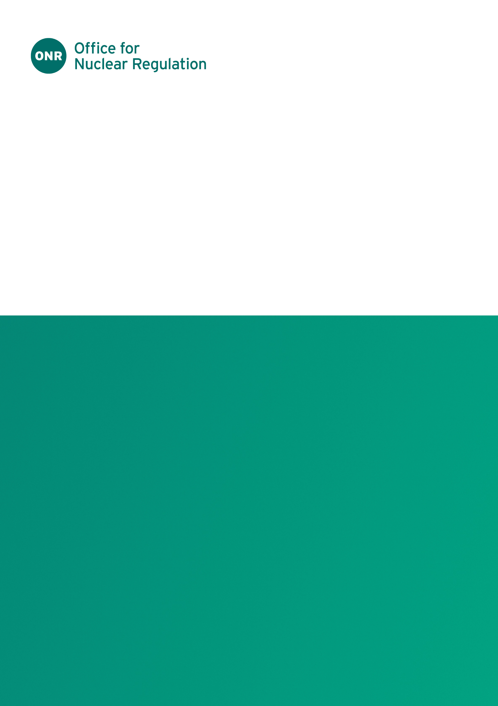

ONR Project assessment report

**Project name**: PR-01822

**Report title**: Modification to the transport package design NOVAPAK 3739A transport frame

**Dutyholder/Applicant**: Nuvia Limited

**Authored by**:

**Report issue no**.: 1

**Publication date**: Jun-25

**Document ID**: ONRW-2019369590-20886

Circulation list (latest issue)

|  |  |  |
| --- | --- | --- |
| Organisation | Recipient | Date report sent |
| ONR |  | 09/06/2025 |
| Nuvia Limited |  | 09/06/2025 |

© Office for Nuclear Regulation, [2025]

For published documents, the electronic copy on the ONR website remains the most current publicly available version and copying or printing renders this document uncontrolled. If you wish to reuse this information visit [www.onr.org.uk/copyright](http://www.onr.org.uk/copyright) for details.

# Executive summary

Nuvia Limited (hereafter referred to as Nuvia) has applied to the Office for Nuclear Regulation (ONR) for a Category A modification to the NOVAPAK 3739A (hereafter referred to as NOVAPAK) transport package design safety report, by endorsement of the modification proposal. The package is currently certified as GB/3739A/B(U)F (Rev.5) until September 2027.

The NOVAPAK packaging is used to transport Contact Handleable Intermediate Level Waste (CHILW) from Nuclear Restoration Services (NRS) Harwell site to Sellafield Ltd. Nuvia are the licence holder, applicant and design authority for the NOVAPAK transport package. Nuclear Waste Services (NWS) are the design authority for the transport frame, used to facilitate transport.

It is usually beneficial to demonstrate that a transport frame completely detaches from a transport package in the event of a serious transport accident – the frame can have a negative impact on the package integrity under such conditions. Historic calculations have been undertaken to ensure that the transport frame completely detaches from the package in the event of a serious transport accident. Due to the replacement of a British Standard, Nuvia undertook additional mechanical accident condition calculations of the transport frame – these demonstrated that a section of the transport frame could remain attached to the package, invalidating the regulatory drop test substantiation. Nuvia modified the transport frame to ensure that the weak link in the fastening devices failed during the accident, as required in the packaged design safety report.

ONR undertook a targeted and proportionate assessment focusing on the changes to Nuvia’s documentation and an intervention of NWS. The ONR engineering assessment focused on the failure mechanisms and supporting calculations. The intervention considered NWS’ arrangements to ensure that the manufacture of transport frames will be undertaken in accordance with an adequate management system and that a quality plan will be adhered to.

Based on ONR’s engineering assessment of Nuvia’s modification proposal and our intervention of NWS, ONR is satisfied that the applicant has demonstrated that the NOVAPAK transport frame modification is compliant with the relevant regulatory design requirements and that the transport frame will be manufactured in accordance with an approved manufacturing specification and quality plan.

The recommendation is that the ONR Transport Competent Authority Head of Regulation endorses modification proposal 96270/DE/MOD/015 Issue B.

Table 1: List of abbreviations.

|  |  |
| --- | --- |
| Term/Acronym | Description |
| ACT | Accident Conditions of Transport |
| AWE | Atomic Weapons Establishment |
| BS | British Standard |
| CA | Competent Authority |
| CHILW | Contact Handleable Intermediate Level Waste |
| EN | European Norm |
| FEA | Finite Element Analysis |
| GB | Great Britain |
| NCT | Normal Conditions of Transport |
| NRS | Nuclear Restoration Services |
| NWS | Nuclear Waste Services |
| ONR | Office for Nuclear Regulation |
| PDSR | Package Design Safety Report |
| TCA | Transport Competent Authority |
| UK | United Kingdom |

Table of contents

Executive summary 3

1. Permission requested 6

2. Background 6

3. Assessment and inspection work carried out by ONR in consideration of this request 7

4. Matters arising from ONR’s work 8

5. Conclusions 8

6. Recommendations 9

References 10

# 

# Permission requested

1. Nuvia Limited (hereafter referred to as Nuvia) applied (ref. [1]) to the Office for Nuclear Regulation (ONR) for a Category A modification to the NOVAPAK 3739A (hereafter referred to as NOVAPAK) transport package design safety report (PDSR) by endorsement of the modification proposal.
2. The package is currently certified as GB/3739A/B(U)F (Rev.5) (ref. [2]) until September 2027.

# Background

1. The NOVAPAK packaging is used to transport Contact Handleable Intermediate Level Waste (CHILW) from Nuclear Restoration Services (NRS) Harwell site to Sellafield Ltd. This material is packed in nominal two hundred litre drums. Up to four drums are loaded in the NOVAPAK.
2. The NOVAPAK packaging consists of two cuboidal packagings - an inner packaging (design number 3738 providing containment) and an outer packaging (design number 3739 providing impact protection, thermal shielding, tie-down and handling features).
3. Nuvia are the licence holder, applicant and design authority for the NOVAPAK transport package. Nuclear Waste Services (NWS) are design authority for the transport frame (used to facilitate transport) and owners / maintainers of the packaging and transport frame.
4. Two NOVAPAK packages are attached to a transport frame - this is an ancillary piece of equipment that is not part of the transport package design but performs an important safety function in the event of a severe accident (accident conditions of transport (ACT) testing).
5. The transport frame is designed to detach from the package in the event of a serious transport accident (via the failure of a weak link in the twistlocks). This ensures that the frame does not impact the package integrity during ACT testing – mechanical drop test calculations do not include the transport frame.
6. Prior to the Atomic Weapons Establishment (AWE) license renewal for the NOVAPAK C variant, Nuvia were required to update the transport frame assessment due to the withdrawal of British Standard (BS) 2573 (BS 2573 was replaced with the BS European Norm (EN) 13001).
7. Calculations undertaken during this assessment demonstrated that a section of the transport frame remained attached to the package during the ACT drop test, invalidating the regulatory drop test substantiation.
8. Nuvia undertook finite element analysis (FEA) to demonstrate that that the ACT drop tests remain valid. However, it became apparent that the cost and time to undertake physical validation would be greater than physically modifying the transport frame weak link.

# Assessment and inspection work carried out by ONR in consideration of this request

1. The modification covers the amendments made to the design of the NOVAPAK transport frame and demonstrates that the new design will detach in accordance with the requirements of the PDSR ‘Type B(U)F Approval for NOVAPAK PCM DN3739A’ Issue E (ref [3]).
2. In accordance with the approved regulatory permissioning strategy, we undertook a targeted and proportionate assessment of the safety submission focusing on the changes to documentation.
3. A new engineered weak link has been incorporated in the twistlock to increase the strength of the structure to withstand normal conditions of transport (NCT) accelerations but fail during ACT, enabling the NOVAPAK to detach from the transport frame without compromising the impact performance of the package.
4. Our engineering assessment (ref. [4]) sampled: updated drawings; the lifting assessment; calculations / analysis; and, tie-down calculations submitted in the application.
5. Further consideration was made to the dutyholder’s understanding of failure mechanisms associated with this modification including: pre-use inspection; annual inspection; maintenance; and, replacement criteria associated with the twistlock design and engineered weak link
6. During our assessment, our engineering assessor discovered a dimensional discrepancy between the twistlock calculations and the manufacturing design drawings. A regulatory query was raised and Nuvia repeated physical stress tests and calculations, the outcome of which required revisions to the modification sheet as well as supporting calculations and drawings.
7. Nuvia submitted a revision to the modification proposal (ref. [5]).
8. The revised calculations and physical tests demonstrate that, in the event of an accident, the twistlocks used to retain the NOVAPAK package to the transport frame perform as they are required to in the PDSR - the NOVAPAK will detach from the transport frame in the event of a serious transport accident, therefore not compromising the impact performance of the package.
9. Our engineering assessor concluded that the modification:

* meets the relevant transport legal requirements, the requirements of the PDSR and follows relevant good practise; and,
* should be approved by the TCA

from an engineering perspective.

1. To support the approval of the design modification, we undertook an inspection (ref. [6]) of NWS, the transport frame design authority (and packaging / transport frame maintainer).
2. NWS will contract a fabricator to carry out the modifications or manufacture new frames. The intervention focused on NWS’ supply-chain arrangements, to gain confidence that the manufacture of transport frames is undertaken in accordance with an adequate management system and that a quality plan will be adhered to.
3. We inspected NWS’ arrangements pertaining to: frame and packaging maintenance; design; maintenance; manufacture and supply chain of transport packaging and ancillary equipment; and, training and competence of employees undertaking these activities. Arrangements were acceptable and in accordance with relevant good practise.
4. It was evident that NWS has adequate arrangements to ensure that the transport frame will be manufactured in accordance with the design specification.

# Matters arising from ONR’s work

1. None.

# Conclusions

1. Based on our engineering assessment of the Nuvia modification proposal (ref. [4]) and our intervention of NWS (ref. [6]), I am satisfied that the applicant has demonstrated that the NOVAPAK transport frame modification is compliant with the relevant design requirements and that the transport frame will be manufactured in accordance with an approved manufacturing specification and quality plan.

# Recommendations

1. I recommend that the ONR Transport Competent Authority Head of Regulation endorses the modification proposal 96270/DE/MOD/015 Issue B (ref. [5]).

# References

|  |  |
| --- | --- |
| [1] | ONRW-2019369590-13667, NOVAPAK DN 3739A Application for Approval of Modification – Amendment to NOVAPAK Transport Frame Design, 96270/DE/MOD/015 Issue A. |
| [2] | Certificate of Approval GB/3739A/B(U)F (Rev.5). |
| [3] | CM9: 2021/86757, Type B(U)F Approval for NOVAPAK PCM DN3739A Issue E, 5 November 2021. |
| [4] | ONRW-2126615823-7234, Mechanical Engineering Assessment (AR-01628) to support the permissioning (PR-01822) of Cat A modification to NOVAPAK Transport Frame. |
| [5] | ONRW-2019369590-20098, NOVAPAK DN 3739A Application for Approval of Modification – Amendment to NOVAPAK Transport Frame Design, 96270/DE/MOD/015 Issue B. |
| [6] | IR-53603, Transport Permissioning Inspection. |